Lesson 8 Demo 1: Working with Nagios Monitoring Tool

This section will show you how to set up and work with Nagios Monitoring tool

This lab has 3 sub-sections:

1. Install Packages Dependencies
2. Install Nagios Core 4.4.6
3. Install Nagios Plugin and NRPE Plugin

**Step 1: Install Packages Dependencies**

* Install the packages dependencies using the following commands:

**sudo apt update**

**sudo apt install -y autoconf bc gawk dc build-essential gcc libc6 make wget unzip apache2 php libapache2-mod-php libgd-dev libmcrypt-dev make libssl-dev snmp libnet-snmp-perl gettext**

**If you get a error that says dpkg is locked by another process, follow the below mentioned steps:**

**Step 2: Install Nagios Core 4.4.6**

* Download the Nagios Core source code.

**cd ~/**

**wget https://github.com/NagiosEnterprises/nagioscore/archive/nagios-4.4.6.tar.gz**

**tar -xf nagios-4.4.6.tar.gz**

**cd nagioscore-*/**

### **Compile and Install Nagios.**

**sudo ./configure --with-httpd-conf=/etc/apache2/sites-enabled**

**sudo make all**

* Run the following commands to install Nagios binaries, service daemon script, and the command mode.

**sudo make install**

**sudo make install-daemoninit**

**sudo make install-commandmode**

**sudo make install-config**

* After this, install the Apache configuration for Nagios and activate the **mod_rewrite** and **mode_cgi** modules and restart the apache service.

**sudo make install-webconf**

**sudo a2enmod rewrite cgi**

**systemctl restart apache2**

* You have installed the Nagios Core 4.4.6. Now create nagiosadmin user

**sudo htpasswd -c /usr/local/nagios/etc/htpasswd.users nagiosadmin**

* Enter your own password.
* For the firewall configuration, run the command below.

**for svc in Apache ssh**

**do**

**ufw allow $svc**

**done**

* In order to start the UFW firewall service and add it to the system boot, run

**ufw enable**

* Type '**y**' and the UFW firewall service will be activated.

**Step 3: Install Nagios Plugins and NRPE Plugin**

* Run the following command:

**sudo apt install monitoring-plugins nagios-nrpe-plugin**

* Now, go to the nagios installation directory **/usr/local/nagios/etc** and create a new directory for storing all server hosts configuration.

**cd /usr/local/nagios/etc**

**mkdir -p /usr/local/nagios/etc/servers**

* Edit the Nagios configuration **nagios.cfg** using vim editor.

**vim nagios.cfg**

* Uncomment the **cfg_dir** option that will be used for storing all server hosts configurations.

**cfg_dir=/usr/local/nagios/etc/servers**

* Save and close.
* Now edit the configuration file **"resource.cfg".**

**vim resource.cfg**

* Define the Nagios Monitoring Plugins path by changing the default configuration as shown below.

**$USER1$=/usr/lib/nagios/plugins**

* Save and close.
* After this, edit the "**objects/contacts.cfg**" file and add the nagios admin email contacts.

**vim objects/contacts.cfg**

* Change the email address with your own.

**define contact{**

**......**

**email <YourEmailId>**

**}**

* Save and close.
* Edit the "**objects/commands.cfg**" file.

**vim objects/commands.cfg**

* You will have to add the following configuration to the end of the line.

**define command{**

**command_name check_nrpe**

**command_line $USER1$/check_nrpe -H $HOSTADDRESS$ -c $ARG1$**

**}**

* Save and close, and the Nagios core configuration has been completed. Run,

**systemctl start nagios**

**systemctl enable nagios**

* The Nagios service should be up and running, check using the following command.

**systemctl status nagios**

* Restart the Apache service to apply a new Nagios configuration.

**systemctl restart apache2**

* Now open your web browser and type the server IP address following the **nagios** URL path.

**http://172.16.0.5/nagios/**

* Now you will have to log in with the user **nagiosadmin** and type your **password**.

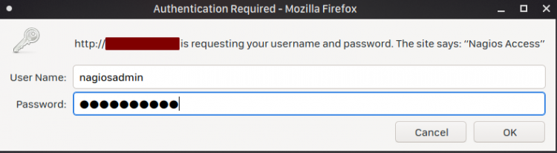

* You will get the Nagios Dashboard as shown below:

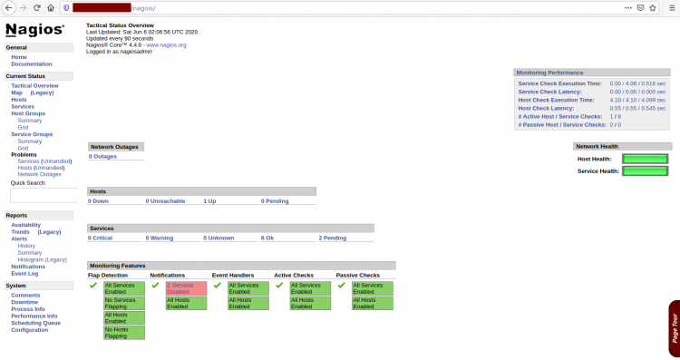

* You've installed Nagios on the Ubuntu server.