Lesson 9 Lesson End Project: Host Docker on Kubernetes Cluster

This section will show you how to host an ASP.NET application on Kubernetes Cluster.

This lab has 2 sub-sections:

1. Clone Docker repo on build server and prepare docker image
2. Host built docker image on Kubernetes Cluster

**Step 1:** Clone Docker repo on build server and prepare docker image.

**git clone https://github.com/Anuj1990/Docker.git**

**cd Docker**

**docker build -t dockerapp**

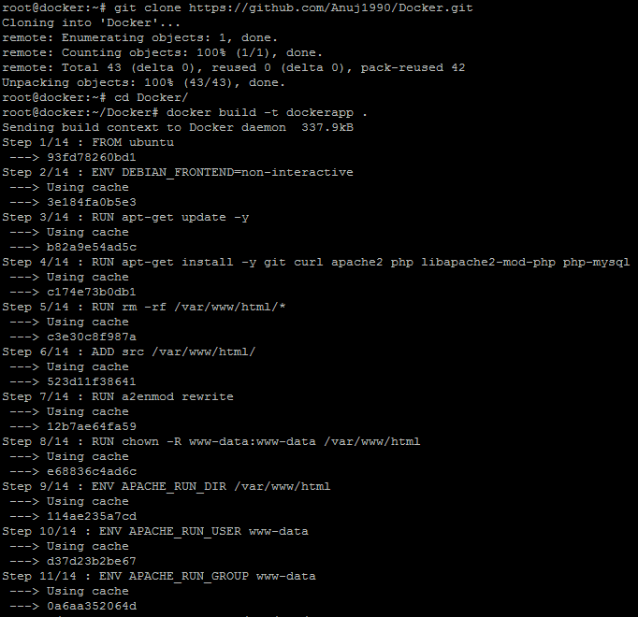

* Once the build is successful, execute the command below to check on the Docker file.

**docker images | grep dockerapp**

* Check if any of the pods are running in the cluster by executing the command mentioned below:

**kubectl get pods**

**Note:** If you end up with the following error -



* Run the command mentioned below:



* Run the Docker app by executing the command below:

**kubectl run dockerapp --image=dockerapp --port=80**

**kubectl expose deployment/dockerapp --port=80 --target-port=80 --type=NodePort**

**kubectl get pods**

**Step 2:** Host built docker image on Kubernetes Cluster.

* Check if the **dockerapp** is running as a service by executing the command mentioned below:

**kubectl get services**

* Check if the **dockerapp** is deployed by executing the command mentioned below:

**kubectl get deployments**

* You should be able to see the output mentioned in the screenshot:

