Arduino Mega 2560 – Pinout & Schematics

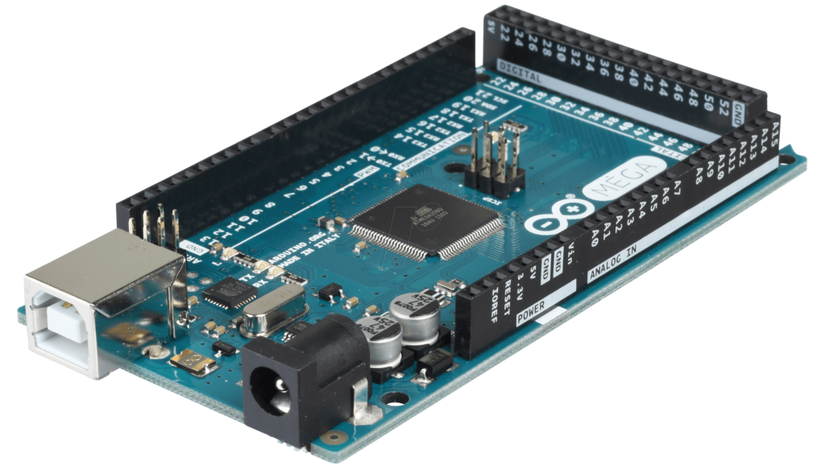

Arduino Mega 2560 Specifications
Arduino Mega – Basic Features
Microcontroller | AVR ATmega 2560 (8bit)
Power Supply | 7-12V (Inbuilt Regulator for Controller)
Digital I/O Pins | 54
Analogue I/O Pins | 16
Total Digital I/O | 70 (Digital + Analogue)
Clock Speed | 16 MHz (Factory set to 1Mhz)
Flash Memory | 128 KB
SRAM | 8 KB
Communication | USB (Programming with ATmega 8), ICSP (programming), SPI, I2C and USART

Timer | 2 (8bit) + 4 (16bit) = 6 timer
PWM | 12 (2-16 bit)
ADC | 16 (10 bit)
USART | 4
Pin Change Interrupt | 24
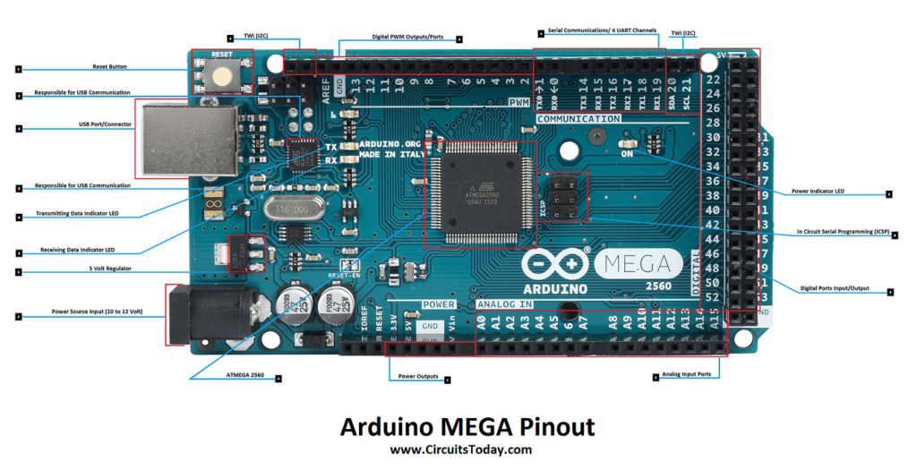

Arduino Mega Pin Diagram
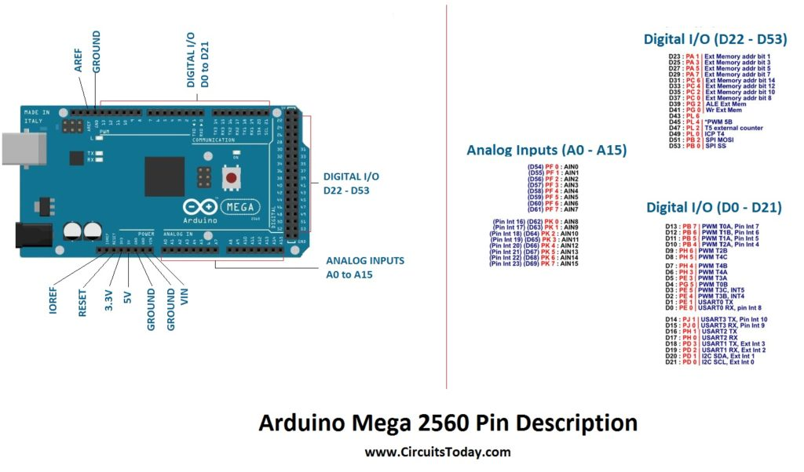

Controller Pins:
RESET: (Reset input) A low level on this pin for longer than the 4 clock cycle will generate a reset. Arduino Mega has inbuilt reset circuit with push button to reset system and this pin can be used by other devices to reset controller.
XTAL1,XTAL2: Crystal (16Mhz) is connected to supply clock for controller with 2 bypass capacitor to ground.
AREF: This pin is used, when we use Adc for analogue to digital conversion with external reference voltage for conversion and don’t want to use internal 1.1V or 5v reference.

Digital pins (70):
Digital pins (0-53) + Analogue (0-15) = Total Digital I/O pins.
Digital Pins: From 0-53(digital) and 0-15(analogue) can be use as input or output for digital transducer and output devices by pinMode() for pin direction, digitalWrite() to write pin and digitalRead() to read pin status.

Analogue Pins (16):
Analogue pins: From 0-15(analogue) can be used as analogue input pin for adc, if not used than it work as normal digital pin. It can be used by pinMode() for pin direction, analogueRead() to read pin status and get digital value for analogue signal, care must be taken for internal or external reference voltage selection and Aref pin.
Application :
Input devices: Ntc thermistor, sensors (like ldr, irled and humidity) and others
Example :
- INPUT analogue signal on Arduino mega board
pinMode(0,INPUT);
analog.Read(0);

Alternative Pins Function:

SPI Pins:
Pin 22 - SS, Pin 23 - SCK, Pin 24 - MOSI, Pin 25 – MISO
These pins are used for serial communication with SPI protocol for communication between 2 or more devices. SPI enable bit must be set to start communication with other devices.

I2C Pins:
Digital pin 20 for SDA and 21 for SCK (Speed 400khz) to enable two wire communication with other devices. Function used are wire.begin() to start I2C conversion, with wire.Read() to read i2c data and wire.Write() to write i2c data.
Application:
Output devices : LCD and communication between multiple devices with two wire.
Input devices : rtc and others.
Example:
I2c master read data from slave
Wire.begin();
Wire.requestFrom(2, 1); //1byte data
Wire.Read();

PWM Pins:
Digital pin 2-13 can be used as PWM output with analogueWrite() to write pwm value from 0-255.It’s alternative of DAC for low cost system to get analogue signal at output by using filter.
Application:
Output devices: speed control of motor, light dimmer, pid for efficient control system.
Example:
- OUTPUT analogue signal on Arduino mega board
pinMode(0,OUTPUT);
analogueWrite(0,255);

USART Pins :
Pin 0 – RXD0, pin 1 – TXD0

Pin 19 – RXD1, pin 18 – TXD1

Pin 17 – RXD2, pin 16 – TXD2

Pin 15 – RXD3, pin 14 – TXD3
These pin are used for serial usart communication with pcs or other systems for data sharing and logging. It is used with serialBegin() to set baud rate setting and start communication with serial.Println() to print array of char on other device output.

Pinchange Interrupt Pins:
Digital Pin 0,22,23,24,25,10,11,12,13,15,14

Analogue Pin 6,7,8,9,10,11,12,13,14,15
This pin is used for pin change interrupt. Enable bit of pinchange interrupt must be set with global interrupt enable.
Application :
Rotary encoder, push button based interrupt and others.
Example :
pinMode(0, OUTPUT);
pinMode(1, INPUT_PULLUP);
attachInterrupt(digitalPinToInterrupt(1), LOW, CHANGE);

Hardware Interrupt Pins :
Digital pin 18 – 21,2,3 hardware interrupt is used for interrupt services. Hardware interrupt must be enabled with global interrupt enable to get interrupt from other devices.
Application:
Push button for ISR program, wake up controller with external devices, sensors like ultrasonic and others.
Example:
pinMode(0, OUTPUT);
pinMode(1, INPUT_PULLUP);
attachInterrupt(digitalPinToInterrupt(1), LOW, LOW);

Arduino Mega Schematic Components:
DC Jack Power Supply :
External Supply for Arduino Mega from range 7-12 volt is given with this port. Arduino Mega R3 has a voltage regulator for 5v and 3.3v supply for Arduino controller and sensor supply.
ICSP 1 (ATmega8) and 2 (AVR 2560):
It has features of programming using serial bus with AVR programmer using SPI communication. AVR 2560 is programmed to run the system and ATmega 8 is programmed for serial communication and programming.

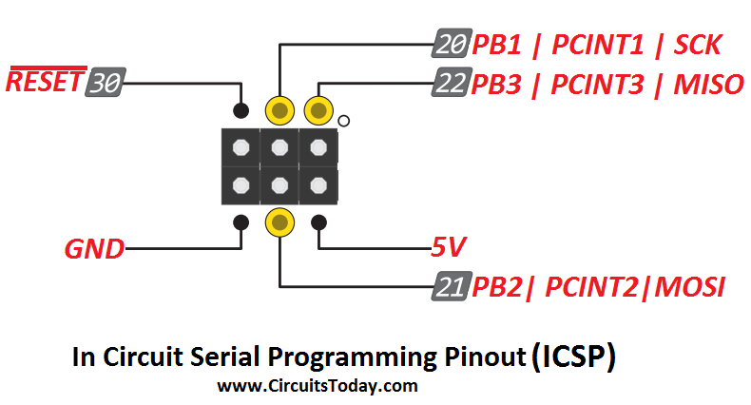Arduino Mega ICSP Pinout for ATmega 2560
Reset :
It has reset circuit with capacitor, button and resistor to reset the controller. A push button is used to get 4 cycle low signal on reset pin to get the controller in reset mode.
Crystal :
It has a crystal circuit with two capacitors and one 16 Mhz crystal for xtal pins 1 and 2 interfacing with avr 2560.
I2C :
It has features of I2C (two wire communication) with an external pull-up resistor.
USART :
It has TXD and RXD pin for serial communication with LED indicator.

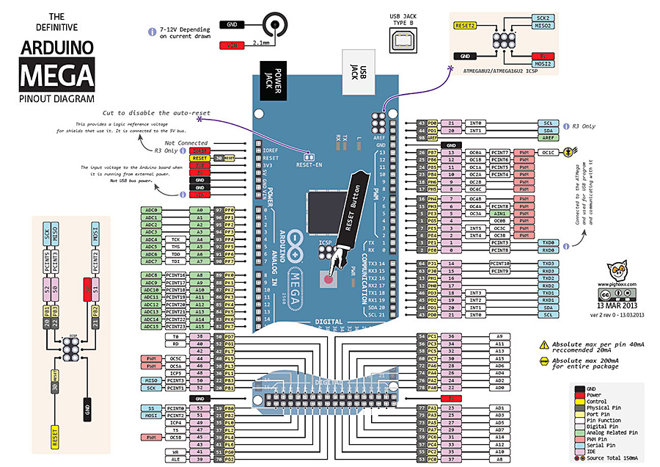
Pin Name | Mapped Pin Name | IDE
OC0B | Digital pin 4 (PWM) | 4 | Temperature
RXD0/PCINT8 | Digital pin 0 (RX0) | 0 | Console_RX0
TXD0 | Digital pin 1 (TX0) | 1 | Console_TX0
OC3A/AIN1 | Digital pin 5 (PWM) | 5
OC3B/INT4 | Digital pin 2 (PWM) | 2
OC3C/INT5 | Digital pin 3 (PWM) | 3
T3/INT6
CLKO/ICP3/INT7
VCC | VCC
GND | GND
RXD2 | Digital pin 17 (RX2) | 17 | Azimuth_RX2
TXD2 | Digital pin 16 (TX2) | 16 | Azimuth_TX2
XCK2
OC4A | Digital pin 6 (PWM) | 6
OC4B | Digital pin 7 (PWM) | 7
OC4C | Digital pin 8 (PWM) | 8
OC2B | Digital pin 9 (PWM) | 9
SS/PCINT0 | Digital pin 53 (SS) | 53
SCK/PCINT1 | Digital pin 52 (SCK) | 52
MOSI/PCINT2 | Digital pin 51 (MOSI) | 51
MISO/PCINT3 | Digital pin 50 (MISO) | 50
OC2A/PCINT4 | Digital pin 10 (PWM) | 10
OC1A/PCINT5 | Digital pin 11 (PWM) | 11
OC1B/PCINT6 | Digital pin 12 (PWM) | 12 | Control_Panel_RX
OC0A/OC1C/PCINT7 | Digital pin 13 (PWM) | 13 | Control_Panel_TX
T4
TOSC2
TOSC1 )
RESET | RESET
VCC | VCC
GND | GND
XTAL2 | XTAL2
XTAL1 | XTAL1
PL0 ( ICP4 ) | Digital pin 49 | 49
PL1 ( ICP5 ) | Digital pin 48 | 48
PL2 ( T5 ) | Digital pin 47 | 47
PL3 ( OC5A ) | Digital pin 46 (PWM) | 46
PL4 ( OC5B ) | Digital pin 45 (PWM) | 45
PL5 ( OC5C ) | Digital pin 44 (PWM) | 44
PL6 | Digital pin 43 | 43
PL7 | Digital pin 42 | 42
PD0 ( SCL/INT0 ) | Digital pin 21 (SCL) | 21
PD1 ( SDA/INT1 ) | Digital pin 20 (SDA) | 20
PD2 ( RXDI/INT2 ) | Digital pin 19 (RX1) | 19 | Altitude_RX1
PD3 ( TXD1/INT3 ) | Digital pin 18 (TX1) | 18 | Altitude_TX1
 | Digital pin 38 | 38
 | Digital pin 41 | 41
 | Digital pin 40 | 40
 | Digital pin 37 | 37
 | Digital pin 36 | 36
 | Digital pin 35 | 35
 | Digital pin 34 | 34
 | Digital pin 33 | 33
 | Digital pin 32 | 32
 | Digital pin 31 | 31
 | Digital pin 30 | 30
VCC | VCC
GND | GND
RXD3/PCINT9 | Digital pin 15 (RX3) | 15 | Focuser_RX3
TXD3/PCINT10 | Digital pin 14 (TX3) | 14 | Focuser_TX3
XCK3/PCINT11
PCINT12
PCINT13
PCINT14
PCINT 15
ALE | Digital pin 39 | 39
AD7 | Digital pin 29 | 29
AD6 | Digital pin 28 | 28
AD5 | Digital pin 27 | 27
AD4 | Digital pin 26 | 26
AD3 | Digital pin 25 | 25
AD2 | Digital pin 24 | 24
AD1 | Digital pin 23 | 23
AD0 | Digital pin 22 | 22
ADC15/PCINT23 | Analog pin 15 | A15
ADC14/PCINT22 | Analog pin 14 | A14
ADC13/PCINT21 | Analog pin 13 | A13
ADC12/PCINT20 | Analog pin 12 | A12
ADC11/PCINT19 | Analog pin 11 | A11
ADC10/PCINT18 | Analog pin 10 | A10
ADC9/PCINT17 | Analog pin 9 | A9
ADC8/PCINT16 | Analog pin 8 | A8
ADC7/TDI | Analog pin 7 | A7
ADC6/TDO | Analog pin 6 | A6
ADC5/TMS | Analog pin 5 | A5
ADC4/TCK | Analog pin 4 | A4
ADC3 | Analog pin 3 | A3
ADC2 | Analog pin 2 | A2
ADC1 | Analog pin 1 | A1
ADC0 | Analog pin 0 | A0

