金边投资回报率 买房出租10%

澳大利亚吸引度很高

越南股市回报率比房租高（但是没有计算房子本身的升值）

全球房价分析表
https://www.numbeo.com/property-investment/rankings.jsp

https://www.numbeo.com/property-investment/rankings_current.jsp

越南股市现在可能是机会
https://tradingeconomics.com/vietnam/stock-market

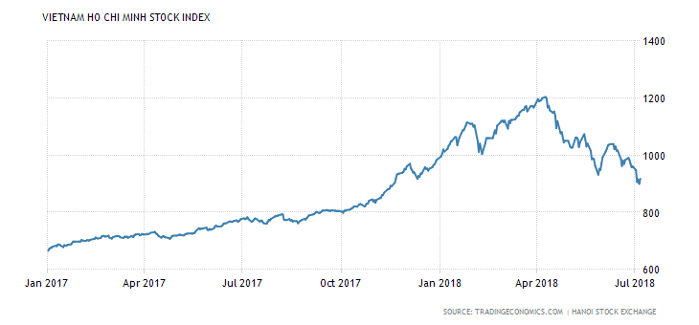
Cambodia

In other countries, where population is higher, demand will come back in short time. However, Cambodian population is still low, so when it experiences oversupply, it can be a big problem

Phnom Panh 高端降价，中段涨价，显示外国人来的不多，本地人开始买房，但是本地人口有限

