 |  | Eco Audit Report
Product name |  |  |  | Cat Teaser Wand (1)
Country of manufacture |  | The Whole World

Country of use |  |  |  | The Whole World
Product life (years) |  |  |  | 1
Summary:

 |  | 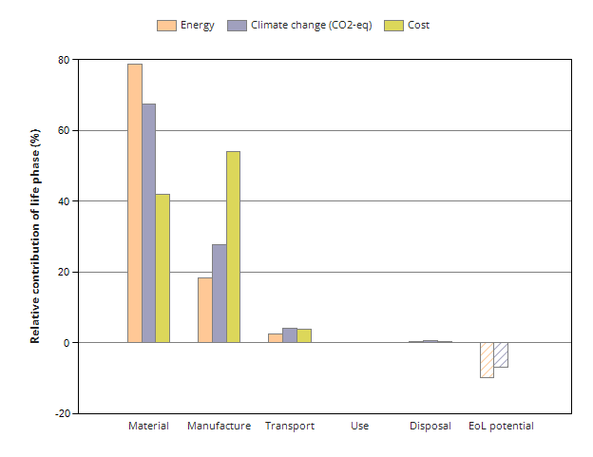
 |  |  | Energy details |  | Climate change (CO2-eq) details |  | Cost details
Phase | Energy  (MJ) | Energy  (%) | Climate change (CO2-eq)  (kg) | Climate change (CO2-eq)  (%) | Cost  (GBP) | Cost  (%)
Material | 2.51e+05 | 78.8 | 9.87e+03 | 67.4 | 4.73e+03 | 42
Manufacture | 5.83e+04 | 18.3 | 4.08e+03 | 27.9 | 6.08e+03 | 54
Transport | 7.85e+03 | 2.5 | 597 | 4.1 | 431 | 3.83
Use | 0 | 0.0 | 0 | 0.0 | 0 | 0
Disposal | 1.45e+03 | 0.5 | 102 | 0.7 | 15.8 | 0.14
Total (for first life) | 3.19e+05 | 100 | 1.46e+04 | 100 | 1.13e+04 | 100
End of life potential | -3.16e+04 |  | -992

Eco Audit Report


Summary

Energy Analysis

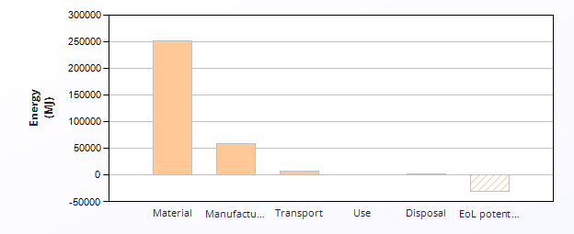
 | Energy (MJ/year)
Equivalent annual environmental burden (averaged over 1 year product life): | 3.19e+05

Detailed breakdown of individual life phases

Material: |  | Summary
Component | Material | Recycled content*  (%) | Part mass  (kg) | Qty. | Total mass processed**  (kg) | Energy  (MJ) | %
Wand (Handle) | ABS (medium-impact, injection molding) | Virgin (0%) | 0.05 | 50000 | 2.5e+03 | 2.4e+05 | 96.8
String | Hemp fiber | Virgin (0%) | 0.015 | 50000 | 7.5e+02 | 8.1e+03 | 3.2
Total |  |  |  | 100000 | 3.3e+03 | 2.5e+05 | 100

*Typical: Includes 'recycle fraction in current supply'

**Where applicable, includes material mass removed by secondary processes

***User-defined material

 | Manufacture: |  |  | Summary
Component | Process | % Removed | Amount processed |  | Energy  (MJ) | %
Wand (Handle) | Polymer molding (injection, blow) | - | 2.5e+03 | kg | 5.6e+04 | 96.7
String | Fabric production | - | 7.5e+02 | kg | 2e+03 | 3.3
String | Cutting and trimming | - | 0 | kg | 0 | 0.0
Total |  |  |  |  | 5.8e+04 | 100

Transport: |  |  | Summary
Breakdown by transport stage

Stage name | Transport type | Distance  (km) | Energy  (MJ) | %
China to UK | Sea, container ship | 1.8e+04 | 7.9e+03 | 100.0
Total |  | 1.8e+04 | 7.9e+03 | 100

Breakdown by components

Component | Mass  (kg) | Energy  (MJ) | %
Wand (Handle) | 2.5e+03 | 6e+03 | 76.9
String | 7.5e+02 | 1.8e+03 | 23.1
Total | 3.3e+03 | 7.9e+03 | 100

Use: |  |  |  | Summary
 | Relative contribution of static and mobile modes
Mode | Energy  (MJ) | %
Static | 0
Mobile | 0
Total | 0 | 100

Disposal: | Summary
Component | End of life option | % recovered | Energy  (MJ) | %
Wand (Handle) | Downcycle | 80.0 | 1.1e+03 | 75.7
String | Downcycle | 90.0 | 3.5e+02 | 24.3
Total |  |  | 1.5e+03 | 100

EoL potential:

Component | End of life option | % recovered | Energy  (MJ) | %
Wand (Handle) | Downcycle | 80.0 | -3.1e+04 | 99.8
String | Downcycle | 90.0 | -68 | 0.2
Total |  |  | -3.2e+04 | 100

Notes: | Summary

Eco Audit Report


Summary

Climate Change (CO2-eq) Analysis

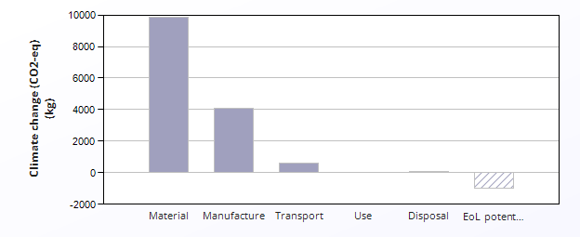
 | CO2 (kg/year)
Equivalent annual environmental burden (averaged over 1 year product life): | 1.46e+04

Detailed breakdown of individual life phases

Material: |  | Summary
Component | Material | Recycled content*  (%) | Part mass  (kg) | Qty. | Total mass processed**  (kg) | Climate change (CO2-eq)  (kg) | %
Wand (Handle) | ABS (medium-impact, injection molding) | Virgin (0%) | 0.05 | 50000 | 2.5e+03 | 9.2e+03 | 93.4
String | Hemp fiber | Virgin (0%) | 0.015 | 50000 | 7.5e+02 | 6.5e+02 | 6.6
Total |  |  |  | 100000 | 3.3e+03 | 9.9e+03 | 100

*Typical: Includes 'recycle fraction in current supply'

**Where applicable, includes material mass removed by secondary processes

***User-defined material

 | Manufacture: |  |  | Summary
Component | Process | % Removed | Amount processed |  | Climate change (CO2-eq)  (kg) | %
Wand (Handle) | Polymer molding (injection, blow) | - | 2.5e+03 | kg | 3.9e+03 | 96.2
String | Fabric production | - | 7.5e+02 | kg | 1.6e+02 | 3.8
String | Cutting and trimming | - | 0 | kg | 0 | 0.0
Total |  |  |  |  | 4.1e+03 | 100

Transport: |  |  | Summary
Breakdown by transport stage

Stage name | Transport type | Distance  (km) | Climate change (CO2-eq)  (kg) | %
China to UK | Sea, container ship | 1.8e+04 | 6e+02 | 100.0
Total |  | 1.8e+04 | 6e+02 | 100

Breakdown by components

Component | Mass  (kg) | Climate change (CO2-eq)  (kg) | %
Wand (Handle) | 2.5e+03 | 4.6e+02 | 76.9
String | 7.5e+02 | 1.4e+02 | 23.1
Total | 3.3e+03 | 6e+02 | 100

Use: |  |  |  | Summary
 | Relative contribution of static and mobile modes
Mode | Climate change (CO2-eq)  (kg) | %
Static | 0
Mobile | 0
Total | 0 | 100

Disposal: | Summary
Component | End of life option | % recovered | Climate change (CO2-eq)  (kg) | %
Wand (Handle) | Downcycle | 80.0 | 77 | 75.7
String | Downcycle | 90.0 | 25 | 24.3
Total |  |  | 1e+02 | 100

EoL potential:

Component | End of life option | % recovered | Climate change (CO2-eq)  (kg) | %
Wand (Handle) | Downcycle | 80.0 | -9.9e+02 | 99.5
String | Downcycle | 90.0 | -4.7 | 0.5
Total |  |  | -9.9e+02 | 100

Notes: | Summary

Eco Audit Report


Summary

Cost Analysis

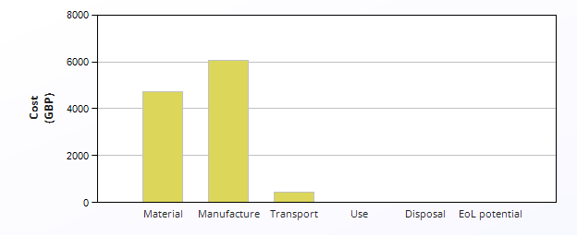
 | Cost (GBP/year)
Equivalent annual environmental burden (averaged over 1 year product life): | 1.13e+04

Detailed breakdown of individual life phases

Material: |  | Summary
Component | Material | Recycled content*  (%) | Part mass  (kg) | Qty. | Total mass processed**  (kg) | Cost  (GBP) | %
Wand (Handle) | ABS (medium-impact, injection molding) | Virgin (0%) | 0.05 | 50000 | 2.5e+03 | 4e+03 | 85.5
String | Hemp fiber | Virgin (0%) | 0.015 | 50000 | 7.5e+02 | 6.8e+02 | 14.5
Total |  |  |  | 100000 | 3.3e+03 | 4.7e+03 | 100

*Typical: Includes 'recycle fraction in current supply'

**Where applicable, includes material mass removed by secondary processes

***User-defined material

 | Manufacture: |  |  |  |  |  | Summary
Country of manufacture |  |  |  | The Whole World
Component | Process | Length (m) | % Removed | Amount processed |  | Cost  (GBP) | %
Wand (Handle) | Polymer molding (injection, blow) | - | - | 2.5e+03 | kg | 6.1e+03 | 100.0
String | Fabric production | - | - | 7.5e+02 | kg | 0 | 0.0
String | Cutting and trimming | - | - | 0 | kg | 0 | 0.0
Total |  |  |  |  |  | 6.1e+03 | 100

Transport: |  | Summary
Package dimensions

Height (m) | Width (m) | Depth (m)
1 | 0.03 | 0.02

Breakdown by transport stage

Stage name | Transport type | Distance  (km) | Cost  (GBP) | %
China to UK | Sea, container ship | 1.8e+04 | 4.3e+02 | 100.0
Total |  | 1.8e+04 | 4.3e+02 | 100

Breakdown by components

Component | Mass  (kg) | Cost  (GBP) | %
Wand (Handle) | 2.5e+03 | 3.3e+02 | 76.9
String | 7.5e+02 | 1e+02 | 23.1
Total | 3.3e+03 | 4.3e+02 | 100

Use: |  |  |  | Summary
 | Relative contribution of static and mobile modes
Mode | Cost  (GBP) | %
Static | 0
Mobile | 0
Total | 0 | 100

Disposal: | Summary
Component | End of life option | % recovered | Cost  (GBP) | %
Wand (Handle) | Downcycle | 80.0 | 12 | 76.9
String | Downcycle | 90.0 | 3.6 | 23.1
Total |  |  | 16 | 100

Notes: | Summary

