**Bachelor of Science (Honours) in Computing**

**Semester 3**

**Module:**

**Web Design and Development 1**

**CA2 Group Report**

**Report Writing**

**‘Plan, Design and Develop**

**a Dynamic Website’**



Lecturer: Enda Lee

Submission Date: 21st November 2016

**Student Details: Word Count**

Stephen Kelly X00119766

Aidan Dunne X00126748

Jordan Gardner X00126750

**Declaration**

The above-named students declare that the content of this Continuous Assessment project is solely the work of the individuals whose name appears on this cover sheet. The work of any other authors has been cited and referenced in full.

|TTT

Table of Contents

Project Overview / Contributions 3

Introduction 4

The User 5

Target Audience & User Types 5

Requirements of User 5

Competitors, Strengths & Weaknesses 6

Site Structure and Design 6

NavigatioN 6

Page Design 7

INDEX.HTML 7

ABOUT.HTML 7

MEMBERSHIP.HTML 7

PRODUCTS.HTML 8

SIGNUP.HTML 9

LOGIN.HTML 9

Color scheme 10

**Part 2** 11

**Conclusions** 13

# Project Overview / Contributions

For the purpose of this assignment we were asked to plan, design and develop a website which included a dynamic element. An example of this it would be a product page that can view, add, update and delete products or users, etc. Each of our team members contributed to this assignment and you will find the breakdown of this below:

X00119766 Stephen Kelly:

* Index.Html
* About.Html
* Membership.Html
* Site Structure
* Storyboard : index, about, membership, products
* Report: Introduction, conclusion
* Play Framework: Transferring html, css etc into the play framework

Part 2:

* Database creation, and implementation into products.scala.html
* Admin capability construction
* Image upload ability
* Review Model and Implementation into products
* Program testing
* Review Model section of report
* Html & CSS Adjustments

X00126748 Aidan Dunne:

* SignUp.html
* login.html
* Products.Html(Main page)
* Storyboard : logIn, signIn
* Report: The User, Site Structure and Design
* Play Framework: Transferring html, css etc into the play framework

Part 2:

* Update Product Feature
* Delete Product Feature
* Report Writing
* Program Testing
* Html & CSS Adjustments

X00126750 Jordan Gardner:

* Equipment.html
* Supplements.html
* Clothing.html
* Play Framework: Transferring html, css etc into the play framework

Part 2:

* Add Product Feature
* Report Writing
* Program Testing
* Html & CSS Adjustments

# Introduction

The goal of this report is to document the process of planning, designing and developing a dynamic website. This project is a part of our Web design and development 1 module for semester 3, the CA is split into part 1 and part 2. Part 1 is further spilt into 1a and 1b.

1a involved the design of a website that meets the requirements of its intended users, defining the different user types, deciding what pages will be needed for the site and how the user should navigate them. Then using the information found to create a site structure that shows the links between the pages.

When the site structure was completed we could begin the page design, which involved creating layouts for the pages, defining the content that should be on each page and specifying the media that will be included. At this stage we have not made the pages in html, we are simply creating the layout.

Part 1b was building the site in HTML5 and CSS using the navigation, pages and page designs created in 1a. What we were building was a static version of the site, as we are going to add dynamic elements to the site in part 2. We included elements such as forms and tables that for the moment are static but will later be dynamic. At this stage we have built a site that can now be put into a Play Framework application. We use common page elements such as the navbar and footer to create a page template in the play framework.

.

# The User

## Target Audience & User Types

While designing our website, the target audience that we had in-mind was ages sixteen and above. The reason we chose this age group as our target audience was, because in order to gain access to a gym here in Ireland you must be at least sixteen years old. We felt that by designing a gym website then we would appeal to a larger audience and a diverse number of users. Some examples of the users we intend to target with our website are:

* Sports Athletes
* People looking to maintain fitness and healthy lifestyle
* People looking to try new things
* Trainers
* People looking to lose weight

The User type that will access the website will be either be a Customer, a Joe’s Online Member or an Admin.

## Requirements of User

We as a group felt that meeting our user’s requirements was a very important part of our website, since they would be the people using the website. We feel that certain requirements are crucial to the user such as:

* User’s should be able to open our website in any browser.
* They should also be able to sign up or sign into their account.
* User’s should be able to navigate through our website with ease.
* Visitors to the website should also be able to purchase products.
* User’s should also be able to view our website on a mobile device.

These are only a few of the crucial user requirements we intend our website to achieve.

## Competitors, Strengths & Weaknesses

We have designed our website to be in direct competition if not two steps ahead our main competitor who we feel are; FLYE Fit Gyms. We feel we are in direct competition with this gym because their website is exactly what we aimed our website to replicate but only better. Some of the strengths of FLYE Fit Gym websites are as follows: 1) Functionality, 2) Navigation and, 3) Accessibility for users.

Although we feel that FLYE Fit Gyms website has a lot of great features there are also a few weaknesses to their website. One main weakness we feel that can be seen whilst using their website is the colour scheme and how dark it is on some pages but yet so vibrant on others. This can cause some users to find their website quite hard on the eyes therefore causing them to lose focus and leave the website. We see this as an opportunity to tune into what their website lacks and develop it on ours furthermore drawing the attention of users who may have left their site and seen the improvement in ours.

# Site Structure and Design

## NavigatioN

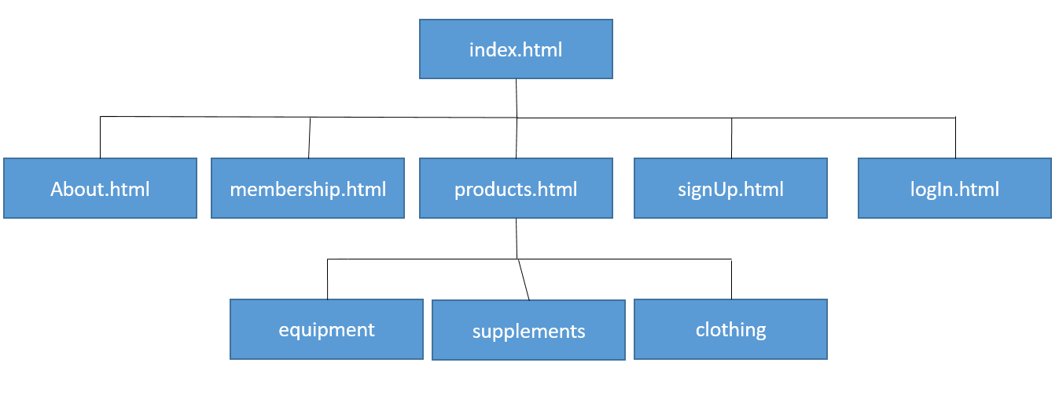

As a team we had studied other websites that related to ours and we decided to go with a similar structure to most because we felt that they suited what we as a team were aiming for. We also felt that we had the best navigation through our website which due to the fact we made it as easy as possible for the user to navigate through the website. This makes for a happier user overall.

## Page Design

### INDEX.HTML

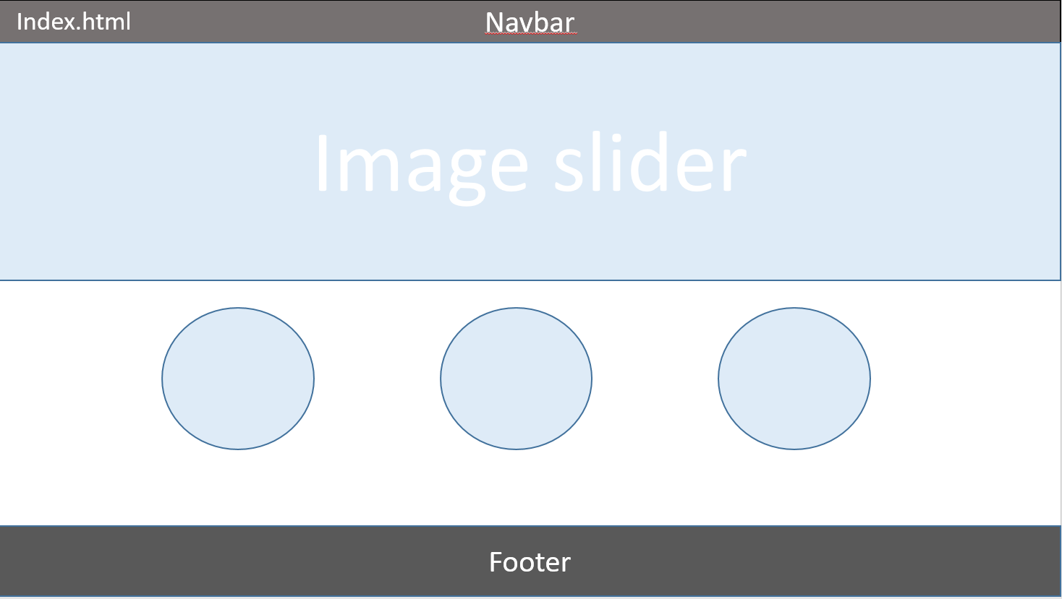

### ABOUT.HTML

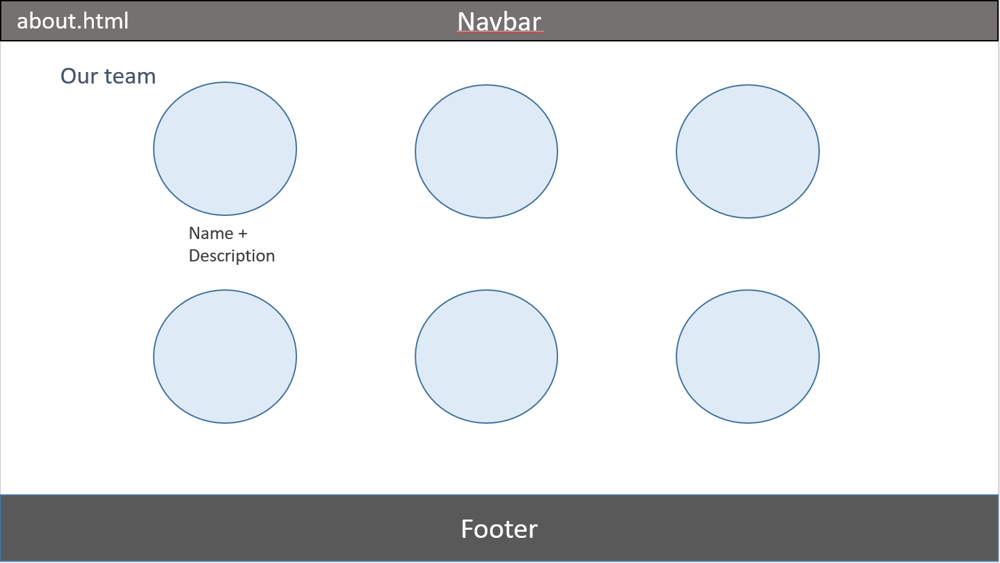

### MEMBERSHIP.HTML

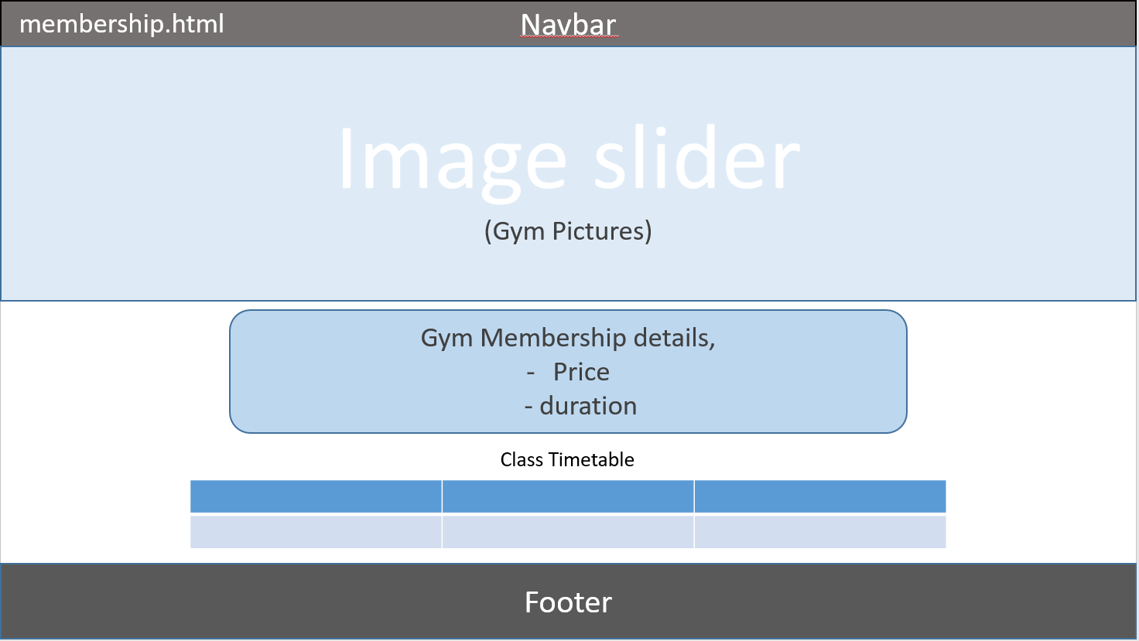

### PRODUCTS.HTML

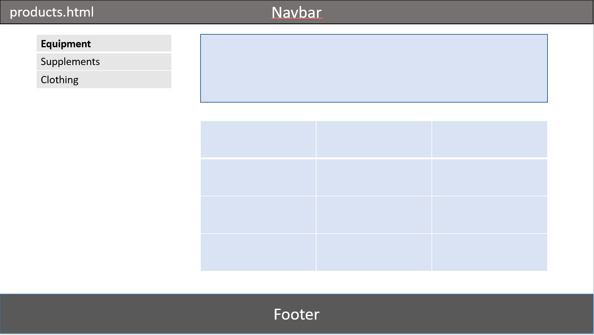

### SIGNUP.HTML

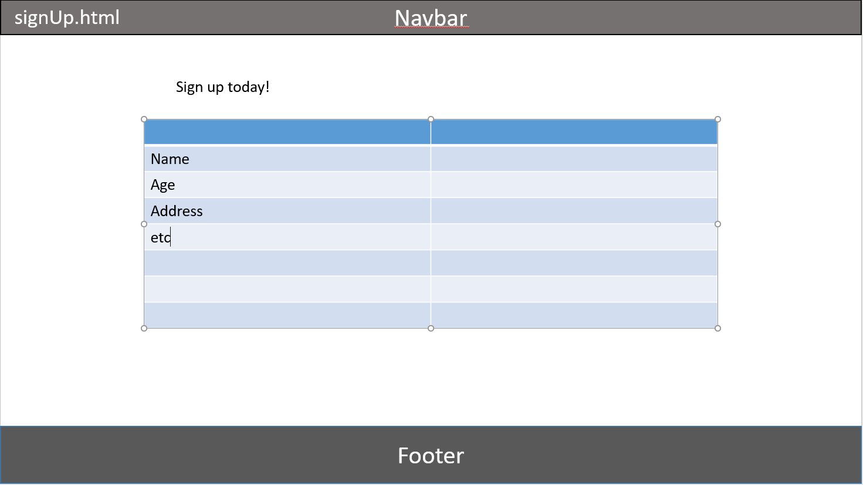

### LOGIN.HTML

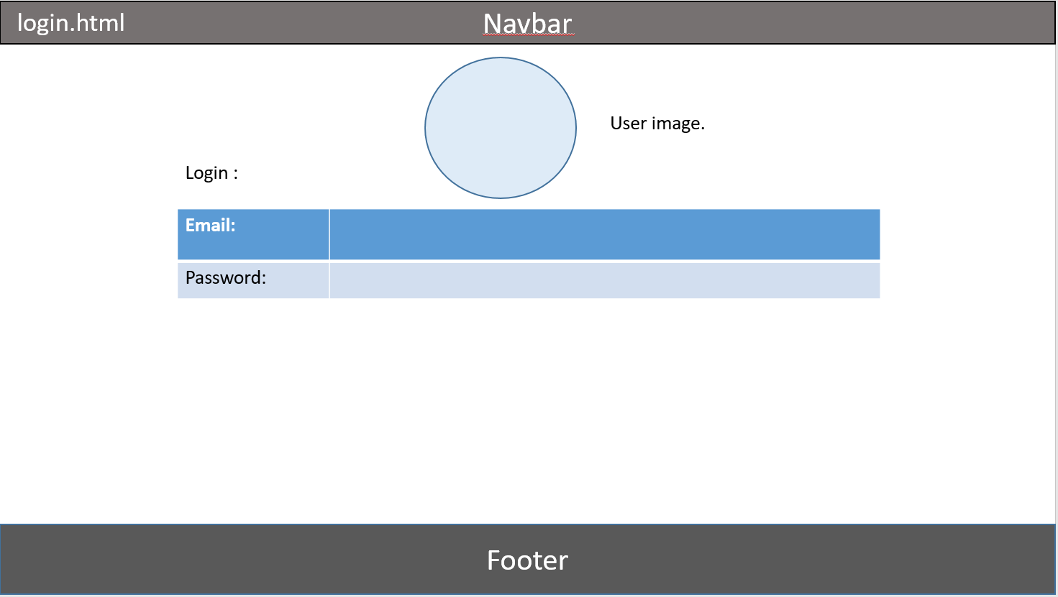

## Color scheme

As a team we knew that the colour scheme of our website was going to be a huge factor when trying to draw users to it. We looked at our competitors when trying to decided what colours we were going to implement on our website. We feel that our competitors may have lost users due to their colour scheme being quite hard on the eyes and in some cases difficult to make out.

We finally came to the conclusion that we were going to use different aspects of our competitors websites to make our website the ‘perfect website’. Our colour scheme includes a lot of black and white to make it very easy to view, we also chose this colour scheme because it gives the website a very clean cut look. We used several images throughout the website to add colour and in fact add our company’s colours(Burgundy & Yellow) but not to vibrant so the user will still be able to see everything on the page with ease.

We feel that we have chosen the perfect colour scheme for our website through studying our competitors and taking from them what works and ditching what doesn’t. We feel in terms of user friendliness we would be up there with the best out there due to the website being so easy on the eyes and easy to find your way through.

# **Part 2**

The server side functionality we decided to add to the webpage was an administrator aspect who could update, delete and add new products to the website. The administrator can login into the webpage using an email and password that we set, the administrator can also update anything from the price to the description of the product, he can also delete any old products that we no longer have on our website. The administrator can also add new products to the website. We used the week 9 lab to be able to add new products to the page.

(Below is an Example of an Add-product button)

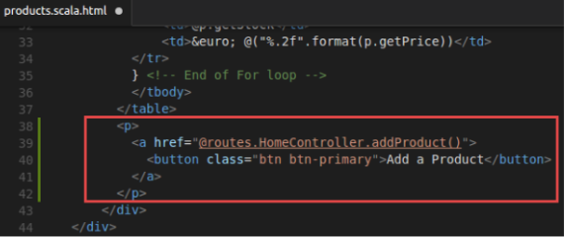

We added the update and delete buttons and functions for said buttons using the lab from week 10. (Below Example of Update button). This was a very important step for us because we felt as we were adding an administrator aspect to the page the admin had to be able to update and edit the products.

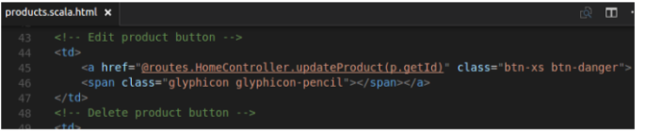

We added a file upload to our product form. For this we used the lab from week 12.

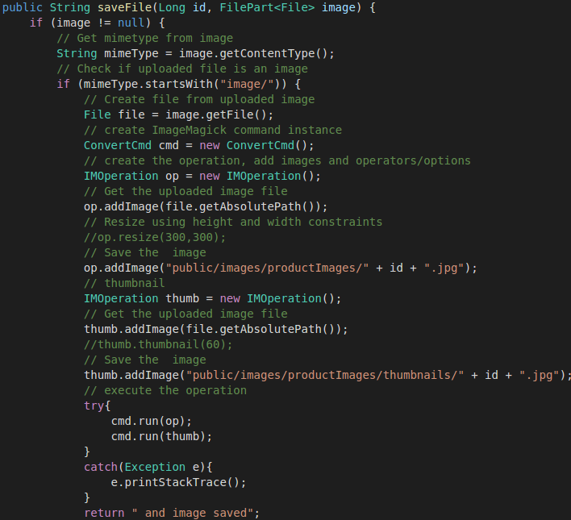

As a group we decided to change the code that was given to us in the lab. We decided to do this because we felt that changing it, better suited are design that we wanted on the webpage. We did this so the pictures would match up to each other better and come out clearer and better quality.

We also decided as a group that it was better suited to remove the login for uses as we didn’t feel it was necessary as users of our gym can sign up in store. So now we just have an administrator login on the website.



Review Model

We added a Review Model into our project to enable each Product to have multiple reviews.

So the relationship between Product and Review was OneToMany, This created a review table in the database and allowed us to insert unique reviews for all the products in the database.

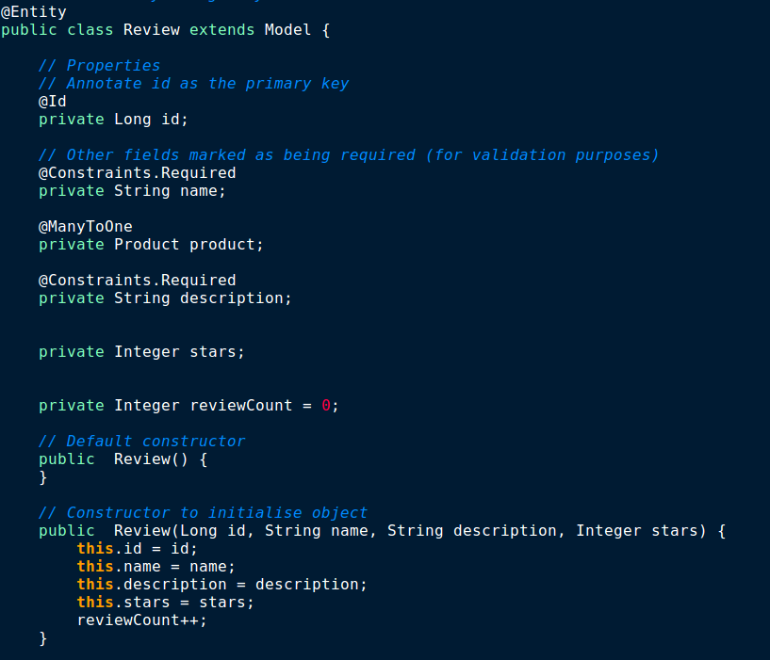We allowed the Review to have a name (which represents the person who gave the review). A description of their thoughts on the product And an optional choice to give the product a number of stars out of 5.

For the purpose of this project the review would be filled out by a customer in the Gym.

This Meant we now needed a way to get the average amount of stars received for a Product, we used java methods in the Product model and If statements in the products.scala.html, to return the correct amount of stars for each product. See below.

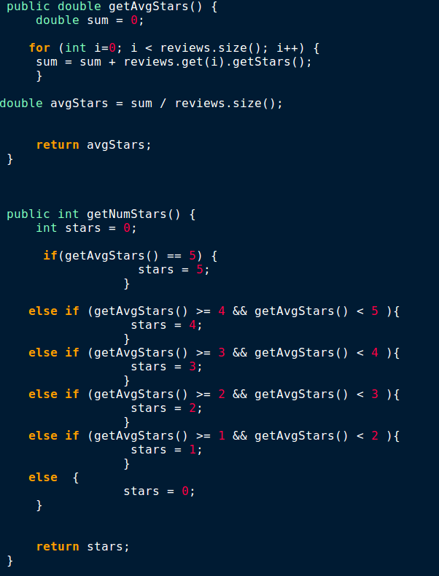

To display our products we used a for loop displaying multiple divs that contained all the relevant information for each Product. Below is an example of the stars being displayed by getting the product Rating. We gave 4 stars for anything 4.0 - 4.9, 3 stars for anything 3.0 – 3.9 and so on.

The use of the reviewCount in the model also allowed us to display the number of reviews completed for each product.

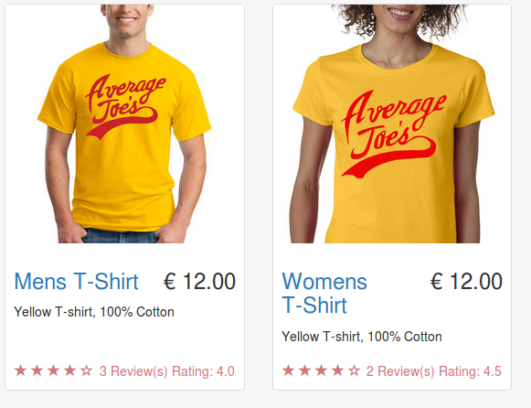

# **Conclusions**

After planning, designing and developing in part 1 of this project we have built the foundations for a dynamic website. We have formed storyboards, site structures, page designs and created a static website in the Play Framework.

We have further developed our website by adding the dynamic elements to our forms, tables and products. Giving the ability to add, update and delete from the products section and allowing the Administrator to log in to the site and have different privileges. We were also open to changing the site structure for the dynamic elements as they required it, We also added the appropriate pages to make all of these elements work in our webpage.

We as a group have learnt a lot from part 1 and part 2, and feel the whole experience has furthered our understanding of the web design and development process.