# Using Multimedia Principles for the Computer-Based Instruction of a Text-Based Subject Matter in a Flipped-Classroom Setting

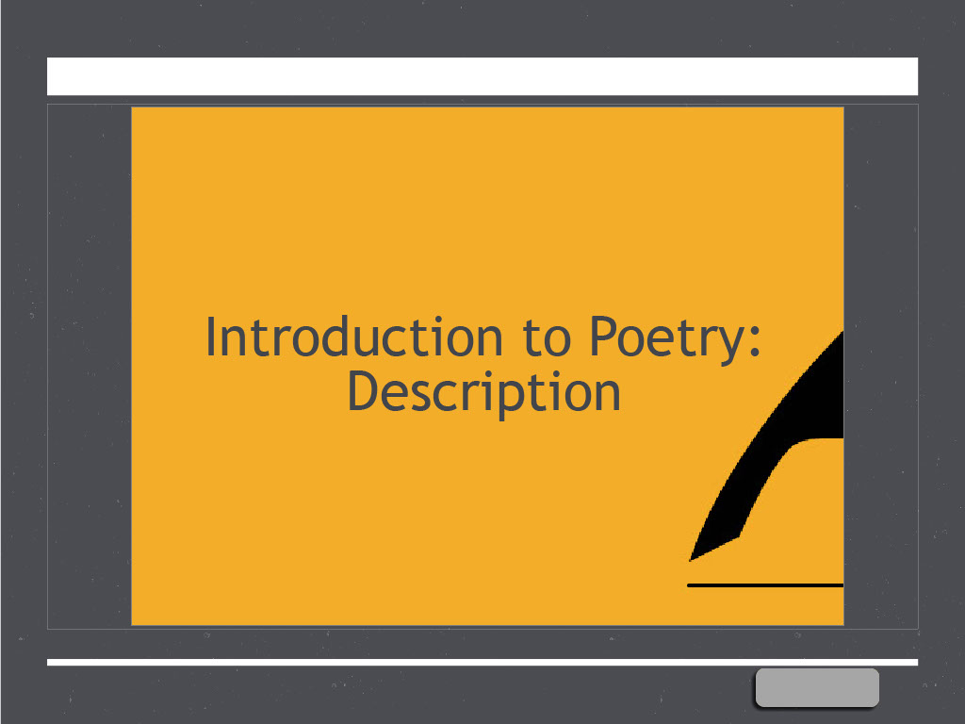

Stephen Anim

Chris Muellenbach

Colton Sinkovich

## Background/Problem

In UNCW’s Creative Writing department, the Intro to Creative Writing course, which covers poetry, fiction, and creative nonfiction, is used to garner interest in the department’s other courses. Poetry, however, continues to struggle with a lower number of candidates majoring in the genre.

Furthermore, students primarily use the Intro to Creative Writing course to fulfill their liberal arts writing requirement and thus typically enter the course without a genuine interest in creative writing, let alone the highly specialized form of writing involved in poetry—meter, rhyme, enjambment, etc. Bachelor’s level students in the Intro to Creative Writing course don’t understand poetry, don’t see how learning it benefits their writing, and lack confidence in performing it.

Currently, the course is taught by graduate teaching assistants who are not experienced in pedagogy or instructional design and are not made aware of the problems from the students’ perspective.

Our team designed and developed a computer-based instruction module that simplifies the definition and goal of poetry, uses prior knowledge to reduce the learning curve, and teaches specific techniques that can be applied to other forms of writing (journalism, marketing copy, persuasive writing, academic writing, scientific writing, and any form of writing that involves description or storytelling). It uses familiar concepts to describe poetry and shows how to translate simple descriptive statements into poetic lines. The content and flow are designed to engage and educate a learner who is new to poetry and doesn’t yet understand its relevance to developing writing skills.

## Computer-Based Instruction

Our computer-based instruction is a self-directed learning module created in Adobe Captivate. It would work quite well in a flipped classroom in which the instructor relied on the module to lecture on the basics of poetry and offer study examples and a practice exercise so that class time can be used for providing feedback on the practice poem and further discussion.

### Advantages and Disadvantages of CBI

The medium of computer-based instruction would carry several advantages for the flipped classroom scenario in our instructional solution. Housing the lecture and study material for the lesson in a self-directed module reduces the instructor’s workload, particularly in the portion of the lesson that can be standardized for all teaching assistants. This would allow teachings assistants to focus class time on interaction with students—answering questions, providing feedback, listening to students’ thoughts on the subject. Furthermore, the multimedia nature of computer-based instruction allows for some concepts to be communicated more clearly than a lecturer merely speaking at a classroom audience.

For all its advantages, however, computer-based instruction must be carefully designed using multimedia principles that enhance the achievement of the desired learning outcomes. The learner’s cognitive load, for instance, must be taken into account. Too much information provided in a short period of time can reduce learning outcomes (Pastore, 2009). Also, too much information on a single screen can reduce learning (Mayer & Fiorella 2014).

Another disadvantage, perhaps supported more by personal experience and logic than by research, is the lack of dialogue between student and instructor or facilitator, at least for a self-directed module. However, some course providers, like Coursera.org, have found ways to address this issue by providing forums in which students can reach out to instructors and fellow students to ask for help understanding a lesson’s content or an assignment. Students can also ask an instructor questions about a CBI module’s content if it is part of a flipped classroom approach to instruction, as would be the case with our module. Still, computer-based learning has limitations in interactivity, and some subject matters (i.e. advanced motor skills like team sports or martial arts) are best taught with a live instructor to provide explanatory feedback in real time.

When teaching creative writing, our team knew that feedback on written assignments (practice) would have to be provided by a real instructor. However, the lecture and study portions of poetry could be taught through a computer-based module.

For subjects and portions of a subject that can be taught well via computer, following sound instructional strategies and multimedia principles can mitigate common mistakes and the format’s inherent limitations. The next section will discuss these tools, specifically the ones used in our flipped classroom module.

## Instructional Strategies and Multimedia Principles

### Instructional Strategy

We used our own modification of Gagné’s nine events to structure the content flow of the learning module. Our changes to Gagné’s model were necessary due to the nature of the subject matter and how needed to be taught in a self-directed module.

#### Gain attention [Slides 1–3]

This section worked to gain the learner’s attention by asking them to question their understanding of poetry and then providing a useful definition of what poetry can be.

#### Inform Learners of Objectives [Slides 4 and 28]

Slide 4 enumerated the main learning objectives and briefly informed the reader on how the lesson will proceed. Because the final section on applying the poetic techniques to the real world has its own short lessons and examples, it was necessary to include a second learning-objective slide. Slide 28 informs the reader of the types of application that will be covered.

#### Stimulate Recall of Prior Learning [Slide 5]

This module would be the first lecture in the Intro to Creative Writing course, since the course begins with a unit on poetry before the nonfiction and fiction units, so it would not be possible to stimulate prior learning from this same course. So instead, slide 5 reminds the reader that they have already encountered poetic techniques in real-world writing, like those found in a music review.

#### Introduce and Explain New Concepts [Slides 6–8, 12, and 16]

Each concept from among the learning objectives was introduced and explained individually so the learner could get a basic understanding before being given examples.

#### Provide Study Examples [Slides 9–10, 13, 17–20, and 23–26]

To illustrate the new concepts, the learner was provided with ample examples to study. Finally, a “worked example” of a full poem was provided.

#### Stimulate Knowledge Retention [Slides 11, 14, 15, 21]

These slides provided quizzes meant to force the learner to thinking about and retain important knowledge in relation to the learning objectives. For example, slide 11 was a multiple choice question that asked the learner to distinguish between the senses that are most commonly used and those that are less often used but are more nuanced. This was meant to remind the learner of the distinction and the fact that the more nuanced senses enrich one’s writing.

Assessment of these quizzes was provided on slide 22.

#### Elicit Performance (Practice) [Slide 27]

Slide 27 provides a link to a writing prompt that gets the learner to utilize the techniques they studied throughout the module in the context of a full poem.

#### Provide Feedback and Assess Performance [Submission to Instructor]

The learner is meant to submit their practice exercise to their instructor for feedback on technique and assessment of overall performance. Feedback and assessment could not be provided for the complex and subjective intellectual skills of poetry; the subject matter is, in nature, quite different from something as simple and objective as mathematics, for which feedback and assessment can be readily provided in an automated medium within a self-directed module.

#### Enhance Retention and Transfer to the Job [Slides 29–32]

The slides 29–31 show examples of how the poetic techniques taught in the main body of the module can be applied to writing in the real world. The final slide, 32, provides a brief review of the module’s main takeaways and advises the learner to continue practicing the techniques learned.

### Multimedia Principles

In keeping with best practices for CBI, our group used the following multimedia principles:

#### Multimedia Principle

Guidelines: People learn better from words and pictures than from words alone (Butcher 2014).

How it was applied: In most of the slides that offered study examples, the module used images to illustrate the concepts of the perceptions that one can use in poetry. Also, some of the text-based slides showed lines of poetry and relied on narration to explain the knowledge to be gained from the analysis of the lines; these slides would also qualify as multimedia.

#### Modality Principle

Guidelines: People learn better from graphics and narration than from graphics and printed text (Lowe & Sweller 2014).

How it was applied: Graphics and narration were used for poetic-thinking study exercises.

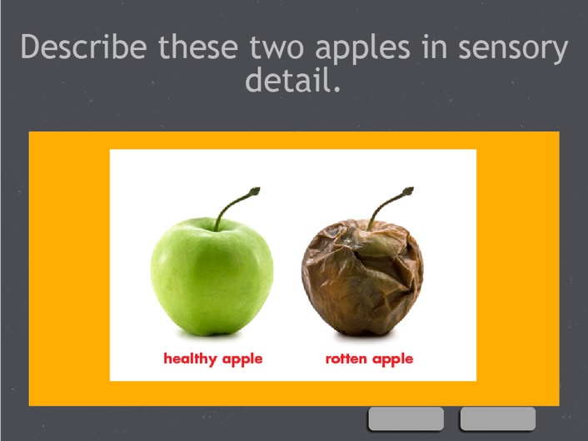

#### Redundancy Principle

Guidelines: People learn better when the same information is not presented in more than one format (Kalyuga & Sweller 2014).

How it was applied: At times when text was more appropriate than images, we displayed the text on screen, summarized its purpose, and then let the learner take time to read the text on their own instead of repeating it in narration.

#### slide8

#### Segmenting Principle

Guidelines: People learn better when a multimedia message is presented in learner-paced segments rather than as a continuous unit (Mayer & Pilegard 2014).

How it was applied: Concepts were broken down into digestible chunks to reduce cognitive load. Altogether, there were four separate units, one for each learning objective.

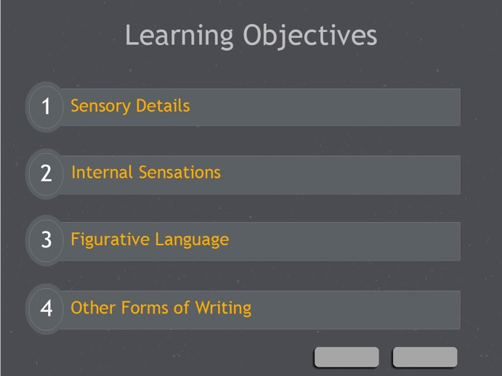

#### Personalization, Voice, and Image Principles

Guidelines: People learn better when the words of a multimedia presentation are in conversational style rather than formal style, when the words are spoken in a standard-accented human voice rather than a machine voice or foreign-accented human voice, but people do not necessarily learn better when the speaker’s image is on the screen (Mayer 2014).

How it was applied: All content is written in conversational style using a human narrator but no image of the narrator.

#### Worked Examples Principle

Guidelines: People learn better when they receive worked examples in initial skill learning (Renkl 2014).

How it was applied: The learner was provided with multiple worked examples. The most complete examples were the poetic lines created from describing an apple on slide 10 and commentary provided for the description poem on slides 24–26.

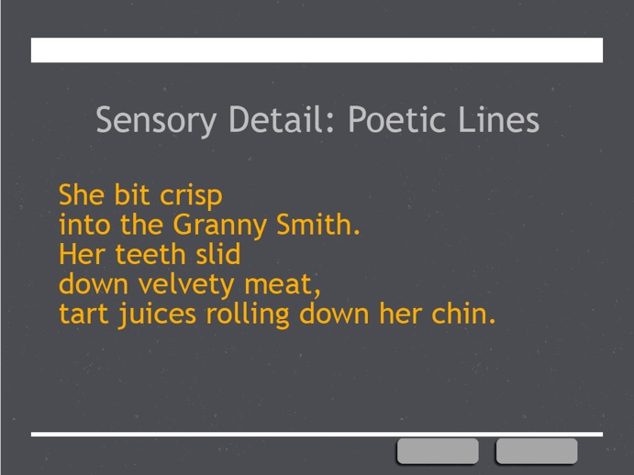 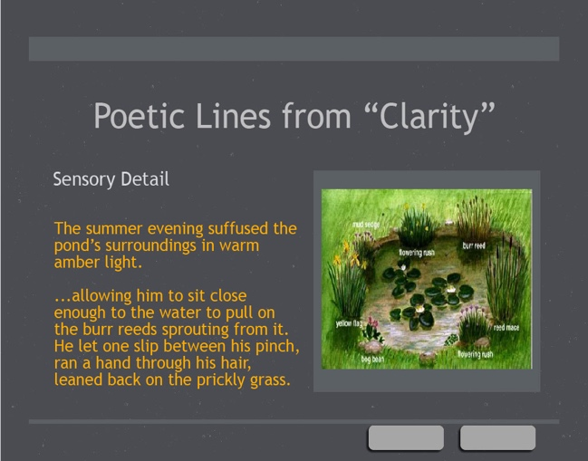

#### Prior Knowledge or Expert Reversal Principle

Guidelines: Instructional design principles that enhance multimedia learning for novices may hinder multimedia learning for more expert learners (Kalyuga 2014).

How it was applied: The module does not define the different types of figurative language, since the learner should already be familiar with them. Instead, it focuses on how some of those types can be applied to poetry.

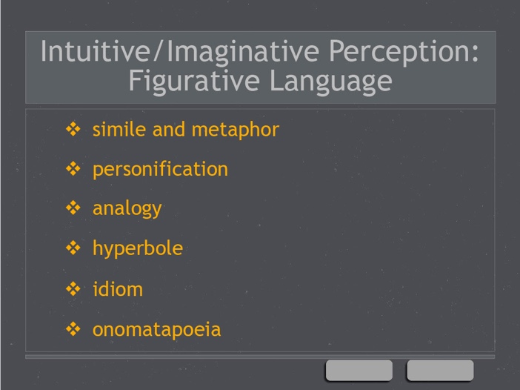

## Conclusions and Recommendations

The module would need to be tested with members of the target audience in a flipped classroom setting and then evaluated before conclusions can be drawn about its effectiveness. For now, however, we can provide our observations about the challenges of communicating ideas for a text-based subject matter via multimedia.

Poetry, and all creative writing, consists of text on a page, but the content of a given poem is still meant to stimulate the reader’s imagination, creating a multisensory and emotional experience in the reader’s mind. Using images and video to inspire a learner of poetry can reinforce this basic goal. Furthermore, portions of a poem can be treated as an image to display on screen while the narrator provides analysis through audio commentary. This is superior to providing a handout with the poem typed out and the commentary marked on the page, since that would lead to issues of coherence and spatial contiguity.

In short, text-based material taught via computer-based instruction should be treated the same way as mathematics taught in this medium, with worked examples visually displayed and a narrator providing audio commentary.

# Reference List

Butcher, K. R. (2014). The Multimedia Principle. In Mayer, R. E. (Ed.), *The Cambridge Handbook of Multimedia Learning* (p. 174). New York: Cambridge University Press.

Kalyuga, S. (2014). The Expertise Reversal Principle in Multimedia Learning. In Mayer, R. E. (Ed.), *The Cambridge Handbook of Multimedia Learning* (p. 576). New York: Cambridge University Press.

Kalyuga, S., & Sweller, J. (2014). The Redundancy Principle in Multimedia Learning. In Mayer, R. E. (Ed.), *The Cambridge Handbook of Multimedia Learning* (p. 247). New York: Cambridge University Press.

Lowe, R., & Sweller, J. (2014). The Modality Principle in Multimedia Learning. In Mayer, R. E. (Ed.), *The Cambridge Handbook of Multimedia Learning* (p. 227). New York: Cambridge University Press.

Mayer, R. E. (2014). Principles Based on Social Cues in Multimedia Learning: Personalization, Voice, Image, and Embodiment Principles. In Mayer, R. E. (Ed.), *The Cambridge Handbook of Multimedia Learning* (p. 345). New York: Cambridge University Press.

Mayer, R. E., & Fiorella, L. (2014). Principles for Reducing Extraneous Processing in Multimedia Learning: Coherence, Signaling, Redundancy, Spatial Contiguity, and Temporal Contiguity Principles. In Mayer, R. E. (Ed.), *The Cambridge Handbook of Multimedia Learning* (p. 279). New York: Cambridge University Press.

Mayer, R. E., & Pilegard, C. (2014). Principles for Managing Essential Processing in Multimedia Learning: Segmenting, Pre-training, and Modality Principles. In Mayer, R. E. (Ed.), *The Cambridge Handbook of Multimedia Learning* (p. 316). New York: Cambridge University Press.

Pastore, R. S. (2009). The effects of diagrams and time-compressed instruction on learning and learners’ perceptions of cognitive load. Educational Technology Research and Development, 58(5), 485-505. doi:10.1007/s11423-009-9145-6

Renkl, A. (2014). The Worked Examples Principle in Multimedia Learning. In Mayer, R. E. (Ed.), *The Cambridge Handbook of Multimedia Learning* (p. 391). New York: Cambridge University Press.