* **Matrix** = rectangular array of #’s w/in square brackets 🡪 a 2D array w/ x rows and y cols
* **A(I,j) =** value in row i and column j 🡪 A(1,2) = value in 1st row, 2nd col
* **Vector =** an n x 1 matrix (only 1 column) 🡪 y = [4, 6, 3 0] = a 4D vector = vector w/ 4 elements
* **Y(i) =** ith element of vector Y
* Can be 1 or 0 indexed (like arrays in programming languages)
* **Matrix Addition** 🡪 add up elements in same coordinates
* 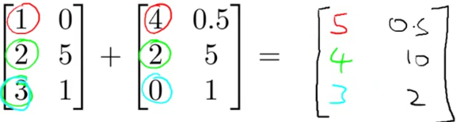
* *Can only add matrices w/ same dimensions*
* Matrices are usually denoted by uppercase names while vectors are lowercase.
* **Scalar (Real #, object that is a single value, not a vector or matrix ) Math** 🡪 multiple/divide matrix by 1 number 🡪 perform operation on each element
* 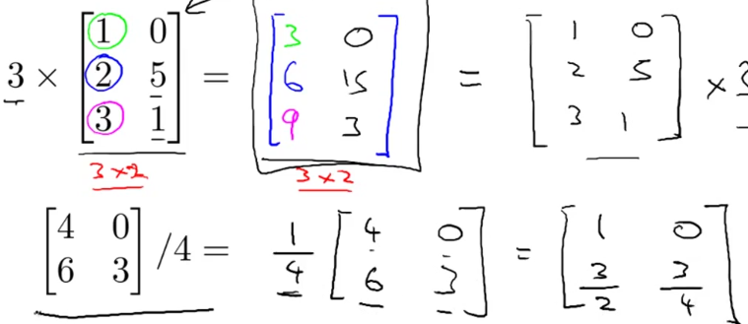
* R refers to the set of scalar real numbers.
* Rn refers to the set of n-dimensional vectors of real numbers.
* Can combine operands
* 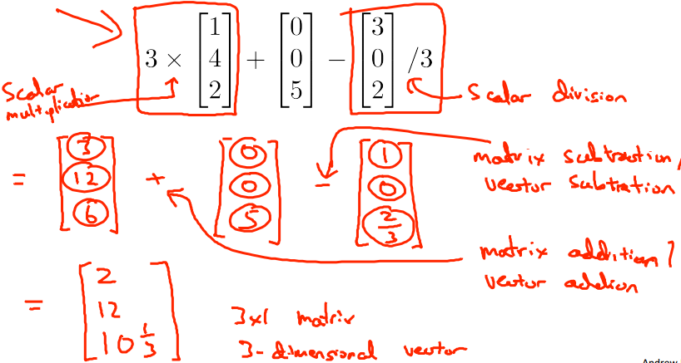
* 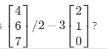 *=* 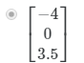
* **Matrix + Vector Multiplication**
* 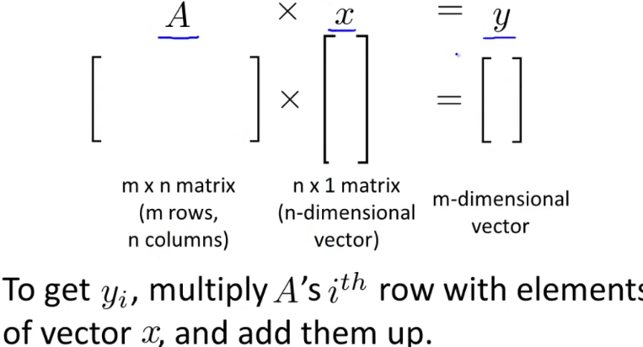
* *Columns in matrix must match rows in/dimension in vector* (n = n)
* *# of rows in matrix = # rows in resulting matrix/vector*
* To get 1st value of resulting vector, take 1st row of matrix, multiply each element by each element in vector, and then sum them up
* (1st # in row * 1st # in vector) + (2nd # in row + 2nd # in vector) + (3rd # in row * 3rd # in vector)

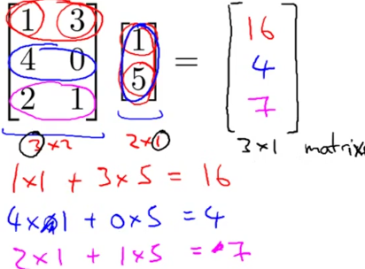

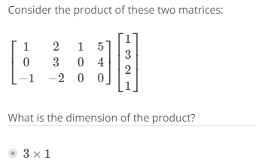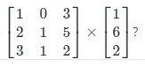 **=** 

* Let’s compute h(x) = -40 + 0.25x for a vector of house sizes

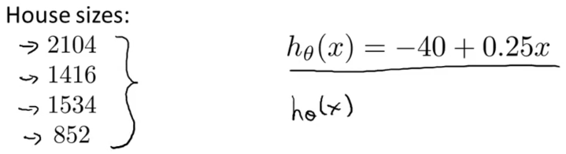

* Construct matrix of col 1 = 1 (to multiply by θ0) and col 2 = housing sizes (to multiple by θ1) and a vector w/ 2 elements, θ0 and θ1, and multiply them together to result in a 4x1 vector
* 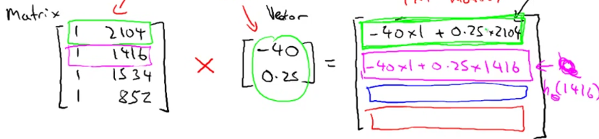
* When implementing this in software, it can be written in 1 line of code (simpler and more computationally efficient than a for loop for prediction(i) through i in n:m
* **Prediction = DataMatrix * Parameters**
* **Matrix + Matrix Multiplication**

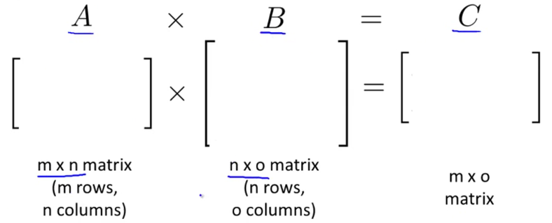

* *# of cols in 1st matrix MUST EQUAL # of rows in 2nd matrix*

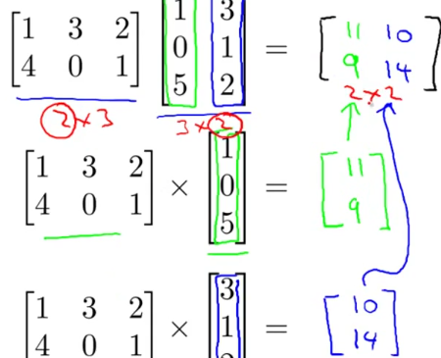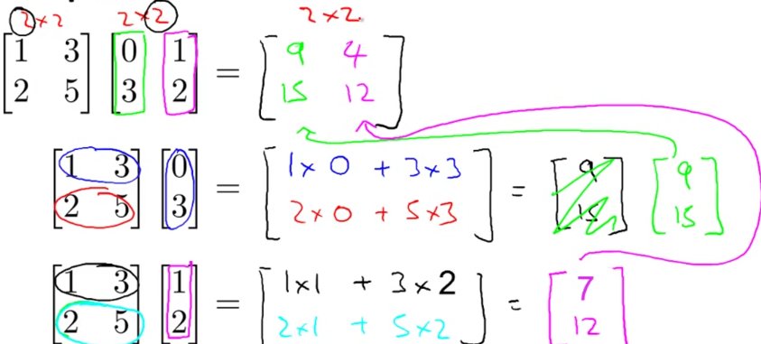

* Let’s compute multiple h(x)’s for a vector of house sizes

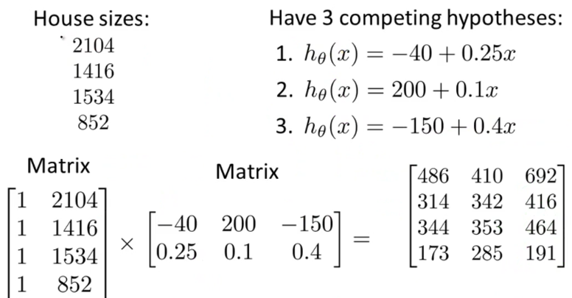

* 1st col in result = predictions of 1st h(x), etc.
* **Commutative Property of Multiplication of Real #’s** 🡪 doesn’t matter order (3x5 = 5x3)
* *NOT TRUE FOR MATRICES*

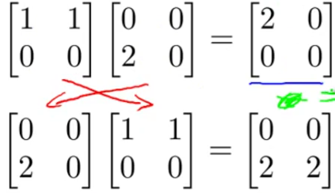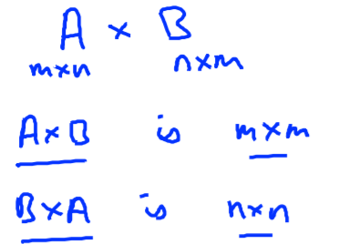

* **Associative Property**

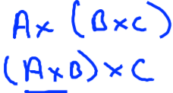

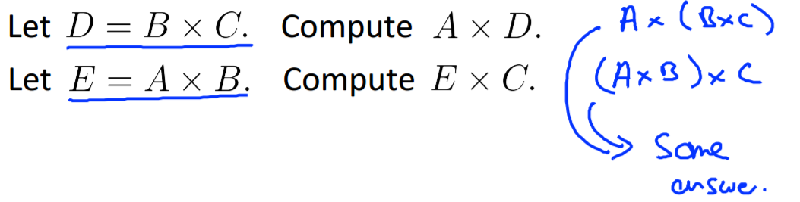

* **Identity Matrix (*I)***
* **1 = identity** 🡪 1*z = z*1 = z for any number z
* Matrix where diagonals = 1

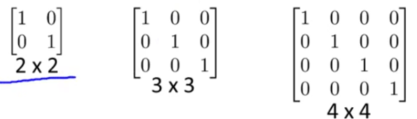

* For any matrix A 🡪 A\**I* = *I*\*A = A 🡪 *only time commutative property is true for matrices*
* **Inverse** of a number = the number that when multiplied by the original number = 1
* 3 * 3^-1 = 1
* Not all #’s have an inverse (0^-1 = 0
* Matrices have inverses 🡪 A*A^-1 = A^-1*A = *I* (identity matrix)
* Must be a **square matrix** (MxM)
* 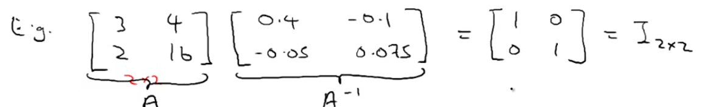
* **Tranpose**
* 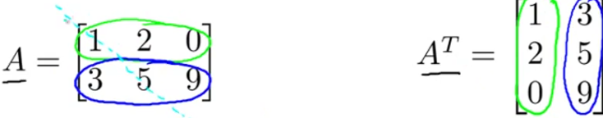

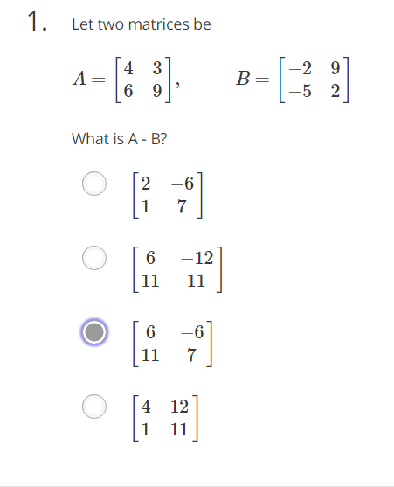

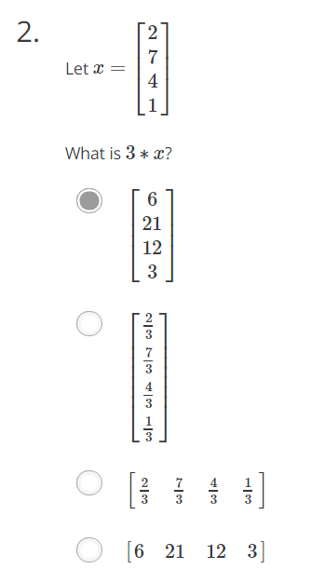

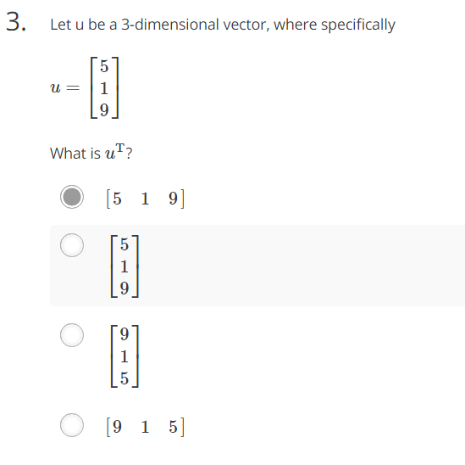

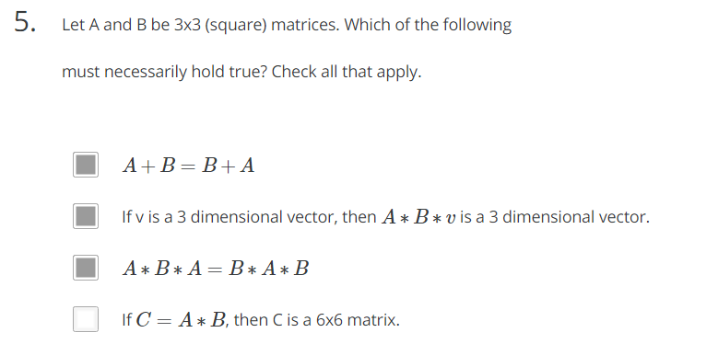



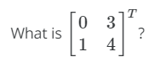 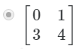

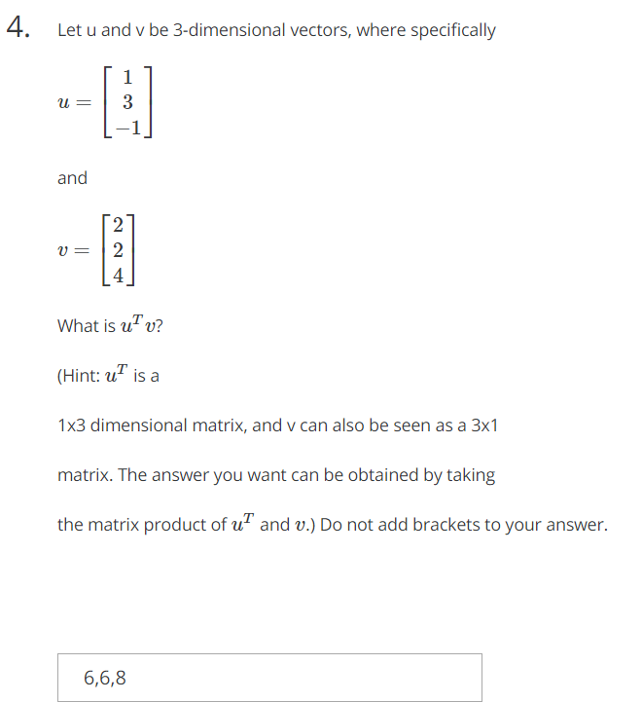

.

Let two matrices be

A=[4639],B=[−2−592]

What is A - B?

[21−67]

[611−1211]

[611−67]

[411211]

1

point

2.

Let x=⎡⎣⎢⎢2741⎤⎦⎥⎥

What is 3∗x?

⎡⎣⎢⎢621123⎤⎦⎥⎥

⎡⎣⎢⎢⎢⎢⎢⎢23734313⎤⎦⎥⎥⎥⎥⎥⎥

[23734313]

[621123]

1

point

3.

Let u be a 3-dimensional vector, where specifically

u=⎡⎣519⎤⎦

What is uT?

[519]

⎡⎣519⎤⎦

⎡⎣915⎤⎦

[915]

1

point

4.

Let u and v be 3-dimensional vectors, where specifically

u=⎡⎣13−1⎤⎦

and

v=⎡⎣224⎤⎦

What is uTv?

(Hint: uT is a

1x3 dimensional matrix, and v can also be seen as a 3x1

matrix. The answer you want can be obtained by taking

the matrix product of uT and v.) Do not add brackets to your answer.

6,6,8

1

point

5.

Let A and B be 3x3 (square) matrices. Which of the following

must necessarily hold true? Check all that apply.

A+B=B+A

If v is a 3 dimensional vector, then A∗B∗v is a 3 dimensional vector.

A∗B∗A=B∗A∗B

If C=A∗B, then C is a 6x6 matrix.