* **Binary Classification**  🡪 the variable that you want to predict, y, is valued via **logistic regression**
* Ex: email spam classification, classifying online transactions as fraudulent/not (someone is using a stolen credit card or stolen user password), classifying tumors as malignant or benign.
* In all of these problems the variable we're trying to predict takes on TWO values 🡪 0/1, spam/not spam, fraudulent/not fraudulent, malignant/benign.
*  🡪 0 = the **negative class** (benign), 1 = **positive class** (malignant)
* Assignment of the 2 classes is somewhat arbitrary
* Intuition = negative class conveys absence of something, positive class conveys presence of
* **Multiclass classification problem** **🡪** values of 1-4, etc.
* Ex: Training set for classifying tumor as malignant or benign where malignancy takes on 2 values, 0/1
* 1 thing we could do, given this training set = apply the Linear regression algorithm that we already know to this data set + try to fit a straight line to the data to get a hypothesis, h(x)
* 
* To make predictions, try to **threshold** the classifier outputs at 0.5 🡪 if hypothesis outputs a value >= 0.5, say y = 1, if < 0.5 say y = 0.
* For this example, it looks like linear regression is actually doing something reasonable, even though this is classification
* But now change the problem a bit w/ 1 training example very out to the right (outlier + if you run linear regression now, we instead get a worse straight line fit to the data + a worse hypothesis.
* 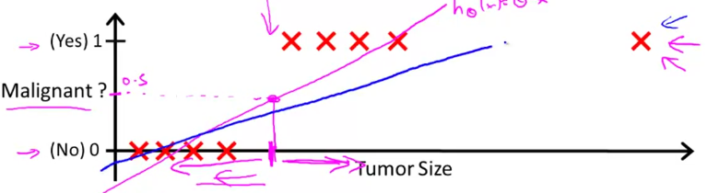
* So, applying linear regression to a classification problem often isn't a great idea.
* In the 1st example, linear regression was just getting lucky + got us a hypothesis that worked well
* For classification we know that y = 0/1, but if using linear regression, h(x) can output values much larger than 1 or less than 0, even if all training examples have labels y = 0 or 1.
* Even though we know the labels should be 0/1, the algorithm can output values much larger than 1 or much smaller than0
* **Logistic regression** has the property that the output/predictions are always between zero and one
* Want our classifier to output values between 0 and 1, so we want a hypothesis that satisfies this property w/ predictions between 0 and 1.
* When using linear regression, h(x) = θ(transpose)*x.
* For logistic regression, we modify this a little bit + make h(x) = g(θ(t)*x), + define g as:
* G(z) = 1 / (1 + E^-z) = the **sigmoid function/the logistic function**
* Put these 2 together 🡪 h(x) = 1 / (1 – E^-(θ(t)*x))

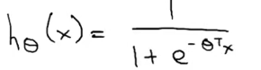

* Plotted, the sigmoid function, g(z), starts off near 0 + rises until it crosses 0.5 at the origin + then flattens out again near 1 = **asymptotes** at one + zero
* So b/c g(z) values are between zero and one, we also have that h(x) must be between zero and one.
* Finally, given this hypothesis representation + given a training set, we need to fit the parameters θ to our data.
* To interpret, when h(x) outputs some number, treat it as the **estimated probability** that y = one on a new input, x.

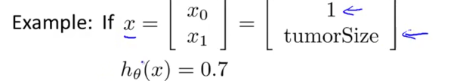

* Patient has a 70% chance, or a 0.7 chance of being malignant.
* *More formally, h(x) outputs the probability* ***P*** *of y = 1 given x, parameterized by θ.*



* Since this is a classification task, we know y must be 0 or 1, so given h(x), we can therefore compute probability of y = 0 as well via (1 – h(x)) b/c probability of y = 0 + probability of y = 1 must = 1.

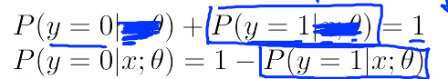

* So h(x) = g(θ(t)*x) = 1 / (1 – E^-(θ(t)*x)) , which slowly increases from 0 to 1.
* H(x) is outputting estimates of the probability that y = one, given x and parameterized by θ.
* We can assume that if h(x) >= 0.5, its more likely to be y = 1 than y equals 0, so we predict y = 1, and vice versa for h(x) < 0.5
* Looking at the sigmoid function, g(z) >= 0.5 whenever z >= 0.
* Since the hypothesis for logistic regression 1 / (1 – E^-(θ(t)*x)), this h(x) is therefore going to be >= 0.5 whenever θ(t)*x (b/c this is z) >= 0.
* So a hypothesis predicts y = 1 whenever θ(t)*x >= 0.
* By similar argument, h(x) < 0.5 whenever g(z) < 0.5 because the range of values of z that cause g(z) to take on values < 0.5 (z = negative)
* So when g(z) < 0.5, a hypothesis will predict y = 0 + h(x) will predict y = 0 whenever θ(t)*x < 0.
* To summarize if we decide to predict y=1 or y=0 depending on whether an estimated probability h(x) >=0.5 or < 0.5, its the same as saying we predict y=1 whenever θ(t)*x >= 0 and predict y is = 0 whenever θ(t)*x < 0

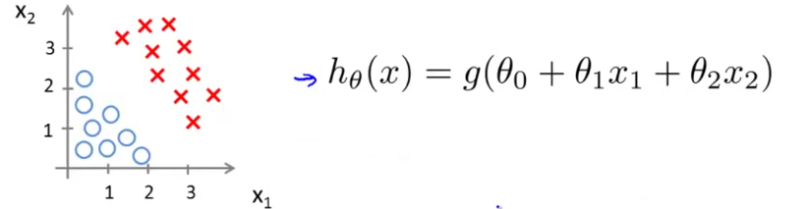

* Suppose we have a training set + a h(x) above + suppose that via a procedure-to-be-specified, we end up choose parameter value θ 0 = -3, θ 1 = 1, θ 2 = 1.
* parameter vector = 3*1 = [-3, 1, 1]
* Given this choice of hypothesis parameters, try to figure out where a hypothesis would end up predicting y = 1 or y = 0.
* We know the probability y = 1 is more likely (>= 0.5) when θ(t)*x > 0, + w/ out θ values, this is: *y = 1 if -3 + x1 + x2 >= 0 🡺 x1 + x2 >= 3*
* X1 + X2 = 3 defines the equation of a straight line which passes through 3 on the x1 + the x2 axis.

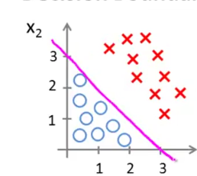

* So the part of the X1-X2 plane that corresponds to when X1 + X2 >= 3 is everything to the upper right portion of the magenta line 🡪 the region where our hypothesis predicts y = 1
* The region where x1 + x2 < 3 corresponds to the region below the line = where our hypothesis predicts y = 0.
* This magenta line = **the decision boundary.**
* X1 + X2 = 3 corresponds to the set of points/region where h(X) = 0.5 exactly = the decision boundary straight line = separates the region where h(x) predicts Y = 1 from the region where it predicts y = 0.
* The decision boundary is a *property of the hypothesis*, including the parameters θ0, θ1, θ2, not of the data set.
* 9:22
* Later we will fit the parameters + use the training set data to determine the value of the parameters
* More complex example 🡪 non-linear

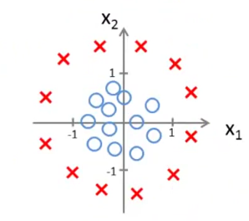

* Could add extra higher-order polynomial terms to our features, like in polynomial regression in linear regression
* Add 2 extra features, x1^2 and x2^2 to the features = 5 parameters, θ0 through θ4.

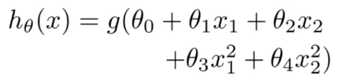

* Assume via a future procedure to be specified, we choose θ0 = -1, θ1 = 0, θ2 = 0, θ3 = 1 + θ4 = one, so our parameter vector = 5*1 🡪 [-1, 0, 0, 1, 1]
* So h(x) predicts y = 1 when -1 + x1^2 + x2^2 >= 0 = whenever θ(t)*my features >= 0 = So h(x) predicts y = 1 when x1^2 + x2^2 >= 1
* Now h(x) is the equation for circle of radius 1 centered around the origin = the decision boundary.

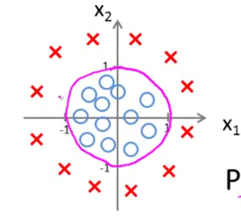

* Everything outside the circle 🡪 predict y = 1, inside the circle 🡪 y = 0.
* So by adding more complex polynomial terms to my features, I can get more complex decision boundaries that don't just try to separate the positive and negative examples in a straight line
* Once again, the decision boundary is a *property*, NOT of the *training set*, but of the *hypothesis* under the parameters.
* the training set is NOT what we use to define the decision boundary.
* The training set *may* be used to *fit the parameters θ.*
* But, once you have the parameters θ, *that* is what defines the decisions boundary.
* More complex example.
* Can we come up w/ even more complex decision boundaries then this if I have even higher polynomial terms?

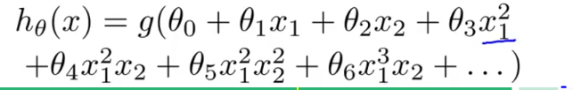

* Now we can find decision boundaries that may be an ellipse or some funny shape

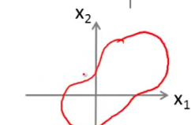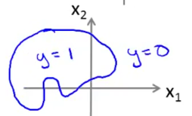

* Now to fit the parameters of θ for the logistic regression and define the optimization objective/cost function we'll use to fit the parameters.
* Here's a supervised learning problem of fitting logistic regression model

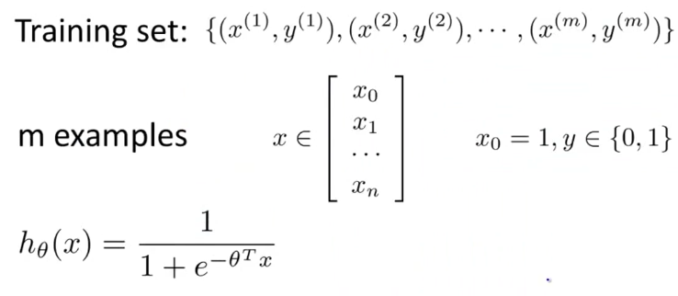

* We have a training set of m training examples + each example is represented by an n+1 dimensional vector w/ x(0) = 1 (1st feature/a zero feature is always equal to 1)
* B/c this is a classification problem, our training set has the property that every label y is either 0 or 1
* *How do we fit the parameter's θ?*
* Back when developing linear regression models, we used the following cost function:

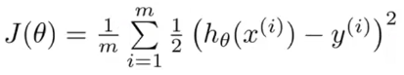

* Now we want to use an alternative way of writing this out by instead of writing out the square of errors, write in here costs(h(x),y)

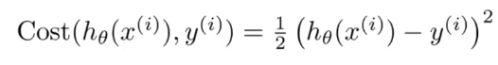

* We define this as one-half of the squared error.
* So now we see more clearly that the **cost function** is a *sum* over my *training* set 🡺 1/m * the sum of my new training cost term.
* 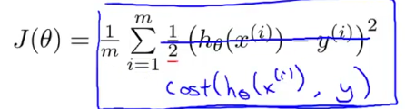
* This is the cost we want our learning algorithm to have to pay if its *output/prediction* = h(x) and the *actual label* = y.
* This cost function worked fine for linear regression, but here, we're interested in logistic regression.
* If we use this particular cost function, this would be a **non-convex function** of the parameter's θ.
* Here's what I mean by non-convex.
* Say we have some cost function j(θ), and for logistic regression, our h(x) function has a nonlinearity 🡪 **1 / (1 + E^-(θ(t)*x)**, a pretty complicated nonlinear sigmoid function.
* If you take this sigmoid function + plug it into the Cost(h(x),y) and plug this cost() into J(θ), you find J(θ) can look like this w/ many local optima, **a non-convex function**

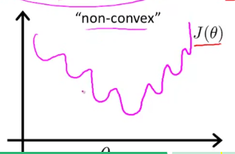

* If you were to run gradient descent on this sort of function, it is not guaranteed to converge to the global minimum.
* What we want is a cost function that is **convex** = a single bow-shaped function so we would be guaranteed that gradient descent would converge to the global minimum.

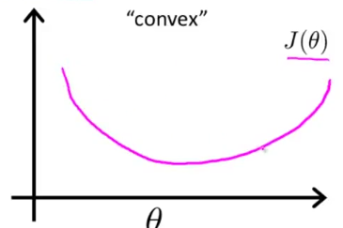

* The problem w/ using this squared cost function is that b/c of the very nonlinear sigmoid function in the place of h(x), J(θ) ends up being a nonconvex function
* Need to instead of come up w/ a different cost function that is convex so we can apply an algorithm, like gradient descent + be guaranteed to find the global minimum.
* **Logistic regression cost function**

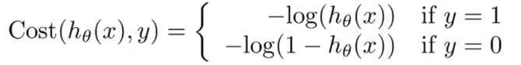

* We to say the cost/penalty the algorithm pays, if it outputs/predicts a value of h(x) (say 0.7) + the actual cost turns out to be the value of y.
* Cost = **-log(h(x))** if y = 1 and **-log(1- h(x))** if y = 0.

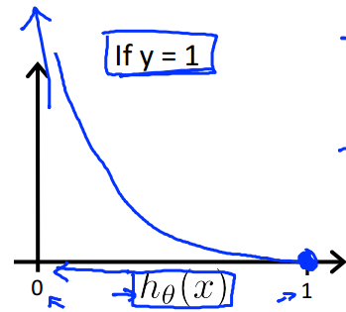

* Here, h(x), varies between 0-1.
* 1 way to see why the plot looks like this is b/c if you plot log z, + it approaches -infinity as z approaches 0

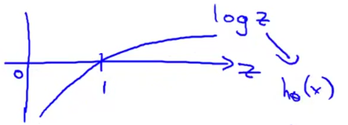

* z is playing the role of h(x)
* In flipping the sign to -log z between 0-1, we're left w/ the curve for the cost function when y = 1

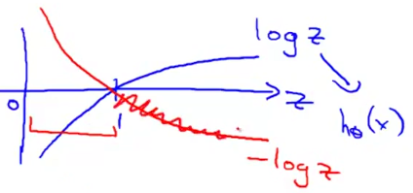

* This cost function has a few interesting and desirable properties.
* notice if y = 1 and h(x) = 1 (in other words, hypothesis exactly predicts the actual value), then cost = 0 🡪 where we'd like it to be b/c we correctly predict the output y so cost is 0.
* As h(x) approaches 0, the cost blows up + goes to infinity + captures the intuition that if a hypothesis = 0 🡪 the chance of y = 1 is equal to 0
* But if it turns out y *actually does* = 1 even though we said probability of it happening = 0, we penalize the learning algorithm by a very, very large cost.
* If y is equal to 0, then the cost looks like -log(1-z)

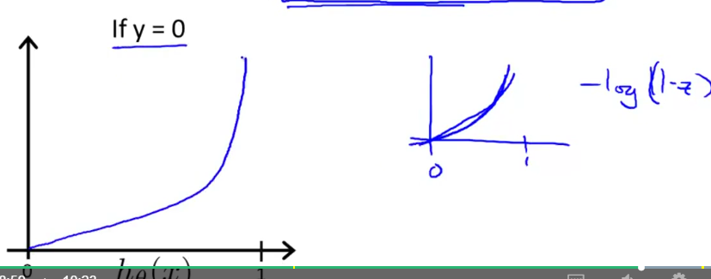

* Cost goes to infinity as h goes to 1 b/c if y turns out to be 0 but we predicted y = 1, we end up paying a very large cost.
* Conversely, if h = 0 and y = 0, the hypothesis accurately predicted y + the cost function = 0.
* So if h(x) = y, cost = 0 whether y = 0 or y = 1 since we correctly predicted y
* Also, regardless of whether y = 0 or 1, if h(x) = 0.5, then cost > 0
* Now for a slightly simpler way to write the cost function than we have been using so far

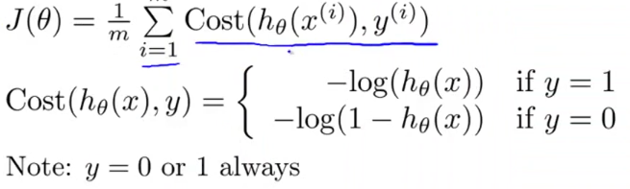

* Rather than writing out a cost function on 2 separate lines w/ 2 separate cases (y = 1 or 0), compress them into 1 equation so its more convenient to write a cost function + derive gradient descent



* We know there are only 2 possible cases, Y = 0 or 1, so suppose Y = 1, then the 2nd term is multiplied by 0 and goes away + we're left w/ only the 1st term, **-y*log(h(x))**, the equation we have up above for if y = 1.
* The other case is y = 0, the 1st term = 0 and the cost function simplifies to the 2nd term, **-(1-y)log (1- h(x))**, which is exactly what we had for when y = 0.
* We can therefore write all our cost functions for logistic regression as follows:

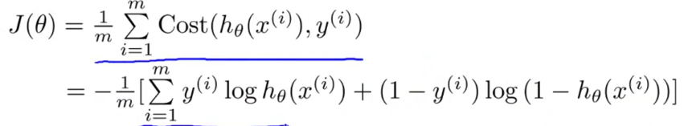

* This cost function can be derived from statistics using the **principle of maximum likelihood estimation**, an idea for how to efficiently find parameters θ for different models + it is convex.
* Given this cost function, in order to fit the parameters θ, try to find the ones that minimize J(θ).
* If given a new example w/ some set of features x, we can then take these θ’s that we fit to our training set + output our prediction

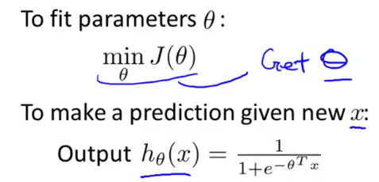

* **Output of h = probability y = 1 given the input x parameterized by θ.**
* All that remains to be done is to figure out how to actually minimize J(θ) as a function of θ so that we can actually fit the parameters to our training set.
* Again, we minimize the cost function using gradient descent.
* 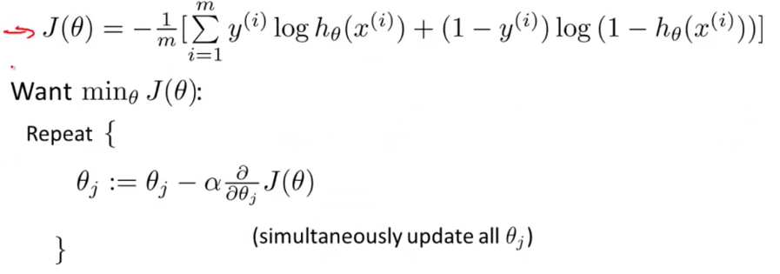
* To minimize J as a function of θ, again, repeatedly update each parameter by updating it as itself minus **learning rate alpha** times the **derivative term**.
* If you actually compute the derivative term, you get this equation:

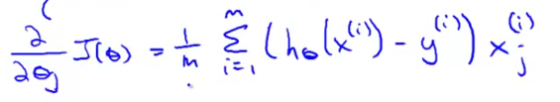

* We can take this partial derivative term and plug it back into the repeating steps + write out our gradient descent algorithm as follows:

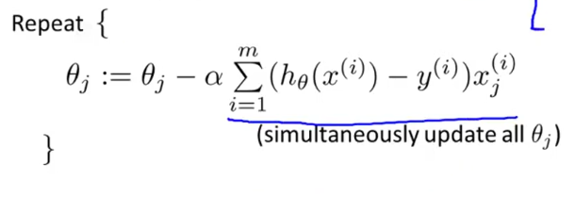

* Now if you have n features, you would have a parameter vector θ w/ parameters θ0 to θn + use this update to simultaneously update all values of θ.

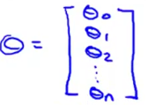

* If comparing this update rule to what we were doing for linear regression, this equation is the same
* *Are linear regression and logistic regression different algorithms or not?*
* For logistic regression, what has changed is the definition for the hypothesis
* For linear regression, we had h(x) = θ(t)*X, for logistic regression, we have 1 / (1 + E^-( θ(t)*X).
* So even though the update rule looks identical, b/c the definition of h(x) changed, this is NOT the same thing as gradient descent for linear regression.
* We usually apply the same method from linear regression to logistic regression to monitor gradient descent to make sure it is converging correctly.

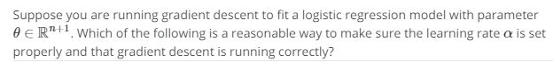



* When implementing logistic regression w/ gradient descent, we have all these different parameter values (θ0 to θn) we need to update
* 1 thing we could do is have a FOR loop 🡪 FOR i = 0:n + 1, update each parameter value in turn.
* Rather than using a FOR loop, ideally we’d also use a vector-wise implementation, which can update all n+1 parameters all in 1 fell swoop.

