Logistic Regression Quiz

1. Suppose that you have trained a logistic regression classifier, and it outputs on a new example x a prediction hθ(x) = 0.7. This means (check all that apply):

* **Our estimate for P(y=0|x;θ) is 0.3.**
* **Our estimate for P(y=1|x;θ) is 0.7.**

Suppose you have the following training set, and fit a logistic regression classifier hθ(x)=g(θ0+θ1x1+θ2x2).

Which of the following are true? Check all that apply.

**Adding polynomial features (e.g., instead using hθ(x)=g(θ0+θ1x1+θ2x2+θ3x21+θ4x1x2+θ5x22) ) could increase how well we can fit the training data.**

At the optimal value of θ (e.g., found by fminunc), we will have J(θ)≥0.

Adding polynomial features (e.g., instead using hθ(x)=g(θ0+θ1x1+θ2x2+θ3x21+θ4x1x2+θ5x22) ) would increase J(θ) because we are now summing over more terms.

If we train gradient descent for enough iterations, for some examples x(i) in the training set it is possible to obtain hθ(x(i))>1.

J(θ) will be a convex function, so gradient descent should converge to the global minimum.

The positive and negative examples cannot be separated using a straight line. So, gradient descent will fail to converge.

Because the positive and negative examples cannot be separated using a straight line, linear regression will perform as well as logistic regression on this data.

1. For logistic regression, the gradient is given by  Which of these is a correct gradient descent update for logistic regression with a learning rate of α?

* **θ:=θ−α1m∑mi=1(11+e−θTx(i)−y(i))x(i).**
* **θ:=θ−α1m∑mi=1(hθ(x(i))−y(i))x(i).**
* 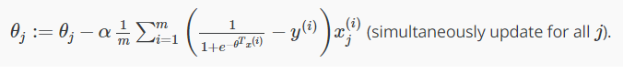
* 

1. Which of the following statements are true? Check all that apply.

* **The one-vs-all technique allows you to use logistic regression for problems in which each y(i) comes from a fixed, discrete set of values.**
* **The cost function J(θ) for logistic regression trained with m≥1 examples is always greater than or equal to zero.**
* The sigmoid function g(z)=  is never greater than one (>1).

Suppose you train a logistic classifier hθ(x)=g(θ0+θ1x1+θ2x2). Suppose θ0=−6,θ1=1,θ2=0. Which of the following figures represents the decision boundary found by your classifier?

when X1 + X2 >= 3 is everything to the upper right portion of the magenta line → the region where our hypothesis predicts y = 1

Figure:

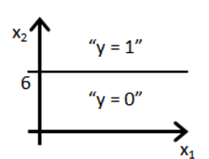

Figure:

Figure:

Figure:

I, Stephen Newns, understand that submitting work that isn’t my own may result in permanent failure of this course or deactivation of my Coursera account. Learn more about Coursera’s Honor Code

Submit Quiz

Activate 5% Cash Back

Activate Later