**Advice for Applying ML**

* You train a learning algorithm + find that it has unacceptably high error on the test set. You plot the learning curve. Is the algorithm suffering from high bias, high variance, or neither?

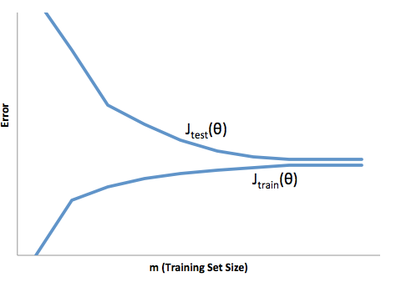

**High bias**

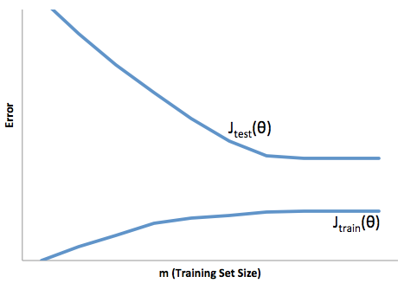

**High variance**

* Suppose you implemented regularized logistic regression to classify what object is in an image However, when you test your hypothesis on a new set of images, it makes unacceptably large errors with its predictions on the new images. However, your hypothesis performs well (has low error) on the training set. Which of the following are promising steps to take?
* **Get more training examples.**
* **Try using a smaller set of features.**
* **Try increasing the regularization parameter λ.**
* Suppose you implemented regularized logistic regression to predict what items customers will purchase on a web shopping site. However, when you test your hypothesis on a new set of customers, it makes unacceptably large errors in its predictions. Furthermore, the hypothesis performs poorly on the training set. Which of the following might be promising steps to take?
* **Try decreasing the regularization parameter λ.**
* **Try adding polynomial features.**
* **Try to obtain and use additional features.**
* Which of the following statements are true? Check all that apply.
* **The performance of a learning algorithm on the training set will typically be better than its performance on the test set.**
* **Suppose you’re training a regularized linear regression model. The recommended way to choose what value of regularization parameter λ to use is to choose the value of λ which gives the lowest CV error.**
* Which of the following statements are true? Check all that apply.
* **If a learning algorithm is suffering from high variance, adding more training examples is likely to improve the test error.**
* **When debugging learning algorithms, it is useful to plot a learning curve to understand if there is a high bias or high variance problem.**
* **If a learning algorithm is suffering from high bias, only adding more training examples may NOT improve the test error significantly.**
* **A model with more parameters is more prone to overfitting and typically has higher variance.**