* Which of the following figures correspond to possible values PCA may return for u(1) (the 1ST eigenvector/1st principal component) of the figure below:
* 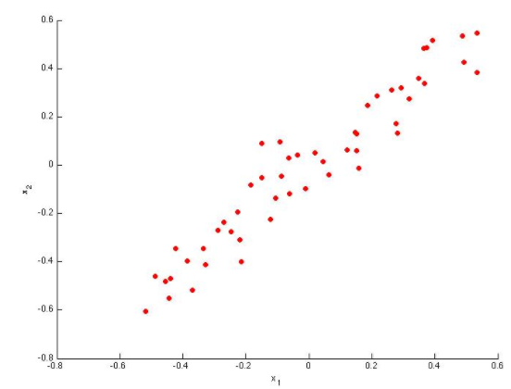

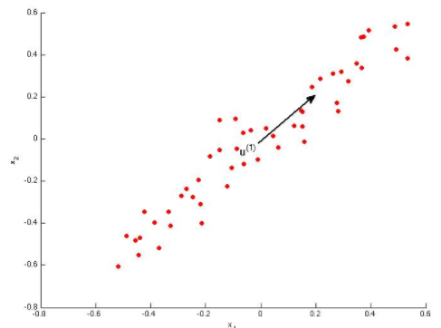

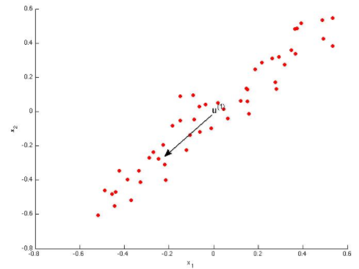

* Which of the following is a reasonable way to select the number of principal components k? (Recall that n = the dimensionality of the input data and m = the number of input examples.)
* **Choose k to be the smallest value so that at least 99% of the variance is retained.**
* Suppose someone tells you they ran PCA in such a way that "95% of the variance was retained." What is an equivalent statement to this?

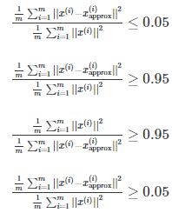

* Which of the following statements are true? Check all that apply.
* **Feature scaling is useful for PCA**
* **If the input features are on very different scales, it is a good idea to perform feature scaling before applying PCA.**
* **Given an input x ∈ Rn, PCA compresses it to a lower-dimensional vector z ∈ Rk.**
* **PCA can be used to reduce the dimensionality of data by more than 11**
* Which of the following are recommended applications of PCA? Select all that apply.
* **Data compression: Reduce dimension of input data x(i), which will be used in a supervised learning algorithm (i.e., use PCA so a supervised learning algorithm runs faster).**
* **Data visualization: Reduce data to 2D (or 3D) so that it can be plotted.**