***Polynomial Linear Regression***

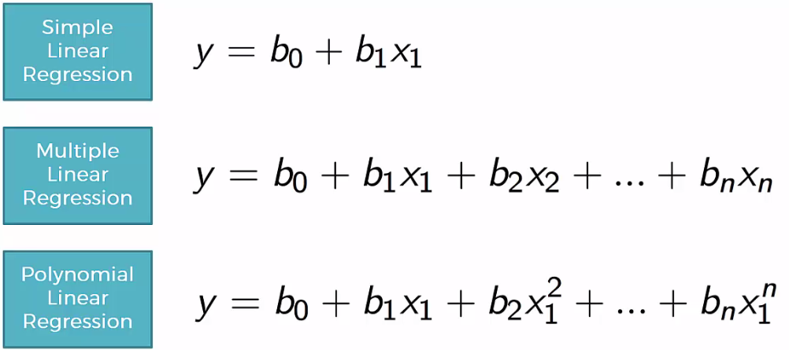

* See that polynomial linear regression is similar to multiple linear regression, but instead we have the *same* variable, but to *different powers*

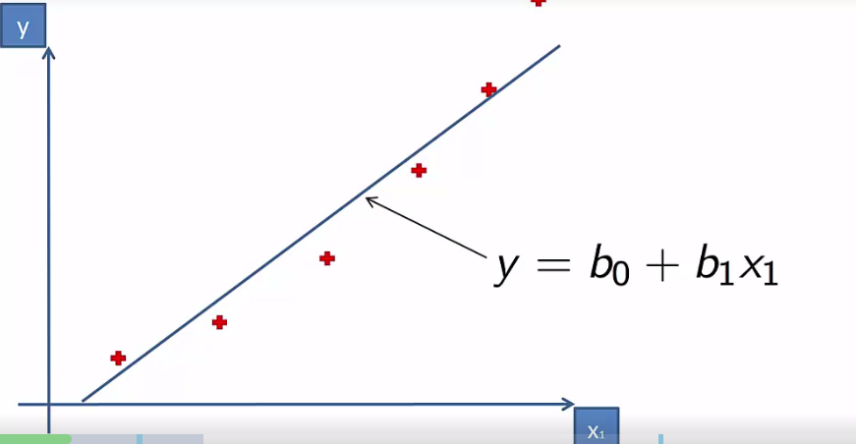

* See the linear regression doesn’t fit the data well, so we use a polynomial equation

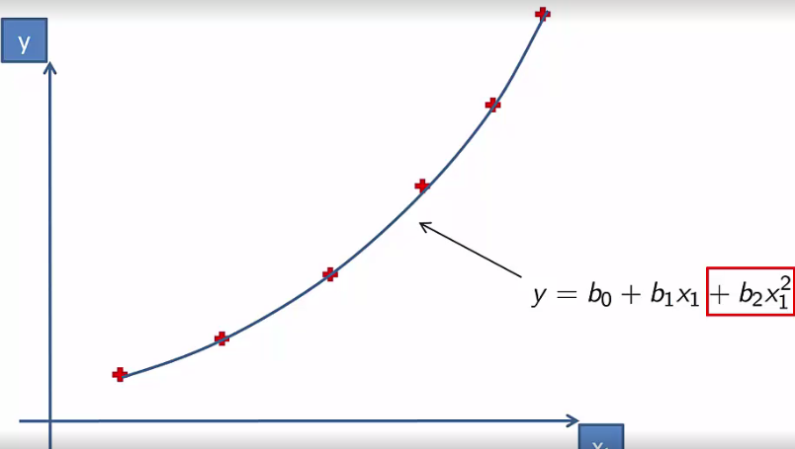

* Whether or not to use a polynomial regression or linear regression depends on a case by case basis
* Polynomials are used to describe how disease spreads and for other use cases.
* This is still called a polynomial “linear” regression, the x’s aren’t linear, but for regression, we’re talking about the *coefficients*
* For regression, we’re asking if “y” as a function of x, can this function be expressed as a linear combination of the coefficients (the unknowns we find out via regression)