**Decision Tree Intuition**

* **CART** = classification + regression trees
* Decision tress splits data based on feature values

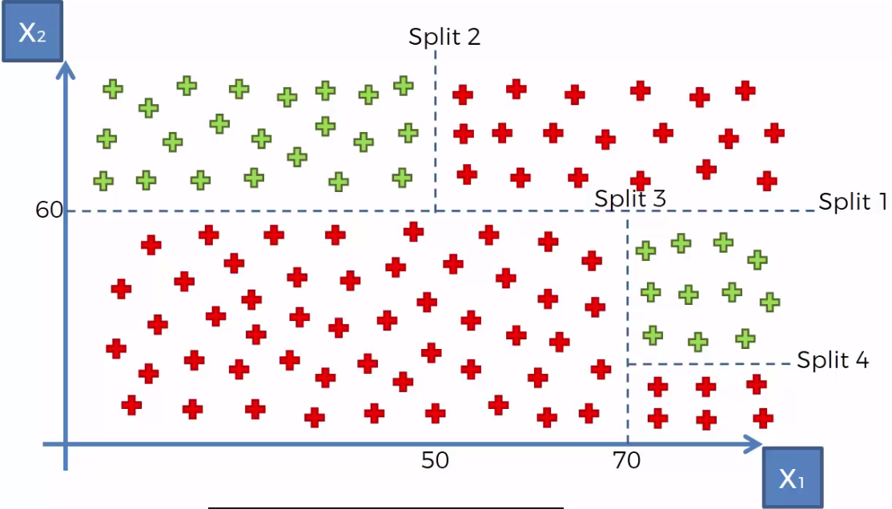

* Splits are done to maximize the # of DP’s of a specific category in a **leaf** (specifically, the final/**terminal leaf**)via complex mathematics to reduce **entropy**
* Split 1 splits when X2 is > or < 60, then split 2 splits the > 60 X2 based on if X1 > or < 50
* Split 3 happens in < 60 X2 when X1 is > or < 70, then split 4 happens when X2 < 20 for X1 > 70

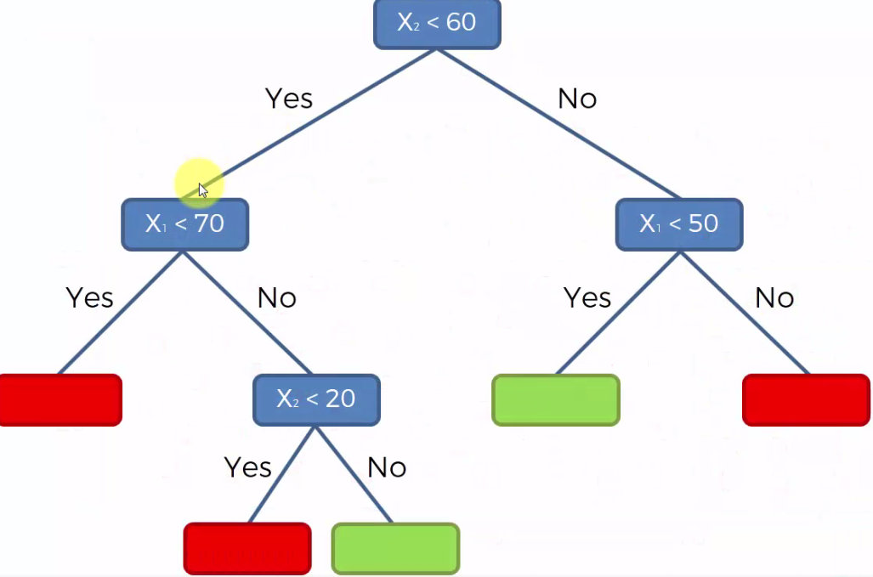

* DT’s are a very old method, but more sophisticated methods had come to replace them
* But they’ve been “reborn” w/ more modern upgrades such as new methods that build on top of DT’s such as **random forests + gradient boosting**