**Eclat**

* Almost like a simple version of the Apriori algorithm
* “People who bought also bought…”

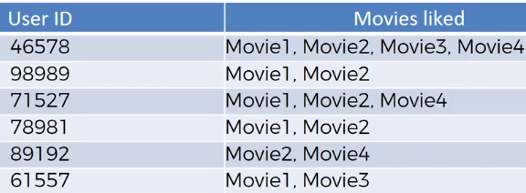

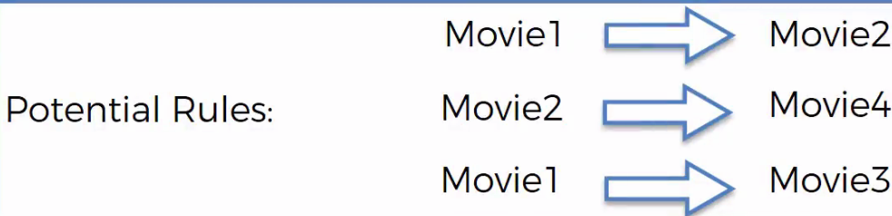

* Instead of utilizing **lift** to judge our algorithm, we’re going to use “sense”
* Eclat model is responsible for going through the potential rules + telling us what to focus on
* We still have **support,** but do NOT have confidence nor lift
* 
* M = a **SET** of movies, since we don’t have confidence or list so it makes little sense to look a single item
* So, how frequently does a **set** occur?
* This model is much more “low-key” and simple, so it runs faster:
* Set minimum support 🡺 Take subset of transactions w/ support > minimum 🡺 sort subsets by decreasing support