* Python is an example of an
* **Interpreted language**
* Declarative language
* OS language
* Data science language
* Low level language
* Data Science is a
* **Interdisciplinary, made up of AI, CS, and Stats**
* Data visualization is not a part of data science.
* **False**

* Which bracketing style does Python use for tuples?
* **()**
* In Python, strings are considered Mutable, and can be changed.
* **False**
* What is the result of the following code: ['a', 'b', 'c'] + [1, 2, 3]
* **['a', 'b', 'c', 1, 2, 3]**
* String slicing is
* **way to make a substring of a string in python**
* When you create a lambda, what type is returned? E.g. type(lambda x: x+1) returns
* **<class 'function'>**
* The epoch refers to
* **January 1, year 1970**
* This code, [x**2 for x in range(10)] , is an example of a
* **List comprehension**
* Given a 6x6 NumPy array r, which of the following options would slice the shaded elements?

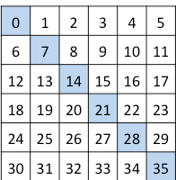

* **r.reshape(36)[::7]**

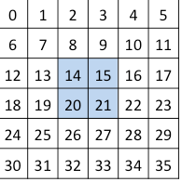

* **r[2:4,2:4]**