***Coursera – Intro to Probability***

*Week 2 Quizzes*

1. Which of the below data sets has the lowest SD?

* 0,1,2,3,4,5,6
* 0, 25, 50, 100, 125, 150, 1000
* **100, 100, 100, 100, 100, 100, 101**
* *CENTER: mean (arithmetic average), median (midpoint), mode (most frequent observation)*
* *SPREAD: SD (variability around the mean), range (max-min), IQR (middle 50% of distribution)*
* *Dataset w/ the most repeated observations = least variability, + hence lowest SD*
* 0,1,3,3,3,5,6

1. The statistic “mean divided by median” can be used as a measure of skewness (right OR left). Suppose we’re dealing w/ a distribution w/ minimum = 0.5. If this statistic (mean/median) is less than 1, the distribution is most likely left skewed.

* **True**
* *In a left skewed distribution, median tends to be greater than the mean, therefore we would expect mean/median to be less than 1.*
* False

1. You’re going to collect income data from a right-skewed distribution of incomes of politicians. If you take a large enough sample from that distribution, the sample mean + sample median will always have the same value.

* True
* **False**
* *ROBUST STATISTIC (e.g. median, IQR) = not heavily affected by skewness + extreme outliers*
* *Think about the unrealistic case where instead of collecting a sample of income data from politicians, you instead collect income data from ALL politicians.*
* *In that case, sample mean + sample median will be close to or equal to the population’s values, which are not equal to each other in a skewed distribution.*

1. A mosaic plot is useful for visualizing the relationship between a numerical + a categorical variable.

* True
* **False**
* *Use CONTINGENCY TABLES + SEGMENTED BAR PLOTS or MOSAIC PLOTS to assess the relationship between 2 CATEGORICAL variables.*
* *CATEGORICAL VS. NUMERICAL = SIDE-BY-SIDE BOX PLOTS*

1. Does meditation cure insomnia? Researchers randomly divided 400 people into 2 equal-sized groups. 1 group meditated daily for 30 minutes, the other attended a 2-hour info session on insomnia. At the beginning of the study, the average difference between the # of minutes slept between the 2 groups was about 0. After the study, the average difference was about 32 minutes, + the meditation group had a higher average # of minutes slept. To test whether an average difference of 32 minutes could be attributed to chance, a statistics student decided to conduct a randomization test. She wrote the # of minutes slept by each subject in the study on an index card. She shuffled the cards together very well, + then dealt them into 2 equal-sized groups. Which of the following best describes the outcome?

* If meditation is effective, the average difference between the two stacks of cards will be more than 32 minutes.
* The average difference between the two stacks of cards will be about 32 minutes.
* **The average difference between the two stacks of cards will be about 0 minutes.**
* *Note that an observed difference in sample statistics suggesting dependence between variables may be due to random chance, + we need to use hypothesis testing to determine if this difference is too large to be attributed to random chance.*
* *Set up null + alternative hypotheses for testing for independence between variables, + evaluate the data support for these hypotheses using a simulation technique.*
* *Since we’re randomly splitting the cards into 2 groups, we would expect similar averages in the 2 groups, yielding a difference of 0 in the averages.*

1. Which of the following is the width of the box in a box plot?

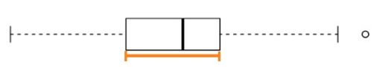

* median
* mean
* range
* standard deviation
* **IQR**

1. The distribution of housing prices in a country where 25% of houses cost < $350k, 50% of houses cost < $450k, 75% of houses cost < $1M + w/ a meaningful # of houses that cost > $6M is most likely

* symmetric
* **right skewed**
* left skewed
* uniform

1. Based on the relative frequency histogram, which of the following is supported by the plot?

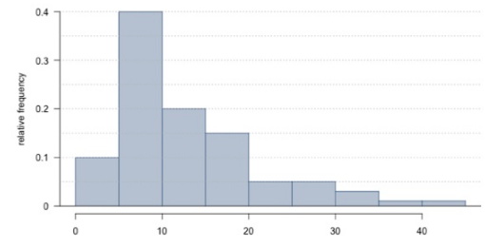

* There are no outliers in the distribution.
* The distribution is multimodal.
* **The mean of the distribution is smaller than its median.**
* The IQR of the distribution is roughly 10.
* It is not possible to estimate the median without knowing the sample size.

1. A recent housing survey was conducted to determine the price of a typical home in a city that is mostly middle-class, with 1 very expensive suburb. The mean price of a house in this city is roughly $650k. Which of the following statements is most likely to be true?

* We need to know the standard deviation to answer this question
* Majority of houses in this city cost more than $650,000.
* There are about as many houses in this city that cost > $650k than less than this amount.
* **Majority of houses in this city cost less than $650,000.**

1. Phi Delta Kappa (PDK) is an international professional organization for educators that, in collaboration w/ Gallup, has been conducting polls on the public’s attitudes toward the public schools since 1969. The following was one of the questions on the 2011 poll:

*”Most teachers in the nation now belong to unions or associations that bargain over salaries, working conditions, and the like. Has unionization, in your opinion, helped, hurt, or made no difference in the quality of public school education in the United States?”*

The respondents’ answers broken down by party affiliation are shown below. Which of the following statements is most justified by these data?

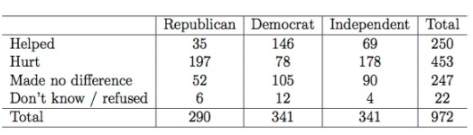

* 14% of Republicans and 58% of Democrats think that teachers belonging to unions or bargaining associations helped the quality of public school education in the United States.
* The results of the survey suggest that opinion on teachers belonging to unions or bargaining associations and political party affiliation appear to be independent.
* A histogram or a box plot would be useful for investigating if distribution of opinion on teachers belonging to unions or bargaining associations varies by political party affiliation.
* **The results of the survey suggest a relationship between opinion on teachers belonging to unions or bargaining associations and political party affiliation.**

1. Professors regularly give 2 versions of an exam. The professor may also provide summary statistics for each version. Suppose the following summary is provided:

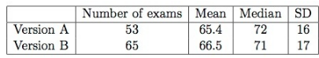

A student who took Version A says that he should get an extra point B/C his exam was harder as evidenced by the lower mean score for Version A, as shown by the mean score. Does the student have a good argument?

* We need to know the minimum and the maximum for each version to determine if this argument is valid.
* Yes. Only 53 students took exam Version A while 65 students took exam Version B.
* **No. The average scores are relatively close when considering the spread of the distributions. The difference might just be due to just chance???????**
* Yes. The difference in the exam scores means that there is a difference in difficulty between the versions.
* We need to know the shape of the distribution for each version to determine if argument is valid.
* No. The median of Version A is higher.