* Last semester, out of 170 students taking a particular statistics class, 71 students were “majoring” in social sciences and 53 students were majoring in pre-med. There were 6 students who were majoring in both. What is the probability a randomly chosen student is majoring in social sciences, given that s/he is majoring in pre-medical studies?
* P(SS) = 71/170 P(PM) = 53/170 P(SS & PM) = 6/170
* P(SS | PM) = P(SS & PM) / P(PM) = (6/170) / (53/170) = **6/53**
* Which of the following states that “the proportion of occurrences with a particular outcome converges to the probability of that outcome?”
* **Law of large numbers**
* Shown below are 4 Venn diagrams. In which of the diagrams does the shaded area represent A and B but not C?

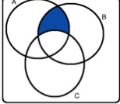

* Each choice below shows a suggested probability distribution for the method of access to online course materials (desktop CPU, laptop CPU, tablet, smartphone). Determine which is a proper probability distribution.
* **desktop CPU: 0.25, laptop CPU: 0.35, tablet: 0.15, smartphone: 0.25**
* desktop CPU: 0.15, laptop CPU: 0.50, tablet: 0.30, smartphone: 0.20
* desktop CPU: 0.30, laptop CPU: 0.40, tablet: 0.35, smartphone: -0.05
* desktop CPU: 0.20, laptop CPU: 0.20, tablet: 0.20, smartphone: 0.20
* Assortative mating is a *nonrandom* mating pattern where individuals w/ similar genotypes and/or phenotypes mate w/ one another more frequently than what would be expected under a random mating pattern. Researchers studying this topic collected data on eye colors of 204 Scandinavian men + their female partners. The table below summarizes the results. For simplicity, assume heterosexual relationships. What is the probability a randomly chosen male respondent w/ blue eyes has a partner w/ blue eyes?

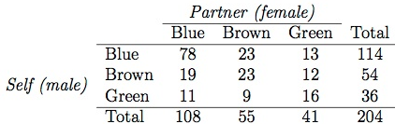

* **78/114**
* Which of the following statements is false?
* Two disjoint outcomes (of the same event) cannot occur at the same time.
* Two complementary outcomes (of the same event) cannot occur at the same time.
* **Two independent events cannot occur at the same time.**
* Two mutually exclusive outcomes (of the same event) cannot occur at the same time.