* Consider width of 2 bootstrap CI’s constructed based on the same sample. 1 intervals = constructed at a 90% confidence level + the other at a 95% confidence level. Which of the following is true?
* **The 95% interval is wider.**
* Which of the following is a situation where the paired test is preferred?
* **Compare artery thicknesses at the beginning of a study and after 2 years of taking Vitamin E.**
* **Assess effectiveness of a diet regimen by comparing the before and after weights of subjects.**
* **Compare pre- (beginning of semester) and post-test (end of semester) scores of students.**
* ~~Assess gender-related salary gap by comparing salaries of randomly sampled men and women.~~
* You've just read a study that investigated the difference in brain sizes between EU + US citizens, based on data from random samples from both populations. At 5% significance level the study failed to reject the null that EU + US citizens have (on average) brains of equal size. Which of the following is true regarding a 99% confidence interval for the difference in brain sizes?
* ~~Since the data come from samples and not populations, no conclusions can be made.~~
* **The interval contains 0.**

* The figure below shows three unimodal and symmetric curves, which assignment is most plausible?

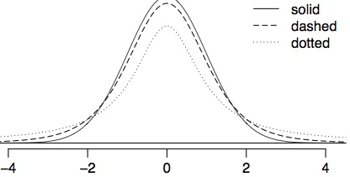

* **solid: normal, dashed: t.df=1, dotted: t.df=5**
* t = shorter + wider, more dF in t = even more shorter + wider (heavier tails)
* We are testing the following hypotheses:

H0 : μ = 3 HA : μ > 3

* The sample size is 18. The test statistic is calculated as T = 0.5. What is the p-value?
* **Greater than 0.1**

pt(.5,17,lower.tail = F)

[1] 0.3117426

* What does ANOVA mean?
* **Analysis of variance**
* Which of the following are conditions required for comparing means across multiple groups w/ ANOVA?
* ~~The means of each group should be roughly equal.~~
* **The data within each group should be nearly normal.**
* **The variability across the groups should be about equal.**
* **The observations should be independent within and across groups.**
* Which of the following looks most like an F distribution?

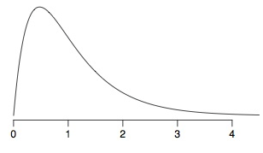

* People of different ages were asked to stand on a “force platform” + maintain a stable upright position. The ``wiggle" of the board in a forward-backward direction is recorded; more wiggle = less balance. Participants are divided into 2 age groups: young + elderly. Average wiggle among elderly people = 26.33 mm + average among young people = 18.125 mm. The bootstrap distribution for the difference in means is shown below, based on 100 bootstrap samples. Of the following choices, which is the most accurate 90% bootstrap confidence interval for the true difference in means?



* **(5 mm, 15 mm)**
* For a 90% CI we’d want to exclude 10% of samples outside of the CI, i.e. 5% on each tail.
* W/ 100 samples, count off 5 points corresponding to 5 bootstrap sample statistics from each end of the bootstrap distribution to determine the endpoints of the CI.
* Suppose we wanted to compare the rates of return for 2 stocks: the tech company Intel + Southwest Airlines. To compare rates of return, we take a random sample of 50 days of Intel's stock returns + another random sample of 50 days for Southwest's stock returns (not necessarily the same days). These data should NOT be treated as paired. Why would these data not be considered paired data?
* **The data can't be considered paired data because the days for which we have Intel data may be different from the days for which we have Southwest Airlines data.**
* ~~When random sampling is involved, data can't be treated as paired.~~
* Which of the following is true about bootstrap and sampling distributions?
* **Both distributions are comprised of sample statistics.**
* ~~Both distributions are created by sampling with replacement from the population.~~
* Only the bootstrap distribution is
* **Bootstrap distributions are centered at the sample statistic, sampling distributions are centered at the population parameter**
* **Both distributions get narrower as the standard deviation decreases.**
* A study examining relationship between weight of school children (4th-6th graders) found a 95% CI for the difference between average # of school days missed by overweight + normal weight children (μ.overweight – μ.normal) to be 1.3-2.8 days. Which of the following is true based on this CI?
* **We are 95% confident that overweight children on average miss 1.3 to 2.8 days more than children with normal weight.**
* An insurance company wants to estimate (using a CI) its average claim amount using data from 20 randomly selected claims. Which of the following is false?
* The critical t-score, t⋆, has 19 degrees of freedom.
* A confidence interval based on this sample is not accurate since the sample size is small.
* If the distribution of the sampled claims is not extremely skewed, a T interval is appropriate.
* The confidence interval can also be calculated using bootstrapping.
* My friend, Tom, believes his supermarket's prices are lower than mine + sets an alternative hypothesis test reflecting this. We construct a list of 10 identical items + purchase them at our respective stores. Tom wants to know if these data support his hypothesis. Which of the following is the correct description of Tom's situation?
* **Tom has a one-sided alternative hypothesis and should do a paired t-test.**
* We are testing the following hypotheses: H0 : μ = 0.5 HA : μ ≠ 0.5
* The sample size is 26. The test statistic is calculated as T = 2.485. What is the p-value?

> pt(2.485,25,lower.tail = F)

[1] 0.0100024

* **between 0.01 and 0.02**
* When doing an ANOVA, you observe large differences in means between groups. W/in the ANOVA framework this would most likely be interpreted as:
* **Evidence strongly favoring the alternative hypothesis.**
* Which is most useful for checking the equal variance across groups condition for ANOVA?
* **Side-by-side box plots showing roughly equally sized boxes for each group.**
* Based on the ANOVA output below, what is the value of the F-statistic? Choose the closest answer.

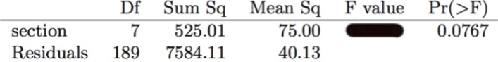

* **1.87** (MS.w / MS.b = 70/40.13)
* A study compared 5 different methods for teaching descriptive statistics: traditional lecture + discussion, programmed textbook instruction, programmed text w/ lectures CPU instruction, + CPU instruction w/ lectures. 45 students were randomly assigned, 9 to each method. After completing the course, students took a 1-hour exam. We’re interested in finding out if the average test scores are different for the different teaching methods. The p-value of the test = 0.0168. What is the conclusion of the test?
* **At least two group means are significantly different from each other.**

* For given values of the sample mean + sample SD when n = 25, you conduct a hypothesis test + obtain a p-value = 0.0667, which leads to non-rejection of the null. What will happen to the p-value if the sample size increases (+ all else stays the same)?
* **Decrease**
* A study compared 5 different methods for teaching descriptive statistics: traditional lecture + discussion, programmed textbook instruction, programmed text w/ lectures CPU instruction, + CPU instruction w/ lectures. 45 students were randomly assigned, 9 to each method. After completing the course, students took a 1-hour exam. We’re interested in finding out if average test scores are different for different teaching methods. How many pairwise tests are needed to compare all pairs of means to each other?
* **10** (groups*(groups – 1) / 2 = (5*4 / 2)