***COURSERA: STATS W/ R SPECIALIZATION***

***COURSE 2 - Inference***

**WEEK 4 - Inference for Proportions**

***4.4.1 Inference For Proportions***

**Introduction**

* Inference for categorical variables where **parameter of interest** = a proportion, as opposed to mean
* Gallup poll results where American public was asked about opinion on same-sex marriages
* Poll where data were collected from a variety of countries trying to answer the if most children in the country have the opportunity to learn + grow every day
* Published study on antihypertensive meds + serious falls on nearly 5k Americans > 70 during a 3 year period + found those who taking antihypertensive meds had a 30-40% greater likelihood of experiencing severe fall-related injuries like hip fractures + head trauma
* What is common between these studies = they deal w/ categorical variables like on same-sex couple marriages, whether children in a country have the opportunity to learn + grow every day, + whether patients taking a certain type of med are more likely to have fall-related injuries.
* Ex1: Simple case = categorical variable only has 2 levels we can categorize as a success or failure (**binary**)
* Success != something positive 🡪 could be a patient dying or suffering from a certain type of disease, or somebody graduating from high school
* Doesn't matter the context = important thing is these = **binary categorical variables** = levels can be categorized as either 1 thing or the other
* In this case, parameter of interest = **proportion of success**.
* Ex2: categorical variable w/ > 2 levels.
* Ex: Socioeconomic status tends to be categorized as low, medium, or high
* Ex3: 2 categorical variables that both have only 2 levels.
* IF somebody is male or female, if they decide to pursue a major in the sciences or not
* Ex4: 2 categorical variables, where either 1 or both of have > 2 levels
* Ex: Socioeconomic status (low, med, high) + educational attainment (finished high school, junior college, college, or graduate degree) + look at the relationship between these 2 variables
* In this case, we evaluate whether these variables appear to be dependent or independent.

**Sampling Variability + CLT for Proportions**

* **Sampling distribution for a sample *proportion***, not a mean, b/c we're dealing w/ categorical variables + **parameter of interest is no longer a mean but a proportion**.
* **CLT for proportions** = very similar to what before but w/ a different measure of the SE
* **Sampling Distribution:** Say you have a population of interest + take a random sample from it
* Based on that random sample, calculate a sample statistic + if variable of interest = categorical, the sample statistic = a sample proportion.
* Take another sample, calculate sample proportion from *that*, + then another, + so on
* Want to take as many samples as possible.
* Distributions of observations w/ in a sample = a **sample distribution**.
* However, when we look at the **distribution of the sample statistics** = **sampling distribution**
* Sample distributions = observations are individual (people, cases, etc.)
* Sampling distribution = observations = sampled statistics.
* Ex: Estimate proportion of smokers in the world, so population = world population, N = population size (everybody in the world), parameter of interest = **p**, the true proportion of smokers in the world
* If we actually had all population data, p = # of smokers in the world / total population size.
* Instead, take many samples from different countries (sample 1K people from Afghanistan + ask each if they’re a smoker or not + so on + so forth w/ many countries)
* Now we have a bunch of samples of 1k observations each, where observation = a person from that country + we summarize these samples.

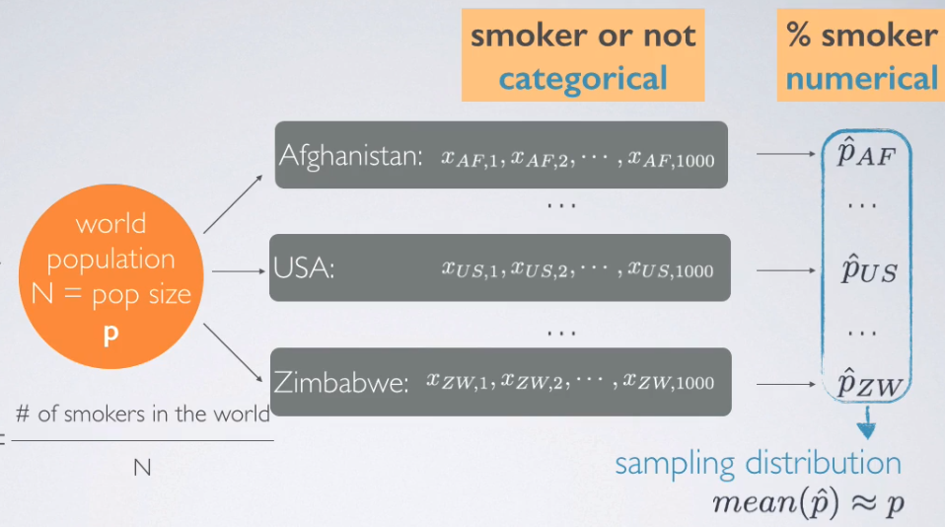

* Calculate proportion of smokers for each country (a sample proportion) + now the data set is not individual people but a data set of proportions
* The distribution of these proportions = the sampling distribution
* Each p^ = somewhat good guess for true p, although we expect variability between these b/c we’d expect trends in smoking habits of people from various countries.
* But overall, we’d expect the mean of the p^ values to be close to our unknown population mean, p
* So, started w/ a categorical variable (smoker or not) + for each sample, calculated a summary statistic = proportion of smokers + then create a distribution of numerical data = proportion of smokers in each country.
* started w/ a categorical variable + ended up w/ a distribution of a numerical variable
* **CLT says the distribution of sample proportions is going to be nearly normal** + just like w/ sample means, it's going to be **centered at the population proportion** (parameter) + w/ the **standard error inversely proportional to sample size** (also seen before)
* CLT tells us about the shape, the center, + the spread of a distribution

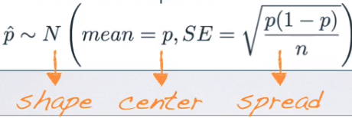

* SE = square root of p (**proportion of success**) times 1 – p divided by n.
* Conditions for the CLT for Proportions
* 1) **Independence of observations** = sampled observations must be independent + to achieve that either use random sampling or assignment, depending on study type
* + If sampling w/out replacement, make sure sample size < 10% of population.
* 2) **Sample size/Skew** = looking for a *balance of the sample size* *+ the proportion of success*.
* There should be at **least 10 successes + 10 failures in the sample**
* n*p + n*(1 - p ) must both be >= 10.
* Talked about this when we were dealing w/ the binomial distribution + were looking for the normal approximation of it
* Same idea holds here = want our sample proportion to be nearly normally distributed + therefore need to meet the **success failure condition** 1 more time.
* However, if p is unknown (for the both calculation of SE + for # of successes + failures), use our sample proportion, p^ b/c best guess for a population parameter = a sample statistic being used as a **point estimate** for that parameter.
* Ex: 90% of all plant species are classified as angiosperms (flowering plants). If you were to randomly sample 200 plants from the list of *all known* plant species, what is the probability at least 95% of the plants in sample will be flowering plants?
* Proportion of success = 0 + sample size, n, = 200
* Asked for probability of at least 95% successes 🡪 angiosperm plant = a success
* Looking for the probability our sample proportion will > 0.95.
* If we knew something about the distribution of p^, we should be able to easily calculate this + if we knew p^ was distributed nearly normally, we can calculate this probability using the normal distribution z scores + percentiles.
* CLT tells us it may be distributed nearly normally, so check to see if conditions for the CLT hold + if so, we can proceed w/ that.
* 1st Independence = 200 is certainly < 10% of all plants, so we can assume plants in our sample are independent of another.
* 2nd Success/Failure condition. n = 200 sample size + p = 0.9, so n*p = 180 + n*(1 – p) = 20
* Both of these are > 10, so success/failure condition holds
* **These 2 facts tell us the distribution of the sample proportion is going to be nearly normal** w/ mean = population parameter 0.90 + SE =



* We have a normal distribution, we know it's mean + it's variability (spread),+ we're looking for a probability associated w/ this distribution.
* 1st to do = draw our curve, mark the mean = 0.90, + then shade area of interest = anything beyond 0.95.

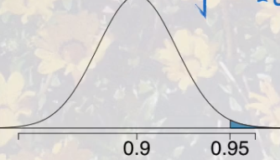

* To calculate this probability, we can refer to a z score.

> p.hat = .9 # mean of our sampling distribution = population parameter (when normal)

> n = 200

> (se <- sqrt((p.hat*(1-p.hat))/n))

[1] 0.0212132

> (z <- (.95 - p.hat)/se)

[1] 2.357023

* We are more than 2 SDs away from the mean at this point, so it's going to be a pretty small probability that at least 95% of plants our sample of 200 will be flowering plants.

> # get proportion of values lower than this z-score on the curve

> pnorm(p.hat,.95,se)

[1] 0.009211063



* We were looking for the probability of at least 95%, + so that seems like we should’ve used the notion p-hat >= 0.95.
* However, remember that **under a continuous distribution** (normal distribution is one), the probability of a random variable being equal to a specific number = 0
* So, we use the CLT to find this, but *could also do this using the binomial distribution as well.*
* Remember, sample size n = 200, proportion of overall success = 0.9, + we're being asked for p(obtaining 95% successes) = 95% of 200 = at least 190 successes in 200 trials where proportion of success is 0.9

> sum(dbinom(min.success:n,n,p)) # want prob of anything >= min of 195, up to 200

[1] 0.00807125

* That is not exactly the probability calculated before, but it’s awfully close
* **What if** the success failure condition is NOT met:
* Center of the sampling distribution will still be around the true population proportion + spread can still be approximated using the same formula for SE.
* However, the ***shape* of the distribution will depend on whether the true population proportion is closer to 0 or closer to 1**
* Remember distributions of proportions have natural boundaries = can only be between 0 + 1.
* So, we know that a sample proportion cannot <0 zero + or > 1
* Think about a situation where success/failure condition is not met + our true population proportion = 0.2, a value closer to 0 than to 1.
* We said the center of a sampling distribution is still around the true population parameter, but we end up w/ a smaller tail to the left of the distribution + a much longer tail to the right
* 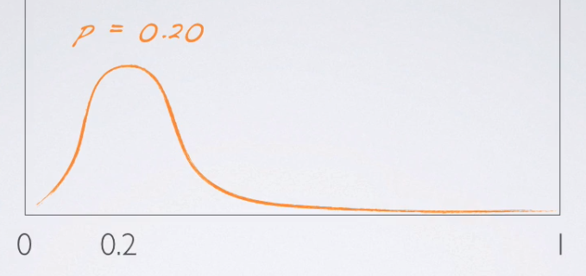
* This is b/c for samples taken from a population where true population proportion = 20%, we’d expect the majority of them to have sample proportions close to 20%, + we’ll still get some that are different than 20% (all the way down to 0 or all the way up to 1)
* But it's much less likely to get a sample proportion = 100% in a random sample from a population where true population proportion = 20%
* Left tail is short b/c we have a natural boundary at 0, but right tail is much longer b/c the natural boundary on the higher end doesn't appear until 1, so that yields a right-skew distribution.
* Similarly, if we had a true population proportion = 80%, we’d see the opposite effect

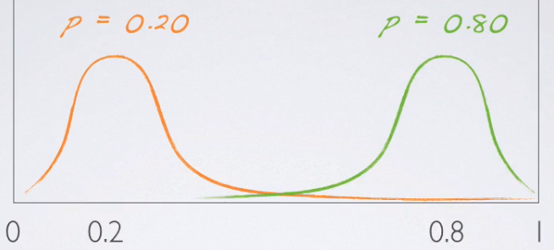

* This is only if the success/failure condition is NOT met.
* If the success/failure condition IS met, that means sample size is higher = will yield a smaller SE, so curves are going to be much more dense around the true population parameters + will look more + more symmetric as the sample size increases.
* 
* 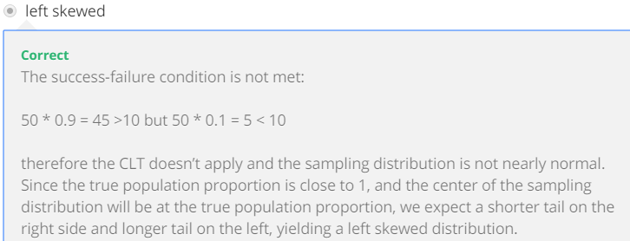

**CI for a Proportion**

* 2 scientists want to know, if a certain drug is effective against high BP. The 1st scientist wants to give the drug to 1K people w/ high BP + see how many experience lower BP levels.
* The 2nd scientist wants to give the drug to 500 people w/ high BP + NOT give the drug to another 500 people w/ high BP + see how many in both groups experience lower BP levels.
* *Which is the better way to test this drug?*
* We know **controlling** is important when running experiments, the 2nd study where the group that doesn't get the drug acts = the **control group**, should be the better design.
* This question was posed to 670 Americans w/in the GSS in 2010, + 99 said all 1K should get the drug.
* So, we're going to be categorizing these as those w/ a “bad intuition” for experimental design
* 571 said 500 should + shouldn’t get drug 🡪 label “good intuition” about experimental design
* Our goal is to **estimate what % of Americans have good intuition about experimental design**.
* **Parameter of interest** = % of all Americans who have good intuition about experimental design, + denote this unknown population parameter, p, for population proportion.
* Our **point estimate** = % of SAMPLED Americans who have good intuition about experimental design, denoted p^, our KNOWN **sample proportion**

> n <- 670

> bad <- 99

> good <- 571

> (p.hat <- good / n) # point estimate

[1] 0.8522388

* When it comes to estimation of an unknown population parameter, it always follows the same structure 🡺 **point estimate +/- a margin of error**.
* In this case our point estimate = sample proportion, p^ + margin of error = z* (critical value) times SE of p-^
* So, once again, *the only new concept here = how to calculate the SE for the sample proportion*
* To calculate SE for PROPORTIONS, use the formula based on the CLT for PROPORTIONS:

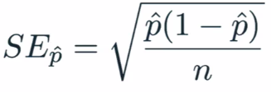

> (se.prop <- sqrt((p.hat*(1-p.hat))/n))

[1] 0.01370956

* We don't know p (true population parameter) so we plug in the sample proportion, p^
* In most instances, we truly don't know the true population parameter + that’s why we're calculating a CI in the first place.
* So, roughly 85% of Americans, answered the question on experiment design correctly + we are asked to estimate using a 95% CI for the proportion of all Americans who have good intuition about experiment design
* **Before we calculate the CI, make sure that conditions for inference have been met**
* 1: Independence: Relies on a random sample/assignment + < 10% of the population being sampled.
* 670 Americans is definitely < 10% of all Americans + we know the GSS samples randomly.
* Therefore, we can assume that whether an American in the sample has good intuition about experimental design is independent of another.
* 2: Sample Size/Skew: check this condition when dealing w/ *categorical* variables + *proportions* as the success/failure conditions.
* Need to make sure that we have at least 10 successes + 10 failures in our sample.
* The sample size overall is large so we should be good here but let's take a look real quick.
* successes <- good # 571
* > failures <- bad # 99
* > (successes >= 10 & failures >= 10)
* [1] TRUE
* We didn't have to even go through the n*p^ route here b/c we already know the # of successes + failures + know both of these #’s are indeed > 10.
* Therefore, since the success-failure condition is met, we can assume the sampling distribution of the proportion is nearly normal.
* Now that we have all of our building blocks we can actually calculate our CI.

alpha = .95

> (z.star = qnorm(1-((1-alpha)/2)))

[1] 1.959964

> (mOe <- z.star*se.prop)

[1] 0.02687024

> (lower <- p.hat - mOe)

[1] 0.8253686

> (upper <- p.hat + mOe)

[1] 0.879109

* We can interpret this as, **we are 95% confident that 82.3% to 87.7% of all Americans have good intuition about experimental design**.
* Also, **95% of random samples of 670 Americans will yield CIs that contain the true proportion of Americans who have good intuition about experimental design**
* The margin of error for this CI was 2.7%, + if we wanted to reduce margin of error to 1% while keeping confidence level the same, at least how many respondents should we sample?
* > desired.mOe <- .01
* > (min.n <- ((z.star/desired.mOe)^2)*(p.hat*(1-p.hat)))
* [1] 4837.465
* 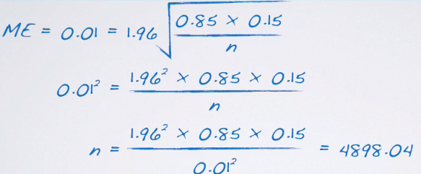
* Remember we need to round this up even though mathematically, it doesn't make sense, b/c this is saying is that “in order to ensure a maximum 1% margin of error, we need 4,898.**04** persons.
* We can't have 0.04 of a person, so we’d need at least 4,899 people in our sample.
* So, for a minor reduction in our margin of error, we have to increase our sample size a lot, b/c the sample size appears *under the square root sign in calculation of the margin of error*.
* So, to have benefits from an increased sample size, increase your sample size by a lot before you can actually start reaping the benefits.
* 1 more point about calculating required sample size for a desired margin of error.
* Remember the formula for the margin of error = a critical value times the standard error.

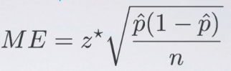

* If there is a previous study we can rely on for the value of p^ in this formula, we’d use that in calculation of the required sample size (what we just did)
* *If not*, use 0.5 for p^ 🡺 2 reasons why we do this
* 1) if you don't know any better + it’s a categorical variable w/ 2 outcomes (S/F), 50-50 = a pretty good guess.
* 2) Using 0.5 for p^ gives the most conservative estimate = the highest possible sample size.
* We like being conservative when it comes to estimating minimum required sample sizes, b/c we definitely don't want to make a mistake + have to re due our sampling.

**Hypothesis Test for a Proportion**

* 1) Set our hypothesis:
* H0 = unknown population parameter p (opposed to mu for means) is set to some null value, +
* H1 = p can be <, >, or != to that null value.
* 2) Calculate point estimate = sample proportion, p^
* 3) Check conditions
* 1) Independence = make sure sampled observations are independent of each other (ensured either through random sampling or random assignment Depending on study type
* A) if sampling w/ a replacement, want sample size to be < 10% of the population.
* 2) Sample Size/Skew = want to make sure we have at least 10 expected successes + expected failures in our sample.
* NOTE: We used p, instead of p^ for this b/c **in a hypothesis test, we have to assume the null is true.**
* Think about definition of a p value = probability of observed or more extreme outcome if the null was true.
* So, when going through the conditions (or any other portion of the hypothesis test), we MUST assume the null is true, + therefore, wherever we see a p, plug in the null value for p
* So, we read this as not 10 *observed* successes + failures, but instead as 10 *expected* successes + failures.
* 4) Draw the sampling distribution before calculating p value + shade where the p-value belongs to.
* Either in one tail (upper or lower) or in a 2 tails
* 5) Calculate test statistic = *ALWAYS* of the form (observed – null) / standard error.
* This is observed sample proportion **p^** - null value **p** comes from null divided by **SE (**square root of p*(1 – p) / n.
* Note again we said **p** + NOT p^, b/c we’re **assuming the null is true + therefore are using what the null has set forth as our true population parameter.**
* We don't *know* if that's the case, but we *must assume* the null is true as we proceed through a hypothesis test.
* 6) Make a decision + interpret it in context of the research question.
* If p < our significance level, reject the null + decide that the data provide convincing evidence for the alternative.
* If, in fact p > our significance level, we fail to reject the null + conclude the data do not provide convincing evidence for the alternative.
* Moral of the Story = use Sample proportion when there's nothing else known + use the population proportion (or at least the null-hypothesized value of the population proportion) when doing a hypothesis test as they dictate that we must assume the null is true.
* If checking the success-failure condition for a **CI**, use *observed sample proportions*.
* If calculating SE for a CI, use observed sample proportion, b/c we don't know any better
* If, checking the success-failure condition for a **hypothesis test** = use *expected counts* + plug in the p that comes from the null.
* If I'm calculating SE for a hypothesis test, SE = square root of p*(1 – p) / n where p comes from the null.
* Ex: 2013 Pew Research poll found 60% of 1,983 randomly sampled American adults believe in evolution. Does this provide convincing evidence that the majority of Americans believe in evolution, where majority is > 50%.
* So if the question is “Is the *true proportion* of Americans who believe in evolution > 50%”, then our alternative H1 is “p > 0.5”
* Using this, we can easily figure out what the null can be, b/c we keep the same population parameter (.5) + same null value, except we simply set it equal to that # as opposed to giving a direction (1 way or another) or saying !=
* Remember, the null always has an equal sign in it vs. the alternative could have >, <, or !=, depending on the research question being posed.
* We are also given a sample proportion p^ = 0.6.
* So, *in this sample*, > 50% of respondents believe in evolution, but we're checking to see if this observed difference between the sample proportion + what we're hypothesizing is statistically significant.
* In other words, does *this particular sample* yield convincing evidence of majority of Americans believing in evolution?
* Before we move on to actually doing inference, always check conditions.
* 1) Independence: n = 1,983 is definitely < 10% of all Americans + we have a random sample, therefore we can assume an American is independent of another.
* 2) Sample Size/Skew of sampling distribution.
* **For proportions, check this using the success-failure condition**
* B/c we're doing a hypothesis test, we have to assume the null is true, so we’d use the p set forth by the null
* So, the total # of expected successes + failures in this sample both = 1983*0.5 = 983 >= 10
* Since both conditions are met, we can assume a nearly normal sampling distribution for our sample proportion +, given a set of hypotheses + characteristics of sample, we can calculate our p-value.
* But before that, we need a test statistic + before *that*, we need to draw the sampling distribution.
* Our p^ is distributed nearly normally according to our conditions + to this CLT for proportions
* The center of that distribution should be @ the true population parameter, which we don't know
* But, since we’re doing a hypothesis test, we are assuming the null is true, so we plug in the value of the population parameter set forth in the null
* **Assume this is indeed the true population parameter for the purpose of this hypothesis test.**

(se.prop <- sqrt((h0*(1-h0))/n))

[1] 0.01122816

* Next, we draw our sampling distribution centered at the null value + shade everything beyond 0.6 ( observed sample proportion, p^

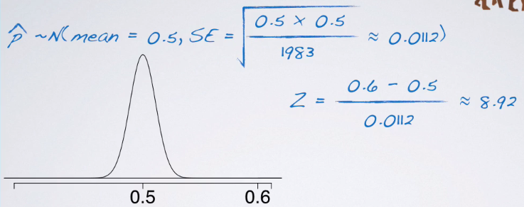

* Then calculate our test statistic

> (z <- (p.hat - h0)/se.prop) # observed - null / n

[1] 8.906178

* That's a pretty high test statistic, if you think about it, b/c it's much farther than 3 SDs from the mean
* So the p value (AUC area under the z curve beyond 8.92) is going to be almost zero.

pnorm(h0,p.hat,se.prop)

[1] 2.641113e-19

* W/ such a small p value, the conclusion is going to be to reject the null

**Estimating the Difference Between Two Proportions**

* Now we’re working w/ 2 categorical variables + evaluating the relationship between them.
* 1 categorical variable = explanatory/grouping variable + the other = response variable.
* Both have 2 levels, so a success + a failure 🡪 calculate proportion of successes in the 2 groups, based on our sample, + compare them to be able to say something about the proportions of their successes in the population
* This an *estimation* = use a CI for the difference between the 2 population proportions (unknown) using data from our samples.
* Early October 2013, Gallup poll asked, "Do you think there should/should not be a law that would ban the possession of handguns, except by the police + other authorized persons?"
* Possible responses = **no**, shouldn’t be such a law, **yes**, should be such a law, or **no opinion**
* Categorize **yes = success**, + either **no opinion or no = failure**.
* Gallop has been asking this since 1959 🡪Look to see how things have changed in the U.S. since then

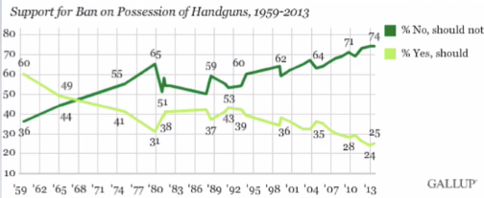

* Back in the 50s or early 60s = higher proportion of people thinking there should be such a law, + but a much lower proportion today at 25%, compared to 74% that say there shouldn’t be such a law
* 74 + 25 = 99% so that 1% = no opinion on the matter.
* Also asked this question to a group of Coursera students

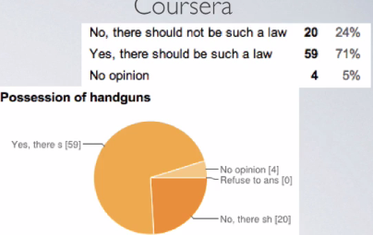

* This seems like a very different population 🡪 probably expected b/c Coursera is a much more international population than the US + possession of guns tends to be a hot topic in the US + may not necessarily be so in other countries.

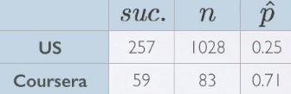

* Oct 2013 = Gallup surveyed 1,028 people + 25% said yes = 257 people
* In the Coursera population, 83 sampled + 71% said yes = 59 respondents
* *How do Coursera students + the American public at large compare w/ respect to their views on laws banning possession of handguns?*
* Parameter of interest = ***difference* between proportions of ALL Coursera students + ALL Americans who believe there SHOULD be a ban on possession of handguns.**

 

* p = unknown population parameter = population proportion
* p^ = sample statistic = serves as **point estimate** for parameter of interest = difference between the proportions of *sampled* Coursera students + *sampled* Americans who believe in a ban
* To estimate differences between proportions 🡪 estimation is usually a CI + a **CI** is always of the form **point estimate +/- a margin of error.**
* Point estimate = difference between 2 sample proportions
* Margin of error = critical score (Z* b/c dealing w/ sample proportions ,+ based on the CLT, we know the distribution of the difference between the sample proportions are going to be nearly normal) times SE of the difference between the 2 sample proportions.



* To calculate the SE for the difference between 2 proportions for calculating a CI

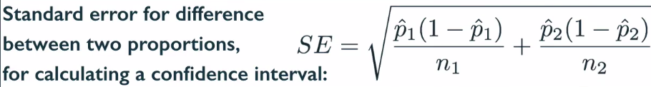

* This is different for CI’s vs. hypothesis tests.
* Bringing 2 unknowns together (sample proportions from 2 groups), so overall variability should increase + hence we're adding the 2 variability components here
* Then we the square root of that to go from variance to SD, or, the SE (SD of the sampling distribution)
* Conditions
* 1) Independence.
* W/in groups 🡺 make sure sampled observations are independent of each other
* Ensured w/ random sample or assignment, depending on whether study type
* If we are sampling w/out replacement, sample size must be < 10% of population.
* Between groups 🡺 make sure groups are independent of each other (data are not **paired**)
* 2) Sample Size/Skew 🡺 ensure normality of the sampling distribution
* EACH sample should meet the **success-failure condition**.

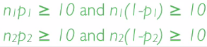

* Remember for a CI, proportions considered to calculate success-failure condition = *observed* sample proportions.
* Using a 95% CI, estimate how Coursera students + the American public at large compare w/ respect to their views on laws banning possession of handguns
* Independence condition 🡪 DO have a random sample for US population, but *not for Coursera population* =simply a voluntary poll posted on Coursera discussion forums, so can't say it was a random sample.
* 10% condition was met for both of the groups = both 1028 + 83 are < 10% of their respective populations
* This means sampled Americans can be assumed to be independent of each other but sampled Coursera students *may not be*.
* So in this case, be wary of generalizing any of conclusion from these findings to the overall population at large b/c we don't really have a good sample from the Coursera population.
* Still move on w/ our analysis only for illustrative purposes
* Sample size + skew condition. 🡪 can we assume the sampling distribution of the *difference* between the 2 proportions is nearly normal
* When dealing w/ proportions, check for this using **success failure rule** + when doing a CI, check for this w/ **observed** successes + **observed** failures
* US = 257 observed successes + (1,028 – 257) = 771 observed failures
* Coursera = 59 successes + 24 failures
* Both of these met = success/failure condition is met for both of the groups + therefore we can assume the sampling distribution of the difference between the 2 proportions is nearly normal
* Now that we got our conditions out of the way, we can actually calculate our CI.

(point.estimate <- p.hat.c - p.hat.a)

[1] 0.4608434

> (point.estimate <- p.hat.c - p.hat.a)

[1] 0.4608434

> alpha = .95

> (z.star = qnorm(1-((1-alpha)/2)))

[1] 1.959964

> (se.diff <- sqrt((p.hat.c*(1-p.hat.c))/n.c + ((p.hat.a*(1-p.hat.a))/n.a)))

[1] 0.05156394

> (point.estimate <- p.hat.c - p.hat.a)

[1] 0.4608434

> alpha = .95

> (z.star = qnorm(1-((1-alpha)/2)))

[1] 1.959964

> (se.diff <- sqrt((p.hat.c*(1-p.hat.c))/n.c + ((p.hat.a*(1-p.hat.a))/n.a)))

[1] 0.05156394

> (mOe <- z.star*se.diff)

[1] 0.1010635

> (lower <- point.estimate - mOe)

[1] 0.3597799

> (upper <- point.estimate + mOe)

[1] 0.5619068

* We are 95% confident the proportion of Coursera students who believe there should be a ban on possession of handguns is 36-56% higher than the proportion of Americans who do.
* That's a huge difference, even when we factor in the variability around the point estimate
* Again, this is probably expected based on how different the composition of the 2 populations are.
* **Does the order of proportions in our calculations matter**? = Yes + No.
* Might change some calculations along the way, but not THE conclusions
* Margin of error is bound to be always positive b/c SE is always going to be positive.
* Conceptually speaking, “negative variability” doesn't make sense + mathematically speaking, SE = a quantity calculated as a square root
* Z*, by definition, is always going to be positive as well.
* On the other hand, point estimate can be positive/negative, depending on the order of subtraction

point.estimate <- p.hat.a - p.hat.c)

[1] -0.4608434

> alpha = .95

> (z.star = qnorm(1-((1-alpha)/2)))

[1] 1.959964

> (se.diff <- sqrt((p.hat.a*(1-p.hat.a))/n.a + ((p.hat.c*(1-p.hat.c))/n.c)))

[1] 0.05156394

> (mOe <- z.star*se.diff)

[1] 0.1010635

> (lower <- point.estimate - mOe)

[1] -0.5619068

> (upper <- point.estimate + mOe)

[1] -0.3597799

* These are actually exactly the same as the 1st interval 🡪 We are 95% confident the proportion of Americans who believe there should be a ban on possession of handguns is 36%-56% lower than the proportions of Coursera students
* As long as your interpreting correctly, it doesn't matter in which order you do the calculations.
* 1 last step 🡺 Based on the CI calculated, *should we expect to find a significant difference between the population proportions of Coursera students + the American public at large who believe there should be a law banning the possession of handguns at the equivalent significance level?*
* In this case, we’re asked to do a kind of mock hypothesis test, + in that case, our null = the difference between the 2 population proportions = 0 = these 2 populations are exactly the same
* For our CI, anything between .36 + .56 is fair game for the difference between the 2 population proportions
* The value= 0 does not appear, + based on that, we’d reject this null + say that “based on this CI, it doesn't appear that these 2 populations are the same w/ respect to proportion of those who believe there should be a law banning the possession of handguns”

pnorm(point.estimate,.95,se.diff)

[1] 3.989529e-165

**Hypothesis Test for Comparing Two Proportions**

* **Hypothesis testing** comparing 2 = estimate the difference between 2 proportions.
* SurveyUSA poll asked respondents whether any of their children have ever been the victim of bullying, including gender of respondent (parent).
* Distribution of responses by gender of the respondent.

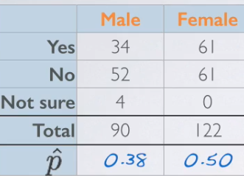

* Remember: We're asking *individuals*, NOT families or households.
* If we see differences between % of bullied kids of males + of females, these may be due to a variety of reasons (single parents, same-sex marriage)
* We're taking the narrow=minded view = 1 mother + 1 father in the household (probably true for majority of the population)
* Could be that 1 gender is more likely than other to even know their kid has been bullied + could also be that 1 gender is more likely than other to actually report this on a survey.

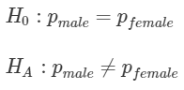 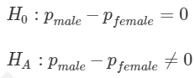

* Calculate a test statistic so we can then calculate a p value.
* Working w/ 1 proportion, to check the success/failure condition w/in the context of a CI, we used our *observed* proportions (*observed* successes + failures).
* When doing a hypothesis test, use the value of the *population proportion* we set equal to in the null
* The null value of p is used to calculate the *expected* successes + failures.
* We use p^ in calculation of the standard error for CI vs. using p (null value of population proportion) for the hypothesis test.
* Moral of the story:
* When dealing w/ a **CI**, use **observed** counts + proportions.
* When dealing w/ a **hypothesis test**, use **expected** counts + proportions.

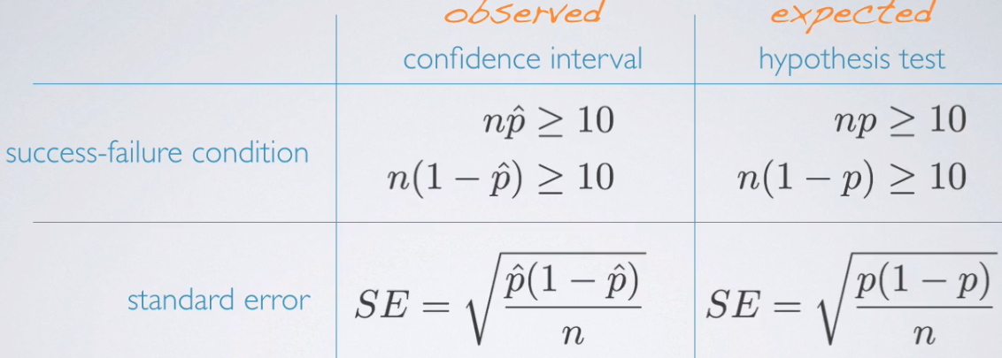

* To translate to working w/ true proportions:
* For CI’s 🡪 look at the total # of observed successes + failures for each group (sample sizes) + multiply them by observed sample proportions to calculate observed # of successes + failures.
* For the calculation of the SE, use observed proportions from the 2 groups as well.
* For HT 🡪 calculating expected successes + failures or expected difference between 2 proportions is not as simple.
* In the null, we say the 2 population proportions should be equal to each other/their difference should be = 0.
* At no point do we define what these p’s should be equal to = don't have a readily-available null value of the population proportion we can use for the 2 groups to calculate expected successes + failures.
* Make one up w/ **pooled proportion**
* Even though the null does not equate the 2 population proportions to something, we could come up w/ a *best guess* for what these could be equal to under the assumption of the null.
* This **pooled proportion** = # of successes / by overall sample size for the 2 groups
* = pooling data from the 2 groups together so it can be calculated as total # of successes in group 1 + total # of successes in group 2 divided by sum of sample sizes for the 2 groups.

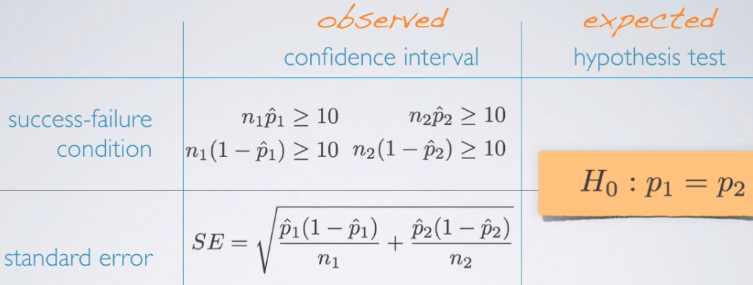

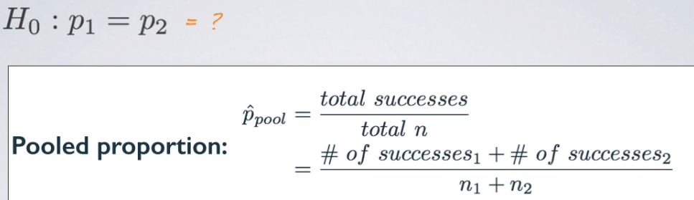

> n.male <- 90

> n.female <- 122

>

> suc.male <- 34

> suc.female <- 61

>

> fail.male <- n.male - suc.male

> fail.female <- n.female - suc.female

>

> (p.hat.male <- suc.male / n.male)

[1] 0.3777778

> (p.hat.female <- suc.female / n.female)

[1] 0.5

>

> (pooled.prop <- (suc.female + suc.male) / (n.male + n.female))

[1] 0.4481132

* Roughly 45% = pooled proportion of males + females who said at least 1 of their children has been a victim of bullying = **good estimate for a common proportion for the 2 groups**,
* For success/failure condition for both groups, use p.hat.pooled to calculate expected # of successes + failures b/c in a hypothesis test, we assume null is true, which states the 2 proportions are equal
* So, we use pooled proportion value as the value they're equal to as the truth in the hypothesis test.
* For SE, plug in the pooled p^ everywhere there was a p^1 or a p^2

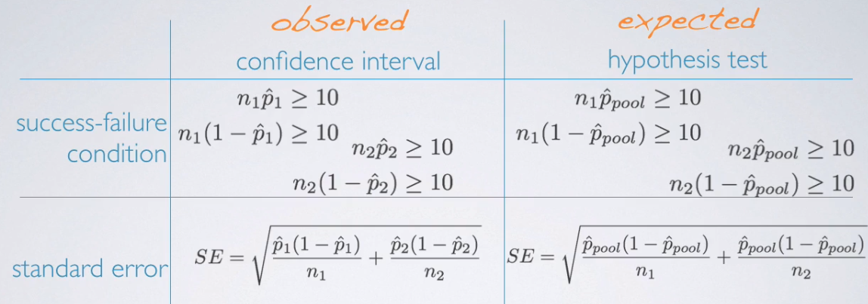

* When doing inference for means, we did NOT have different formulas for SE when doing a CI vs. HT
* W/ means our parameter of interest = µ, which is not in the SE formula (S / square root of n)
* doesn't matter what µ is set equal to in the null, it's not going to influence the SE calculation
* **When doing a HT for proportion, we set p to some null value + *that same p* DOES appear in SE calculation**
* **B/c it *does* appear in the SE calculation + b/c we *must assume the null is true* in our calculations, we need to make a different distinction between when we DO have a null we must assume is true (HT) vs. when we DON'T have a null we must assume to be true (CI)**
* Are conditions for inference met for conducting a HT to compare the 2 proportions?
* Condition of independence:
* W/in Group = 90 + 122 = less < 10% of all males + females + we have a random sample, so, sampled males + sampled females can be assumed to be independent of each other
* Between Group = Think about how these data were collected in the 1st place.
* An *overall random* sample + some people happen to be male + some happen to be female.
* Therefore, we really have no reason to expect that sampled males + sampled females in this sample are dependent on each other.
* These are not necessarily **paired** people + even if we had worries about that, the different sample sizes from the 2 groups = they're definitely not 1:1 pairs.
* = No reason to expect dependence between the 2 groups + can assume between group independence condition is met as well.
* Sample size + skew: Remember to consider the success failure condition for a HT for the difference between the 2 proportions = use **pooled proportion** summary table.

> exp.succ.male <- pooled.prop*n.male

> exp.fail.male <- (1-pooled.prop)*n.male

>

> exp.succ.female <- pooled.prop*n.female

> exp.fail.female <- (1-pooled.prop)*n.female

>

> (exp.succ.male >= 10 & exp.fail.male >= 10)

[1] TRUE

> (exp.succ.female >= 10 & exp.fail.female >= 10)

[1] TRUE

* Can now assume **this sampling distribution of the difference** between the 2 sample proportions is nearly normal.
* Conduct a HT a 5% significance level, evaluating if males + females are equally likely to answer “yes”.
* H0: The 2 proportions are = to each other H1: the 2 are different from each other.
* Ultimate goal of a HT = calculate a p value, but 1st need a test statistic, + for that, we need to figure out our sampling distribution.
* Sampling distribution of the difference between the 2 sample means = nearly normal w/ mean 0 (0 comes from our null value) + we calculate the SE using the pool proportion.

#(z <- (p.hat - h0)/se.prop) # observed - null / n = test statistic

> (se.prop.ht <- sqrt(((pooled.prop*(1-pooled.prop))/n.male) + ((pooled.prop*(1-pooled.prop))/n.female)))

[1] 0.06910121

> (point.estimate <- p.hat.male - p.hat.female)

[1] -0.1222222

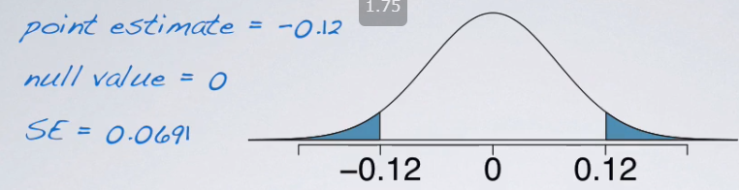

> h0 <- 0

> (z <- (point.estimate - h0)/se.prop.ht) # observed - null / n = test stat

[1] -1.768742

* Our p value = AUC of the absolute value of the z-score beyond 1.74 (-1.74 or lower + 1.74 or higher)

> 2*pnorm(point.estimate,h0,se.prop.ht)

[1] 0.0769369

* Final step = compare this to our significance level, + finally make a decision on the research question we were working w/ 🡪 > sig. level = fail to reject null
* 