**Binomial Proportions**

* When X is a Binomial random variable with n trials and probability of success, p, (**X ~ Binomial(n,p)**), we know that:
* P(success) from our Bernoulli trials (sample proportion of success) **== p^ = X/n** = the MLE for p
* **E[p^] = p (***i.e. MLE is unbiased***) Var(p^) = p(1-p)/n**
*  follows a normal distribution for large n (from the CLT since **p^ =** average of Bernoulli trials)
* i.e. p^ - its mean divided by its Std. Error (SD/sqrt(n) = sqrt(variance/n))
* This fact leads to the **Wald CI** for p: 
* Z = relevant Normal quantile
* **Wald CI** performs *terribly*
* The fact that we grab the appropriate normal quantile Z means that, asymptotically, via the CLT, coverage of the CI = 95% when α = .05
* Coverage probability varies wildly, sometimes being very low for certain value of *n* even when *p* is not near the boundaries
* Ex: p = .5, n = 40, actual coverage of 95% WCI is only 92%
* When *p* is small or large, coverage can be very poor even for large *n*
* Ex: p = .005, n = 1876, actual coverage of 95% WCI is only 90%
* Simple fix to WCI: Add 2 success + 2 failures
* i.e. Let p~ **= (X+2)/(n+4)** 🡪 results in **Agresti-Coull (Wilson Score) CI =** 
* When *p* is small/large, distribution of p^ is *skewed* so it doesn’t make sense to center the interval @ the MLE
* Adding the pseudo-observations pulls the center of the interval towards .5
* This interval ends up being the exact inverse of a **Score test** from hypothesis testing
* **Ex:** Random sample of at-risk population, 13/20 subjects had hypertension. Estimate prevalence of hypertension in the population
* p^ = 13/20 = .65, n = 20 **p~** = 15/24 = .625, n~ = 24 Z­.975 = 1.96 (1 SD)
* Wald CI = [.44,.86] AC CI = [.44,.82] 1/8 likelihood CI = [.42,.84]
* All give roughly the same value == good
* 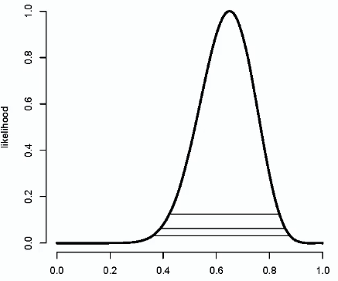 = see likelihood peaks @ MLE = .65
* **Bayesian analysis/statistics =** posits a **prior** (some distribution) on parameter of interest
* All inferences performed on the distribution of the parameter, *given the (objective) data* (**posterior**)
* In general, posterior is proportional to likelihood*prior 🡺 
* Not exactly equal due to a constant of proportionality
* Therefore, (like in diagnostic testing), likelihood = the factor by which priors are **updated** to produce conclusions in light of data
* Binomial data is **discrete** (values between 0-n), but the we’re treating the proportion we’re trying to estimate as **continuous**
* To specify a probability distribution on this parameter, we need a continuous distribution bounded by 0 on lower end + bounded by 1 on the upper end that’s easy to work w/
* This = **Beta** **distribution** (good default distribution for priors for binomial proportions/for parameters between 0-1)
* **Beta density** depends on 2 parameters α + β
* Beta density looks like a **Gamma function =**  
* Gamma of alpha α + β divided by Gamma of α * Gamma of β = **constant of proportionality** we need to obtain to get the integral to integrate to 1
*  == 1
* Remember for kernels of density (here = ) that had a finite integral, we had to divide that function by its integral over the whole range of values to get a **proper density**
* **Mean of Beta density =** α/(α + β) **w/ variance =** 
* α + β = both positive, so *mean must be between 0-1* == mean lies w/in range of values for which the density > 0
* **Uniform density =** special case of the Beta density when **α = β = 1**
*  becomes a constant between 0-1
* May not know Gamma functions for the density, but don’t need to b/c we know the density is a constant density between 0-1 so it must be exactly the uniform density.

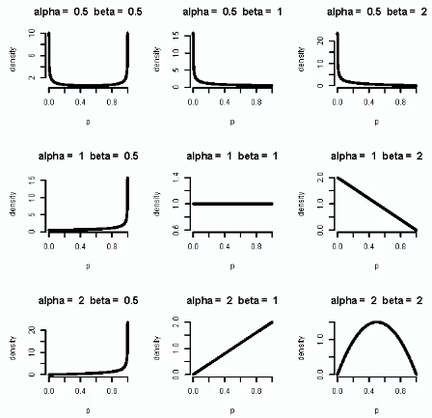



* If doing Bayesian analysis, we need to pick values α + β of such that the shape of the Beta distribution/density represents our beliefs about parameter *p*
* Suppose we choose our values of α + β such that the **beta prior** is indicative of our degree of belief regarding *p* in the absence of data
* Then, using + throwing out anything not dependent on *p* (b/c we’re talking about constants of proportionality) we get 
* Threw out binomial constant **nChoosex** + the ratio of Gamma functions 🡺 don’t depend on p
* **Posterior** 
* This density = just another Beta density w/ parameters **α~ = x + α** and **β~ = n - x + β**