**Unit 1: Probability models and axioms**

**Lecture 2: Mathematical background: Sets; sequences, limits, and series; (un)countable sets**

**Sets**

* **Set =** collection of distinct elements:
* **Finite set 🡺** {a, b, c, d}
* **Infinite se** 🡺 {ℜ} (where ℜ = all real numbers)
* X is an element of set S = 
* X is NOT an element of set S =
* Can specify a set by saying we have a set of all real numbers whose Cos > ½ = {x ε ℜ : cos(x) > 1/2}
* Restricting a set to a particular property
* **Universal set** {Ω} = fix a collection of all possible objects we might want to consider
* Can then consider smaller sets that lie inside the universal set, or say all elements that belong to Ω but not to subset S (green) = S(c) = **complement** of S

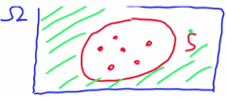

* Can formally say this as x is part of the complement of S if it’s in the universal set but not in S



* Complement of the complement is the set itself 🡪 (S(c))(c) = S
* **Empty set φ =** set of no elements (complement of universal set)
* Suppose we have 2 sets where S > T 🡪 S is a subset of set T

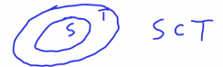

* This means if x is an element of S, it is also an element of T
* There’s also a possibility that subset S = the larger set T



* **Union** of 2 sets = all elements that belong to 1 set, the other, or both
* Some element x belongs to (S U T) if + only if x belongs to 1 of the 2 sets
* **Intersection** = collection of elements that belong to BOTH sets
* Some element x belongs to (S intersect T) if + only if x belongs both sets

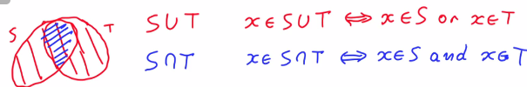

* Can define unions + intersections of infinitely many sets
* S(n) = infinite collection of sets



* Can still define their union to be the set of all elements that belong to 1 of those sets S(n) that we started w/
* X belongs to that union if + only if X belongs to some set we started w/



* X belongs to the intersection of all these sets if + only if X belongs to S(n) *for ALL n.*



* **Set operations** satisfy certain basic properties.

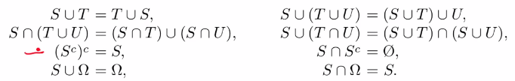

* The union of a set w/ another set = union of the 2 sets in different order.
* If you take the union of 3 sets, can do it by forming:
* the union of 2 sets + then the union w/ 3, or in any alternative order.
* The same would be true for intersections 🡪 intersection of 3 sets is the same no matter how you put parentheses around different sets.
* If you take a union of a set w/ a universal set, you cannot get anything bigger than the universal set, so you just get the universal set.
* On the other hand, if you take the intersection of a set w/ universal set, you get just the set itself
* Perhaps the more complicated properties out of this are a distributive property of intersections + unions.  
  
* The way that you verify them is by proceeding logically.
* If X is an element of (T U U), X must be an element of S + must also be an element of either T or U.
* Therefore, it's going to belong either to (S intersect T) or to (S intersect U)
* Fact: If S is a subset of T, and T is a subset of S, this implies that the 2 sets are equal

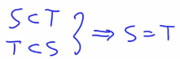

* You can use a similar argument to convince yourselves about the 2nd equality

**De Morgan's laws**

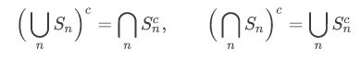

* **De Morgan's laws** are some very useful relations between sets + their complements
* If we take the intersection of 2 sets + then take the complement of this intersection, we obtain the union of the complements of the 2 sets.

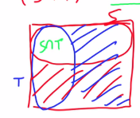

* If X belongs to the complement of (S intersect T), this is the same as saying X does NOT belong to (S intersect T)
* Since it’s not in the intersection, it’s the same as saying X does not belong to S nor to T.
* This is the same as saying X belongs to S(c) or x belongs to T(c).
* This is equivalent to saying that X belongs to the union of the 2 complements
* This establishes this 1st De Morgan's law.

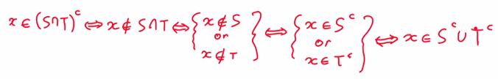

* There's another De Morgan's law, obtained from this 1st one by syntactic substitution.
* Wherever we see an S, replace it w/ S(c) + vice versa + then do the same for T
* Then take the complement of both sides (complement of complement = set itself)



* This 2nd De Morgan's law tells us the intersection of the complements = the complement of a union
* It turns out De Morgan's laws are valid when we take unions or intersections of more than 2 sets as well in a more general form.

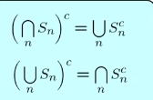

* If we have a collection of sets, Sn, perhaps an infinite collection, + we take the intersection of those sets + then the complement, that result is the union of the complements.
* If we have the union of certain sets + we take the complement, we obtain the intersection of the complements

**Sequences and their limits**

* **Sequence = some collection of elements from some set that is indexed by natural numbers**
* Sequence **a(i)** or sequence **{a(i)}** 🡪 index i trends over the natural numbers (set of real positive integers) + each a(i) is an element of some set
* In many cases the set is the real line lR in which we’re dealing w/ a sequence of real numbers
* Set could also be over the Euclidean space (n-dimensional) 🡪 this is a sequence of vectors
* 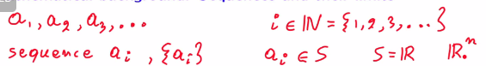
* Formally, a sequence = a function that associates an element of set s to any natural number
* 
* Evaluate f() at some index i 🡪 f(i) 🡪 we get the i-th element of the sequence
* Typically care if sequence converges to some number a 🡺 a(i) 🡪 a as i converges to infinity (limits)

 

* Plot sequence as function of i
* For a sequence to converge to a certain number a, we need the elements of the sequence to get closer to a as i increases

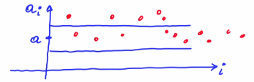

* For some positive number Epsilon, we define a band around a and there exists a time, i(0), after which a(i) will get inside the band + stay there (is w/in Epsilon of a)
* Convergence of a sequence to a certain number a:

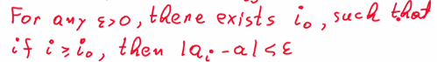

* Can derive this in other things 🡪 say a(i) converges to a and b(i) converges to b, therefore we can write a new sequence a(i) + b(i) converges to a + b or a(i)*b(i) = ab
* Also, if g is a continuous function, g(a(i)) converges to g(a)
* 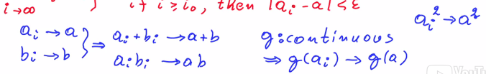

**When does a Sequence Converge?**

* How can we tells whether a given sequence converges or not?
* 2 common criteria to determine this:

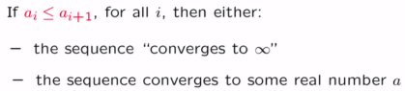

* 1) case w/ a sequence of #’s that keep increasing (or at least never decrease)
* In this case these #’s may go up forever w/ no bound
* If you look at any particular value, there's going to be a time at which the sequence has exceeded that value
* Here, the **sequence converges to infinity**
* 2) if not, the entire of the sequence are bounded (don’t grow arbitrarily large)
* Then it’s guaranteed the **sequence converges to a certain number**
* Can also derive some bound on the distance of the sequence from the number we suspect to be the limit, a
* If the distance gets smaller + smaller + we bound that distance by a certain number which goes to 0, it’s guaranteed that sequence a(i) would converge to a
* Variation of this argument = **sandwich argument**
* We have a certain sequence that converges to a certain number a + we have another sequence that converges to that same # a,
* If our sequence is somewhere in-between, our sequence must also converge to a

