**Unit 1: Probability models and axioms**

**Lecture 3: Solved problems**

**The Probability Of The Difference Of Two Events**

* Give a mathematical derivation of the formula

for the probability that exactly one of the events A and B will occur. Your derivation should be a sequence of steps, with each step justified by appealing to one of the probability axioms.

* So we start with 2 events, A + B, + there might be some intersection between the 2 events.
* The set of points/samples in A + not in B = a set **C = A intersection B(c)**
* Similarly, for all points in B + not in A, we'll call it **D = A(c) intersection B.**
* Finally, for points that are in the intersection of A + B, call it E = **A intersection B.**

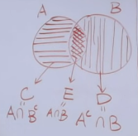

* Rewrite our objective as:
* Show that the P(C U D) = P(A) + P(B) – 2P(E)
* Review what the axioms are,
* 1) Non-negativity = Take any event A, then P(A) must be *at least 0*.
* 2) Normalization = probability of the entire space Ω must be equal to 1.
* 3) Additivity axiom (ADD) 🡪 if there are 2 events, A + B, *that are* ***disjoint*** (have nothing in common), their intersection = the empty set.
* Then the probability of their union **P(A U B) = P(A) + P(B)**
* 1st invoke the additivity axioms to argue the P(C U D) = P(C) + P(D)
* b/c set C + set D are completely disjoint from each other.
* In a similar way, also notice A = union of sets C + E, and C + E are disjoint w/ each other, b/c C + E, by definition, don't share any points.
* Therefore, P(A) = P(C) + P(E)
* In a similar way, P(B) = P(D) + P(E) b/c event B is the union of D + E and D + E are disjoint
* This should be enough to prove our final claim.

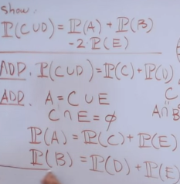

* We have the P(C U D) = **P(C) + P(D)**
* Insert 2 terms to make the connection with a 2nd part of the equation more obvious.
* Write P(C) + P(D) **= P(C) + P(E) + P(D) + P(E)**
* We added 2 terms, P(E), so to make the equality valid we'll subtract out 2P(E)
* We know P(A) = P(C) + P(E) and P(B) = P(D) + P(E), so we can sub them back in to get
* P(C U D) = P(A) + P(B) – 2P(E), the final equation.
* 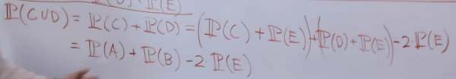

**Geniuses and chocolates**

* Out of the students in a class, 60% are geniuses, 70% love chocolate, + 40% fall into both. Determine the probability a randomly selected student is neither a genius nor a chocolate lover.
* P(G) = .6, P(C) =.7, P(G U C) = .4
* 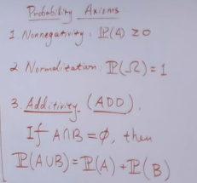
* So, these events are NOT disjoint (A intersect B is NOT the empty set 🡪 they DO intersect in a Venn Diagram), so cannot use the additivity axiom
* **Partitioning:** 2 conditions must be met:
* **Cut up Ω (the SS) such that each piece is disjoint**
* **When all pieces are put together, they must comprise the entire SS Ω**
* Partition this SS as X, Y, Z, W that do not overlap + comprise Ω

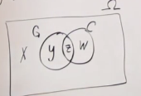

* Want to find P(X)
* Since events are disjoin:
* P(G) = P(Y U Z) = P(Y) + P(Z) = .6 P(C) = P(W U Z) = P(W) + P(Z)= .7 P(Z) = .4
* Therefore, P(Y) = .2 and P(W) = .3
* We know X, Y, Z, and W form a partition of Ω 🡪 P(Ω) = P(X) + P(Y) + P(Z) + P(W)
* 1 = P(X) + .2 + .3 + .4 🡪 1 = P(X) + .9 **🡺 P(X) = .1 = 10%**

**Uniform probabilities on a square**

* Romeo & Juliet have a date at a given time, + each will arrive at the meeting place w/ a delay between 0-1 hour, w/ all pairs of delays being equally likely 🡪 that is, according to a uniform probability law on the unit square. The 1st to arrive will wait for 15 minutes + will leave if the other has not arrived. What is the probability that they will meet?
* Make it simpler at 1st to get intuition for the problem 🡪 assume they can only arrive in 15 minute increments (15 min late, 30 min late, etc.:

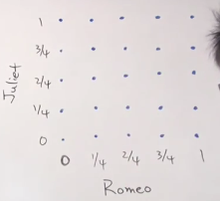

* **Discrete uniform probability law**: all outcomes in probabilistic experiment = equally likely
* Each in current SS = 1/25
* Have to find which outcomes result in R & J arriving w/in 15 min of each other
* 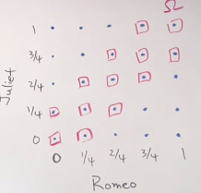
* Now must count how many outcomes (w/ P = 1/25) we have 🡪 13 outcomes * (1/25) = 13/25 probability in this *DISCRETE* case
* So, to solve original problems, must come up w/ a SS, a probability law, + ID the events of interest + calculating probability of those events
* Really, time is continuous, so R & J can arrive at any time + our Ω grid square
* Consider the probabilities are area b/c we’re in the continuous world now
* Our P(Ω) = 1, + area of the grid = 1 since our grid = Ω w/ *P(any event/shape in the grid) = area of the shape*
* ID of interest = R & J arrive w/in 15 min of each other
* Ex: any time Juliet arrives before 15 minutes if Romeo is on-time counts as this 🡪 this is seen as a vertical line segment at x = 0 from y = 0 to y = 15, and this can be drawn out to every possible combo

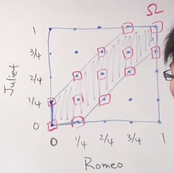

* Have to calculate this area to the P() 🡪 area of whole square = 1, remove 2 triangles outside the colored area 🡪 ½*(.75)*(.75) for 2 triangles = 0.28125*2 = .5625
* So **P() = 1 - .5625 = .4375** OR **P() = 1 – 9/16 = 7/16**
* Can extent his problem even further and find how long Romeo should wait for a 90% chance of meeting up

**Bonferroni's inequality**

* (a) Prove that for any two events A1 and A2, we have **P(A1∩A2) ≥ P(A1) + P(A2) − 1.**

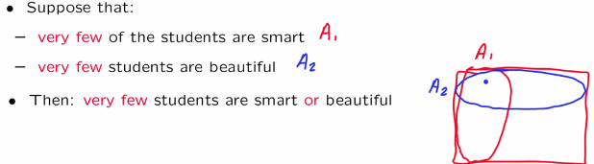

* i.e. if we pick a student at random, assume P(A1) = small and P(A2) = small
* The **union bound** tells us **P(A1 U A2) <= P(A1) + P(A2)**
* Now flip it around + both A1 and A2 are large sets, A1(c) + A2(c) are both small, so outside of these complement 2 sets, whichever is left is the union of A1 + A2

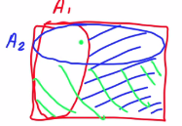

* This should be a big set, so most students should belong to both A1 + A2



* This is the **Bonferroni inequality** 🡪 Since P(A1) and P(A2) are both close to 1 (are large sets), on the RHS we have ~1 + ~1 – 1 = some # close to 1, so P(A1 intersect A2) is close to 1
* To prove this, we want to show the probability of a certain event is bigger than something.
* 1 way to do so 🡪 show that probability of the complement of this event has small probability
* can use **De Morgan's laws**

 

* Tells us the complement of an intersection = the union of the seperate complements.



* Since our 2 sets/events are identical, their probabilities are also equal, so their union is <= the sum of their separate probabilities

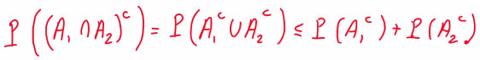

* Getting close, except we have complements but we want the opposite
* Since probability of a complement of an event = 1 - probability of that event, do the same thing for the terms we have here + cancel out two of the 1’s, we get our proven relation



* (b) Generalize to case of n events A1-An, by showing **P(A1 ∩ A2∩⋯ ∩An) ≥ P(A1) + … + P(An)−(n−1)**
* This inequality has a generalization to the case where we take the intersection of n events w/ the same intuitive content.
* Suppose each event A1 up to An is almost certain to occur = has a probability close to 1.
* So, P(A1) + ….. P(n) be close to n + we subtract n – 1, which ends up resulting in a # close to 1.



* Therefore the probability of the intersection <= something close to 1 🡺 this is big.
* Essentially, its saying if we have big sets + take their intersection, that intersection will also be big (in terms of having large probability)
* PROVE IT 🡪 Look at the complement of LHS event + use De Morgan's laws to write this complement as the union of the complements.



* Use the union bound to write the RHS as <= probability of all sets A1 – An



* Now sub in 1 - probability of the intersection of the NON-complement + cancel out the 1’s to prove the inequality



* So Bonferroni inequalities = a nice illustration of how one can combine De Morgan's laws, set-theoretical operations, + the union bound to obtain interesting relations between probabilities