***Udacity Data Analyst Track***

**I. Into to Descriptive Stats**

6. Normal Distribution

* **Probability Distribution Function (PDF) =** a normal curve w/ area = 1 beneath it, to represent the *cumulative frequency of values.*

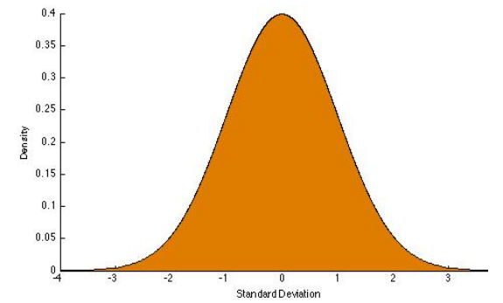

* Can use the PDF to *find the probability of specific measurements occurring*.
* 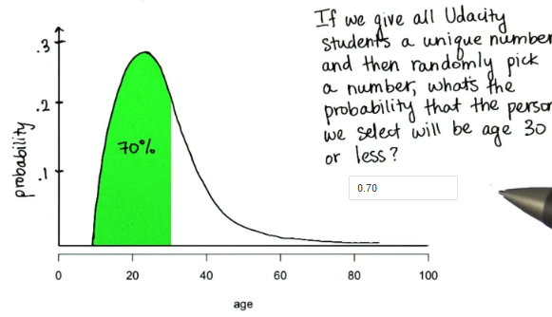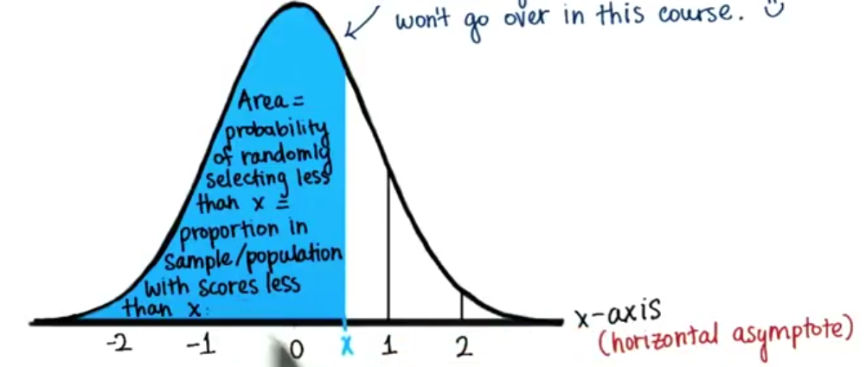
*  = **INTEGRAL**
* EX: Average height of students at a private university = 1.85 meters w/ SD = 0.15 meters. What % of students are shorter or as tall as Margie = 2.05 meters.
* To solve, 1st find z-score 🡪 2.05 – 1.85 / 0.15 = **1.33**
* Use **z-score table** to find proportion below z-score = 1.33.
* 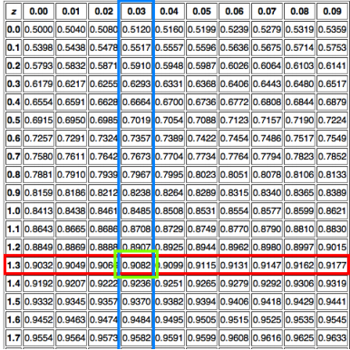
* Get 0.9082 = *Margie is taller than* ***90.82%*** *of her classmates*
* What % of students are taller than her? 🡪 Since area under the normal curve = 1, we can find that proportion 🡪 1 - 0.9082 = 0.0918 = **9.18%** of her classmates are taller than her
* Anne = 1.87 meters. What proportion of classmates are *between Anne and Margie’s heights?*
* Already know 90.82% = shorter that Margie.
* Find % of students shorter than Anne 🡪 1.87– 1.85 / 0.15 = **0.33** 🡪 use z-table 🡪 see z-score corresponds w/ a proportion of 0.5517 = 55.17% are shorter than Anne
* To get proportion in between 🡪 subtract the 2 proportions from each other. 🡪 90.82 - 55.17 = **35.65% of classmates are between Anne and Margie’s heights**

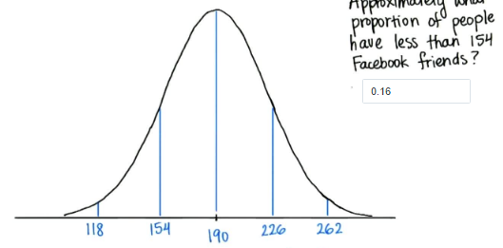

* 0.68 = w/in 1 SD 🡪 / by 2 🡪 0.34 = 1 SD above/below mean 🡪 middle = 0.5 🡪 middle + -1 SD = 0.5 – 0.34 = **0.16**

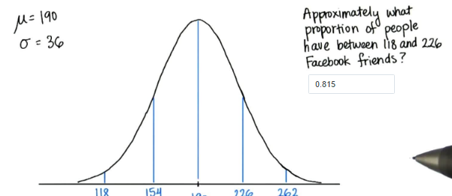

* 0.84 (1 SD above mean) – 0.025 (below 118) = **0.815**

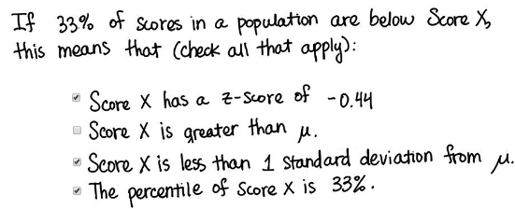

* 2007-2008 🡪 average height of a professional basketball player = 2.00 meters w/ SD = 0.2 meters. Harrison Barnes = 2.03 meters. What % of players are taller than Barnes?
* 2.03 – 2 / 0.2 = **0.15** 🡪 0.5596 = 55.96% are shorter 🡪 44.04% are taller
* Chris Paul = 1.83 meters. What proportion of players are between Paul and Barne’s heights?
* 1.83 – 2 / 0.02 = **-0.85** 🡪 0.1997 = are shorter 🡪 80.03% are taller
* 55.96% - 19.97% = **35.99% are between**
* 92% of candidates scored as good or worse on a test than Steve. If the average score = 55 w/ SD = 6 points, what was Steve’s score?
* Z-table of 0.9200 🡪 closest = 1.41 🡪 1.41 = (x – 55) / 6 🡪 1.41*6 + 55 = x = **63.46**