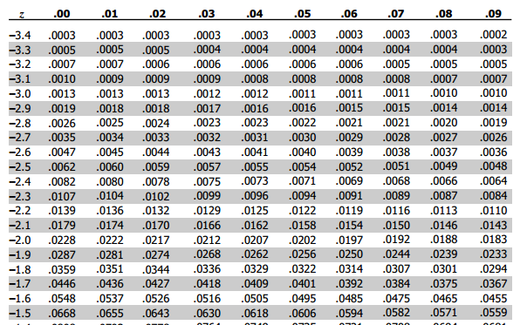

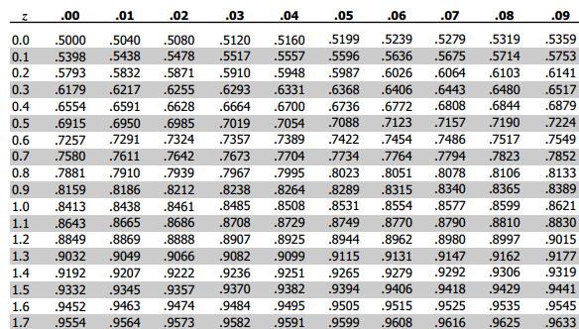



|  |  |
| --- | --- |
| **Mean** | 19.59 |
| **Median** | 20.00 |
| **Mode** | 21.00 |
| **Variance** | 24.82 |
| **St. Dev.** | 4.98 |