***Udacity Data Analyst Track***

**I. Into to Descriptive Stats**

1. Into and Descriptive Stats Review

* John Tucket 🡪 an approximate answer to the right problem is worth much more than the exact right answer to the approximate problem
* 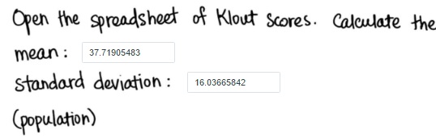
* Sample size of 35 🡪 mean of this distribution = same as population (37.91) 🡪 SD = 16.0366 / sqrt(35) = 2.71 (skinny)
* Increase sample size 🡪 decrease sample SD