* Basic definition of **stats** = *science of learning from data* (Matie Davidian)
* **Wrangle** + visualize data
* 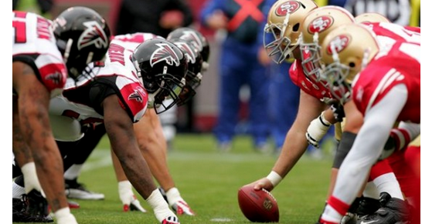 🡺 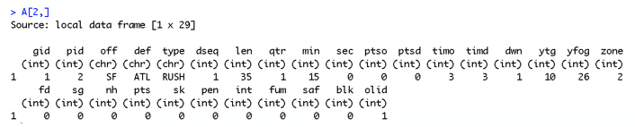
* 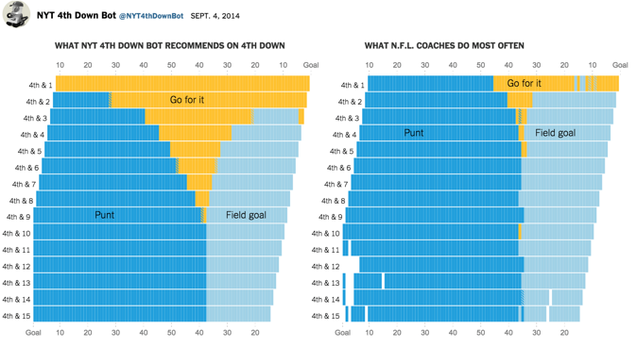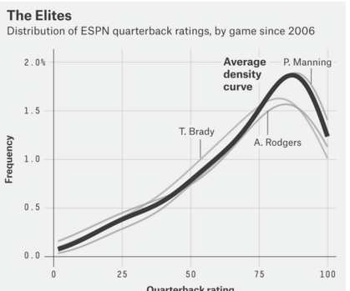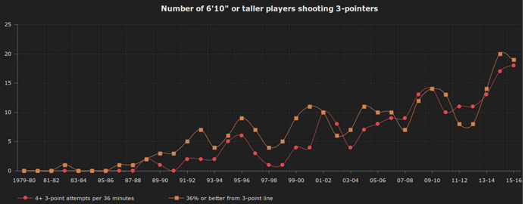
* **Statistical tools (**t-tests, regression, ANOVA, etc.)
* 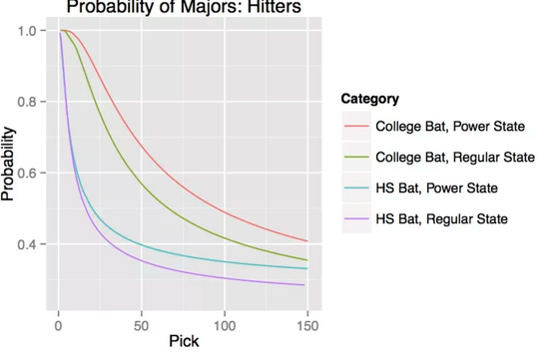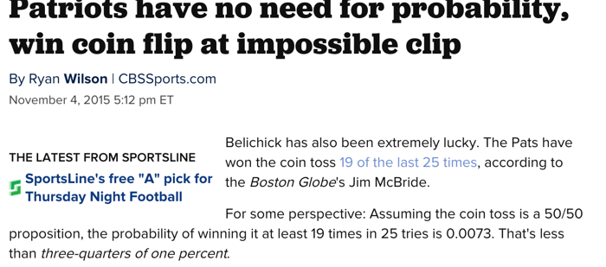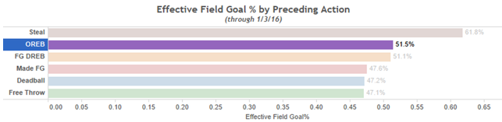
* Measuring **uncertainty** (practical vs. statistical significance)
* 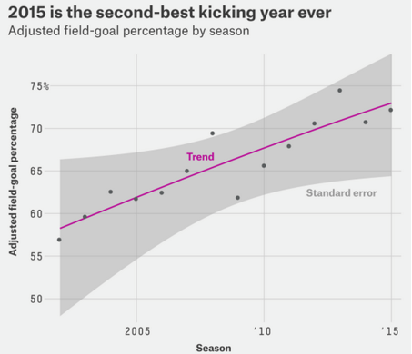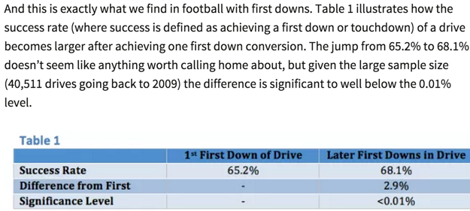
* **Communicate** results (appropriate generalizability)
* Rough History of Stats in Sports
* “James”-ian era (1970’s – 2004ish) 🡺 “Hey, you can apply statistics to sports!”
* *Bill James Baseball Abstract*, 1977
* “Stein’s Paradox in Statistics” – 1977, Efron and Morris
* “On the optimal time to pull the goalie” – 1976, Morrisonn
* “Operations research in football” – Carter & Machol, 1971
* Modern era (2004ish – current)
* “Get more data, do cool stuff” 🡺 “Get even more data, do some *really* cool stuff, get hired” 🡺 Nomenclature change to a more sexier “sports analytics”
* “NHL Analytics Awakening”
* “How Numbers Have Changed the NBA”
* 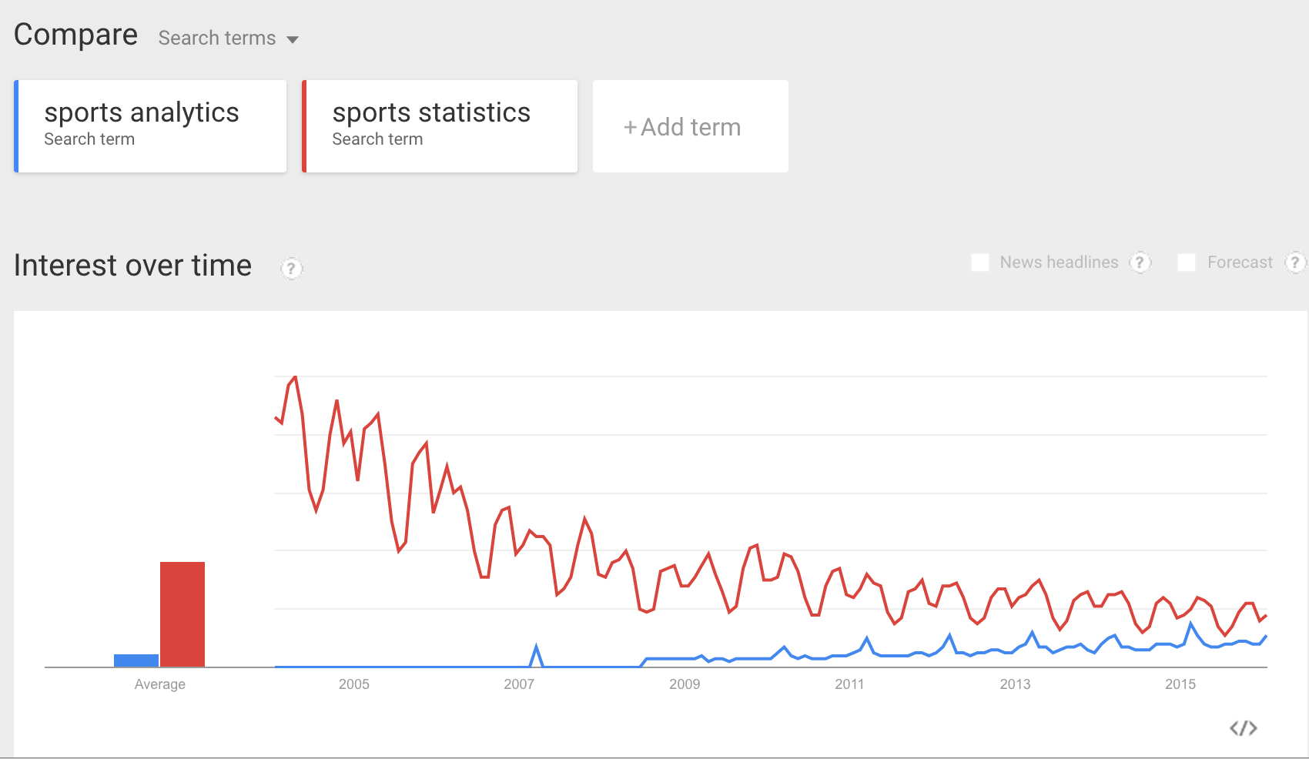
* Future (Current - ????) 🡺 “Holy shit, we have too much data”
* 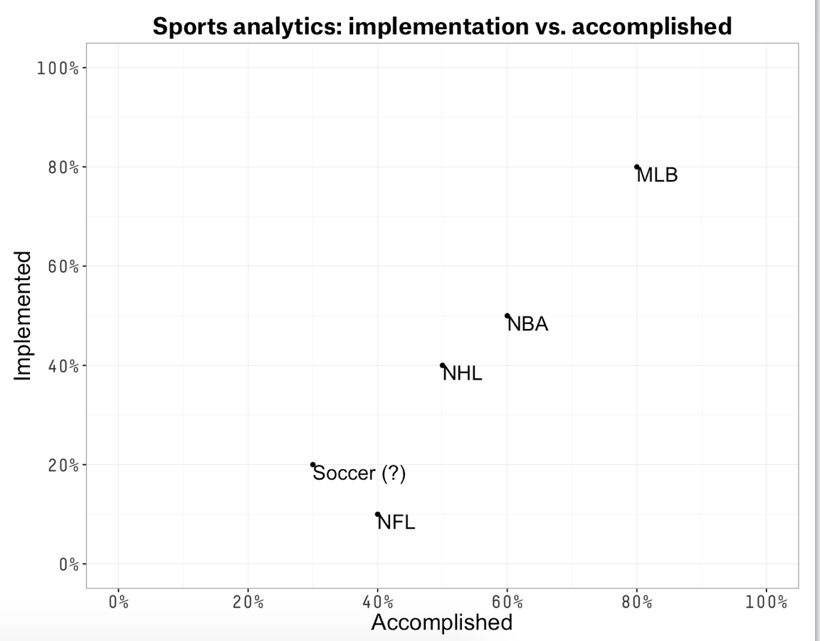
* “The NFL is Finally Tapping Into the Power of Data”
* 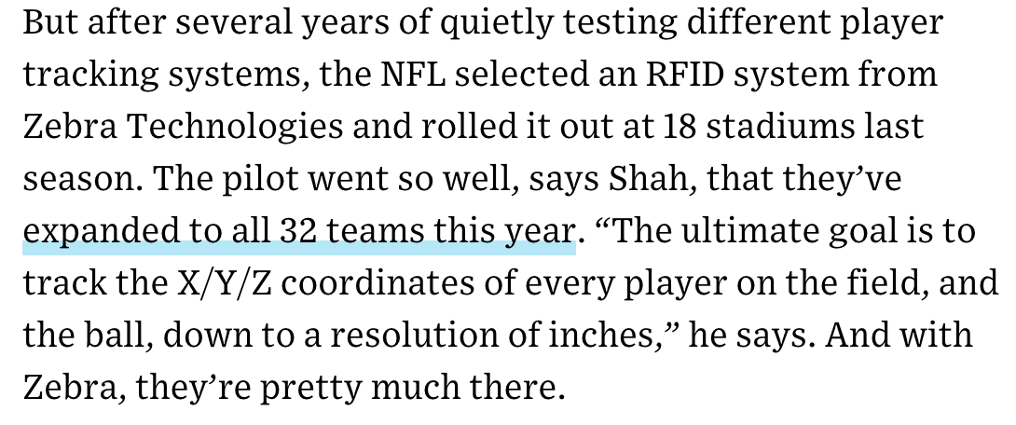
* “The Transformative Power of Big Data Analytics in Sports”
* 