Kickers Are Forever

* <https://fivethirtyeight.com/features/kickers-are-forever/>
* Football = constant power struggles, both on + off field: players v. players, offenses v. defenses, passing v. running, coaches v. coaches, new ways of thinking v. old ways
* Kickers = battling no one but [themselves](http://skepticalsports.com/?p=791) (<https://skepticalsports.com/yes-espn-professional-kickers-are-big-fat-chokers/>) + goalposts
* Come on field in moments most mundane + most decisive = take blame when fail + little credit when succeed.
* Year in + year out, just a little bit at a time: get better, + better, + better, until game = completely different, + no one even noticed kickers were 1 of the main reasons why.
* FG from long range made at ever-increasing rate, culminating in 2013 🡺 > 67% from 50+ yards w/ a record 96 such makes.
* Lot of speculation (<https://nypost.com/2013/12/21/improved-placekicking-changing-game/>) about how kickers suddenly became so good @ long kicks, ranging from PEDs (<https://www.washingtonpost.com/sports/redskins/field-goals-is-it-time-to-punt/2012/10/21/ec03fea2-1804-11e2-9855-71f2b202721b_story.html>) to kickers’ special “k-balls” (<http://www.businessinsider.com/why-nfl-kickers-always-squeeze-the-ball-2012-10>) to more kick-friendly stadiums.
* Prior to 2014 season, set out to try to see how recently this improvement had taken place, whether it had been gradual or sudden, + whether specific to very long kicks or reflected improvement in kicking accuracy as a whole.
* What found fundamentally changed understanding of game of football (+ **possibly offered insight into how competitive sports can conceal remarkable changes in human capability**)
* The complete(ish) history of NFL kicking
* Pro Football Reference = kicking data broken down by categories (0-19 yards, 20-29, 30-39, 40-59, 50+ yards) back to 1961.
* W/ this, can see how FG% has changed through years for each range:

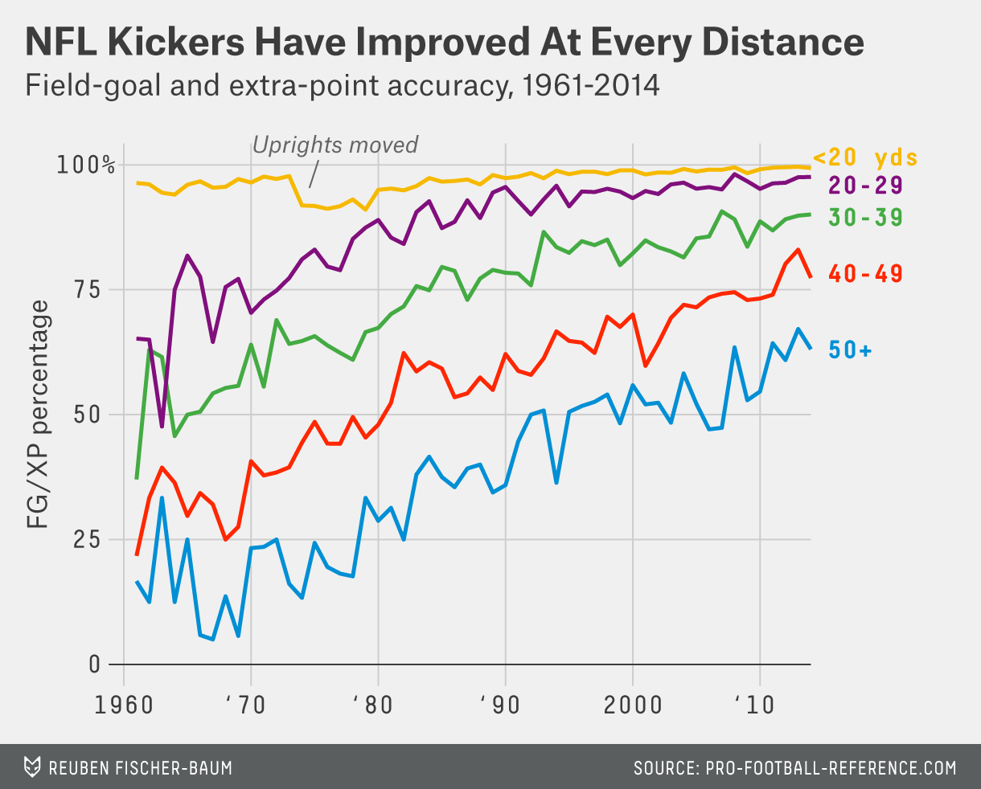

* Distance doesn’t matter; kicking = on a steady upward climb.
* Look back even further 🡺 can see indicators kicking has been on a similar trajectory for entire history of the league.
* Oldest data = 1932 = 8 teams in NFL made just 6 FG (unknown how many attempted) + missed 37/113 XPA, for a conversion rate of 67.3%
* Following year = moved goal posts up to front of EZ 🡪 led to a whopping 36 made FG + skyrocketing XP conversion rate of 79.%.
* W/ uprights @ front of end zone, kickers missed only 30/145 XP
* For comparison, those 30 missed XPA (all w/ goalposts in front of EZ) = more than league’s 28 missed XPA (all coming from 10 yards further out) from 2011-2014, on 4,939 attempts.
* 1938-39 = 1st year we know # of regular FGA 🡪 93/235 FG (39.6%) to go w/ 347/422 XP (82.2%).
* ‘40’s 🡪 made 40.0% of FG (don’t know distances) + 91.3% of XPs
* ’50s 🡪 rose to 48.2% of all FG + 94.8% of XPs
* ’60s 🡪 must’ve seemed like golden era: 56% of FG (breaking 50% barrier for 1st time) + 96.8% of XP
* For comparison, since 2010, NFL kickers have made 61.9% of FGA, *from more than 50 yards.*
* 60s 🡺 start to get data on FGA broken down by distance, allowing for more complete pic above
* 1972 = narrowed hash marks from 18.5 yards from 40 = improved FG% overall by reducing # of attempts taken from awkward angles
* 1974 = moved goal posts to back of EZ = as kick distances are recorded relative to the posts, **main effect** of this move = small (+ temporary) decline in XP conversion rate (in top line of chart above)
* Then we have data on the kicks’ *exact* distance, + field + stadium type, after 1993
* Combine everything: XPA + distances prior to 1961, kicks by category from 1961-1993, kicks’ exact distance after 1993, + changing placement of goal posts + hash marks.
* **Using this data, can model the likely success of any kick.**
* W/ those factors held constant, here’s how good kickers have been relative to set of kicks in any given year using a **binomial probit regression** with ALL variables, using “year taken” as a categorical variable, similar to how [SRS](http://www.pro-football-reference.com/blog/?p=37) determines how strong each team is relative to its competition (<https://web.archive.org/web/20080127075333/http://www.pro-football-reference.com/blog/?p=37>)

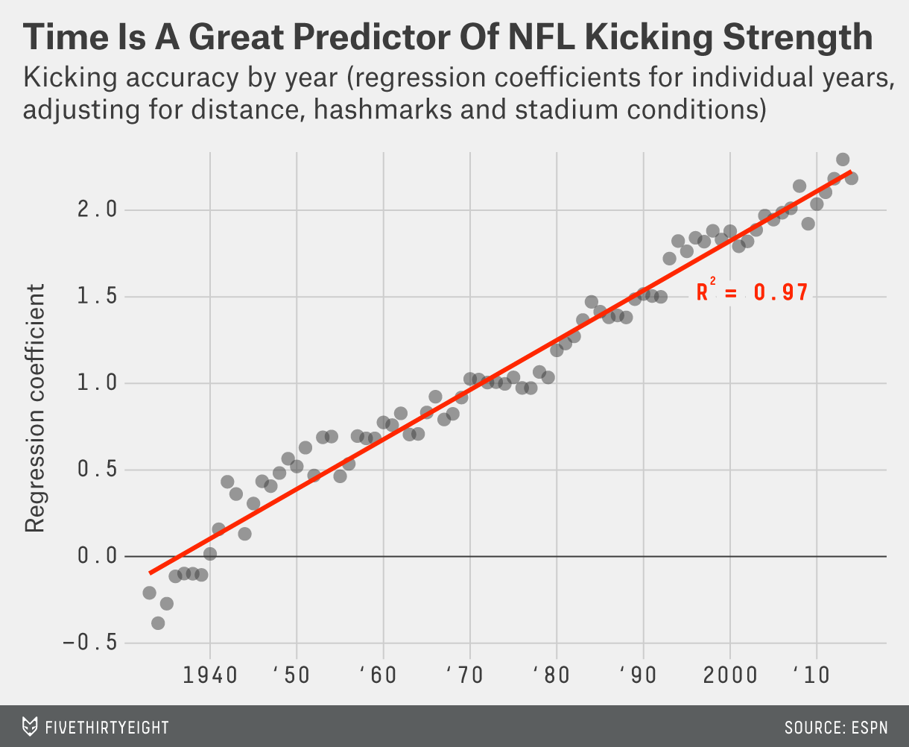

* Like Hacker Gods got lazy + just set a constant Kicker Improvement parameter throughout the universe
* ***Great thing about this = since improvement in kicking has been almost perfectly linear, can treat “year” as just another continuous variable, **allowing us to generalize the model to any kick in any situation at any point in NFL history\*\*\***
* Applying this year-based model to kicking-distance data, can see just how predictable improvement in kicking has actually been:

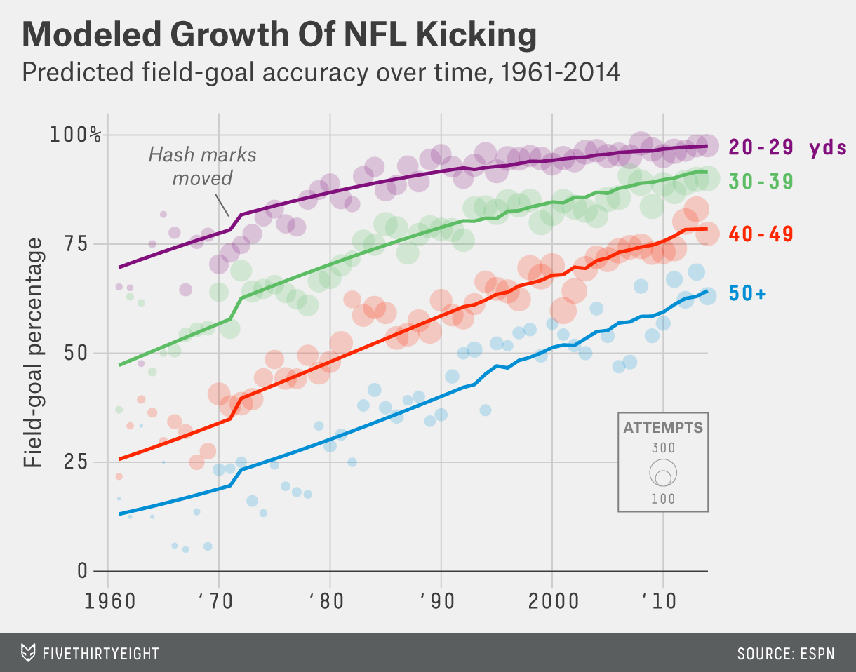

* Model may give teams too much credit in early ’60s (an era for which we have a lot less data) but over course of NFL history, it does extremely well (also predicts back to 1932, but not shown)
* What’s amazing 🡺 While model incorporates things like hashmark location + (more recently) field type, **virtually all work is handled by distance + year alone**.
* Ultimately, it’s an extremely (virtually impossibly) accurate model considering how few variables it relies on
* How accurate is this thing? TBH, in all my years of building models, never seen anything like it
* Model misses a typical year/distance group prediction by average of just 2.5%.
* **Majority of those predictions involve only a couple hundred observations — at most**
* **For comparison, SD for 250 observations of a 75% event = 2.7% 🡺 i.e. model pretty much couldn’t have done any better even if it knew the exact probability of each kick**
* While there is possibly a smidge of overfitting (**usually is**), the risk here = lower than usual, since vast majority of each prediction is driven **solely** by year + distance.
* Regression output: 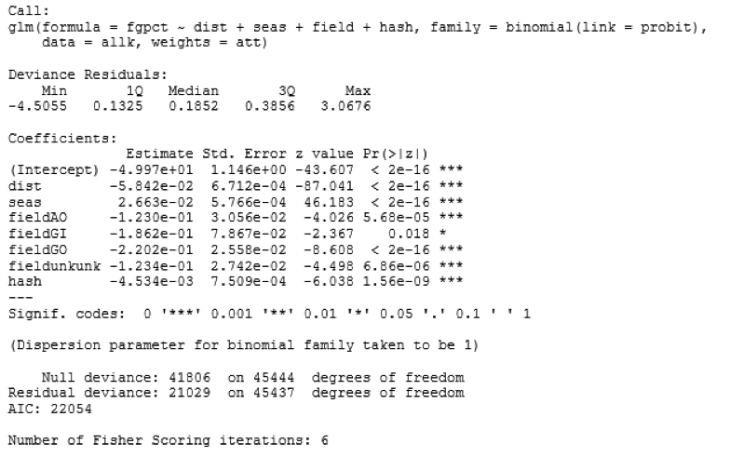
* This isn’t just trivia = has real-world implications, from tactical (how to manage clock knowing opponent needs only moderate yardage to get into FG range?) to organizational (maybe good kicker = worth more than league minimum).
* Then there’s the big one = **Fourth down**
* “Dead zone” between roughly the 25-40-yard lines = punts accomplish little + FG = supposedly too long to be good gambles.
* W/ ’90s-quality kickers, settling for FG in the dead zone = practically criminal.
* As of 10 years ago (around when **go-for-it models** rose to prominence), we were still right.
* **But much has changed in 10 years** such that FG Kicking = now good enough that many previous calculations = outdated.
* Comparison between a FG kicking curve from 2004 vs. 2014:

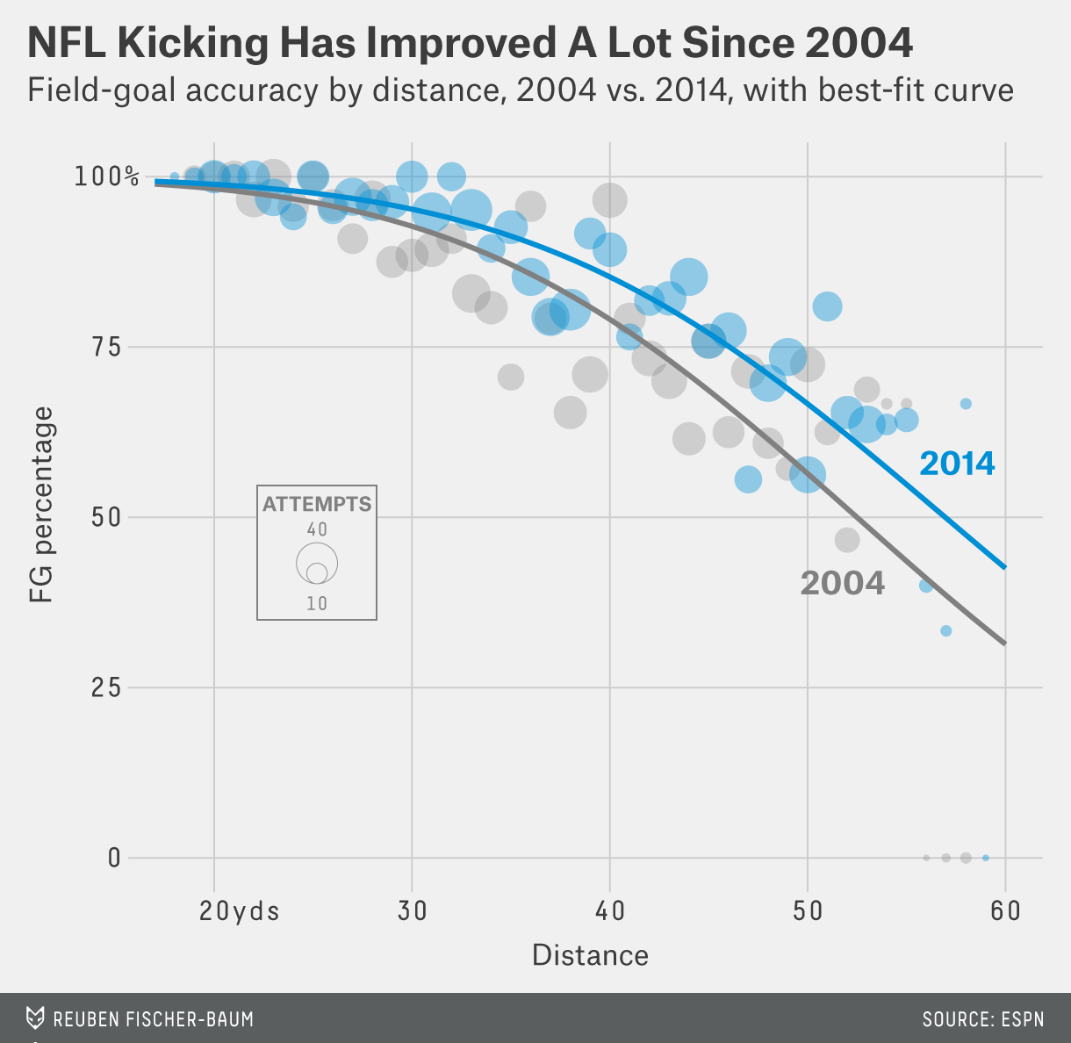

* No 1 universally-agreed-upon system for when you should go for it on 4th down.
* Very popular = NYT’s **4th Down Bot** (<https://twitter.com/NYT4thDownBot>), powered by models built by Brian Burke, founder of Advanced Football Analytics + pioneer in quantitative analysis of football
* Calculates **expected value** (either in points or win %’s) for every 4th-down play in NFL + tweets live results during games.
* 19k+ followers = treated to bot’s particular emphasis on the many, many times coaches fail to go for it on 4th down when they should.
* Very helpful feature of 4th Down Bot = its game logs break down each 4th-down decision into its component parts (<http://nyt4thdownbot.com/game.html?gameid=09072014_MIN@STL>)
* Means we can see **exactly what assumptions bot is making about success rate of each kick**.
* Comparing those to above model, looks like bot’s kickers = approximately 2004-quality. (Burke agrees bot is probably at least a few years behind + says its kicking assumptions = based on a fitted model of the most recent 8 years of kicking data)
* Full statement: “Bot = ~3-4 years behind trends in FG accuracy, which have been improving at longer distances. It uses a kicking model fitted to the average of the recent 8-year period of data. AFA’s more advanced model for team clients is on the current ‘frontier’ of kick probabilities, + can be tuned for specific variables like kicker range, conditions, etc. Please keep in mind bot is intended to be a good first-cut on analysis + a demonstration of what is possible w/ real-time analytics**. It’s not intended as the final analysis.**”
* don’t blame Burke or others for not updating models based on last few years b/c it’s good to be prudent + not assume temporary shifts 1 way or the other will hold.
* Normally = *is* better to go w/ weight of history rather than w/ recent trends.
* **But in this case, recent trends = backed by the weight of history**
* More importantly, these breakdowns allow us to essentially recalculate bot’s recommendations **given a different set of assumptions.**
* The improvement in kicking dramatically changes calculus of whether to go for it on 4th in the dead zone
* Following table compares “Go or No” charts from 4th Down Bot as it stands right now, vs, w/ projected 2015 kickers[8](https://fivethirtyeight.com/features/kickers-are-forever/#fn-8)
* 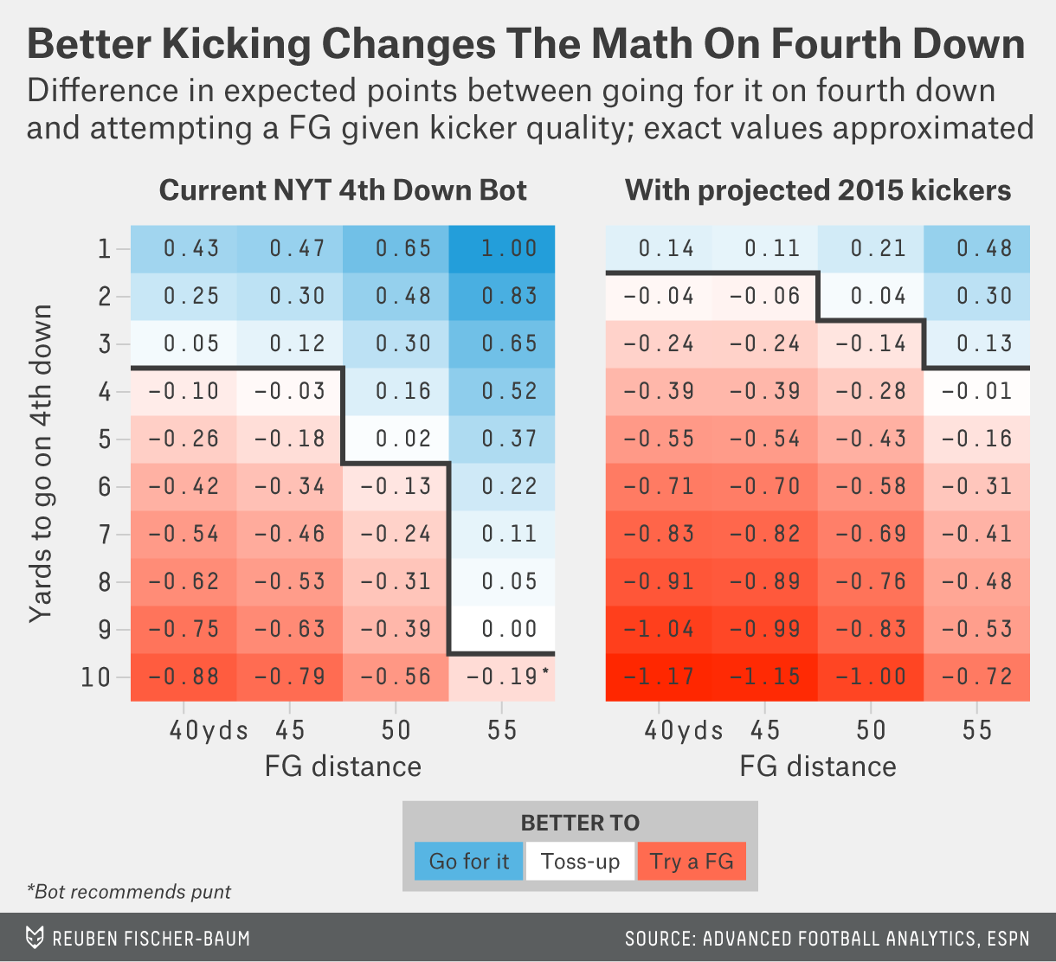
* exact values in chart may differ slightly from reports on NYT’s site b/c we had to reverse-engineer bot’s decision-making process.
* Basically = assuming this model gets everything exactly right, as far as expected value, from various field locations, chances of converting a 4th-down attempt, etc., then recalculating final expected value comparison using 2015 kickers
* Having better kickers = big difference, seen from the blue sea on left vs. red sea on the right.
* Complete “Go or No” table  = <https://www.nytimes.com/2014/09/05/upshot/4th-down-when-to-go-for-it-and-why.html?abt=0002&abg=1>
* Getting 4th-down calls wrong = potentially big problem for the model.
* As a test case, tried applying 4th Down Bot’s model to a selection of most relevant kicks from between 25-55 yards in 2013, then looked at what coaches actually did in those scenarios.
* Graded both against kicking-adjusted results for 2013.
* While updated version still concluded coaches = too conservative (particularly on 4th + short), it found coaches were (very slightly) making more correct decisions than 4th Down Bot.
* Differences = small (coaches beat bot by only a few points over entire season), but even being just as successful as the bot would be a drastic result considering how absolutely terrible coaches’ go-for-it strategy has been for decades.
* **In other words, maybe it’s not that NFL coaches were wrong, they were just ahead of their time!**
* Time-traveling kickers
* Having such an accurate model also allows us to see the overall impact kicking improvement has had on football
* Ex: Can calculate how kickers from different eras would’ve performed on a common set of attempts.
* See how many more/fewer PPG typical team would’ve scored if kickers from a different era had taken its kicks (red line = actual PPG from FG that year):

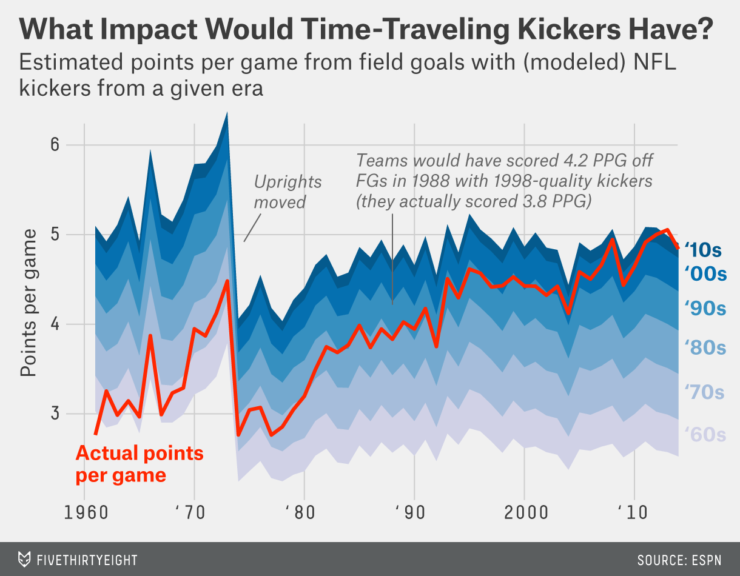

* The last time kickers were as big a part of the game as they are today 🡺 *league moves posts back*
* Since the rule change, amount of scoring from FG has increased by > 2 PPG.
* Small part of the overall increase (overall movement of the red line) = result of *taking* more FG, but most comes from improvement in accuracy alone (width of the “ribbon”).
* **How does this compare to broader scoring trends?**
* As a baseline for comparison: take average points scored in every NFL game since 1961 + see how much league scoring deviated from that at any given point in time (“**scoring anomaly**”).
* Then look @ how much of that anomaly was a result of kicking accuracy.[9](https://fivethirtyeight.com/features/kickers-are-forever/#fn-9):
* 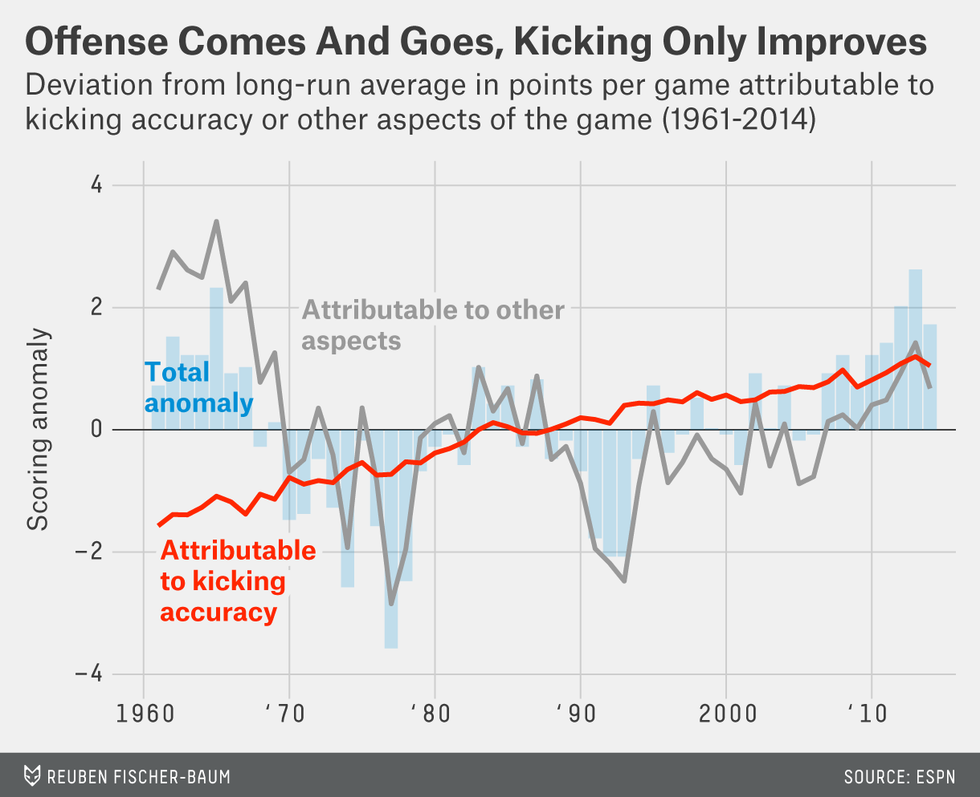
* Amid wild fluctuations in scoring, kicking has remained a steady, driving force.
* For all the talk of [West Coast offenses](http://en.wikipedia.org/wiki/West_Coast_offense), the invention of the pro formation, the [wildcat](http://www.nfl.com/videos/nfl-network-playbook/09000d5d80b1831e/WK-3-Anatomy-Wildcat-formation), [5-wide sets](http://en.wikipedia.org/wiki/Spread_offense), the rise of [the pass-catching tight-end](http://en.wikipedia.org/wiki/Rob_Gronkowski), [Bill Walsh](https://www.google.com/search?q=bill+walsh+coaching+tree&rlz=1C1CHFX_enUS603US604&espv=2&biw=585&bih=572&tbm=isch&tbo=u&source=univ&sa=X&ei=Sx3IVNrdA8GMyASc2oDICw&ved=0CB0QsAQ), the [Greatest Show On Turf](https://fivethirtyeight.com/features/revisiting-the-greatest-show-on-turf/), and the general recognition that passing, passing and more passing is the best way to score in football, half the improvement in scoring in the past 50-plus years of NFL history has come solely from field-goal kickers kicking more accurately.[10](https://fivethirtyeight.com/features/kickers-are-forever/#fn-10)
* The past half-century has seen an era of defensive innovation — running roughly from the mid-’60s to the mid-’70s — a chaotic scoring epoch with wild swings until the early ’90s, and then an era of offensive improvement. But the era of kickers is forever.
* Reuben Fischer-Baum contributed graphics.
* **CORRECTION (Jan. 28, 2:22 p.m.):**An earlier version of this article incorrectly gave the distances from which extra-point kicks were taken in 1933 and in recent years. Actual extra-point distances aren’t recorded.