Name: Stephen Lord
Date: March 4, 2026
Course: IT FDN 130 GP
GitHub URL: https://github.com/stephenlord10/DBFoundations

Views, Functions and Stored Procedures
Introduction
In week six of IT Foundations of Database Management, we explored Views, Functions, and Stored Procedures. These are super helpful when security/access is a concern, as well as when it’s necessary to simplify complex queries. Additionally, we got introduced to GitHub to share our files for submission with peers for a peer-review.

SQL View
A SQL View is a great way to display data from tables within a database. Often providing an extra layer of integrity in a database, a SQL View is created, applied, and given to users to access the specific view(s) of the table. Views are often used in conjunction with the intent to hide sensitive information, or to simplify complex queries.
In Figure 1:1, a Categories table resides. In Categories there are two columns: CategoryID and CategoryName. There might be a scenario where we only ever want users to see the CategoryName when viewing/querying. In the scenario, we create a View (vCategories) and only select CategoryName from the dbo.Categories. This yields an available View (vCategories) that can be selected, that only has the CategoryName; Figure 1:2.
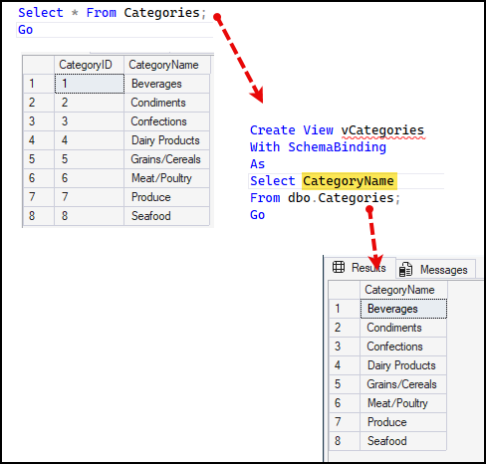
Figure 1:1 – SQL View
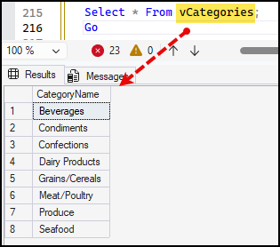
Figure 1:2 – SQL View: User Select

SQL Function and Stored Procedure
In SQL, there are Views, Functions, and Stored Procedures that all work to define, extract, and calculate data in a database.
A View, as demonstrated earlier, is a snapshot of what is specifically defined/allowed/accessible for users with access to the database. Think of a View as a picture, you can see everything that’s within the frame of the picture, yet you can’t touch, smell, or taste what you see in the picture at that very moment. A View allows for access to data, yet a user can’t manipulate the underlying data. In some cases, the user can’t even see data that is sensitive in nature. Views make it easier to simplify access and control what the end users can see.
A Function does the leg work of a query and returns a value/table. When querying, we create functions to return results from a defined table. We might see this in the form of an aggregate function such as the COUNT() of something. Where we want to know the count of a specific item, in a specific table.
A Stored Procedure performs various SQL commands. It might return data, run other queries, or allow a user to modify data in the tables. In short, they are reusable SQL statements that can be ran inside the database.

Summary
Week six of IT Foundations of Database Management continued expanding on the foundations of building a structurally sound and database and table(s) with integrity. We explored practical uses of View(s), Function(s), and Stored Procedure(s) when needed. I feel that the more work that goes into Views, the easier it might be to turn complex work into more simplified script writing.

