**The genome sequence of the Australian filarial nematode, *Cercopithifilaria johnstoni***

Authors: Kirsty McCann1&, Warwick Grant1+*, Stephen R. Doyle2+*

1. Department of Physiology, Anatomy & Microbiology, La Trobe University, Bundoora, Australia
2. Parasites & Microbes Programme, Wellcome Sanger Institute, Hinxton, Cambridgeshire, CB10 1SA, United Kingdom

* Correspondence: [w.grant@latrobe.edu.au](mailto:w.grant@latrobe.edu.au) or [stephen.doyle@sanger.ac.uk](mailto:stephen.doyle@sanger.ac.uk)

+ These authors contributed equally to this work

& Current address: School of Medicine, Deakin University, Warun Ponds, Geelong, Australia

# Abstract

We present a genome assembly and annotation of an individual female *Cercopithifilaria johnstoni*, a parasitic filarial nematode that is transmitted by hard ticks (Ixodidae) to infect a broad range of native Australian murid and marsupial hosts. The genome sequence is 76.9 Mbp in length, and although in draft form (N50 = 99 kbp, N50[n] = 232), is largely complete based on universally conserved orthologs (BUSCOs; genome = 94.9%, protein = 96.5%) and relative to other related filarial species. These data represent the first genomic resources for the genus *Cercopithifilaria*, a group of parasites with a broad host range, and form the basis for comparative analysis with the human-infective parasite, *Onchocerca volvulus*, both of which are responsible for similar eye and skin pathologies in their respective hosts.

# Keywords

*Cercopithifilaria johnstoni,* filarial nematode, genome assembly, Illumina MiSeq

# Species taxonomy

Eukaryota; Opisthokonta; Metazoa; Eumetazoa; Bilateria; Protostomia; Ecdysozoa; Nematoda; Chromadorea; Rhabditida; Spirurina; Spiruromorpha; Filarioidea; Onchocercidae, Cercopithifilaria, *Cercopithifilaria johnstoni* (taxon ID: 2874296)

# Background

*Cercopithifilaria johnstoni* [(Mackerras, 1954)](https://paperpile.com/c/3RGDWV/xFva) is a parasitic filarial nematode transmitted by ixodid ticks to infect a diverse range of native Australian mammalian hosts [(Spratt and Haycock, 1988)](https://paperpile.com/c/3RGDWV/4LIX), including monotremes, marsupials, and native rodents. The ability to infect such a broad host range is unusual for a filarial parasite; however, it is yet to be determined if this reflects permissive infectivity and persistence in diverse hosts or cryptic species diversity among morphologically indistinguishable parasites. Over 30 years ago, investigation of *C. johnstoni* infection of native hosts and experimentally-infected laboratory rats (*Rattus norvegicus*) revealed that *C. johnstoni* could cause skin and ocular immunopathologies that appear to be analogous to those seen in humans infected with *Onchocerca volvulus* [(Spratt and Haycock, 1988; Vuong et al., 1993)](https://paperpile.com/c/3RGDWV/4LIX+tNNm)*,* the causative agent of the neglected tropical disease onchocerciasis. This research prompted the hypothesis that *C. johnstoni* infection of *R. norvegicus* could provide an immunologically relevant and experimentally tractable laboratory model of onchocerciasis. Motivated by this hypothesis and progress in the development of *C. johnstoni* as a laboratory model, we have generated a draft genome assembly and annotation to understand the basic biology of the parasite. These genomic data will facilitate the investigation of hypotheses relating to host specificity, provide a resource for comparative analysis between related filarial species, and in particular, be used to characterise the genetic determinants of disease pathology and their relevance to human onchocerciasis.

# 

# Genome sequence report

The genome was sequenced from DNA extracted from a single female parasite collected via post-mortem dissection of an Australian bush rat, *R. fuscipes*. A total of 24,374,948 300 bp paired-end reads representing ~190-fold coverage of the genome were obtained by Illumina MiSeq sequencing. Trimmed reads (n = 22,065,411) were assembled, which, after contamination and haplotype removal, resulted in an assembly with a total length of 76.9 Mbp in 2,091 scaffold sequences with a scaffold N50 of 99,003 bp and N50(n) of 232 (Table 1). Compared to other filarial nematodes with assembled genomes, the *C. johnstoni* assembly ranked 6th of 18 based on both genome contiguity (N50) and completeness (Genome BUSCOs); we note that three assemblies with better genome contiguity and completeness statistics - *O. volvulus* [(Cotton et al., 2016)](https://paperpile.com/c/3RGDWV/oTJS), *Brugia malayi* [(Foster et al., 2020)](https://paperpile.com/c/3RGDWV/M4gU), and *Loa loa* (prjna246086)[(Tallon et al., 2014)](https://paperpile.com/c/3RGDWV/iJCs) - were all assembled using high-throughput sequencing together with one or more long molecule technologies, i.e., long-read PacBio sequencing and optical mapping, to improve contiguity whereas a further two assemblies - *L. loa* (prjna37757)[(Desjardins et al., 2013)](https://paperpile.com/c/3RGDWV/vBI9) and *O. flexuosa* (prjna230512) - have incorporated long-range mate-pair sequencing libraries for scaffolding. Annotation of the *C. johnstoni* genome identified 10,565 genes and 11,690 transcripts, broadly consistent with the number of reported annotation features for other filarial nematodes (Table 1; range = 8,140-16,203 for both gene and transcript features). Similar to the genome statistics described above, the annotation of the predicted proteome is also highly resolved, with 96.5% complete BUSCOs identified (Table 1).

The immunopathology of *O. volvulus* infection is hypothesised to be driven by the recognition of immunoreactive proteins of Wolbachia [(Saint André et al., 2002)](https://paperpile.com/c/3RGDWV/v38f), a species of intracellular bacteria found in several filarial nematodes where it is thought to play a symbiotic role in host metabolism and/or reproduction [(Taylor et al., 2005)](https://paperpile.com/c/3RGDWV/xBcG). The similar pathologies caused by *C. johnstoni* infection of rats and *O. volvulus* infection of humans prompted us to examine the presence of Wolbachia in our *C. johnstoni* assembly. Analysis of raw sequencing reads revealed only 0.38% of reads classified as bacterial, with less than 0.02% attributed to Rickettsiales (a group of obligate intracellular bacteria to which Wolbachia belong). Alignment of *C. johnstoni* protein-coding sequences to a diverse collection of Wolbachia reference genomes [(Lefoulon et al., 2020)](https://paperpile.com/c/3RGDWV/VSh8) revealed 18 candidates; only two proteins, CJOH_00023800.t1 (blast match to YadA-like family protein) and CJOH_00083160.t1 (blast match to a prophage tail fibre N-terminal domain-containing protein / collagen-like protein) were over-represented by bacterial (but not Wolbachia specifically) relative to nematode blast hits, whereas the remaining candidates were enriched in proteins that localise to mitochondria and were present in both filaria and non-filarial nematodes. Finally, quantification of nucleotide similarity between Wolbachia and the *C. johnstoni* genome revealed that, on average, only 1.38% of the Wolbachia genome (at 65.05% nucleotide identify) was represented in sequence matches to the *C. johnstoni* scaffolds and contigs. Collectively, we conclude that Wolbachia is absent from *C. johnstoni*, and that a Wolbachia-independent mechanism drives immunopathology in *C. johnstoni* infections.

# Methods

## Sample collection

Bush rats (*R. fuscipes*; Fig. 1a) were collected from Mogo State Forest (GPS coordinates: -35.7689484, 150.1027441; New South Wales, Australia, Fig. 1b) using baited Elliot traps set under logs and in covered areas (permits: AEC 13-23, NSW – Scientific Licence 5L 101280, VIC – Scientific Permit 10007169). Collected rats were housed with food, water, and shelter before being screened for the presence of dermal microfilariae by taking a small ear biopsy that was subsequently placed in 0.9% physiological saline to observe microfilariae migration out of the tissue. Adult worms were collected by post-mortem dissection of a captive adult rat.

## 

## DNA extraction, library preparation, and sequencing

A single adult female worm (approximately 7 cm in length) was cut into approximately 1 cm length pieces using a sterile scalpel blade before being placed in a lysis solution (lysis buffer and proteinase K solution) for 18 h. Genomic DNA from the worm lysate was extracted using an ISOLATE II Genomic DNA Kit (Bioline, Australia) following the manufacturer’s instructions, except for the following modification: the sample was eluted from the extraction column in 50 µl of extraction buffer, which was passed back through the extraction column a second time to collect additional DNA remaining on the column before further analysis.

Genomic DNA (500 ng in 50 µl) was sheared before sequencing library preparation using a Covaris S220 Focused-ultrasonicator with the following settings optimised for generating fragments approximately 400-600 bp: Peak incidence power = 175 W; Duty factor = 5%; cycles per burst = 200; treatment time = 55 s. A DNA sequencing library was prepared from 500 ng DNA using a NEBNext Ultra Library Prep Kit for Illumina, following the manufacturer’s instructions. The resulting library was run on a 2% agarose gel, from which a gel cut was made to extract the 500-700 bp fragment fraction, which was subsequently purified using a Promega Gel and PCR clean-up kit (Promega, Australia).

The sequencing library was diluted to 15 pM and spiked with 1% PhiX control DNA (Illumina) before being sequenced on an Illumina MiSeq using Illumina V3 2x301 bp PE sequencing chemistry. In total, 24,374,948 reads (91.16% of total) passed filters and were used for further analysis.

### 

## Genome assembly

Before assembly, raw sequencing reads were first visualised for quality and inherent bias using FastQC (<http://www.bioinformatics.babraham.ac.uk/projects/fastqc/>). Reads were adapter and quality trimmed using Trimmomatic version 0.32 [(Bolger et al., 2014)](https://paperpile.com/c/3RGDWV/P6pE) (CROP:150 SLIDINGWINDOW:10:20 MINLEN:100), after which 22,065,411 paired-end reads were retained for assembly. Genome size was estimated from the trimmed reads using GenomeScope 2.0 [(Ranallo-Benavidez et al., 2020)](https://paperpile.com/c/3RGDWV/TlVk), which predicted a length of 63.24 Mbp.

*De novo* genome assembly was performed using SPAdes version 3.10.1 [(Prjibelski et al., 2020)](https://paperpile.com/c/3RGDWV/Fvwy) using default parameters. The raw assembly was decontaminated, first using Redundans [(Pryszcz and Gabaldón, 2016)](https://paperpile.com/c/3RGDWV/TEsTn) to remove additional haplotypes present in the assembly, followed by BlobTools [(Laetsch and Blaxter, 2017)](https://paperpile.com/c/3RGDWV/OH6a) to identify putative bacterial and host contamination present in the assembly (**Fig. 2**). Only scaffolds containing hits to “Nematoda” or “no-hit” (the origin of these sequences is unclear but could potentially be novel nematode sequences) and with a mapped average read depth of 10 or greater were retained. The decontaminated assembly was further scaffolded using OPERA-LG [(Gao et al., 2016)](https://paperpile.com/c/3RGDWV/pstDy) to encourage unique joins that could not be previously made due to alternative haplotypes present, followed by a second-round using Redundans to fill gaps. The iterative improvements to the assembly are documented in Table 2, demonstrating improved contiguity while maintaining and recovering conserved BUSCOs.

The mitochondrial genome was assembled independently of the nuclear genome. Briefly, mitochondrially-derived sequencing reads were identified by mapping all trimmed reads to mitochondrial genomes of *Onchocerca volvulus* (NC_001861.1), *Acanthocheilonema viteae* (HQ186249.1)*, Brugia malayi* (NC_004298.1)*, Dirofilaria immitis* (AJ537512.1)*, Litomosoides sigmodontis* (AP017689.1)*, Loa loa* (HQ186250.1)*, Onchocerca ochengi* (KX181290.2)*,* and *Wuchereria bancrofti* (HQ184469.1)*.* Reads that mapped were then *de novo* assembled using Velvet version 1.2.10 [(Zerbino and Birney, 2008)](https://paperpile.com/c/3RGDWV/M6QOL) using default parameters, with kmer=99 identified as optimal using Velvet-optimiser version 2.2.5 (<https://github.com/tseemann/VelvetOptimiser#zerbino2008>). Velvet was unsuccessful in producing a closed mtDNA genome, so an iterative mapping and joining approach was used to manually curate the assembly, resulting in a complete single contig of 13,716 bp. Validation of the assembly was performed by multiple sequence alignment to available filarial mtDNA genomes above using Mesquite version 3.04 [(Maddison and Maddison, 2019)](https://paperpile.com/c/3RGDWV/zDFZk) and visualised in progressiveMauve (20150213) [(Darling et al., 2010)](https://paperpile.com/c/3RGDWV/iKHmj).

## Genome annotation

The mtDNA genome sequence was initially annotated using MITOS (Bernt et al., 2013). The *C. johnstoni* annotation was improved manually by comparing sequence alignments and GFF3 annotation files from *C. johnstoni* with the closely related filarial nematodes *L. loa*, *D. immitis*, *A. viteae*, *B. malayi*, *O. ochengi*, *O. volvulus*, *W. bancrofti*.

The nuclear genome assembly was annotated using Braker v2 [(Brůna et al., 2021)](https://paperpile.com/c/3RGDWV/dKDV). As no RNA-seq data were available, we generated hints (predicted introns, start and stop codons) for Braker using the ProtHint pipeline (<https://github.com/gatech-genemark/ProtHint>); spliced alignments were generated by mapping proteins from OrthoDB Metazoan protein database (<https://v100.orthodb.org/download/odb10_metazoa_fasta.tar.gz>), from which evidence (prothint_augustus.gff) was used as an input to Braker.

Annotation statistics were determined using GAG [(Geib et al., 2018)](https://paperpile.com/c/3RGDWV/qt2b).

The final GFF containing both nuclear and mitochondrial genome annotations was converted to EMBL format for submission to ENA using EMBLmyGFF3 [(Norling et al., 2018)](https://paperpile.com/c/3RGDWV/40LL).

## Genome and annotation completeness

Genome and annotation completeness was estimated using BUSCO (Benchmarking Universal Single-Copy Orthologues) version 4 [(Seppey et al., 2019)](https://paperpile.com/c/3RGDWV/dKW9k) with lineage set to nematode_odb9 and mode set to “genome” or “protein” for the assembly or protein-coding genes, respectively, using “*Caenorhabditis”* as a training species for gene identification. Comparative genome assembly statistics were generated using assembly stats version 1.0.1 (<https://github.com/sanger-pathogens/assembly-stats>). All genomic and proteomic data from available assemblies of related filarial nematode species were obtained from WormBase Parasite release 16 [(Howe et al., 2017)](https://paperpile.com/c/3RGDWV/RfWH).

## Wolbachia analyses

The presence of Wolbachia was assessed in three ways. First, raw sequencing reads were assessed using Kraken2 [(Wood et al., 2019)](https://paperpile.com/c/3RGDWV/jHbv) against an in-house database (--db: silva_ssu_nr99_release_132). Second, all protein-coding sequences derived from the genome annotation were aligned against a diverse collection of complete Wolbachia genomes, including wMel (accession: [NC_002978](https://www.ncbi.nlm.nih.gov/nuccore/NC_002978)), wBm ([NC_006833](https://www.ncbi.nlm.nih.gov/nuccore/NC_006833)), wBp ([NZ_CP050521](https://www.ncbi.nlm.nih.gov/nuccore/NZ_CP050521)), wCauA ([CP041215](https://www.ncbi.nlm.nih.gov/nuccore/CP041215)), wCfeJ ([NZ_CP051157.1](https://www.ncbi.nlm.nih.gov/nuccore/NZ_CP051157.1)), wCfeT ([NZ_CP051156.1](https://www.ncbi.nlm.nih.gov/nuccore/NZ_CP051156.1)), wCle ([NZ_AP013028](https://www.ncbi.nlm.nih.gov/nuccore/NZ_AP013028)), wCtub ([CP046579](https://www.ncbi.nlm.nih.gov/nuccore/CP046579)), wDcau ([CP046580](https://www.ncbi.nlm.nih.gov/nuccore/CP046580)), wDimm ([CP046578](https://www.ncbi.nlm.nih.gov/nuccore/CP046578)), wFol ([NZ_CP015510](https://www.ncbi.nlm.nih.gov/nuccore/NZ_CP015510)), wLsig ([CP046577](https://www.ncbi.nlm.nih.gov/nuccore/CP046577)), wOo ([NC_018267](https://www.ncbi.nlm.nih.gov/nuccore/NC_018267)), wOv ([NZ_HG810405](https://www.ncbi.nlm.nih.gov/nuccore/NZ_HG810405)), wPip ([NC_010981](https://www.ncbi.nlm.nih.gov/nuccore/NC_010981)), and wTpre ([NZ_CM003641](https://www.ncbi.nlm.nih.gov/nuccore/NZ_CM003641)), using exonerate 2.4.0 [(Slater and Birney, 2005)](https://paperpile.com/c/3RGDWV/5Xpd), from which hits were queried using BLASTP. Finally, the relative proportion of Wolbachia genome sequence matches to the *C. johnstoni* assembly was quantified using PROmer version 3.07 [(Kurtz et al., 2004)](https://paperpile.com/c/3RGDWV/BQOC).

# 

# Data availability

The genome sequence is released openly for reuse. Raw sequence data, genome and annotation have been deposited in the ENA, available under the study accession number [PRJEB47283](https://www.ebi.ac.uk/ena/browser/view/PRJEB47283). The code used to analyse data and generate figures is available here: <https://github.com/stephenrdoyle/cercopithifilaria_johnstoni>. The assembly will also be made available at WormBase Parasite (https://parasite.wormbase.org/), the primary repository for helminth genomes and annotations.

# Author contributions

Sample collection: KM, WNG

DNA extraction and sequencing: SRD

Genome assembly and curation: KM, SRD

Project Management: WNG, SRD

Manuscript: SRD, assisted by all authors

# Competing interests

No competing interests were disclosed.

# Acknowledgements

We thank Will Ritchie for assistance in establishing the project, Jacquline Orian and Phuc Dang for help with the animal dissections to recover parasites, the Grant Lab for valuable discussions throughout the project, and the Pathogen Informatics team (Wellcome Sanger Institute) for informatic assistance. For the purpose of Open Access, the authors have applied a CC BY public copyright licence to any Author Accepted Manuscript version arising from this submission.

# Grant information

This research was supported by a Bill and Melinda Gates Grand Challenges Exploration Grant (WG), UNICEF/UNDP/World Bank/World Health Organization Special Programme for Research and Training in Tropical Diseases (WHO/TDR) (WG, SRD), and an Illumina MiSeq Grant (SRD). SRD is supported by a UKRI Future Leaders Fellowship (MR/T020733/1) and Wellcome’s core funding of the Wellcome Sanger Institute (grant WT206194).

# References

[Bolger, A.M., Lohse, M., and Usadel, B. (2014). Trimmomatic: a flexible trimmer for Illumina sequence data. Bioinformatics *30*, 2114–2120.](http://paperpile.com/b/3RGDWV/P6pE)

[Brůna, T., Hoff, K.J., Lomsadze, A., Stanke, M., and Borodovsky, M. (2021). BRAKER2: automatic eukaryotic genome annotation with GeneMark-EP+ and AUGUSTUS supported by a protein database. NAR Genom Bioinform *3*, lqaa108.](http://paperpile.com/b/3RGDWV/dKDV)

[Cotton, J.A., Bennuru, S., Grote, A., Harsha, B., Tracey, A., Beech, R., Doyle, S.R., Dunn, M., Hotopp, J.C.D., Holroyd, N., et al. (2016). The genome of Onchocerca volvulus, agent of river blindness. Nat Microbiol *2*, 16216.](http://paperpile.com/b/3RGDWV/oTJS)

[Darling, A.E., Mau, B., and Perna, N.T. (2010). progressiveMauve: multiple genome alignment with gene gain, loss and rearrangement. PLoS One *5*, e11147.](http://paperpile.com/b/3RGDWV/iKHmj)

[Desjardins, C.A., Cerqueira, G.C., Goldberg, J.M., Dunning Hotopp, J.C., Haas, B.J., Zucker, J., Ribeiro, J.M.C., Saif, S., Levin, J.Z., Fan, L., et al. (2013). Genomics of Loa loa, a Wolbachia-free filarial parasite of humans. Nat. Genet. *45*, 495–500.](http://paperpile.com/b/3RGDWV/vBI9)

[Foster, J.M., Grote, A., Mattick, J., Tracey, A., Tsai, Y.-C., Chung, M., Cotton, J.A., Clark, T.A., Geber, A., Holroyd, N., et al. (2020). Sex chromosome evolution in parasitic nematodes of humans. Nat. Commun. *11*, 1964.](http://paperpile.com/b/3RGDWV/M4gU)

[Gao, S., Bertrand, D., Chia, B.K.H., and Nagarajan, N. (2016). OPERA-LG: efficient and exact scaffolding of large, repeat-rich eukaryotic genomes with performance guarantees. Genome Biol. *17*, 102.](http://paperpile.com/b/3RGDWV/pstDy)

[Geib, S.M., Hall, B., Derego, T., Bremer, F.T., Cannoles, K., and Sim, S.B. (2018). Genome Annotation Generator: a simple tool for generating and correcting WGS annotation tables for NCBI submission. GigaScience *7*.](http://paperpile.com/b/3RGDWV/qt2b)

[Howe, K.L., Bolt, B.J., Shafie, M., Kersey, P., and Berriman, M. (2017). WormBase ParaSite − a comprehensive resource for helminth genomics. Molecular and Biochemical Parasitology *215*, 2–10.](http://paperpile.com/b/3RGDWV/RfWH)

[Kurtz, S., Phillippy, A., Delcher, A.L., Smoot, M., Shumway, M., Antonescu, C., and Salzberg, S.L. (2004). Versatile and open software for comparing large genomes. Genome Biol. *5*, R12.](http://paperpile.com/b/3RGDWV/BQOC)

[Laetsch, D.R., and Blaxter, M.L. (2017). BlobTools: Interrogation of genome assemblies. F1000Research *6*, 1287.](http://paperpile.com/b/3RGDWV/OH6a)

[Lefoulon, E., Clark, T., Guerrero, R., Cañizales, I., Cardenas-Callirgos, J.M., Junker, K., Vallarino-Lhermitte, N., Makepeace, B.L., Darby, A.C., Foster, J.M., et al. (2020). Diminutive, degraded but dissimilar: Wolbachia genomes from filarial nematodes do not conform to a single paradigm. Microb Genom *6*.](http://paperpile.com/b/3RGDWV/VSh8)

[Mackerras, M.J. (1954). Two new species of Dipetalonema (Nematoda: Filarioidea) from Australian marsupials (Proceedings of the Royal Society of Queensland).](http://paperpile.com/b/3RGDWV/xFva)

[Maddison, W., and Maddison, D. (2019). MESQUITE: a modular system for evolutionary analysis http://www.mesquiteproject.org.](http://paperpile.com/b/3RGDWV/zDFZk)

[Norling, M., Jareborg, N., and Dainat, J. (2018). EMBLmyGFF3: a converter facilitating genome annotation submission to European Nucleotide Archive. BMC Res. Notes *11*, 584.](http://paperpile.com/b/3RGDWV/40LL)

[Prjibelski, A., Antipov, D., Meleshko, D., Lapidus, A., and Korobeynikov, A. (2020). Using SPAdes De Novo Assembler. Curr. Protoc. Bioinformatics *70*, e102.](http://paperpile.com/b/3RGDWV/Fvwy)

[Pryszcz, L.P., and Gabaldón, T. (2016). Redundans: an assembly pipeline for highly heterozygous genomes. Nucleic Acids Research *44*, e113–e113.](http://paperpile.com/b/3RGDWV/TEsTn)

[Ranallo-Benavidez, T.R., Jaron, K.S., and Schatz, M.C. (2020). GenomeScope 2.0 and Smudgeplot for reference-free profiling of polyploid genomes. Nat. Commun. *11*, 1432.](http://paperpile.com/b/3RGDWV/TlVk)

[Saint André, A. v., Blackwell, N.M., Hall, L.R., Hoerauf, A., Brattig, N.W., Volkmann, L., Taylor, M.J., Ford, L., Hise, A.G., Lass, J.H., et al. (2002). The role of endosymbiotic Wolbachia bacteria in the pathogenesis of river blindness. Science *295*, 1892–1895.](http://paperpile.com/b/3RGDWV/v38f)

[Seppey, M., Manni, M., and Zdobnov, E.M. (2019). BUSCO: Assessing Genome Assembly and Annotation Completeness. Methods Mol. Biol. *1962*, 227–245.](http://paperpile.com/b/3RGDWV/dKW9k)

[Slater, G.S.C., and Birney, E. (2005). Automated generation of heuristics for biological sequence comparison. BMC Bioinformatics *6*, 31.](http://paperpile.com/b/3RGDWV/5Xpd)

[Spratt, D.M., and Haycock, P. (1988). Aspects of the life history of Cercopithifilaria johnstoni (Nematoda:Filarioidea). Int. J. Parasitol. *18*, 1087–1092.](http://paperpile.com/b/3RGDWV/4LIX)

[Tallon, L.J., Liu, X., Bennuru, S., Chibucos, M.C., Godinez, A., Ott, S., Zhao, X., Sadzewicz, L., Fraser, C.M., Nutman, T.B., et al. (2014). Single molecule sequencing and genome assembly of a clinical specimen of Loa loa, the causative agent of loiasis. BMC Genomics *15*, 788.](http://paperpile.com/b/3RGDWV/iJCs)

[Taylor, M.J., Bandi, C., and Hoerauf, A. (2005). Wolbachia.Bacterial Endosymbionts of Filarial Nematodes. Advances in Parasitology 245–284.](http://paperpile.com/b/3RGDWV/xBcG)

[Vuong, P.N., Spratt, D., Wanji, S., Aimard, L., and Bain, O. (1993). Onchocerca-like lesions induced by the filarioid nematode Cercopithifilaria johnstoni, in its natural hosts and in the laboratory rat. Ann. Parasitol. Hum. Comp. *68*, 176–181.](http://paperpile.com/b/3RGDWV/tNNm)

[Wood, D.E., Lu, J., and Langmead, B. (2019). Improved metagenomic analysis with Kraken 2. Genome Biology *20*, 257.](http://paperpile.com/b/3RGDWV/jHbv)

[Zerbino, D.R., and Birney, E. (2008). Velvet: Algorithms for de novo short read assembly using de Bruijn graphs. Genome Research *18*, 821–829.](http://paperpile.com/b/3RGDWV/M6QOL)

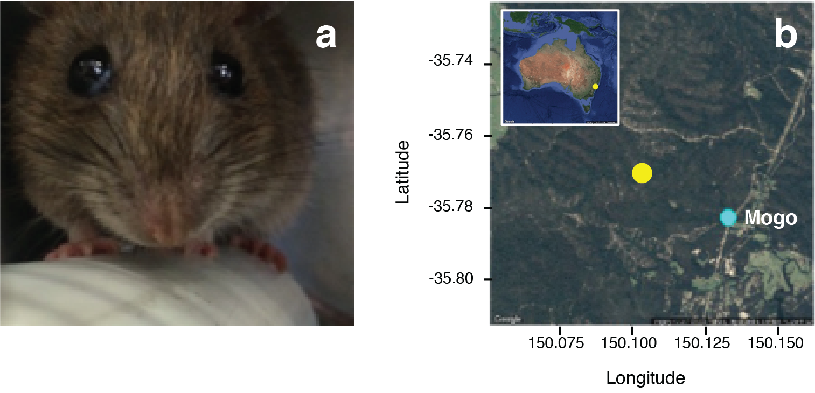

**Figure 1**. **a**. The bush rat, *Rattus fuscipes*, is one of several host species infected by and from which *Cercopithifilaria johnstoni* used in this studywere collected(photo: K. McCann). **b**. Sampling site (yellow point) from which bush rats were collected in the Mogo State Forest near Mogo, NSW, Australia.

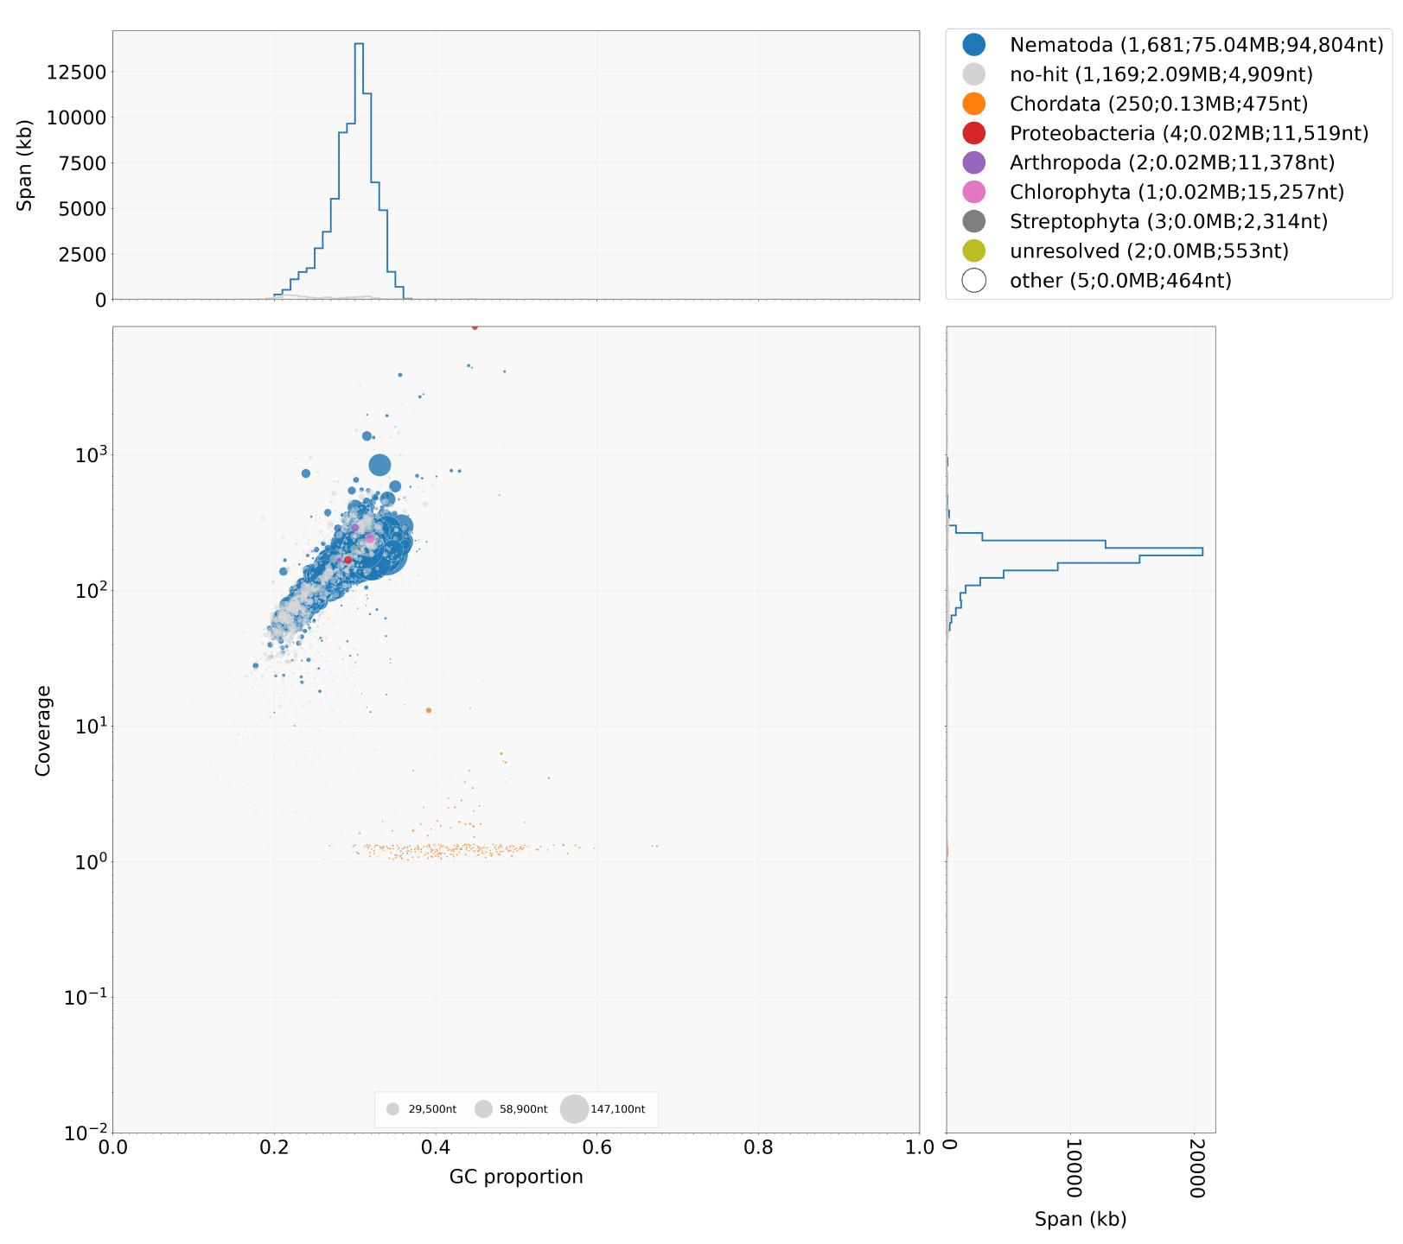

**Figure 2.** Decontamination screen using BlobTools. The plot shows variation in GC content (x-axis), mapped read coverage (y-axis), and blast-classification (colours, see key above) of the assembly scaffolds, from which putative contaminants are commonly identified as outliers of the distributions.

**Table 1**: Genome assembly statistics of *Cercopithifilaria johnstoni* and related Clade III filarial nematodes

| **Species (WBP accession ID1)** | **Assembly length (bp)** | **Sequences (n)** | **N50**  **length**  **(bp)** | **N50**  **(n)** | **Genome BUSCOs2**  **(%, n=982)** | **Genes / transcripts**  **(n)** | **Protein BUSCOs2**  **(%, n=982)** |
| --- | --- | --- | --- | --- | --- | --- | --- |
| *C. johnstoni*  (current study) | 76,938,880 | 2092 | 99,003 | 232 | C:94.9 [S:94.2, D:0.7], F:3.9, M:1.2 | 10565, 11690 | C:96.5 [S:86.5, D:10.0], F:2.3, M:1.2 |
| *A. viteae*  (prjeb1697) | 77,350,906 | 6796 | 25,808 | 819 | C:90.5 [S:88.8, D:1.7], F:7, M:2.5 | 10,397, 10,397 | C:88.3 [S:86.5 ,D:1.8], F:8.8, M:2.9 |
| *B. malayi*  (prjna10729) | 88,235,797 | 197 | 14,214,749 | 3 | C:97.6 [S:96.5, D:1.1], F:1.0, M:1.4 | 10,928, 16,904 | C:98.9 [S:71.6 ,D:27.3], F:0.9, M:0.2 |
| *B. pahangi*  (prjeb497) | 90,545,113 | 14029 | 65,666 | 300 | C:89.8 [S:89.2, D:0.6], F:6.6, M:3.6 | 14,674, 14,674 | C:89.8 [S:88.7, D:1.1], F:6.7, M:3.5 |
| *B. timori*  (prjeb4663) | 64,930,714 | 23963 | 4,919 | 3497 | C:54.9 [S:54.6, D:0.3], F:20.2, M:24.9 | 16,203, 16,203 | C:57.3 [S:56.8, D:0.5], F:20.6, M:22.1 |
| *D. immitis*  (prjeb1797) | 88,309,529 | 16061 | 71,281 | 219 | C:92.0 [S:89.8, D:2.2], F:3.8, M:4.2 | 12,857, 12,857 | C:91.6 [S:89.2, D:2.4], F:4.3, M:4.1 |
| *E. elaphi*  (prjeb502) | 82,568,297 | 8,078 | 25,590 | 874 | C:77.6 [S:77.3, D:0.3], F:5.4, M:17.0 | 10,410, 10,410 | C:87.5 [S:87.2, D:0.3], F:6.6, M:5.9 |
| *L. sigmodontis*  (prjeb3075) | 64,813,410 | 3165 | 45,863 | 377 | C:92.5 [S:90.6, D:1.9], F:5.1, M:2.4 | 10,246, 10,246 | C:90.4 [S:88.2, D:2.2], F:6.7, M:2.9 |
| *L. loa*  (prjna246086) | 96,405,338 | 2250 | 180,288 | 117 | C:97.6 [S:96.3, D:1.3], F:2.0, M:0.4 | 12,473, 12,473 | C:94.7 [S:93.4 , D:1.3], F:3.5, M:1.8 |
| *L. loa*  (prjna37757) | 91,373,458 | 5,773 | 174,388 | 130 | C:96.4 [S:95.7, D:0.7], F:3.2, M:0.4 | 14,908, 15,445 | C:96.5 [S:91.3, D:5.2], F:3.5, M:0.0, |
| *O. flexuosa*  (prjeb512) | 86,175,476 | 45472 | 2,943 | 6666 | C:48.4 [S:48.2, D:0.2], F:21.5, M:30.1 | 16,119, 16,119 | C:67.0 [S:66.3, D:0.7], F:7.9, M:25.1 |
| *O. flexuosa*  (prjna230512) | 67,740,367 | 1,604 | 540,294 | 22 | C:72.9 [S:72.3, D:0.6], F:4.3, M:22.8 | 8,140, 8,235 | C:67.0 [S:66.3, D:0.7], F:7.9, M:25.1 |
| *O. ochengi*  (prjeb1465) | 95,513,350 | 24,057 | 12,317 | 1,896 | C:86.3 [S:83.1, D:3.2], F:9.9, M:3.8 | 13,990, 13,990 | C:84.7 [S:81.4, D:3.3], F:11.3, M:4.0 |
| *O. ochengi*  (prjeb1204) | 91,660,559 | 20243 | 16,199 | 1317 | C:85.5 [S:85.0, D:0.5], F:9.8, M:4.7 | 12,816, 12,816 | C:86.2 [S:85.3, D:0.9], F:8.9, M:4.9 |
| *O. volvulus*  (prjeb513) | 96,427,137 | 708 | 25,485,961 | 2 | C:97.7 [S:97.4, D:0.3], F:1.6, M:0.7 | 12,109, 13,945 | C:99.2 [S:98.3, D:0.9], F:0.8, M:0.0 |
| *S. digitata*  (prjna479729) | 78,770,088 | 1,879 | 121,247 | 168 | C:94.8 [S:94.3, D:0.5], F:3.6, M:1.6 | 10,531, 10,531 | C:87.6 [S:86.6, D:1.0], F:6.2, M:6.2% |
| *W. bancrofti*  (prjeb536) | 76,991,470 | 1350 | 9,917 | 1916 | C:75.5 [S:75.1, D:0.4], F:11.6, M:12.9 | 13,058, 13,058 | C:77.2 [S:76.7, D:0.5], F:11.1, M:11.7 |
| *W. bancrofti*  (prjna275548) | 90,325,107 | 5105 | 56,670 | 351 | C:93.5 [S:86.6, D:6.9], F:3.6, M:2.9 | 11,068, 11,068 | C:87.4 [S:80.2, D:7.2], F:7.7, M:4.9 |

1. WormBase Parasite release 16 [(Howe et al., 2017)](https://paperpile.com/c/3RGDWV/RfWH).
2. BUSCOs: C: complete, S: complete, single copy; D: duplicated; F: fragmented; M: missing.

**Table 2.** Iterative improvement of the *Cercopithifilaria johnstoni* genome assembly

|  | **Spades** | **Spades + Redundans** | **Spades + Redundans + Blobtools** | **Spades + Redundans + Blobtools + OPERA-LG** | **Spades + Redundans + Blobtools + OPERA-LG +**  **gap filling (Redundans)** |
| --- | --- | --- | --- | --- | --- |
| **Assembly statistics** |  |  |  |  |  |
| Assembly size (bp) | 79,062,707 | 77,312,925 | 77,015,453 | 77,032,887 | 76,924,992 |
| Sequences (n) | 7,152 | 3,117 | 2,568 | 2,263 | 2,091 |
| N50 (bp) | 88,758 | 91,012 | 91,596 | 99,003 | 99,003 |
| N50 (n) | 263 | 253 | 252 | 232 | 232 |
| Average length (bp) | 11,054.63 | 24,803.63 | 29,990.44 | 34,040.16 | 36,788.61 |
| Largest scaffold (bp) | 588,165 | 588,165 | 588,165 | 588,165 | 588,166 |
| Ns (bp) | 56,933 | 56,921 | 56,921 | 74,355 | 3,888 |
| Gaps (n) | 299 | 298 | 298 | 603 | 414 |
| **Genome BUSCOs (n=982)** |  |  |  |  |  |
| Complete | 929 (94.6%) | 930 (94.7%) | 930 (94.7%) | 930 (94.7%) | 932 (94.9%) |
| Complete, single | 922 (93.9%) | 923 (94%) | 923 (94%) | 923 (94%) | 925 (94.2%) |
| Complete, duplicate | 7 (0.7%) | 7 (0.7%) | 7 (0.7%) | 7 (0.7%) | 7 (0.7%) |
| Fragmented | 40 (4.1%) | 39 (4.0%) | 39 (4.0%) | 40 (4.1%) | 38 (3.9%) |
| Missing | 13 (1.3%) | 13 (1.3%) | 13 (1.3%) | 12 (1.2%) | 12 (1.2%) |