Notes

Messages to Luis about Windows Automation App Idea.

2019.01.03 1:00 am

Blue Stephen White Luis

* + I want to make a windows program that automates actions you do on the computer. Like I want to be able to make my own keyboard shortcuts. also When i create a new document i want the data to be added to the beginning of the title. Or when I plugin a device I want it to automatically open to a specific folder. Like if I plug in my phone I want it to open the media folder. There is no deadline to this project. I'm trying to optimize my life. But, Creators typically organize via date because it makes sense. I always have to type out the date. I cant make a keyboard shortcut to input the date for me on windows Hence, project. Thoughts? Should I reach out to youtubers and ask how they sort and get around to dating things? I think they will say its a useful app. The date is useful. in windows if you share files or make copies of files to move them you lose the date created and the ability to sort chronologically. 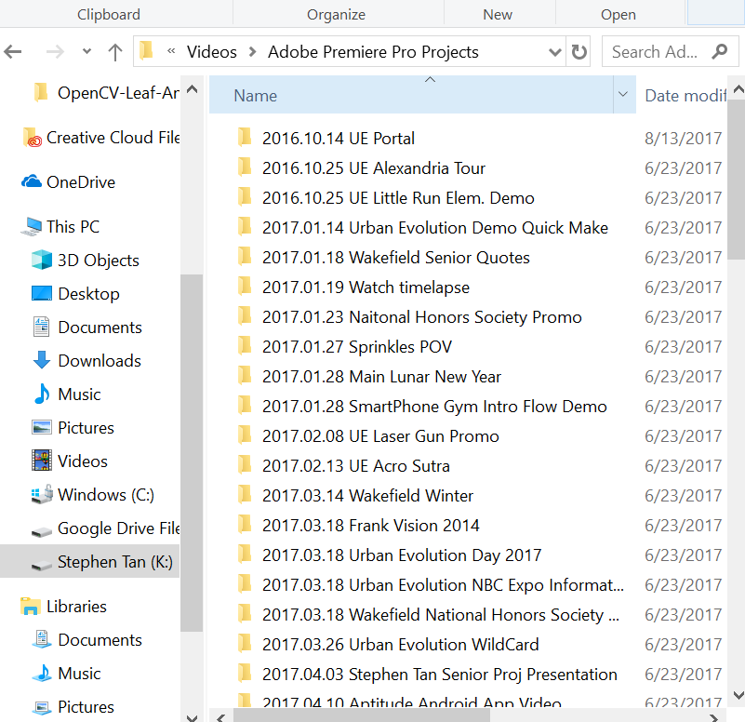
  + Or like whenever a photo is moved to the desktop it should auto upload to google photos (something I do)
  + This is an image of video projects I've done
  + I always date and it takes time to date
  + like its a hassle I haven't been able to make easier because of the challenge
  + Have you considered editing the registry?
  + <https://winaero.com/blog/change-default-new-folder-name-template-in-windows-10/>
  + You can change the default prompt when creating a new folder
  + Probably find what variable is for date in the way you want
  + Not sure if it's an actual solution
  + Just came to mind
  + I'd do some proper research before changing the registry tho
  + So don't quote me on this
  + Exactly, but people who create things like videos aren't creators.
  + So they can't solve the problem on their own
  + People might be searching for this
  + Also a good reason for us to message awesome creator
  + To see if we're going well
  + Making something useful\*
  + Suggestion.
  + I see
  + Oh in order to avoid some errors looks like it's better to make your own context entry command in the register
  + <https://www.howtogeek.com/107965/how-to-add-any-application-shortcut-to-windows-explorers-context-menu/>
  + Then you'd follow this other tutorial
  + <https://superuser.com/questions/1155368/windows-10-how-to-change-new-folder-default-name-for-folders-in-explorer-to-cu/1162117>
  + So Everytime you Do a right click you'd see a button titled "make a folder like Stephen wants it" or something like that
  + Saw that. Non-computer people won't do that
  + I didn't do that
  + I mean just temporarily for you efficiency debacle
  + 'm a computer person
  + I didn't want to criple my my computer.
  + Hahaha
  + I changed the registry once to add the prompt "open terminal here" sort of how Linux does it
  + But I see your point
  + So how do you envision de program?
  + But, this could be a continues project.
  + I envision it being a full program that runs in the background
  + Windows program
  + We would have to use video studio code
  + Probably c++ or c
  + I've never made a full Windows app
  + This would be an open source project
  + A lot of windows programs modify the registry, you could look into streamlining the process
  + But I feel like you want it to be versatile
  + Allow people to choose what format they want to organize their stuff
  + For my music I use media monkey
  + They use scripts to rename files
  + Program looks into the metadata of a song and automatically renames it based on the format you want
  + Yes versitile
  + Mhmm
  + Thoughts?
  + I find it very useful for organizing my music
  + 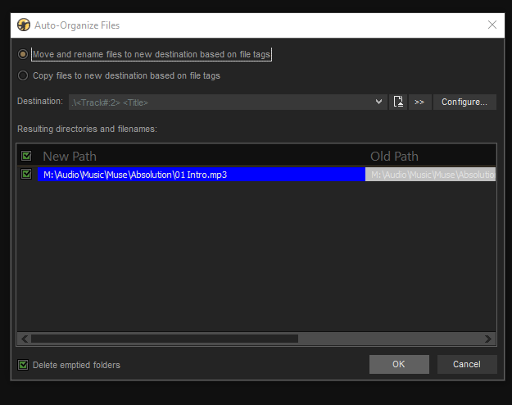
  + so I think It's a good idea
  + In the future let's reach out to creators and ask them how they do things
  + Customer discovery
  + I know it would help me so I'm already interested in working on it
  + I looked into cool company names
  + My fave which we can't use is: Skynet