SMU Honors Physics Section

SMU Department of Physics
FALL 2017

Professor Stephen Sekula

Syllabus for Honors Physics

General Information
The Honors Physics Section is intended to provide honors students with additional activities, information, and challenges to allow them to broaden and deepen their physics knowledge while concurrently taking the introductory physics course sequence. The framework of this syllabus is intended to allow honors students to go above and beyond the normal classroom environment without creating a huge additional burden on the students. Honors students should be looking to go a little further than non-honors students, and this syllabus reflects that.

Participants in the Honors Physics Section will engage in the following activities each semester:

- They will use class time to engage in learning exercises that synthesize information from the 130X introductory physics courses, allowing them to find more breadth and depth in the subject of physics.
- They will have access to expertise from outside the classroom environment, including faculty, staff, and students from SMU and other institutions, as well as individuals with a physics background working in private industry. The goal here is to enrich their learning environment by giving them direct access to experts at various levels of the field.
- They will engage in a coherent, semester-long project. Preparing for, and delivering, this project will be the focus of various activities throughout the semester. Honors students will be expected to learn to present their work to an audience, including (but not limited to) their peers in the Honors Physics Section.
- Students will pass or fail the section based on an assessment of their work and participation, to be determined by the instructor.

Honors Physics Section - FALL 2017
Professor Stephen Sekula (TA: Christopher Milke)

Students will engage in a semester-long “Grand Challenge” problem-solving exercise. This will define the arc of the semester, setting the tone for planning out classroom activities and eventually defining the deliverable at the end of the course. In between class periods relevant to the development of solutions to the Grand Challenge Problem, the students will be engaged in demonstrations of physics principles and exercises to explore these demonstrations. These class periods will follow a pattern consistent with the scientific method: observation of a physical phenomenon, hypothesis building to explain the phenomenon, and calculation and testing to assess the hypothesis. The details of this program are given below. Taking into account Thanksgiving in the Fall and Spring Break in the Spring, each semester has 14 weeks in which a classroom period or activity of the Honors Physics Section is possible.

Plan of Activities

WEEK | ACTIVITY
1 | Introduction to the Honors Physics Section
2 | Development of teams for Grand Challenge Problem
 | Adventures in Space-Time
3 | Gravity's Relentless Pull
4 | What Worlds are Made From
5 | First “Honors Collaboration Meeting”  Presentation of the three ideas on outcomes of the premise in the Grand Challenge Problem
6 | How to Present Your Findings
7 | The Unseen Dangers of Space
8 | FALL BREAK
9 | Second “Honors Collaboration Meeting”  Presentation of status of solutions to the Grand Challenge Problem, including first draft of your posters.
10 | The Shape of Alien Worlds
11 | Shields Up! Electro-Magnetic Shields
12 | TBD
13 | Third “Honors Collaboration Meeting”  Final presentations of status of solutions to the Grand Challenge Problem, including nearly final poster drafts.
14 | PHYSICS DISCUSSION WEEK  (Each team meets with the instructors for 1 hour at a mutually determined time during the week. This substitutes for class period. Last chance to finalize posters!)
15 | Final Poster Presentations  Location TBD  All 130X students are invited to ask questions of the presenters. Food and beverages will be provided.

Assessment

Student performance for Honors Credit will be assessed as follows:

- Attendance in weekly classroom meetings
- Participation in weekly classroom meetings
- Quality of presentations at “Honors Collaboration Meetings”
- Quality of final poster
- Quality of final poster presentation and Q&A skills

The Grand Challenge Problem
The focal event of each semester is the solving of a “Grand Challenge” problem. This is a physics problem with no textbook solution. Rather, you will draw upon your own creativity, informed by the principles of physics you are learning in PHYS 130X, to address the question in as detailed a manner as possible. You will be assessed on:

- your incremental progress on developing answers to the question (see below);
- the creativity, originality, or novelty of the ideas that lead to your final answers;
- your ability to investigate the ideas through physics calculations and supporting material;
- and the reliability and accuracy of your calculations.

This is not purely a storytelling process; rather, you will engage in a mathematical and physical exercise where the math speaks, and you will describe what it says. The Grand Challenge process and solution will build gradually over the semester, woven into the fabric of the Honors Physics Section.

The Grand Challenge will be a team exercise. You will be randomly assembled into teams at the beginning of the semester. Your team will be expected to meet at least once a week outside of class to discuss the Grand Challenge and, in particular, how what you have learned that week might be used to explore a consequence of the theme of the Grand Challenge. Your team will report the status of your work (each individual presenting a brief, 5-minute overview of their status) at the “Honors Collaboration Meetings” - periods of in-class time (see schedule) devoted entirely to a public airing of progress. Members of other teams are free to ask questions and offer suggestions or criticism of presented work. In addition, one of our week's will be devoted to in-depth discussions on the physics principles and details; these discussions will happen outside of class time (instead of class period) between each team and the instructors. This entire exercise is to model how real, collaborative, scientific work, as well as peer review, operates in the real world.

A separate and detailed explanation of the entire Grand Challenge exercise will be made available by the instructor.

University Honor Code

The student honor code can be found on page 32 of the 2014-2015 student handbook. All students will be expected to adhere to it. Any student found cheating or plagiarizing another's work will be given a zero for that work and a complaint will be ﬁled through the Vice President for Student Affairs Ofﬁce. If you are uncertain of the definition of plagiarism as it regards independent works of mathematical and physical computation, documentation, and demonstration, it is your responsibility to speak with the instructor and understand these rules.

Disability Accommodations

Students needing academic accommodations for a disability must first register with Disability Accommodations & Success Strategies (DASS). Students can call 214-768-1470 or visit http://www.smu.edu/Provost/ALEC/DASS to begin the process. Once registered, students should then schedule an appointment with the professor as early in the semester as possible, present a DASS Accommodation Letter, and make appropriate arrangements. Please note that accommodations are not retroactive and require advance notice to implement.

University Policy on Religious Observance

Religiously observant students wishing to be absent on holidays that require missing class should notify their professors in writing at the beginning of the semester, and should discuss with them, in advance, acceptable ways of making up any work missed because of the absence. (See University Policy No. 1.9.)

Excused Absences for University Extracurricular Activities

Students participating in an officially sanctioned, scheduled University extracurricular activity should be given the opportunity to make up class assignments or other graded assignments missed as a result of their participation. It is the responsibility of the student to make arrangements with the instructor prior to any missed scheduled examination or other missed assignment for making up the work. (University Undergraduate Catalogue)

I-M-A Physicist
An Approach to Active Peer Learning
In this course, your are dropped into situations involving one or more physical phenomena and expected to explore, play, hypothesize, test, and share your results. These are the core traits of a good scientist. To help guide this process, which otherwise might lead you nowhere, please try to implement in some form the “I-M-A Physicist” approach in your group. Your groups typically contain 3 people. In the case that there are exactly three people, you should designate one person to fulfill each of the following roles in the group:
- (I)nquirer: this person asks questions about the phenomena, intended to inspire the other members of the team to take a step in inquiry. When another member of a team has drawn a conclusion, the inquirer might ask a challenge question. For instance, if the phenomenon demonstrated in the class is that two objects of different mass, dropped at the same time from the same height, are observed to reach the ground at the same time, an opening inquiry might be:
  - “I wonder whether the material that makes the objects has any effect on the outcome?”
- (M)easurer: this person’s job is to perform a measurement (or if more than one person is needed for measurement, coordinate the measurement between people) intended to gather data that addresses an inquiry. In the example above, the measurer’s job is to response to the inquirer by proposing that different materials be dropped, whether of the same mass as one another or of different masses. The measurer’s job is to make sure the materials really do start at the same height, and to record (e.g. using a camera phone) the moment when they reach the ground. Measurement can take many forms: a meter stick and marked paper, a video, an audio recording, etc. Be creative! Use the tools you have in your pocket, or ask for tools you do not have.
- (A)nalyst: this person’s job is to take the data from the measurer and draw conclusions from it. Conclusions should be rooted in the data; no conclusion not supported by the data should be drawn. Perhaps this is by watching a video or listening to an audio recording, and stating a conclusion (or more than one) from what is recorded. Perhaps this is by reading marks made using a pencil and meter stick, or time measurements recorded in a chart. Data takes many forms, and the Analyst’s job is to determine what the data are saying.
Inquiry, Measurement, and Analysis (IMA) are core to the progress of knowledge using the scientific method. This way of thinking about roles in a team-based exercise can help guide you in learning how to conduct each step. In a real-world situation, each scientist is expected to conduct inquiry, measurement, and analysis, either by themselves or as part of a team.
If there are MORE than 3 team members, the others in the group can help with measurement and other activities, but at least one of them should be designated as a dedicated “opponent”:
- (O)pponent: this person’s job is to challenge, in a constructive manner, any assumptions that are implicit in inquiry, measurement, or analysis, and to offer alternative explanations of the data that might be consistent with the data but not considered by the other members of the team. To be constructive, the opponent should not merely stand in the way of assumptions or conclusions, but offer a selection of next steps to eliminate or verify their opposition.
If there are only three members, all three team members should take the role of the Opponent after a round of Inquiry-Measurement-Analysis has concluded. Challenging assumptions and conclusions are essential to the progress of science; what differentiates science from other human endeavors is that a scientific opponent offers in return the test that verifies or refutes their challenge, and accepts the result of their proposed test (even if it dis-confirms their challenge), regardless of its outcome.

GRAND CHALLENGE PROBLEM (FALL 2017)

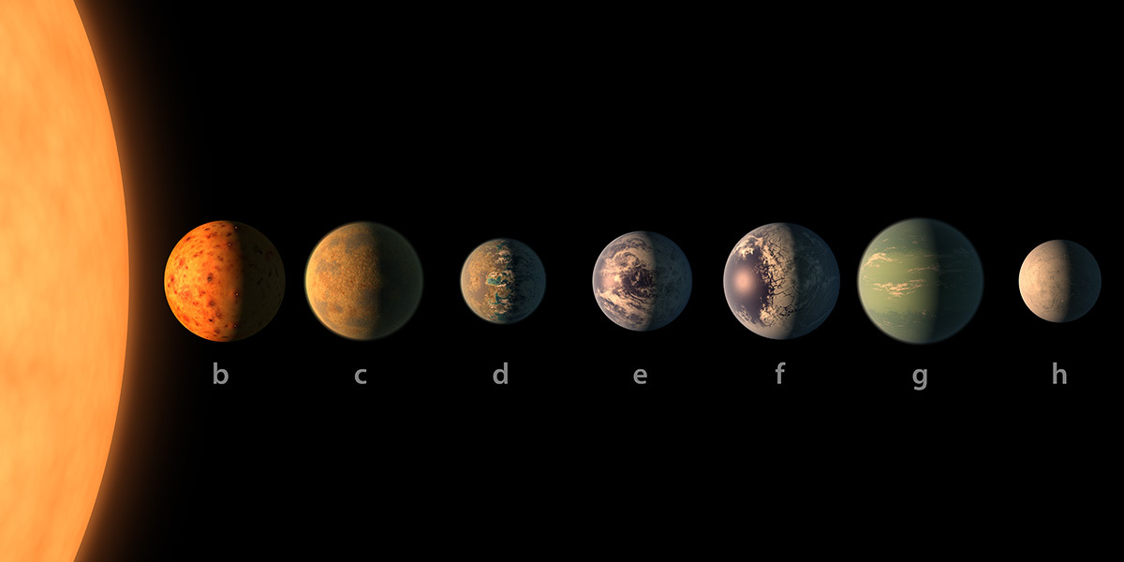
You are to send a small (approximately mobile-phone-sized) probe to one of the 7 known planets of the TRAPPIST-1 system. TRAPPIST-1 lies 40 years at the speed of light from Earth in the constellation Aquarius. Define in detail three design aspects of this probe related to any of the following areas (choose three):

Propulsion • Energy • Material Composition • Sensors and Hardware •
Communication •

Each group will be assigned to land their probe on a different one of the 7 planets. Each world presents distinctive challenges that will shape your design choices. Start by learning more about TRAPPIST-1 and its planets:
https://exoplanets.nasa.gov/trappist1/

Depending on the number of students in the Honors Physics Section, we will revisit this aspect of the Grand Challenge Problem.
http://www.smu.edu/StudentAffairs/StudentLife/StudentHandbook

