camera流程

1:初始化入口
static void __init comip_init_camera(void)
{
comip_set_camera_info(&comip_camera_info);
}
comip_camera_info:摄像头硬件配置模式描叙
comip_set_camera_info：
--->comip_register_device(&comip_device_camera, info);
--->platform_device_register(dev);//注册camera为平台设备

comip_register_device(&comip_device_camera, info);
comip_register_device(&comip_device_camera,&comip_camera_info);
comip_device_camera:描叙lc1860端的camera控制器的相关寄存器地址和物理地址
struct platform_device comip_device_camera = {
.name = "comip-camera",
.id = -1,
.dev = {
.dma_mask = &comip_camera_dma_mask,
.coherent_dma_mask = COMIP_DMA_BIT_MASK,
},
.num_resources = ARRAY_SIZE(comip_resource_camera),
.resource = comip_resource_camera,
#if defined(CONFIG_COMIP_IOMMU)
.archdata = {
.dev_id = 2, /*1: SMMU0 , 2: SMMU1*/
.s_id = 1, /* Stream ID */
},
#endif
};

comip_resource_camera
static struct resource comip_resource_camera[] = {
[0] = {
.start = ISP_BASE,//isp的物理地址分配
.end = ISP_BASE + 0x7ffff,
.flags = IORESOURCE_MEM,
},

[1] = {
.start = INT_ISP,//isp中断资源的物理分配
.end = INT_ISP,
.flags = IORESOURCE_IRQ,
},
};

comip_camera_info:摄像头外设的硬件描叙
comip_camera_info:
static struct comip_camera_platform_data comip_camera_info = {//
.i2c_adapter_id = 3,//平台i2c设置
.flags = CAMERA_USE_ISP_I2C | CAMERA_USE_HIGH_BYTE
| CAMERA_I2C_PIO_MODE | CAMERA_I2C_STANDARD_SPEED,
.anti_shake_parms = {
.a = 12,
.b = 3,
.c = 3,
.d = 4,
},
.flash_parms = {
.redeye_on_duration = 500,
.redeye_off_duration = 100,
.snapshot_pre_duration = 400,
.aecgc_stable_duration = 3500,
.torch_off_duration = 100,
.flash_on_ramp_time = 150,
.mean_percent = 50,
.brightness_ratio =10,//32
},
.client = comip_camera_clients,//对应每个不同的camera设备
.client_num = ARRAY_SIZE(comip_camera_clients),
};
static struct comip_camera_client comip_camera_clients[] = {
#if defined(CONFIG_VIDEO_OV13850) || defined(CONFIG_VIDEO_OV13850R2A)
{
.board_info = &ov13850_board_info,//i2c平台设备Info
.flags = CAMERA_CLIENT_IF_MIPI
|CAMERA_CLIENT_CLK_EXT
|CAMERA_CLIENT_ISP_CLK_HHIGH,//lrs add for test, org=HIGH
.caps = CAMERA_CAP_FOCUS_INFINITY
| CAMERA_CAP_FOCUS_AUTO
| CAMERA_CAP_FOCUS_CONTINUOUS_AUTO
| CAMERA_CAP_METER_CENTER
| CAMERA_CAP_METER_DOT
| CAMERA_CAP_FACE_DETECT
| CAMERA_CAP_ANTI_SHAKE_CAPTURE
| CAMERA_CAP_HDR_CAPTURE
| CAMERA_CAP_FLASH ,
.if_id = 0,
.mipi_lane_num = 4,
.mclk_parent_name = "pll1_mclk",//后置摄像头的时钟设置 前置设置在代码中
.mclk_name = "clkout1_clk",
.mclk_rate = 26000000,
.power = ov13850_power,
.reset = ov13850_reset,
.flash = camera_flash,
},
#endif
#if defined(CONFIG_VIDEO_OV5648_2LANE_19M)
{
.board_info = &ov5648_board_info,
.flags = CAMERA_CLIENT_IF_MIPI,
.caps = CAMERA_CAP_FOCUS_INFINITY
| CAMERA_CAP_FOCUS_AUTO
| CAMERA_CAP_FOCUS_CONTINUOUS_AUTO
| CAMERA_CAP_METER_CENTER
| CAMERA_CAP_METER_DOT
| CAMERA_CAP_FACE_DETECT
| CAMERA_CAP_ANTI_SHAKE_CAPTURE
| CAMERA_CAP_HDR_CAPTURE,
.if_id = 1,
.mipi_lane_num = 2,
.power = ov5648_power,
.reset = ov5648_reset,
},
#endif
};

ov13850_board_info
static struct i2c_board_info ov13850_board_info = {
.type = "ov13850-mipi-raw",
.addr = 0x10,
.platform_data = &ov13850_setting,
}；

camera平台驱动流程
comip_camera_init
--->platform_driver_probe(&comip_camera_driver, comip_camera_probe);
comip_camera_probe
---->isp_device_init(isp);
--->isp_int_init(isp);
--->isp_i2c_init(isp);
--->isp_i2c_register(isp);
--->isp->i2c.xfer_cmd = isp_i2c_xfer_cmd;
--->adap->algo = &isp_i2c_algorithm;
--->.master_xfer = isp_i2c_xfer,
--->i2c->xfer_cmd(isp, &cmd);
--->isp_i2c_xfer_cmd
--->isp_reg_writew(isp, cmd->reg, COMMAND_BUFFER);//写i2c reg
--->isp_reg_writew(isp, cmd->data, COMMAND_BUFFER + 2);//写入i2c reg中的data数据
---->isp_reg_writeb(isp, val, COMMAND_REG1);//确认i2c的读写flag 以及地址的位数
--->isp_reg_writeb(isp, cmd->addr, COMMAND_REG2);//设置I2c设备的地址
--->isp_reg_writeb(isp, 0x01, COMMAND_REG3); //启动i2c的数据
--->isp_send_cmd(isp, CMD_I2C_GRP_WR, ISP_I2C_TIMEOUT)//等待i2c cmd发送完成 CMD_I2C_GRP_WR:i2c的控制命令
--->isp_reg_writeb(isp, id, COMMAND_REG0);//COMMAND_REG0:控制Isp的模式
--->cmd->data = isp_reg_readb(isp, COMMAND_BUFFER + 3); //读回数据

--->.functionality = isp_i2c_functionality,
--->i2c_add_numbered_adapter(adap);//注册i2c平台设备
--->comip_set_i2c3_info(pdata);
--->csi_phy_init();
--->ret = v4l2_device_register(NULL, &camdev->v4l2_dev);
--->comip_camera_init_subdev(camdev);
--->comip_camera_init_client(camdev,&pdata->client[i], camdev->clients);//注册每个client
--->if (client->flags & CAMERA_CLIENT_INDEP_I2C)
i2c_adapter_id = client->i2c_adapter_id;//使用设备指定的i2c
else
i2c_adapter_id = camdev->pdata->i2c_adapter_id;//使用平台指定的i2c
--->ret = comip_camera_get_mclk(camdev, client, index);//获取后置摄像头的clk
--->isp_dev_call(camdev->isp, init, client);
--->isp_init
--->ret = isp_clk_init(isp, client);
--->isp->clk[i] = clk_get(isp->dev, isp_clks_high[i].name);
--->clk_set_rate(isp->clk[i], isp_clks_high[i].rate);//设置时钟
--->ret = comip_subdev_power_on(camdev, client, index);
--->comip_subdev_mclk_on(camdev, client, index);
--->clk_enable(camdev->csd[index].mclk);//使能后置摄像头 mclk
--->isp_dev_call(camdev->isp, mclk_on, client);//使能前置摄像头mclk
--->isp_mclk_on
--->comip_mfp_config(MFP_PIN_GPIO(173), MFP_GPIO173_ISP_CLKOUT1);
--->isp_clk_enable(isp, ISP_CLK_DEV, client);
--->ret = client->power(1);//设备上电
--->ret = client->reset();//设备复位
--->ret = isp_dev_call(camdev->isp, open, &csd->prop);//isp open
--->isp_open
--->isp_mfp_init(isp, prop);
--->comip_mfp_config(MFP_PIN_GPIO(173), MFP_GPIO173_ISP_CLKOUT1);
--->comip_mfp_config(MFP_PIN_GPIO(178), MFP_GPIO178_CLK_OUT2);
--->isp_powerup();
--->isp_clk_enable(isp, ISP_CLK_MAIN, client);
--->isp_boot(isp, prop);
--->isp_clk_enable(isp, ISP_CLK_CSI, client);
--->ret = isp_mipi_init(isp,
prop->if_id,
client->mipi_lane_num,
(int)(client->flags & CAMERA_CLIENT_YUV_DATA));
--->csd->i2c_adap = i2c_get_adapter(i2c_adapter_id);//获取i2c adapt
--->csd->sd = v4l2_i2c_new_subdev_board(&camdev->v4l2_dev,
csd->i2c_adap,
client->board_info,
NULL);
--->client = i2c_new_device(adapter, info);//注册i2c设备
--->sd = i2c_get_clientdata(client);
--->v4l2_device_register_subdev(v4l2_dev, sd)
HAL层流程

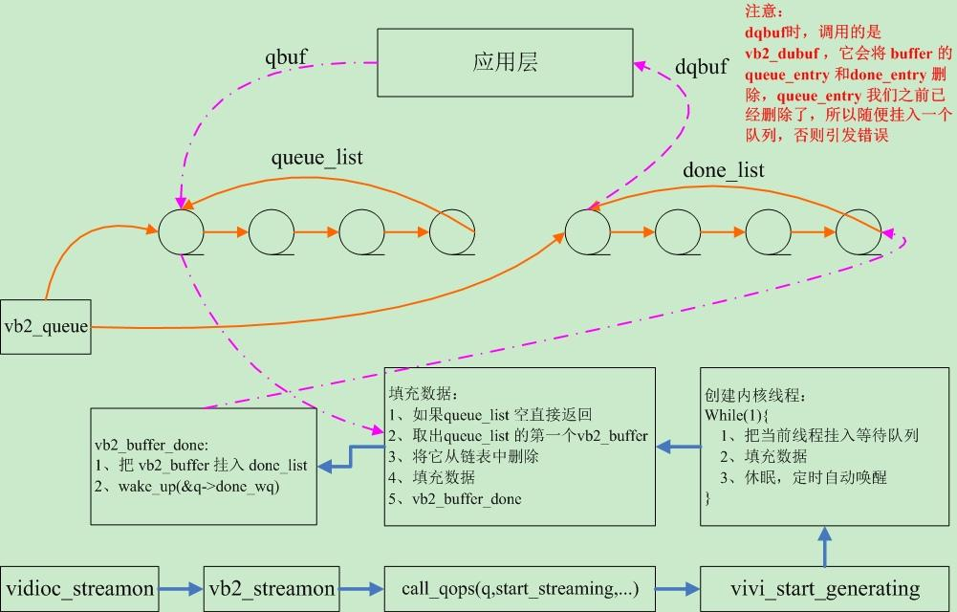

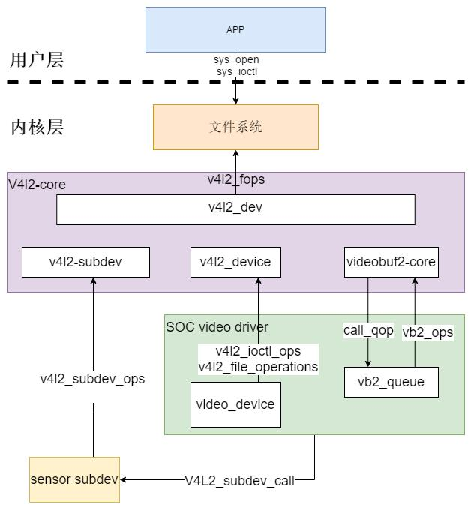
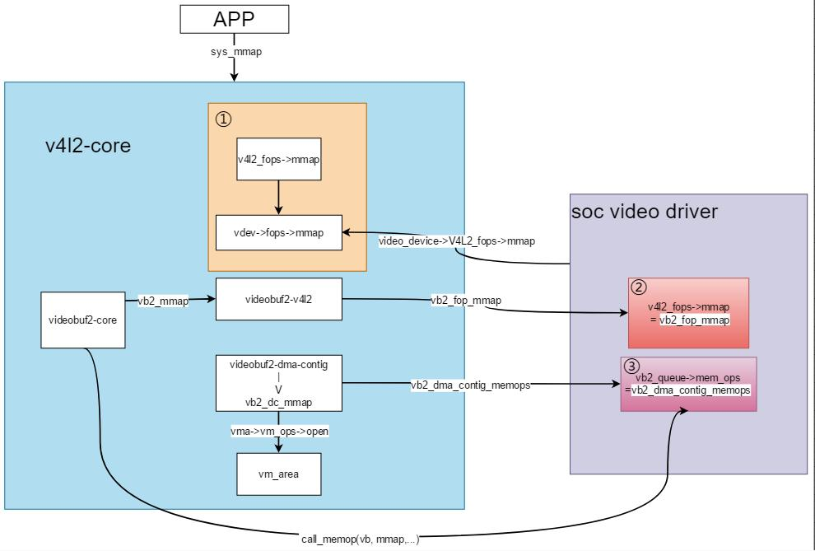

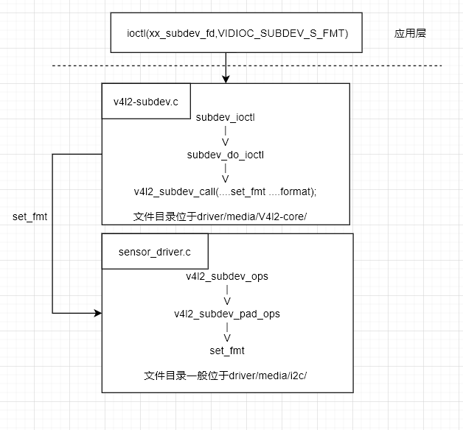
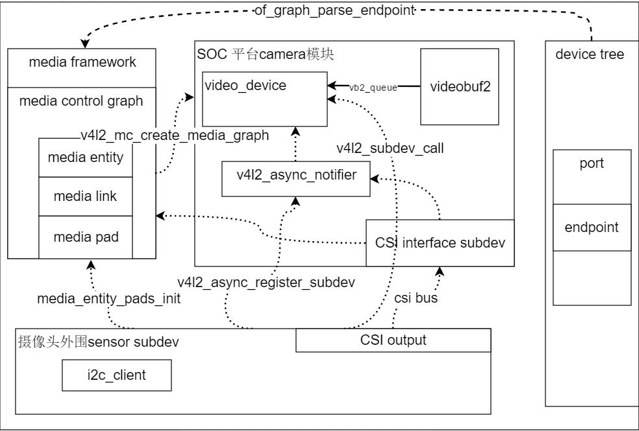

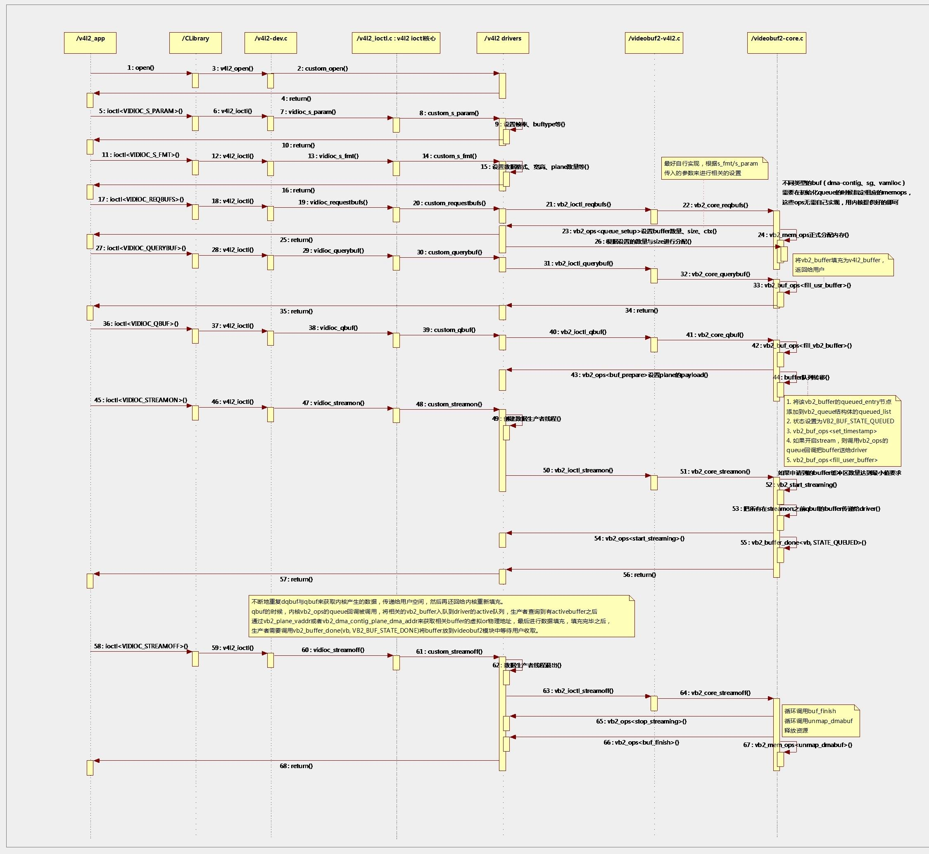

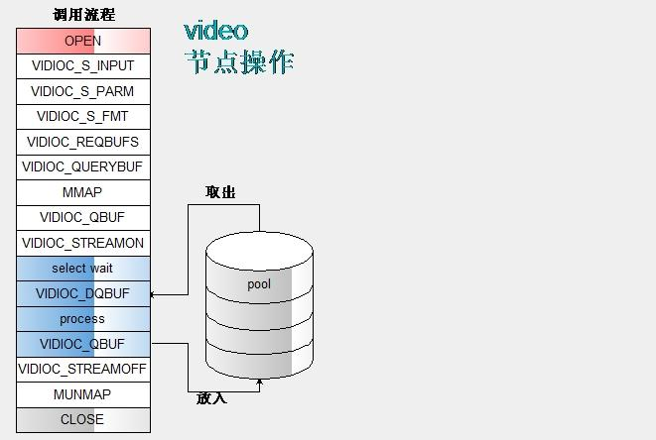

ComipCameraHWInterface.cpp (hardware\leadcore\libcamera)
CameraHardwareComip::CameraHardwareComip(int cameraId, camera_device_t *dev)
--->mComipCamera->initCamera(cameraId, &(mGrallocHal->common));//初始化摄像头
ComipCamera.cpp (hardware\leadcore\libcamera)
---> m_cam_fd = open(CAMERA_DEV_NAME, O_RDWR);//打开摄像头
--->v4l2_querycap(m_cam_fd);
--->ioctl(fp, VIDIOC_QUERYCAP, &cap);//获取摄像头的属性

5:v4l2_s_input(m_cam_fd, index)
1:comip_vidioc_s_input
--->1.1:isp_dev_call(camdev->isp, init, camdev->csd[index].client);//isp初始化
--->1.1.1:isp_init //时钟初始化
--->1.2:comip_subdev_power_on(camdev,camdev->csd[index].client, index);//子系统上电
--->1.2.1:comip_subdev_mclk_on(camdev, client, index);//sensor mclk
--->1.2.2:client->power(1);//sensor 上电
--->1.2.3:client->reset();//sensor 复位
--->1.2.4:ctrl.id = V4L2_CID_ISP_SETTING;
--->1.2.5:ctrl.value = (int)&csd->prop.setting;//
--->1.2.6:v4l2_subdev_call(csd->sd, core, g_ctrl, &ctrl);//在ov13850中将isp的效果参数赋值给setting
--->1.2.7:ctrl.id = V4L2_CID_ISP_PARM;
--->1.2.8:v4l2_subdev_call(csd->sd, core, g_ctrl, &ctrl);
--->1.2.9:csd->prop.parm = (struct v4l2_isp_parm *)ctrl.value;
--->1.2.10:capture->aecgc_control =
comip_camera_get_aecgc_control(csd->prop.parm->sensor_vendor);
--->1.2.11:ctrl.id = V4L2_CID_GET_ISP_FIRMWARE;
--->1.2.12:ctrl.value = (int)&csd->prop.firmware_setting;
--->1.2.13:ret = v4l2_subdev_call(csd->sd, core, g_ctrl, &ctrl);

ComipCamera::initCamera
1:m_cam_fd = open(CAMERA_DEV_NAME, O_RDWR);
2:ret = v4l2_querycap(m_cam_fd);
3:m_sensorName = (char*)v4l2_enuminput(m_cam_fd, index);
4:m_sensorID = findSensorInSensorRes();
5:ret = v4l2_s_input(m_cam_fd, index);
6:ret = v4l2_cropcaps(m_cam_fd, &cap);
7:

Android6.0---->android4.0

1:flags_camera_client_if_mipi ----> CAMERA_CLIENT_IF_MIPI
2:flags_camera_client_framerate_dyn ----->CAMERA_CLIENT_FRAMERATE_DYN
3:flags_client_isp_clk_hhigh ----->CAMERA_CLIENT_ISP_CLK_HHIGH
4:caps_camera_cap_meter_center ----->CAMERA_CAP_METER_CENTER
5:caps_camera_cap_meter_dot ----->CAMERA_CAP_METER_DOT
6:caps_camera_cap_face_detect ----->CAMERA_CAP_FACE_DETECT
7:caps_camera_cap_anti_shake_capture ----->CAMERA_CAP_ANTI_SHAKE_CAPTURE
8://caps_camera_cap_hdr_capture ----->//CAMERA_CAP_HDR_CAPTURE 屏蔽
9://caps_camera_cap_flash ----->//CAMERA_CAP_FLASH 屏蔽

10:if_id = <1>; ---->.if_id = 1,
11:mipi_lane_number = <4> ---->.mipi_lane_num = 4,
12:camera_id = <CAMERA_ID_FRONT>
13:preview_size_table
14:picture_size_table
15:pixel_array_size
16:active_array_size
17:support_focus = <0>;
18:sensor_mount_angle = <90>;
19:focal_length = <385>;
20:filter_densities = <1>;
21:support_optical_stab = <0>;

Comip-video.c (g:\work\pj\lc1860-android6.0-sourcefile\linux-3.10.y\drivers\comip\camera) 120696 2020/10/29
comip_camera_probe
--->1:pdata = comip_camera_parse_dt_pdata(pdev);
--->1.1:comip_camera_parse_dt_pdata_info(pdev, pdata);
--->1.1.1:pdata->i2c_adapter_id = tmp_val;
--->1.1.2:pdata->flags |= CAMERA_USE_ISP_I2C;//CAMERA_USE_HIGH_BYTE
--->1.2:pdev->dev.platform_data = pdata;
--->1.3:pdata->client = comip_camera_parse_dt_client(pdev, pdata);
--->1.4:pdata->client_num = of_get_child_count(pdev->dev.of_node);//获取有几个camera子节点
--->1.4.1:comip_camera_parse_dt_client_info(np, &client[i++]);
//client->board_info = board_info;//设置board info的参数
--->1.4.2:board_info->addr = tmp_val;//addr-->sensor 的i2c地址
--->1.4.3:client->gpio = gpio;//设置sensor的gpio
--->1.4.4:gpio->power_gpio= rc;//
--->1.4.5:gpio->reset_gpio= rc;//
--->1.4.6:gpio->mclk_gpio= rc;
--->1.4.7:client->flags|= CAMERA_CLIENT_IF_MIPI;//
--->1.4.8:client->caps|= CAMERA_CAP_FLASH;
--->1.4.9:client->if_id = tmp_val;
--->1.4.10:client->mipi_lane_num = tmp_val;
--->1.4.11:client->camera_id = tmp_val;
--->1.4.12:client->mclk_rate = tmp_val;
--->1.4.13:client->mclk_parent_name = tmp;
--->1.4.14:client->mclk_name = tmp;
--->2:comip_camera_regulator_init(pdev,pdev->dev.of_node); //电压控制
--->2.1:regulator_set_voltage(camera_supplies[POWER_CAMERA_CORE].consumer,
1200000, 1200000);
--->2.2:regulator_set_voltage(camera_supplies[POWER_CAMERA_ANALOG].consumer,
2850000, 2850000);
--->2.3:regulator_set_voltage(camera_supplies[POWER_CAMERA_IO].consumer,
1800000, 1800000);
--->2.4:regulator_set_voltage(camera_supplies[POWER_CAMERA_AF].consumer,
2850000, 2850000);
--->2.5:regulator_set_voltage(camera_supplies[POWER_CAMERA_PHY].consumer,
1800000, 1800000);
--->3:platform_get_resource(pdev, IORESOURCE_MEM, 0);
--->4:platform_get_irq(pdev, 0);
--->5:request_mem_region(res->start,
res->end - res->start + 1, dev_name(&pdev->dev));
--->6:ret = isp_device_init(isp);
--->6.1:isp->base = ioremap(res->start, res->end - res->start + 1);
--->6.2:ret = isp_int_init(isp);
--->6.3:request_irq(isp->irq, isp_irq, IRQF_SHARED,
"isp", isp);
--->6.3:ret = isp_i2c_init(isp);
--->7:ret = v4l2_device_register(NULL, &camdev->v4l2_dev);
--->8:ret = comip_camera_init_subdev(camdev);
--->8.1:for (i = 0; i < pdata->client_num; i++)
--->8.2:comip_camera_init_client(camdev,
&pdata->client[i], camdev->clients);
--->8.3:if (client->flags & CAMERA_CLIENT_INDEP_I2C)
--->8.4:i2c_adapter_id = client->i2c_adapter_id;
--->8.5:comip_camera_get_mclk(camdev, client, index);
--->8.6:isp_dev_call(camdev->isp, init, client);
--->8.6.1:isp_init
--->8.6.1.1:isp_clk_init(isp, client);
--->8.7:comip_subdev_power_on(camdev, client, index);
--->8.8:csd->i2c_adap = i2c_get_adapter(i2c_adapter_id);
--->8.9:csd->sd = v4l2_i2c_new_subdev_board(&camdev->v4l2_dev,
csd->i2c_adap,
client->board_info,
NULL);

