T710充电 设备树：

charger-manager {

compatible = "charger-manager";

cm-name = "battery";

cm-poll-mode = <2>;//轮询模式

cm-poll-interval = <15000>;//轮询时间间隔

cm-battery-stat = <2>;//电池在位检测方法：2：电压法

cm-fullbatt-vchkdrop-ms = <30000>;//满电后的 检查复充条件的周期

cm-fullbatt-vchkdrop-volt = <60000>;//复充的电压条件

cm-fullbatt-voltage = <4200000>; //满电电压检测

cm-first-fullbatt-current = <150000>; //满电的电流第一次检测

cm-fullbatt-current = <120000>;//满电的电流检测

cm-fullbatt-capacity = <100>;//满电显示100%

cm-num-chargers = <1>;//充电ic数量

cm-num-fast-chargers = <1>;//快充ic数量

cm-chargers = "sc2703_charger"; //充电器名称

cm-fast-chargers = "sc2730_fast_charger"; //快充充电ic名字

cm-fuel-gauge = "sc27xx-fgu";//电量计名字

/* in deci centigrade */

cm-battery-cold = <200>;//电池低温阈值

cm-battery-cold-in-minus;//负温标志

cm-battery-hot = <800>;//电池高温阈值

cm-battery-temp-diff = <100>; //修正异常时cold和overhead阈值

/* Allow charging for 10hr */

cm-charging-max = <36000000>; //允许连续充电的最长时长10小时

/* recovery charging after stop charging 3hr */

cm-discharging-max = <10800000>;//停止充电后 插着充电器 允许复充的时间

/* the interval to feed charger watchdog */

cm-wdt-interval = <60>; //喂看门狗的周期

/* drop voltage in microVolts to allow shutdown */

cm-shutdown-voltage = <3150000>; //电压降到3150mv 后关机

/* when 99% of the time is exceeded, it will be forced to 100% */

cm-tickle-time-out = <1500>;//电量维持在99% 15分钟后跳到100%

/* how much time to allow capacity change */

cm-one-cap-time = <30>;//电量增加1%的 最快时间

/* when the safe charging voltage is exceeded, stop charging */

cm-charge-voltage-max = <6500000>;//充电器的过压保护阈值

/* drop voltage in microVolts to restart charging */

cm-charge-voltage-drop = <700000>;

/* when the safe charging voltage is exceeded, stop charging */

cm-fast-charge-voltage-max = <10500000>;

/* drop voltage in microVolts to restart charging */

cm-fast-charge-voltage-drop = <700000>;//电压drop 700mv重新充电

cm-dcp-jeita-temp-table = <1000 1030 0 4400000>, <1150 1180 700000 4400000>,

<1450 1420 2000000 4400000>, <1600 1570 700000 4100000>;

cm-sdp-jeita-temp-table = <1000 1030 0 4400000>, <1150 1180 500000 4400000>,

<1450 1420 500000 4400000>, <1600 1570 500000 4100000>;

cm-cdp-jeita-temp-table = <1000 1030 0 4400000>, <1150 1180 700000 4400000>,

<1450 1420 1500000 4400000>, <1600 1570 500000 4100000>;

cm-unknown-jeita-temp-table = <1000 1030 0 4400000>, <1150 1180 500000 4400000>,

<1450 1420 500000 4400000>, <1600 1570 500000 4100000>;

cm-fchg-jeita-temp-table = <1000 1030 0 4400000>, <1150 1180 700000 4400000>,

<1450 1420 3250000 4400000>, <1600 1570 700000 4100000>;

monitored-battery = <&bat>;//电池参数信息

cm-capacity-track;

regulator@0 {

cm-regulator-name = "vddgen0";

cable@0 {

cm-cable-name = "USB";

extcon = <&pmic_typec>;

};

};

};

1：

1：读取电池温度

Sc27xx_fuel_gauge.c (drivers\power\supply) 48190 2022/2/28

sc27xx_fgu_get_property

--->case POWER_SUPPLY_PROP_TEMP:

--->ret = sc27xx_fgu_get_temp(data, &value);

--->ret = iio_read_channel_processed(data->channel, &vol);//有俩个adc通道iio_channel *channel 和iio_channel *charge_cha

--->regmap_read(data->regmap, data->base + SC27XX_FGU_CURRENT, &cur);//读取通道0的adc

--->sc27xx_fgu_get_current(data, &bat_current);//读取电流

--->regmap_read(data->regmap, data->base + SC27XX_FGU_CURRENT, &cur);

/*

* It is ADC values reading from registers which need to convert to

* corresponding current values.

*/

--->*val = sc27xx_fgu_adc_to_current(data, cur - SC27XX_FGU_CUR_BASIC_ADC);//adc转换为电流

--->temp = (s64)adc * 1000 + data->cur_1000ma_adc / 2;

--->div_s64(temp, data->cur_1000ma_adc);

获取通道:电池温度adc：data->channel = devm_iio_channel_get(&pdev->dev, "bat-temp");充电电压adc data->charge_cha = devm_iio_channel_get(&pdev->dev, "charge-vol");

Adc通道:Sc2730.dtsi (arch\arm64\boot\dts\sprd) 11155 2022/2/28

pmic_fgu: fgu@c00 {

compatible = "sprd,sc27xx-fgu", "sprd,sc2730-fgu";

reg = <0xc00>;

bat-detect-gpio = <&pmic_eic 3 GPIO_ACTIVE_HIGH>;

nvmem-cell-names = "fgu_calib";

nvmem-cells = <&fgu_calib>;

io-channels = <&pmic_adc 0>, <&pmic_adc 14>;

io-channel-names = "bat-temp", "charge-vol";

interrupt-parent = <&sc2730_pmic>;

interrupts = <3 IRQ_TYPE_LEVEL_HIGH>;

};

电池温度adc ---> bat-temp ---> pmic_adc 0通道

充电电压adc ---> charge-vol ---> pmic_adc 14通道

adc通道32个，26个用于内部的状态监控，如电池电压，充电电压等，另外6个用于外部使用

UMP510G芯片

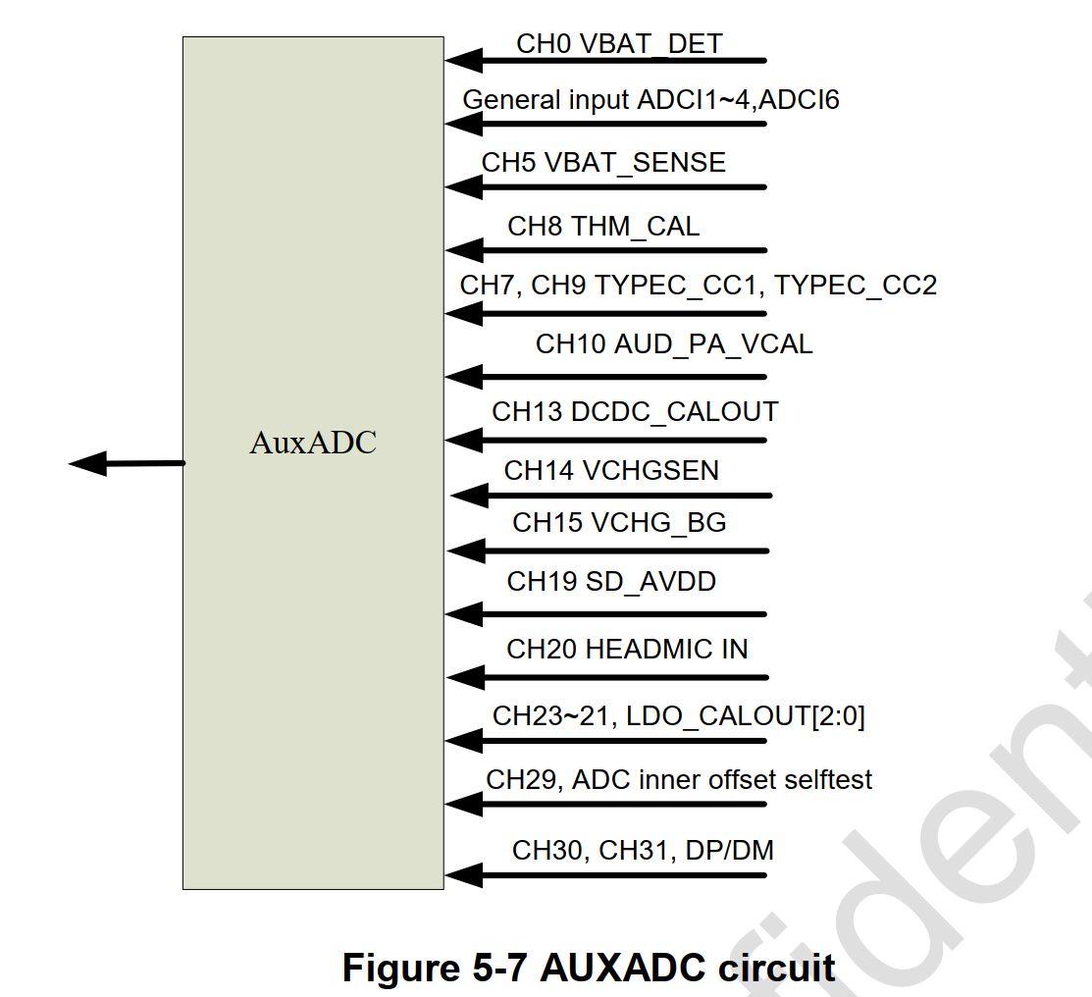

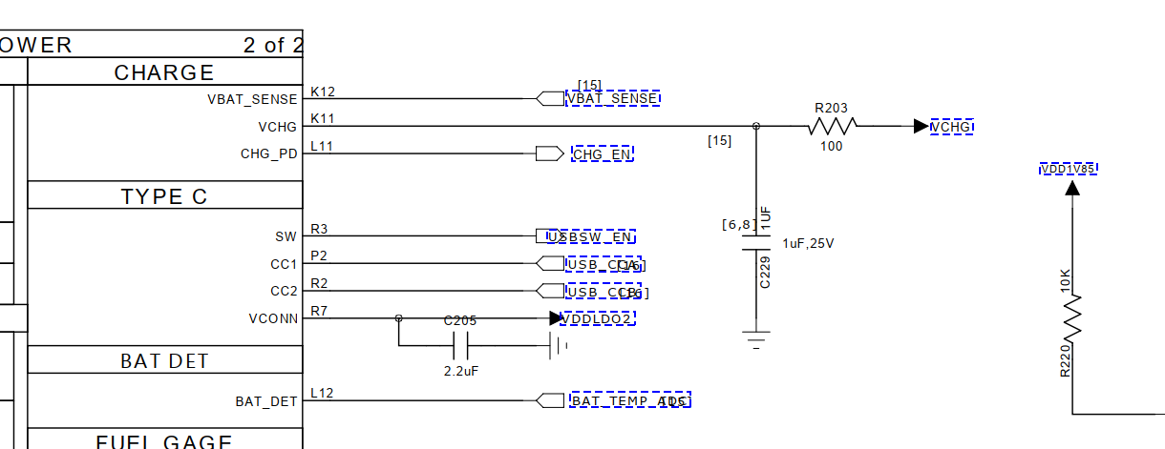

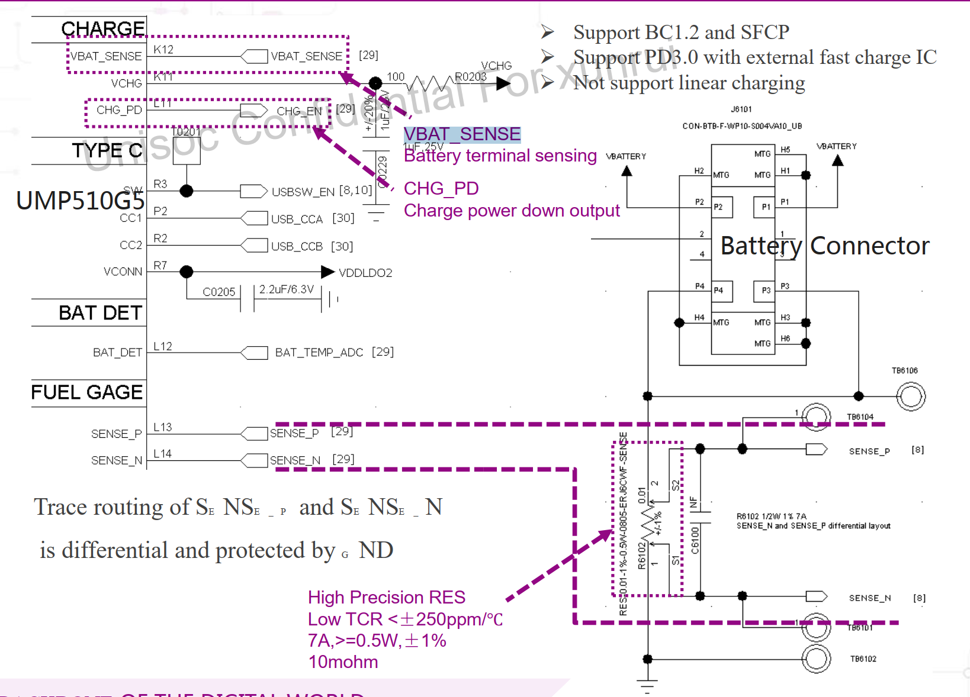

--->resistance_vol = bat_current * data->comp_resistance / 1000;

--->vol = vol - resistance_vol + (resistance_vol *(vol - resistance_vol)) / (1850 - resistance_vol);

电压的计算：因为ntc电阻是连接到库仑计的内阻上，且板地阻抗是1850mv,所以需要补偿库伦电阻对地阻抗的电压Loss

/*

* Due to the ntc resistor is connected to the coulomb counter

* internal resistance and the board ground impedance at 1850mv.

* so need to compensate for coulomb resistance and voltage loss

* to ground impedance.

* Follow the formula below:

* formula:

* Vadc = Vresistance + (1850 - Vresistance) * R / 47k + R

* ->

* UR = Vadc -Vresistance +

* Vresistance * (Vadc - Vresistance) / (1850 - Vresistance)

*/

--->*temp = sc27xx_fgu_vol_to_temp(data->temp_table,

data->temp_table_len,

vol * 1000);

--->*temp = sc27xx_fgu_get_average_temp(data, *temp);

--->data->bat_temp = *temp;

Sc27xx_adc.c (drivers\iio\adc) 20793 2022/2/28

--->一共32个adc通道

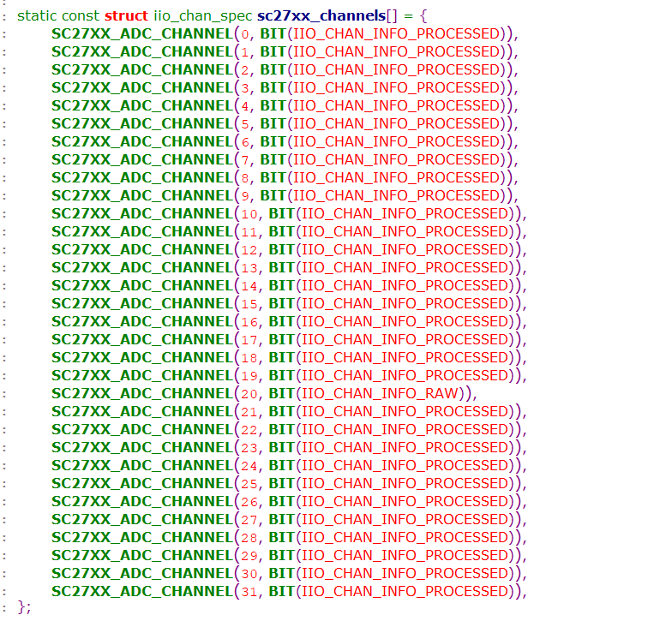

通过iio方式注册

indio_dev = devm_iio_device_alloc(&pdev->dev, sizeof(*sc27xx_data));

sc2703-charger sc2703-charger: battery present = 1, charger type = 0 //充电电流为2A

enum usb_charger_type {

    UNKNOWN_TYPE,

    SDP_TYPE,

    DCP_TYPE,

    CDP_TYPE,

    ACA_TYPE,

};

各种充电类型的电流设置

1:设备树

./ud710-2h10.dts +172

--->capacity-temp-table = <45 100>, <25 100>, <10 97>, <0 95>, <(-10) 82>, <(-20) 62>;

resistance-temp-table = <45 100>, <25 100>, <10 483>, <0 680>, <(-10) 789>, <(-20) 816>;

charge-sdp-current-microamp = <500000 500000>;//sdp充电电流500MA 对应的是pc电脑,D+ D-具有15欧下拉电阻，可以数据通信

charge-dcp-current-microamp = <2000000 3000000>;//dcp 2A d+ d-短路

charge-cdp-current-microamp = <1500000 1500000>;//cdp 1.5A D+ D-具有15欧下拉电阻，可以数据通信 快充模式

charge-unknown-current-microamp = <500000 500000>;//unknown 500MA

charge-fchg-current-microamp = <3000000 2000000>;

● 标准下行端口（SDP）

这种端口的D+和D-线上具有15kΩ下拉电阻。限流值为：挂起时2.5mA，

连接时为100mA，连接并配置为较高功率时为500mA。

它其实就是一种普通的USB模式，当USB处于这种模式时

既可以为外部设备（手机充电、充电宝）充电，

也可以起到数据连接的作用（U盘、手机上传/下载）。

● 专用充电端口（DCP）

这种端口不支持任何数据传输，但能够提供1.5A以上的电流。

端口的D+和D-线之间短路。这种类型的端口支持较高充电能

力的墙上充电器和车载充电器，无需枚举。它其实就是简单

的充电器，当USB处于这种模式时只能进行充电而不能进行数据连接。

● 充电下行端口（CDP）

这种端口既支持大电流充电，也支持完全兼容USB 2.0的数据传输。

端口具有D+和D-通信所必需的15kΩ下拉电阻，也具有充电器检测阶

段切换的内部电路。内部电路允许便携设备将CDP与其它类型端口

区分开来。它其实就是带有快充功能（1.5A）的USB接口，当USB

处于这种模式时既可以进行快充，也可以起到数据连接的作用。

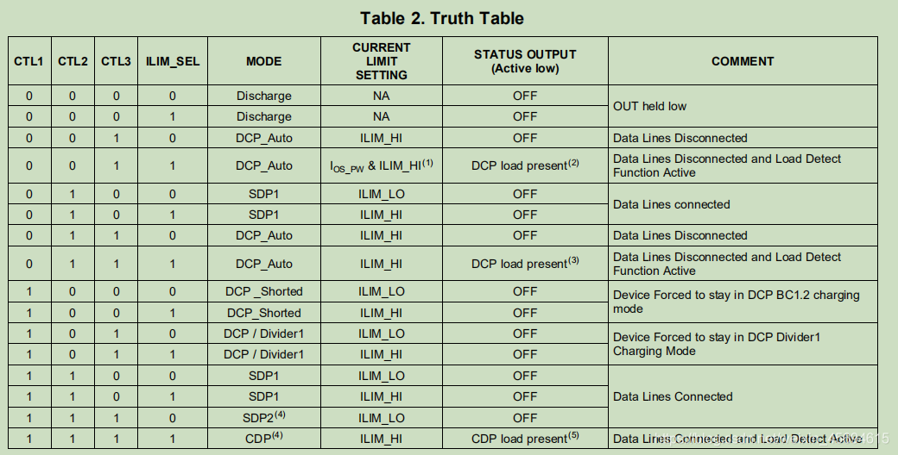

获取设备树

Power_supply_core.c (drivers\power\supply) 37232 2022/2/28

power_supply_get_battery_info

--->of_property_read_u32_index(battery_np, "charge-sdp-current-microamp", 0,

&info->cur.sdp_cur);

of_property_read_u32_index(battery_np, "charge-sdp-current-microamp", 1,

&info->cur.sdp_limit);

of_property_read_u32_index(battery_np, "charge-dcp-current-microamp", 0,

&info->cur.dcp_cur);

of_property_read_u32_index(battery_np, "charge-dcp-current-microamp", 1,

&info->cur.dcp_limit);

of_property_read_u32_index(battery_np, "charge-cdp-current-microamp", 0,

&info->cur.cdp_cur);

of_property_read_u32_index(battery_np, "charge-cdp-current-microamp", 1,

&info->cur.cdp_limit);

of_property_read_u32_index(battery_np, "charge-aca-current-microamp", 0,

&info->cur.aca_cur);

of_property_read_u32_index(battery_np, "charge-aca-current-microamp", 1,

&info->cur.aca_limit);

of_property_read_u32_index(battery_np, "charge-unknown-current-microamp", 0,

&info->cur.unknown_cur);

of_property_read_u32_index(battery_np, "charge-unknown-current-microamp", 1,

&info->cur.unknown_limit);

of_property_read_u32_index(battery_np, "charge-fchg-current-microamp", 0,

&info->cur.fchg_cur);

of_property_read_u32_index(battery_np, "charge-fchg-current-microamp", 1,

&info->cur.fchg_limit);

查看充电器的状态

查看输入电流

Cat /sys/class/power_supply/sc2703_charger/input_current_now

查看输入充电类型

Cat /sys/class/power_supply/sc2703_charger/charge_type

充电流程：

Sc2703-charger.c (drivers\power\supply) 47867 2022/2/28

sc2703_charger_work

1:判断电池是否在位

--->present = sc2703_charger_is_bat_present(info);

2:根据充电器类型设置充电电流和和限制电流

--->switch (info->usb_phy->chg_type) {

case SDP_TYPE:

limit_cur = info->cur.sdp_limit;

cur = info->cur.sdp_cur;

break;

case DCP_TYPE:

limit_cur = info->cur.dcp_limit;

cur = info->cur.dcp_cur;

break;

case CDP_TYPE:

limit_cur = info->cur.cdp_limit;

cur = info->cur.cdp_cur;

break;

default:

limit_cur = info->cur.unknown_limit;

cur = info->cur.unknown_cur;

}

3:设置限制电流

--->sc2703_charger_set_limit_current(info, limit_

4:设置充电电流

--->sc2703_charger_set_current(info, cur);

5:启动充电

--->sc2703_charger_start_charge(info);

Vbus充电通知

obj-$(CONFIG_SPRD_ROC1_USB2_PHY) += phy-sprd-roc1.o

obj-$(CONFIG_SPRD_USB3_PHY) += phy-sprd-usb3.o

Phy-sprd-roc1.c (drivers\usb\phy) 16369 2022/2/28

--->

hsphy的充电通知和检测

static int sprd_hsphy_vbus_notify(struct notifier_block *nb,

unsigned long event, void *data)

{

struct usb_phy *usb_phy = container_of(nb, struct usb_phy, vbus_nb);

struct sprd_hsphy *phy = container_of(usb_phy, struct sprd_hsphy, phy);

dev_info(usb_phy->dev, "[%s]enter phy->is_host(%d) event(%ld)\n", __func__, (int)phy->is_host, event);

if (phy->is_host) {

dev_info(phy->dev, "USB PHY is host mode\n");

return 0;

}

if (event)

usb_phy_set_charger_state(usb_phy, USB_CHARGER_PRESENT);

else

usb_phy_set_charger_state(usb_phy, USB_CHARGER_ABSENT);

return 0;

}

ssphy充电通知和检测

Phy-sprd-usb3.c (drivers\usb\phy) 21350 2022/2/28

static int sprd_ssphy_vbus_notify(struct notifier_block *nb,

unsigned long event, void *data)

{

struct usb_phy *usb_phy = container_of(nb, struct usb_phy, vbus_nb);

struct sprd_ssphy *phy = container_of(usb_phy, struct sprd_ssphy, phy);

dev_info(usb_phy->dev, "[%s]enter phy->is_host(%d) event(%ld)\n", __func__, (int)phy->is_host, event);

if (sprd_usbm_event_is_active()) {

dev_info(usb_phy->dev, "is_active\n");

return 0;

}

if (phy->is_host) {

dev_info(usb_phy->dev, "USB PHY is host mode\n");

return 0;

}

if (event) {

usb_phy_set_charger_state(usb_phy, USB_CHARGER_PRESENT);

} else {

u32 msk = MASK_IPA_AHB_UTMISRP_BVALID_REG |

MASK_IPA_AHB_OTG_VBUS_VALID_PHYREG;

/* dwc3 vbus invalid */

if (atomic_read(&phy->inited))

regmap_update_bits(phy->ipa_ahb, REG_IPA_AHB_USB_CTL0,

msk, 0);

usb_phy_set_charger_state(usb_phy, USB_CHARGER_ABSENT);

}

return 0;

}

充电器检测

Phy-sprd-roc1.c (drivers\usb\phy) 16369 2022/2/28

static enum usb_charger_type sprd_hsphy_charger_detect(struct usb_phy *x)

{

struct sprd_hsphy *phy = container_of(x, struct sprd_hsphy, phy);

if (!phy->pmic)

return UNKNOWN_TYPE;

return sc27xx_charger_detect(phy->pmic);//返回充电类型

--->

}

Ssphy充电器检测

Phy-sprd-usb3.c (drivers\usb\phy) 21350 2022/2/28

static enum usb_charger_type sprd_ssphy_charger_detect(struct usb_phy *x)

{

struct sprd_ssphy *phy = container_of(x, struct sprd_ssphy, phy);

if (!phy->pmic)

return UNKNOWN_TYPE;

return sc27xx_charger_detect(phy->pmic);

sc2730-usb-charger.h (include\linux\power) 950 2022/2/28

--->static enum usb_charger_type sc27xx_charger_detect(struct regmap *regmap)

{

enum usb_charger_type type;

u32 status = 0, val;

int ret, cnt = 10;

do {

ret = regmap_read(regmap, SC2730_CHARGE_STATUS, &val);

if (ret)

return UNKNOWN_TYPE;

if (val & BIT_CHG_DET_DONE) {

status = val & (BIT_CDP_INT | BIT_DCP_INT | BIT_SDP_INT);

break;

}

msleep(200);

} while (--cnt > 0);

switch (status) {

case BIT_CDP_INT:

type = CDP_TYPE;

break;

case BIT_DCP_INT:

type = DCP_TYPE;

break;

case BIT_SDP_INT:

type = SDP_TYPE;

break;

default:

type = UNKNOWN_TYPE;

}

return type;

}

}

sc2730-usb-charger.h (include\linux\power) 950 2022/2/28

充电模式检测

1:先设置充电检测函数

Phy-sprd-orca.c (drivers\usb\phy) 17254 2022/2/28

sprd_ssphy_probe

--->phy->phy.charger_detect = sprd_ssphy_charger_detect;

Phy-sprd-usb3.c (drivers\usb\phy) 21350 2022/2/28

phy->phy.charger_detect = sprd_ssphy_charger_detect;

2：初始化充电的工作队列

Phy.c (drivers\usb\phy) 22147 2022/2/28

static void usb_charger_init(struct usb_phy *usb_phy)

{

usb_phy->chg_type = UNKNOWN_TYPE;

usb_phy->chg_state = USB_CHARGER_DEFAULT;

usb_phy_set_default_current(usb_phy);

INIT_WORK(&usb_phy->chg_work, usb_phy_notify_charger_work);

}

3：在usb_phy_notify_charger_work中获取充电，类型并notify消息 notify the USB charger state

static void usb_phy_notify_charger_work(struct work_struct *work)

{

struct usb_phy *usb_phy = container_of(work, struct usb_phy, chg_work);

char uchger_state[50] = { 0 };

char *envp[] = { uchger_state, NULL };

unsigned int min, max;

switch (usb_phy->chg_state) {

case USB_CHARGER_PRESENT:

if (usb_phy->chg_type == UNKNOWN_TYPE)

usb_phy->chg_type = usb_phy->charger_detect(usb_phy);//这个chg_type更新后，pmic可以获取

usb_phy_get_charger_current(usb_phy, &min, &max);

atomic_notifier_call_chain(&usb_phy->notifier, max, usb_phy);

snprintf(uchger_state, ARRAY_SIZE(uchger_state),

"USB_CHARGER_STATE=%s", "USB_CHARGER_PRESENT");

break;

case USB_CHARGER_ABSENT:

usb_phy_set_default_current(usb_phy);

atomic_notifier_call_chain(&usb_phy->notifier, 0, usb_phy);

snprintf(uchger_state, ARRAY_SIZE(uchger_state),

"USB_CHARGER_STATE=%s", "USB_CHARGER_ABSENT");

break;

default:

dev_warn(usb_phy->dev, "Unknown USB charger state: %d\n",

usb_phy->chg_state);

return;

}

kobject_uevent_env(&usb_phy->dev->kobj, KOBJ_CHANGE, envp);

}

4：

设置电流会shedule 充电work

usb_phy_set_charger_current

--->schedule_work(&usb_phy->chg_work);