Consider using fopen_s instead. To disable deprecation, use _CRT_SECURE_NO_WARNINGS. See online help for details. c:\users\administrator\desktop\solutionproj\game\include\opencv\cvlib249\include\opencv2\flann\logger.h
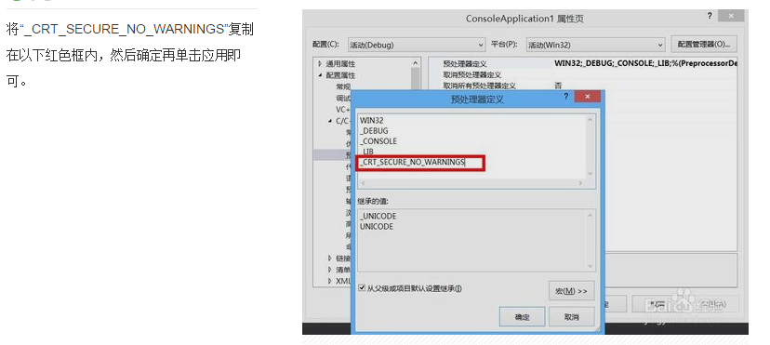
“ _CRT_SECURE_NO_WARNINGS “ 复制进去 问题OK
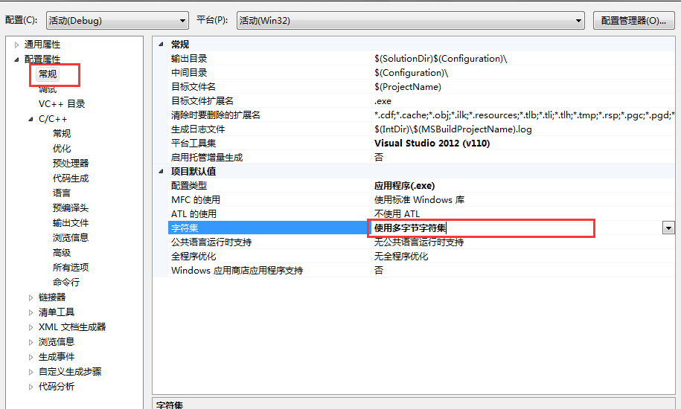
关于字符的出现的一些不知名的问题,

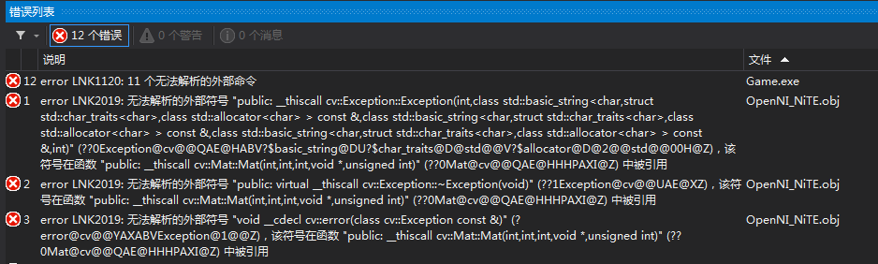
////OpenCV head file
#include "cv.h"
#include "highgui.h"
#pragma comment(lib,"opencv_highgui249.lib")
#pragma comment(lib,"opencv_core249.lib")
#pragma comment(lib,"opencv_highgui249.lib")
#pragma comment(lib,"opencv_imgproc249.lib")
问题,OK

关闭一些警告
#pragma warning ( push )
#pragma warning ( disable : 4005 )

#include "util\Util.h"
#include "scene\MyScene.h"
#include "util\OpenNI_NiTE.h"

#pragma warning ( pop )

此方法只能播放 .wav格式的音乐
#include <mmsystem.h> //导入声音头文件库
#pragma comment(lib,"winmm.lib")//导入声音的链接库
void CMyScene::fnLoadingMusic(){
::PlaySound((LPCSTR)"sound/music/GoodTime.wav", NULL, SND_FILENAME | SND_ASYNC);
}

