Google Search: android todo list app tutorial

<https://www.sitepoint.com/starting-android-development-creating-todo-app/>

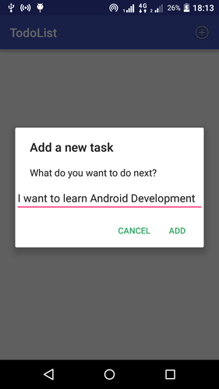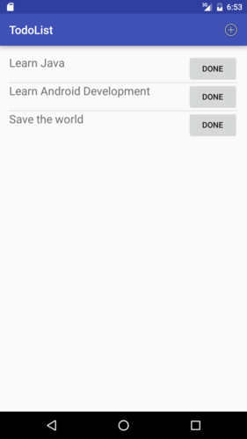

SQLite, ListView, dialog input

<https://www.codercrunch.com/post/47915445/build-a-todo-app-in-android>

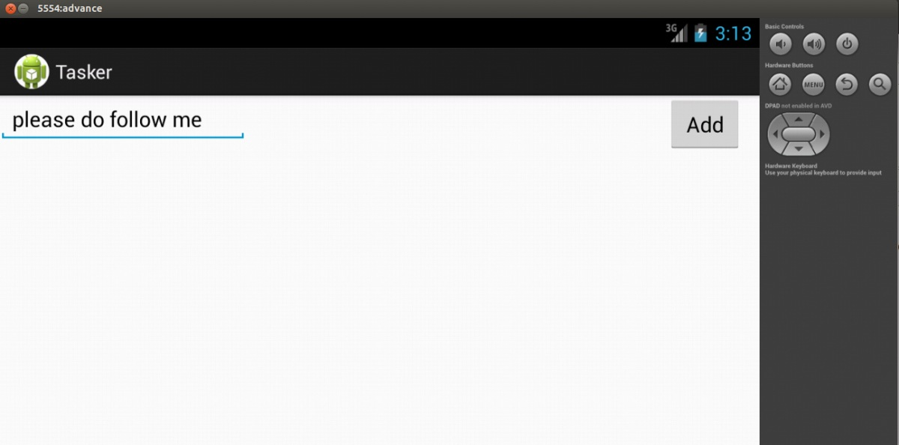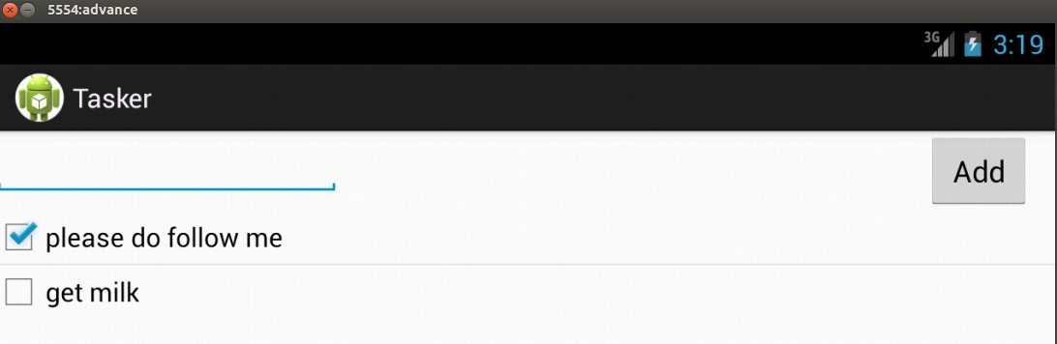

SQLite, ListView

<https://javapapers.com/android/android-todo-list-application-tutorial/>

<https://javapapers.com/wp-content/uploads/2014/11/androidtodo.zip>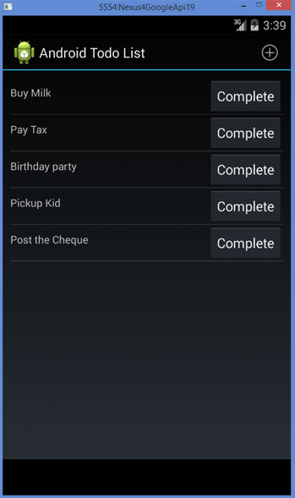 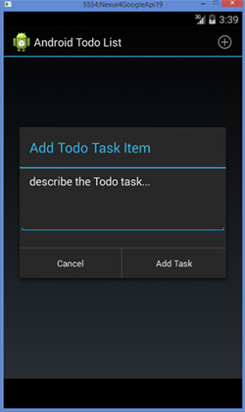

Dialog, SQLite, ListView

<https://androstock.com/tutorials/create-a-todo-task-app-on-android-android-studio.html>

<https://androstock.com/?smd_process_download=1&download_id=368>

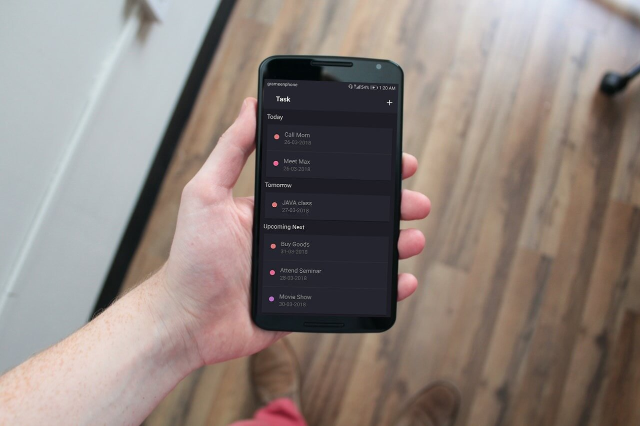

SQLite, ListView, AsyncTask

Video Tutorial

<https://www.journaldev.com/20688/android-room-todo-list-application>

<https://www.journaldev.com/wp-content/uploads/2018/04/AndroidRoomTodoList.zip>

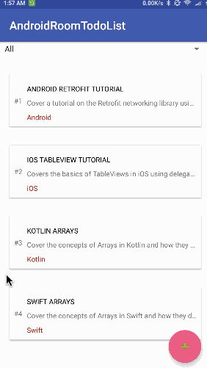

RecyclerView, CardView, SQLite

<http://dandroiddeveloper.github.io/list>

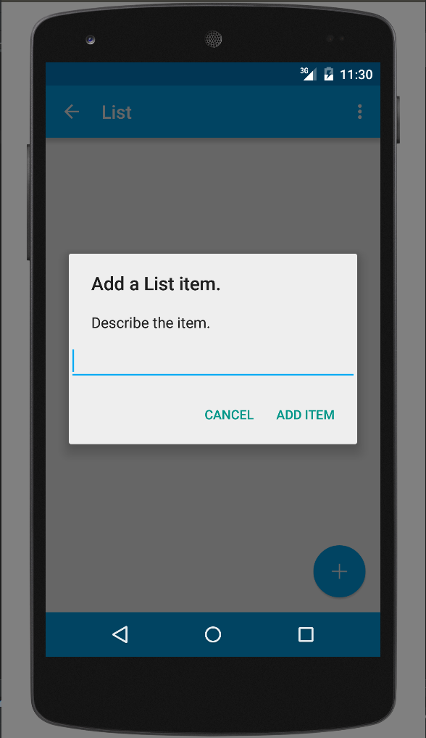 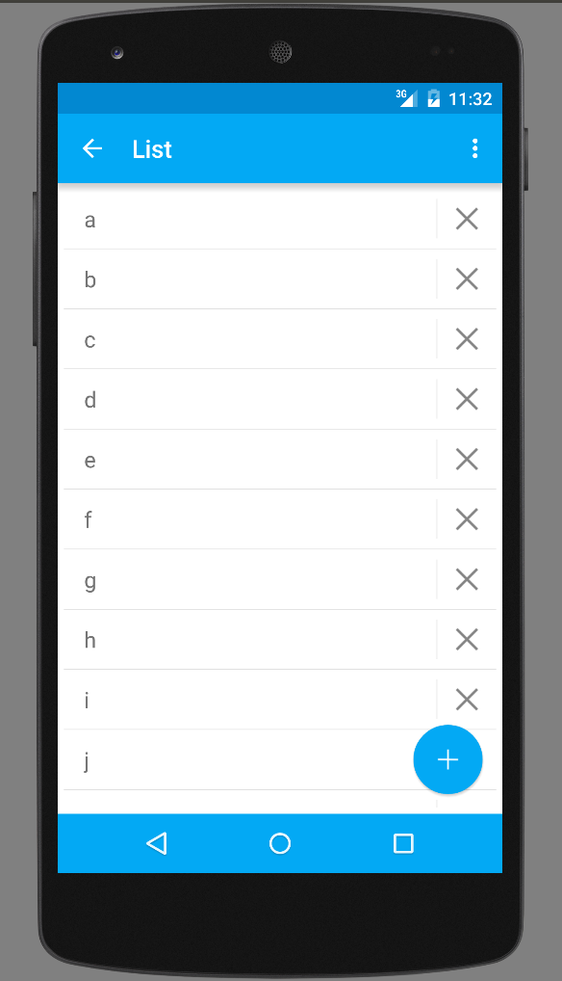

SQLite, ListView

<https://inducesmile.com/android/android-realm-database-creating-reactive-todo-list-using-realm-database/>

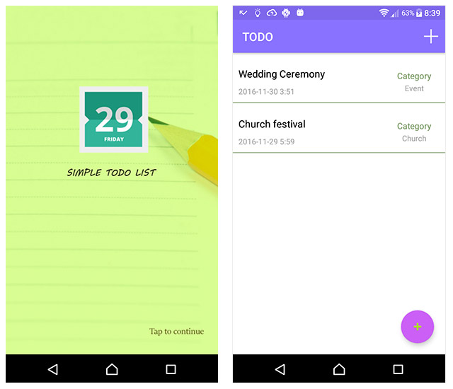 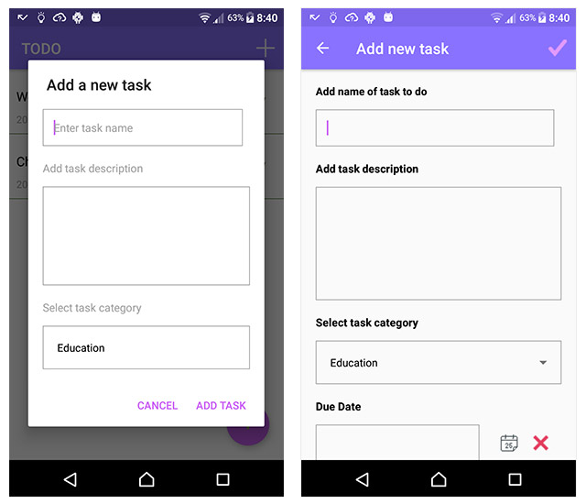

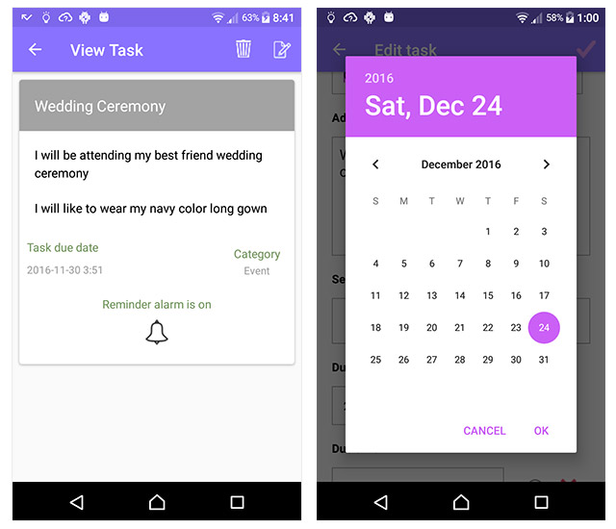

Realm database