**NAME: JAMES JOSHUA CHUKWUAMAKA**

**REG NO.: 20171070645**

**COURSE: CSC501 ASSIGNMENT**

**Assignment page 8-12**

**contact-form.php**

<!DOCTYPE html>

<html lang="en">

<head>

<meta charset="UTF-8">

<title>Contact Form</title>

</head>

<body>

<h2>Contact Us</h2>

<p>Please fill in this form and send us.</p>

<form action="process-form.php" method="post">

<p>

<label for="inputName">Name:<sup>\*</sup></label>

<input type="text" name="name" id="inputName">

</p>

<p>

<label for="inputEmail">Email:<sup>\*</sup></label>

<input type="text" name="email" id="inputEmail">

</p>

<p>

<label for="inputSubject">Subject:<sup>\*</sup></label>

<input type="text" name="subject" id="inputSubject">

</p>

<p>

<label for="inputComment1">Message:<sup>\*</sup></label>

<textarea name="message" id="inputComment" rows="5" cols="30"></textarea>

</p>

<input type="submit" value="Submit">

<input type="reset" value="Reset">

</form>

</body>

</html>

**process-form.php**

<!DOCTYPE html>

<html lang="en">

    <head>

        <meta charset="UTF-8">

        <title>Contact Form</title>

    </head>

    <body>

        <h1>Thank You</h1>

        <p>Here is the information that you submitted</p>

        <ol>

            <li><em>Name:</em> <?php echo $\_POST['name']?></li>

            <li><em>Email:</em> <?php echo $\_POST['email']?></li>

            <li><em>Subject:</em> <?php echo $\_POST['subject']?></li>

            <li><em>Message:</em> <?php echo $\_POST['message']?></li>

        </ol>

    </body>

</html>

**OUTPUT**

**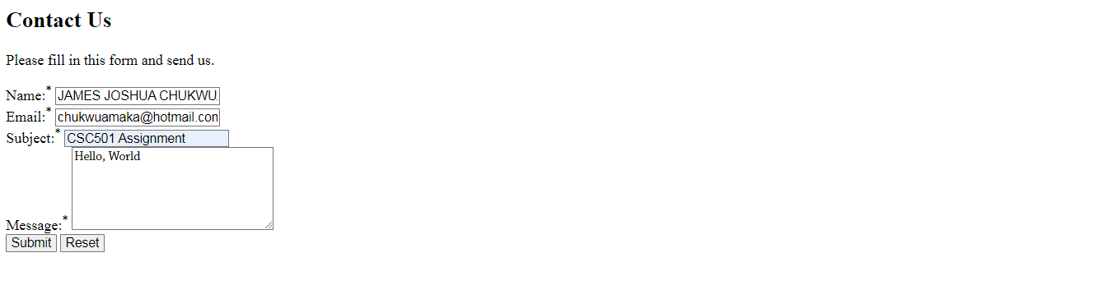**

****

**form.php**

<!DOCTYPE html>

<html lang="en">

<head>

<style type='text/css'>

.error {

color: red;

}

.success{

color: green;

}

</style>

<title>Contact form</title>

</head>

<body>

<h2>Contact Us</h2>

<p>Please fill in this form and send us</p>

<?php

$name = '';

$email = '';

$subject = '';

$message ='';

$emailErr = '';

$messageErr = '';

$nameErr = '';

?>

<form action="contact.php" method="post">

<p>

<label for="inputName">Name:<sup>\*</sup></label>

<input type="text" name="name" id="inputName" value="<?php echo $name; ?>">

<span class="error"><?php echo $nameErr; ?></span>

</p>

<p>

<label for="inputEmail">Email:<sup>\*</sup></label>

<input type="text" name="email" id="inputEmail" value="<?php echo $email; ?>">

<span class="error"><?php echo $emailErr; ?></span>

</p>

<p>

<label for="inputSubject">Subject:<sup>\*</sup></label>

<input type="text" name="subject" id="inputSubject" value="<?php echo $subject; ?>">

</p>

<p>

<label for="inputComment1">Message:<sup>\*</sup></label>

<textarea name="message" id="inputComment" rows="5" cols="30"><?php echo $message; ?></textarea>

<span class="error"><?php echo $messageErr; ?></span>

</p>

<input type="submit" value="Send">

<input type="reset" value="Reset">

</form>

</body>

</html>

**contact.php**

<?php

// functions to filter user inputs

function filterName($field){

// validate username

$field = filter\_var(trim($field), FILTER\_SANITIZE\_STRING);

// validate user name

if(filter\_var($field, FILTER\_VALIDATE\_REGEXP, array("options"=>array("regexp"=>"/^[a-zA-Z\s]+$/")))){

return $field;

}else{

return False;

}

}

function filterEmail($field){

// sanitize e-mail address

$field = filter\_var(trim($field), FILTER\_SANITIZE\_EMAIL);

// validate e-mail address

if(filter\_var($field, FILTER\_VALIDATE\_EMAIL)){

return $field;

}else{

return FALSE;

}

}

function filterString($field){

if(empty($field)){

return FALSE;

} else {

// sanitize string

$field = filter\_var(trim($field), FILTER\_SANITIZE\_STRING);

return $field;

}

}

// define variables and initialize with empty values

$nameErr = $email1Err = $messageErr = "";

$name = $email = $subject = $message = "";

// processing from data when form is submitted

if($\_SERVER["REQUEST\_METHOD"] == "POST"){

// validate user name

if(empty($\_POST["name"])){

$nameErr = 'Please enter your name.';

}else{

$name = filterName($\_POST["name"]);

if($name == FALSE){

$nameErr = 'Please enter a valid name';

}

}

// validate email address

if (empty($\_POST["email"])){

$email1Err = 'Please enter your email address';

}else{

$email = filterEmail($\_POST["email"]);

if($email==FALSE){

$email1Err = 'Please enter a valid email address';

}

}

// validate message subject

if(empty($\_POST["subject"])){

$subject = "";

}else{

$subject = filterString($\_POST["subject"]);

}

// validate user comment

if(empty($\_POST["message"])){

$messageErr = 'Please enter your comment.';

}else{

$message = filterString($\_POST["message"]);

if($message == FALSE){

$messageErr = 'Please enter a valid comment.';

}

}

// check input errors before sending email

if(empty($nameErr) && empty($email1Err) && empty($messageErr)){

// recipient email address

$to = 'webmaster@example.com';

// create email headers

$headers = 'From: '.$email."\r\n";

$headers .= 'Reply-To: '.$email."\r\n";

$headers .= 'X-Mailer: PHP/'.phpversion();

// sending email

if (mail($to, $subject, $message, $headers)){

echo '<p class="success"> Your message has been sent successfully!</p>';

} else{

echo '<p class="error"> Unable to send email. Please try again!</p>';

}

}

}

?>

**Output:**

****

****

**Assignment pages 30-31**

**post\_method.php**

<!DOCTYPE html>

<html lang="en">

<head>

<title>Example of PHP POST method</title>

</head>

<body>

<?php

if(isset($\_POST['name'])){

$name = htmlentities($\_POST['name']);

echo $name;

}

?>

<form method="post" action="<?php echo $\_SERVER['PHP\_SELF'];?>">

<label for="inputName">Name:</label>

<input type="text" name="name">

<input type="submit" value="Submit">

</form>

</body></html>

**Output**

joshua_5.PNG



**request.php**

<!DOCTYPE html>

<html lang="en">

<head>

<title>Example of PHP $\_REQUEST variable</title>

</head>

<body>

<?php

if(isset($\_REQUEST['name'])){

echo "<p>Hi, ".$\_REQUEST['name']."</p>";

$name = htmlentities($\_POST['name']);

echo $name;

}

?>

<form method="post" action="<?php echo $\_SERVER['PHP\_SELF'];?>">

<label for="inputName">Name:</label>

<input type="text" name="name" id=inputName">

<input type="submit" value="Submit">

</form>

</body>

</html>

**Output**

joshua_5.PNG

