**BIOL 125 Lab Report**

***Assignment #1: Introduction and References***

Dissemination of findings is an important part of the research process: If your results stay in your lab notebook, no one has the opportunity to benefit from them! This semester, you will communicate the results of your experiments through a lab report. The purpose of this assignment is to learn how to clearly communicate your work to other scientists.

A lab report has 6 sections: (1) Title, (2) Introduction, (3) Methods, (4) Results, (5) Discussion, (6) References. Because science writing is a skill developed through practice, you will turn in drafts of each section and have the opportunity to receive feedback on your work before submitting the final draft. In this assignment, you will complete drafts of the **Introduction** and **References** sections.

Introduction:

* In the Introduction section, you will present background information relevant to your work, describe the motivation for your study, and introduce your research questions. After reading your Introduction, the reader should have a basic understanding of your research area and be convinced that your work is important.
* For this lab report, your Introduction should be brief (~2 pages double-spaced).
* Questions that may be important to address:
  + What is a bacteriophage?
  + Why is it worthwhile to isolate bacteriophages that can infect *Bacillus*?
  + Why is it important to isolate novel bacteriophages? (*Hint:* Think about phage therapy or other potential applications)
* Your Introduction should reference at least 3 sources. One of these papers may be a review article, and two papers should present results from an original research study[1]. All of your sources should be peer-reviewed[2].
  + PubMed and ScienceDirect are two good sources for peer-reviewed scientific articles. You can access both of these databases (and many more!) by going to the UMW Libraries website (<https://libraries.umw.edu/>), clicking on “Databases,” then clicking on “View full database list.” PubMed can be found under “P,” and Science Direct can be found under “S.” Feel free to browse and look at other databases if you would like!

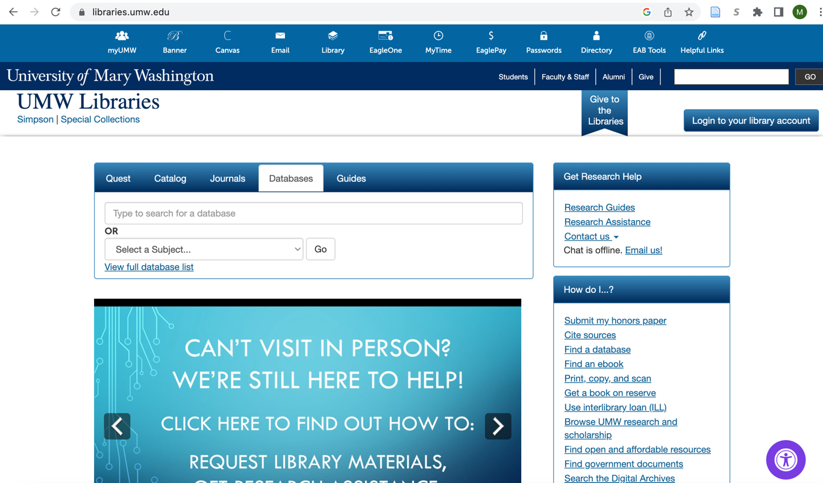

* We will show an example of how to search for an article on ScienceDirect, but similar guidelines apply across databases:
  1. Go to ScienceDirect (<https://www.sciencedirect.com/>). The home page will look like this:

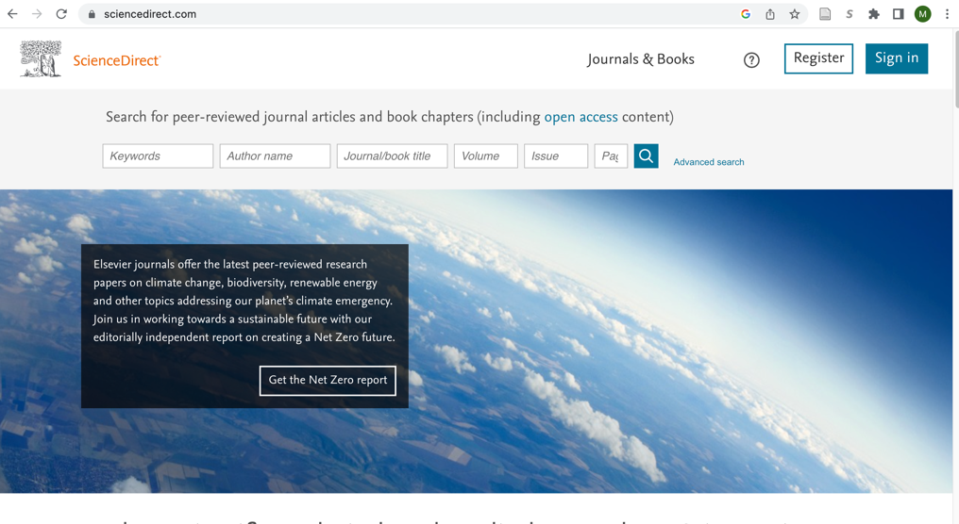

* 1. Enter your search terms in the “Keywords” box. If you would prefer that the article include all of your search terms, separate each term by “AND” (e.g., bacteriophage AND therapy). If the article only needs to contain one of your search terms, separate each term by “OR” (e.g., bacteriophage OR therapy).
  2. 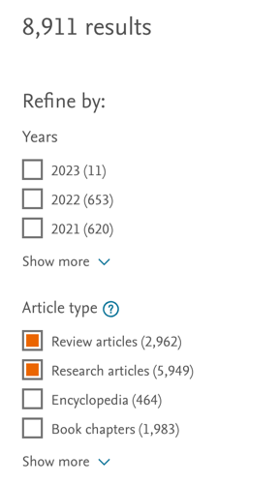On the results page, limit your results to review articles and research articles. Though not required, you may also want to refine your results by year, prioritizing recent papers (published within the last 5 years) over older papers.
* *Note:* If you are interested in an article but cannot find the full text, please e-mail Mallory or Dr. Agrawal, and they will find a copy for you. You should NOT cite an article that you have not read in its entirety.
* Each paper should be cited in-text **and** included in your References list. Please use APA citation format. For instructions on how to use APA format for your citations, see the [APA Style Guide](https://owl.purdue.edu/owl/research_and_citation/apa_style/apa_formatting_and_style_guide/general_format.html) from the Purdue University Online Writing Lab.
  + You may want to consider installing a citation manager, like Zotero. A citation manager is helpful for collecting and organizing your sources. The software also generates formatted in-text citations and references, which is a big time-saver! Instructions for installing Zotero can be found here: <https://libguides.umw.edu/zotero>
* Your Introduction should conclude with a description of your study, including your research questions or objectives. As an example (from an unrelated field), here is one of Mallory’s study descriptions. Note that this paragraph employs first-person point of view. Traditionally, scientific articles have used third-person point of view, but some journals now prefer first-person narrative. You can use either third-person or first-person narrative in your lab report.

*In the current study, we employed a co-twin comparison design in a sample of Finnish twins followed longitudinally from adolescence to young adulthood. We examined a series of adolescent risk and protective factors for alcohol misuse, including academic performance, early adolescent substance use, externalizing problems, internalizing problems, parent-child relationship quality, peer environment, and physical health. The alcohol misuse outcome included frequency of alcohol use and frequency of intoxication. Our aims were as follows:*

1. *Evaluate adolescent predictors of young adult alcohol misuse in individual-level analyses, which are comparable to prior studies conducted on samples of unrelated individuals.*
2. *Use the co-twin comparison design to evaluate whether observed individual-level associations remain significant after controlling for genetic and environmental influences shared by twin siblings.*

References:

* Include an APA-formatted references list on a separate page. Remember that each paper on your references list should also be cited in the text. Instructions for creating an APA-formatted reference list can be found in the [APA Style Guide](https://owl.purdue.edu/owl/research_and_citation/apa_style/apa_formatting_and_style_guide/general_format.html) .

**Due Dates:**

* By Friday, October 28, submit your references list to Dr. Agrawal or Mallory for approval. You may submit your references via e-mail or bring them to office hours.
* Your Introduction draft and references are due on **Monday, November 7.**

1. A review article summarizes findings from many previously published studies, whereas an original research study presents new research conducted by the author(s). Examples of a review article and original research paper will be provided on Canvas.
2. A peer-reviewed article has been evaluated and approved for publication by individuals with expertise related to the article’s contents.