**Energy Consumption in the City of Chicago**

**Principal Investigator: Stephen Steiner (ssteiner4@uwalumni.com)**

*In this project, I study how natural gas and electricity consumption varies across the City of Chicago. Where are the biggest users of energy located? How does temperature affect consumption? What does the demand curve look like for natural gas and electricity? I begin by giving several interesting summary statistics, including the elasticity of temperature for different building types, as well as a mapping of energy consumption across Chicago. I find that, after doing away with the seasonality in the data, there is a statistically significant relationship between price per KWH and electricity consumption for residential buildings; a 1 cent increase in price per KWH is associated with a .135 KWH/sqft decrease in residential electricity consumption. While price per KWH and electricity consumption for commercial buildings has a statically significant relationship, the magnitude of the coefficient suggests that there is an omitted variable. I also find a statistically significant relationship between natural gas consumption and price, but I am concerned about bias due to what seems like a price shock in the summer of 2010.*

**Analysis**

For this section, I will be referring to electricity in units of kilowatt-hours (KWH) per square foot and natural gas per square foot in units of therms (1 therm = 100,000 BTUs). For reference, an average air conditioner will require 3 to 5 KWHs to run1 and an average furnace will require .8 to 1 therms per hour, or 80,000 to 100,000 BTUs;2 the amount of energy consumed per square foot will vary by building size but bear in mind that the average house in the US is 2,687 square feet.3

Additionally, most of what I will be discussing will be with regards to heating and/or cooling. These are generally the largest consumers of energy and drive much of the variation in energy consumption over the course of the year as the seasons change.

**Energy Concentrations across Chicago and Elasticity of Temperature**

Before getting into the heart of the analysis, it would be useful to familiarize ourselves with the distribution of energy consumption in communities across the city. It should come as little surprise that Figures 1a and 1b below show very clearly that the Loop consumed the largest amount of energy per square foot. Note that the maps below show average monthly energy consumption per square foot through the city; for example, buildings in the Loop consumed on average 631,074.6 KWH/sqft of electricity and 679,280.1 therm/sqft of natural gas.

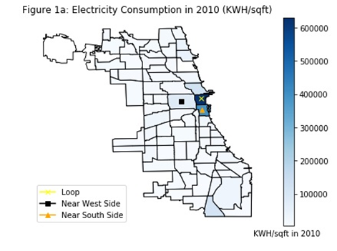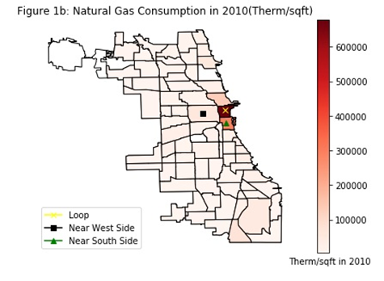

In Figures 2 and 3, August and December were chosen as representative months of the Summer and Winter seasons, respectively, because they are the most demanding seasons of the year. The advent of heating and air conditioning systems brought unprecedented energy demands—these seasons of extreme temperatures require the high levels of energy in order to maintain favorable temperatures.

Interestingly, when looking at aggregate natural gas consumption for August and December in Figures 2b and 3b, the Near West Side uses the most; this is because it has many industrial buildings (5,796,167 therms were used in December alone). Interestingly, as seen in Figure 2a, the Loop uses almost as much electricity in August as the Near West Side despite the concentration of industrial buildings on the Near West Side (48,097,101 KWH in the Loop and 51,589,125 KWH in the Near West Side) and actually uses more electricity than the Near West Side in December (62,344,363 KWH in the Loop and 40,901,987 in the Near West Side).

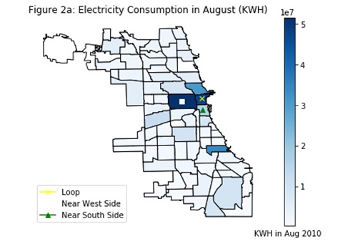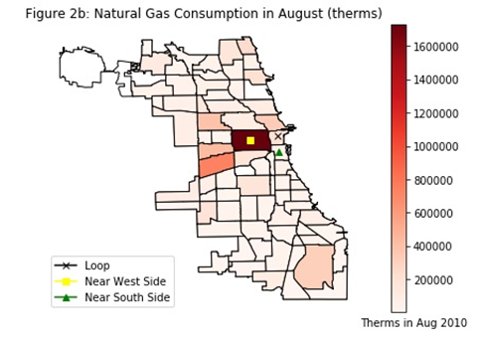

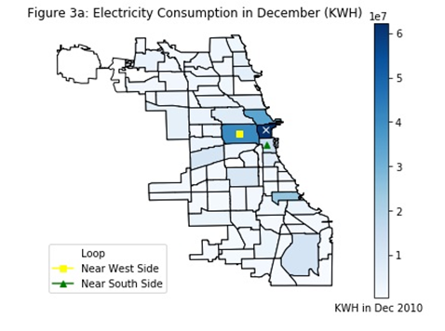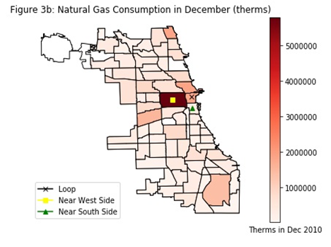

Before delving too much farther into my analysis, I should note that the dataset specifically omitted several thousand observations due to privacy concerns and lumped them into the community observations, which are shown in the maps. After getting rid of the empty observations, I was left with 26 industrial buildings, preventing me from performing any meaningful analysis regarding industrial buildings (therefore I omit industrial buildings from much of my analysis moving forward). Thankfully, there were more than enough commercial and residential building observations in the roughly 67,000 observations to analyze. I’ve separated them because their energy demands are very different, as shown Figures 4a and 4b. One can see quite clearly the stark contrast in mean energy consumption per square foot that would necessitate their separation.

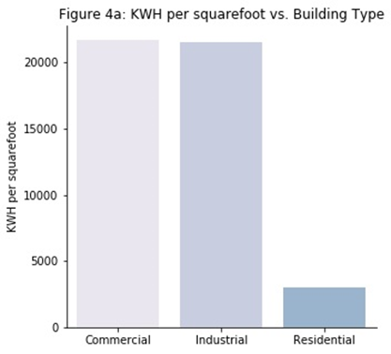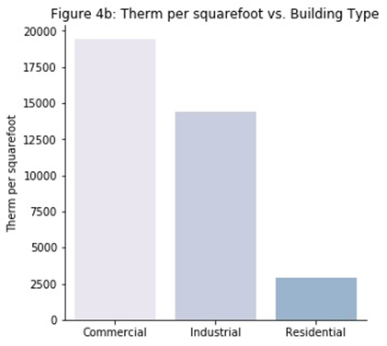

In Table 1 below, I list a number of summary statistics regarding census block, climate characteristics, and their effect on aggregate energy consumption during each month of 2010. I am more interested in aggregate consumption here because I would like to reflect on how building size impacts aggregate consumption; I look at energy consumption per square foot later in the report in order to take a closer look at individual preferences.

Initially, the negative coefficient on average building age seems counterintuitive. But this is likely because newer buildings are built to be bigger, house more people, have more amenities, etc. than older buildings, resulting in higher energy demands. Furthermore, the sharp increase in energy consumption associated with a one floor increase in building size doesn’t come as much of a surprise, but it is still quite astonishing to see such a large coefficient.

Not surprisingly, the data also reflects a seasonal change in energy consumption; as average temperature for a given month increases by 1 degree, we see an increase in electricity consumption by 42.73 KWH for residential buildings and a 51.25 KWH increase for commercial buildings. Conversely, a increase in average temperature by one degree is associated with a 47.27 therm decrease for residential buildings and a 57.65 therm decrease for commercial buildings. The positive relationship between electricity and temperature reflects the high demand of air conditioners during summer months while the inverse relationship between natural gas consumption and temperature reflects the high demand of furnaces during winter months. This seasonality in the data proved to be challenging when trying to find the relationship between price and quantity demanded.

|  |  |  |  |  |
| --- | --- | --- | --- | --- |
| **Table 1: Summary Statistics** | | | | |
|  | **Residential** | | **Commercial** | |
| **Parameters** | **Natural Gas (Therms)** | **Electricity (KWH)** | **Natural Gas (Therms)** | **Electricity (KWH)** |
| **Average Temperature** | -47.27 | 42.73 | -57.65 | 51.25 |
| **Average Stories** | 210.73 | 1284.92 | 760.42 | 25,350 |
| **Average Building Age** | -3.07 | -42.78 | -16.88 | -404.30 |
| **Population** | 4.88 | 29.94 | 10.34 | 43.24 |
| * All coefficients above are statistically significant at the 1% level. | | | | |

**Energy Demand (TWO-STAGE LEAST SQUARES MODEL)**

In order to find the true relationship between price and monthly energy demand, I first had to get rid of the seasonality in the data. I found that electricity and natural gas demands seemed to have an inverse relationship over the course of the year, so I used electricity consumption as an instrument for the relationship between price per therm and natural gas consumption and natural gas consumption as an instrument for the relationship between price per KWH and electricity consumption. I did not control for temperature in this model because of the strong multicollinearity between price and average temperature.

***KWH/sqft Equations***

***Therm/sqft Equations***

I would argue that the instruments are exogenous because of the large fixed costs associated with replacing heating and cooling systems. Electricity and natural gas can most certainly be considered substitutes, but due to the lags associated with purchasing and installing new systems, it is unlikely that we would see a significant relationship between the instruments and their respective model error terms in the short term. Below are the tests for relevance of each instrument in Table 2. Initially, the coefficients appear small, but when one considers the sheer volume of KWHs and therms consumed, their relevance is clear.

|  |  |  |  |  |
| --- | --- | --- | --- | --- |
| **Table 2: Relevance of Instruments (Robust Standard Errors)** | | | | |
| **Parameter** | **Coefficient** | **Standard Error** | **Z-Statistic** | **P-Value** |
| **KWH Price regressed on Residential Therms/sqft** | | | | |
| **Residential Therms/sqft** | -3.618 | 0.271 | -13.36 | 0 |
| **Therm Price regressed on Residential KWH/sqft** | | | | |
| **Residential KWH/sqft** | -1.514 | 0.105 | -11.38 | 0 |
| **KWH Price regressed on Commercial Therms/sqft** | | | | |
| **Commercial Therms/sqft** | -0.757 | 0.056 | -13.51 | 0 |
| **Therm Price regressed on Commercial KWH/sqft** | | | | |
| **Commercial KWH/sqft** | -0.100 | 0.012 | -8.64 | 0 |
| *Each of the regressions above were run while holding population, average stories, and average building age constant. P-values are sufficiently close to zero such that they are listed as zero. | | | | |
|

I am concerned, however, about bias that may be introduced into my natural gas models by what appears to be a natural gas price shock during the Summer of 2010. The price per therm seemed to have been declining through the Spring only to shoot up in the Summer and decrease again headed into Fall. There did not seem to be a significant increase in natural gas demand for any of the building types to cause this, suggesting that there was some shock to the natural gas market that I was unable to account for. This would also imply biased results for the relationship between residential natural gas consumption and price per therm; further research is required to investigate this possible price shock and its implications in the model. My other concern is about commercial electricity consumption; the model predicts that commercial consumers will consume negative amounts of electricity when prices reach their highest (as shown in Figure 5b), a prospect which simply cannot be true. I include these results in the table below but will only discuss residential electricity consumption because these results have very little, if any, bias and are therefore closest to the actual value.

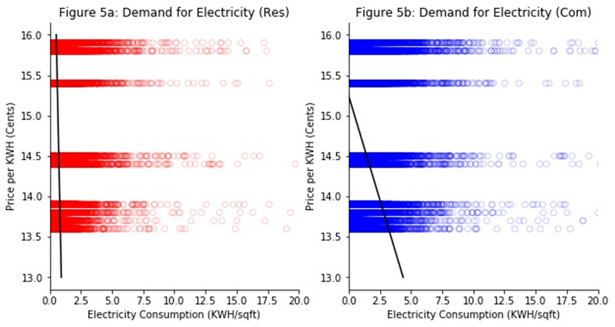

According to my findings, a one cent increase in KWH price is associated with a 0.135 KWH/sqft decrease in electricity consumption for residential consumers. This would suggest that consumers are relatively price inelastic with regards to energy consumption. Such a conclusion is consistent with basic intuition; one would assume that in the Winter, a consumer would not be particularly concerned with the price of energy but would instead be concerned about keeping their house at a reasonable temperature. The same logic follows for Summer months and extreme heat.

|  |  |  |  |  |
| --- | --- | --- | --- | --- |
| **Table 3: Instrumental Variable Estimates** | | | | |
| **Parameter** | **Coefficient** | **Standard Error** | **T-Statistic** | **P-Value** |
| **Residential KWH/sqft regressed on KWH Price** a | | | | |
| **KWH Price** | -0.135 | 0.017 | -7.76 | 0* |
| **Residential Therm/sqft regressed on Therm Price** b | | | | |
| **Therm Price** | -0.015 | 0.002 | -7.66 | 0* |
| **Commercial KWH/sqft regressed on KWH Price** c | | | | |
| **KWH Price** | -1.556 | 0.118 | -13.23 | 0* |
| **Commercial Therm/sqft regressed on Therm Price** d | | | | |
| **Therm Price** | -0.150 | -0.018 | -8.22 | 0* |
| a Instrumental Variable: residential therm/sqft. b Instrumental Variable: residential KWH/sqft. c Instrumental Variable: commercial therm/sqft. d Instrumental Variable: commercial KWH/sqft. *P-Values are sufficiently close to zero such that they are listed as zero. All models above were run while holding population, average stories, and average building age constant. | | | | |
|

**Conclusions and directions for future research**

Over the course of this project, I learned more about the distribution of energy consumption across the City of Chicago and that there is a statistically significant relationship between temperature and energy consumption. I also found a relationship between price and energy consumption for residential and commercial buildings, but there is still much more work to be done with regards to commercial electricity and natural gas consumption for both.

The model suggests that commercial consumers would start to consume negative amounts of electricity. This simply cannot be true and suggests that there is an omitted variable in my model, a problem that certainly warrants further research. I would also like to investigate what I suspect to be a shock to the natural gas market during the summer of 2010. Residential, Commercial, and Industrial natural gas consumption decreased during that time while prices rose, which would imply that there was some market force that drove prices to increase. Because the instrument I chose merely did away with the seasonality in my estimates, it is likely that the aforementioned shock led to bias in my natural gas price coefficients. Therefore, any future research would have to investigate this price shock in an effort to eliminate bias.

**Works Cited**

1. “Electricity Usage of a Central Air Conditioner.” *Electricity Usage of a CFL Light Bulb - Energy Use Calculator*, energyusecalculator.com/electricity_centralac.htm.

2. Miller, Renee. “The Average BTU of Furnaces.” *Home Guides | SF Gate*, 21 Nov. 2017, homeguides.sfgate.com/average-btu-furnaces-88602.html.

3. Perry, Mark J. “New US Homes Today Are 1,000 Square Feet Larger than in 1973 and Living Space per Person Has Nearly Doubled.” *AEI*, 5 June 2016, www.aei.org/publication/new-us-homes-today-are-1000-square-feet-larger-than-in-1973-and-living-space-per-person-has-nearly-doubled/.

4. “Peoples Gas Historical Gas Charge Rates per Therm.” *Illinois Commerce Commission*, www.icc.illinois.gov/ags/pgarates.aspx.

5. Bureau of Labor, Statistics. “BLS Electricity Price ($/KWH) in Chicago 2010.” Oct. 2018.

6. City of, Chicago. “Chicago Energy Usage 2010”; “Community Geographic Boundaries.” Chicago Data Portal, 11 July 2018.