**Energy Consumption in the City of Chicago, 2010**

*In this project, I study how natural gas and electricity consumption varies across the City of Chicago. Where are the biggest users of energy located? How does temperature affect consumption? I begin by giving several interesting summary statistics, including the relationship between energy consumption and average temperature for residential buildings, as well as a mapping of energy consumption across Chicago. I then offer avenues for future research.*

**Analysis**

For this section, I will be referring to electricity in units of kilowatt-hours (KWH) per square foot and natural gas per square foot in units of therms (1 therm = 100,000 BTUs). For reference, an average air conditioner will require 3 to 5 KWHs to run1 and an average furnace will require .8 to 1 therms per hour, or 80,000 to 100,000 BTUs;2 the amount of energy consumed per square foot will vary by building size but bear in mind that the average house in the US is 2,687 square feet.3

Additionally, most of what I will be discussing will be with regards to heating and/or cooling. These are generally the largest consumers of energy and drive much of the variation in energy consumption over the course of the year as the seasons change.

**Energy Distribution across Chicago and Energy’s Relationship with Temperature**

Before getting into the heart of the analysis, it would be useful to familiarize ourselves with the distribution of energy consumption in communities across the city. It should come as little surprise that Figures 1a and 1b below show very clearly that the Loop consumed the largest amount of energy per square foot. Note that the maps below show average energy consumption per square foot through the city, so buildings in the Loop consumed on average 631,074.6 KWH/sqft of electricity and 679,280.1 therm/sqft of natural gas.

Average monthly temperature data in the city of Chicago was gathered from a website called “Weather Underground”.7 In Figures 2 and 3, August and December were chosen as representative months of the Summer and Winter seasons, respectively, because they are two of the most demanding months of the year. The advent of heating and air conditioning systems brought unprecedented energy demands—these extreme temperature months require the high levels of energy in order to maintain favorable temperatures.

Interestingly, when looking at aggregate natural gas consumption for August and December in Figures 2b and 3b, the Near West Side uses the most; this is because it has many industrial buildings (5,796,167 therms were used in December alone). Interestingly, as seen in Figure 2a, the Loop uses almost as much electricity in August as the Near West Side despite the concentration of industrial buildings on the Near West Side (48,097,101 KWH in the Loop and 51,589,125 KWH in the Near West Side) and actually uses more electricity than the Near West Side in December (62,344,363 KWH in the Loop and 40,901,987 in the Near West Side).

Before delving too much farther into my analysis, I should note that the dataset specifically omitted several thousand observations due to privacy concerns and lumped them into the community observations, which are shown in the maps. Thankfully, there were more than enough residential building observations in the roughly 67,000 observations to analyze. As shown in Figures 4a and 4b, residential census blocks have very different energy demands relative to commercial and industrial census blocks. Presumably, residential consumers have much more straightforward energy consumption patterns so they will be the focus of the analysis moving forward. Future research could potentially investigate commercial and industrial census blocks’ consumption patterns so long as the researcher has other data on these census blocks that could address potential omitted variable bias.

For the discussion of summary statistics, I take the natural log of census block electricity and natural gas consumption. Figures 5a and 5b illustrate this; certain census blocks used remarkably high levels of energy relative to others. By taking the logs of these values, they are now normally distributed and thus may be analyzed in a simple OLS model. Additionally, all standard errors shown are clustered around community to address any potential clustering effects within communities.

In Table 1 below, I list a number of summary statistics regarding census block, climate characteristics, and their effect on aggregate energy consumption during each month of 2010. I am more interested in aggregate consumption here because I would like to reflect on how building size impacts aggregate consumption; I look at energy consumption per square foot later in the report in order to take a closer look at individual preferences.

Initially, the negative relationship between average building age and electricity consumption seems counterintuitive because newer homes are built to be more efficient than their predecessors. But this is likely because newer buildings are built to be bigger, house more people, have more amenities, etc., than older buildings, resulting in higher electricity demands. Surprisingly, we do not see a statistically significant relationship between average number of stories and energy consumption.

As expected, the data also reflects a seasonal change in energy consumption; as average temperature for a given month increases by 1 degree, we see an increase in electricity consumption by .6% KWH for residential buildings. Conversely, an increase in average temperature by one degree is associated with a 4.4% therm decrease for residential buildings. The positive relationship between electricity and temperature reflects the high demand of air conditioning during summer months while the inverse relationship between natural gas consumption and temperature reflects the high demand of heating during winter months, thus reflecting the seasonal pattern we expected to see.

**Energy Demand and Directions for Future Research**

Over the course of this project, I learned more about the distribution of energy consumption across the City of Chicago and that there is a statistically significant relationship between temperature and energy consumption. Unfortunately, I could not determine the price elasticities for natural gas and electricity because prices were not included in the dataset. While I tried using average prices for electricity and natural gas from the Bureau of Labor Statistics5 and Illinois Commerce Commission6, respectively, the results were inconclusive. Further work could potentially be done with Chicago’s utility companies to determine electricity and natural prices to the census blocks within this dataset.

I would also like to investigate what I suspect to be a shock to the natural gas market during the summer of 2010. Residential, Commercial, and Industrial natural gas consumption decreased during that time while prices rose, which would imply that there was some market force that drove prices to increase. Any future research would have to investigate this price shock in an effort to eliminate bias.

**Appendix**

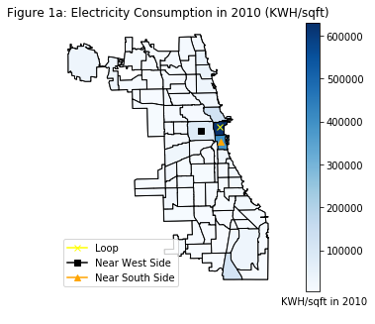 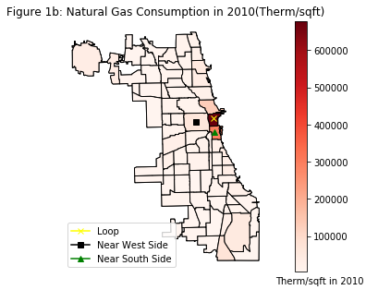

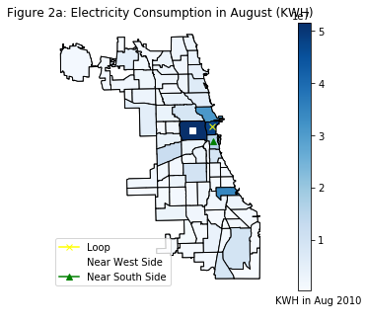 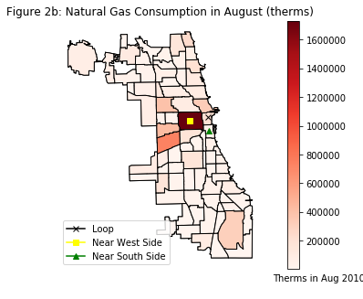

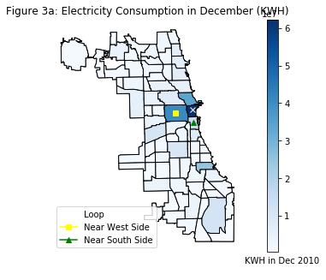 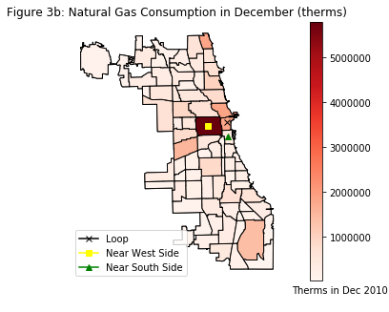

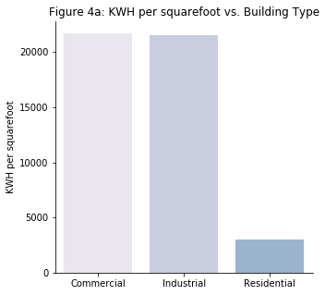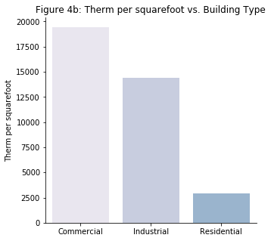

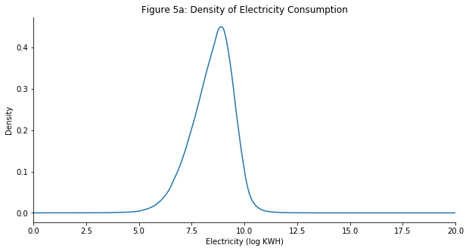

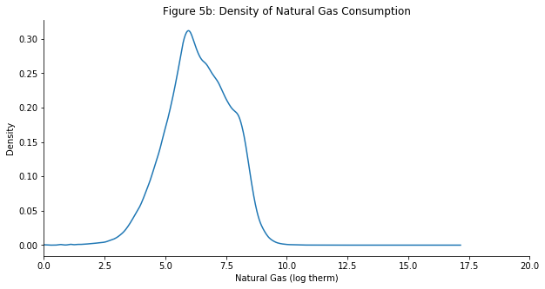

**Table 1: Summary Statistics**

|  |  |  |
| --- | --- | --- |
|  | **Residential** | |
| **Parameters** | **Natural Gas (Log Therms)** | **Electricity (Log KWH)** |
| **Average Temperature** | -0.044 (~0)*** | .006 (~0)*** |
| **Average Stories** | 0.040 (0.03) | -0.026 (0.05) |
| **Average Building Age** | 0.001 (~0)* | -0.004 (~0)*** |

**Works Cited**

1. “Electricity Usage of a Central Air Conditioner.” *Electricity Usage of a CFL Light Bulb - Energy Use Calculator*, energyusecalculator.com/electricity_centralac.htm.

2. Miller, Renee. “The Average BTU of Furnaces.” *Home Guides | SF Gate*, 21 Nov. 2017, homeguides.sfgate.com/average-btu-furnaces-88602.html.

3. Perry, Mark J. “New US Homes Today Are 1,000 Square Feet Larger than in 1973 and Living Space per Person Has Nearly Doubled.” *AEI*, 5 June 2016, www.aei.org/publication/new-us-homes-today-are-1000-square-feet-larger-than-in-1973-and-living-space-per-person-has-nearly-doubled/.

4. “Peoples Gas Historical Gas Charge Rates per Therm.” *Illinois Commerce Commission*, www.icc.illinois.gov/ags/pgarates.aspx.

5. Bureau of Labor, Statistics. “BLS Electricity Price ($/KWH) in Chicago 2010.” Oct. 2018.

6. City of, Chicago. “Chicago Energy Usage 2010”; “Community Geographic Boundaries.” Chicago Data Portal, 11 July 2018.

7. “Chicago, IL Weather Historystar_ratehome.” *Weather Underground*, www.wunderground.com/history/monthly/us/il/chicago/KORD/date/2010-12.