Prepared by: Shek Yu, Wong
Date: June 3, 2025
Tools Used:
IBM Telco Customer Churn Dataset,
Power BI, DAX, Power Query,
Tableau Public, Calculated Fields, Custom Groups
Telco Customer Churn Analysis
Power BI and Tableau Dashboard Report

Contents
Project Overview 2
Key Objectives 2
Dashboard Structure and Dataset 2
GitHub Link 2
Power BI and Tableau Screenshots 3
Page 1 – Overview 3
Page 2 – Customer Profile & Service 4
Page 3 – Churn Drivers & Retention 5
Retention Insight for the IBM Churn Dataset 6

Project Overview
This Power BI and Tableau dashboards analyze customer churn behavior in a telecom company using the IBM Telco Churn dataset. It explores churn trends by customer profiles, contract types, tenure, monthly charges, and service usage.

Key Objectives
- Identify high-risk churn segments
- Understand churn drivers by service type and pricing
- Provide actionable retention insights

Dashboard Structure and Dataset
- Data Source: IBM Telco Customer Churn Dataset (~7,000 records, 21 columns)
- Visualization Pages:
  - Overview – Churn KPIs by contract/payment/tenure
  - Customer Profile & Service – Demographics and service churn behavior
  - Churn Drivers & Retention – Monthly charges, tenure, and dissatisfaction factors

GitHub Link
https://github.com/stephensyw/telecom-churn-dashboard

Power BI and Tableau Screenshots

Page 1 – Overview
Customers with month-to-month contracts and paying via electronic check show the highest churn rate, indicating lower commitment and potential dissatisfaction with service terms.
Power BI | Tableau
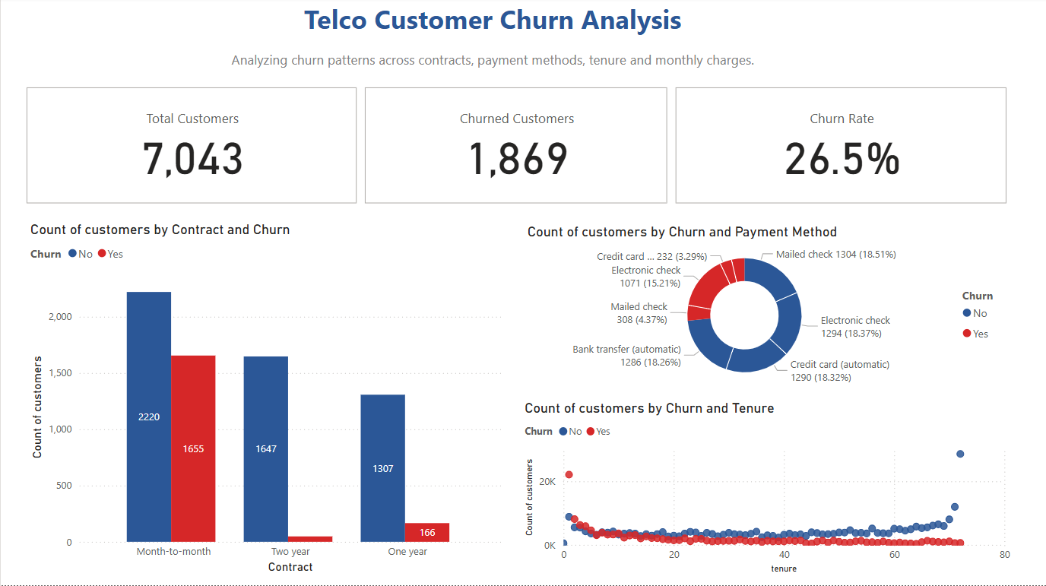 | 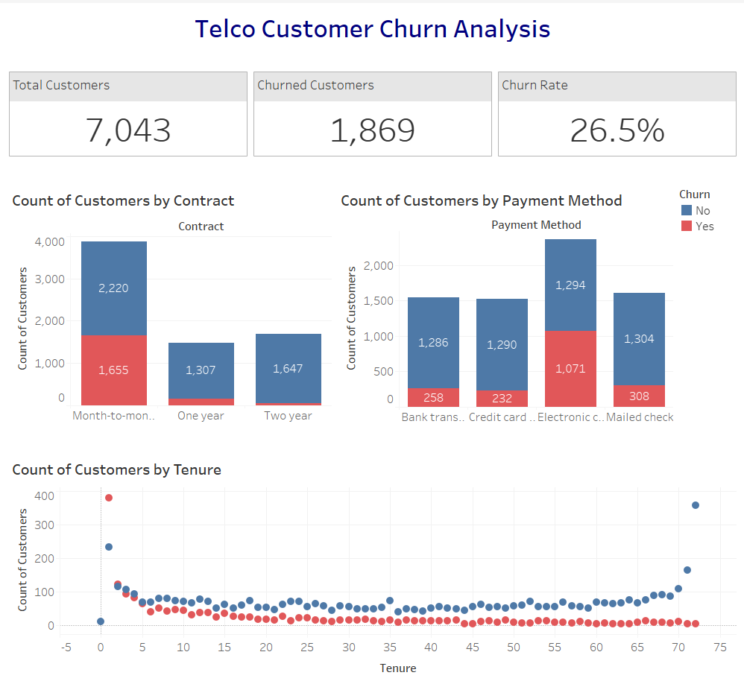

Page 2 – Customer Profile & Service
Customers with dependents, those using fiber optic and those without tech add-on services (e.g., online security, backup) are more likely to churn, suggesting targeted retention opportunities.
Power BI | Tableau
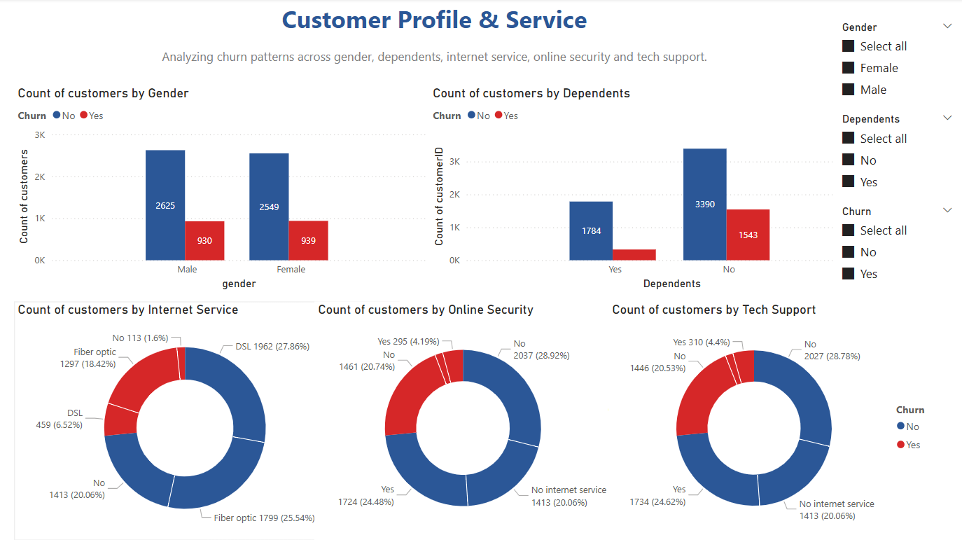 | 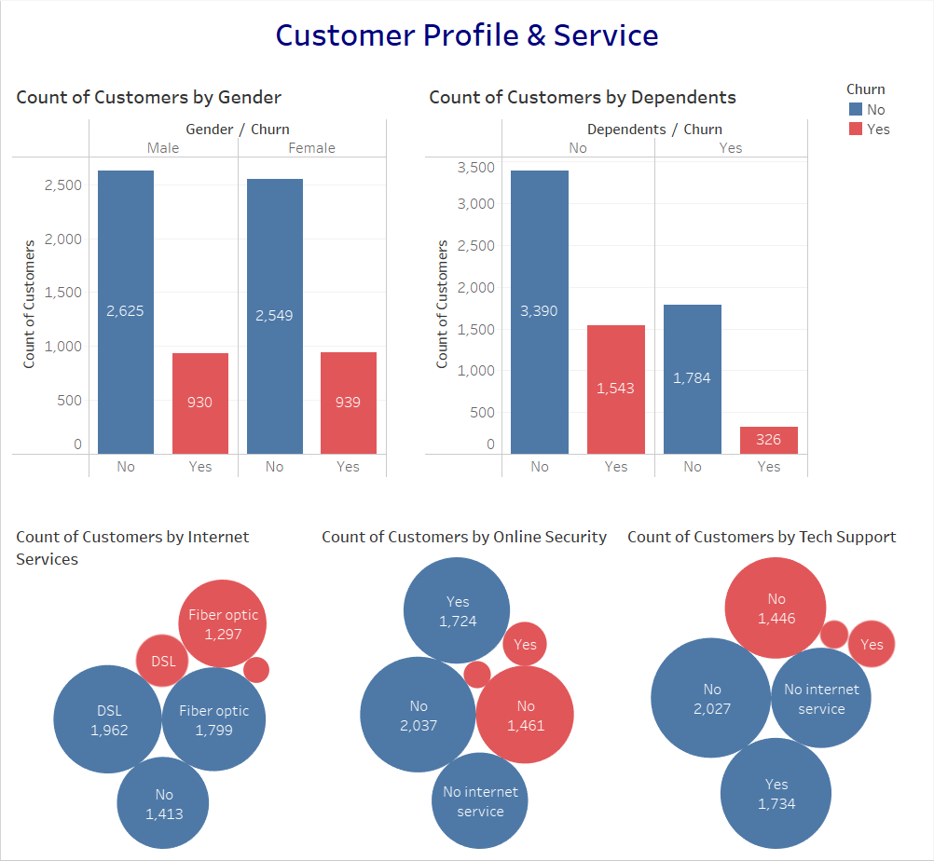

Page 3 – Churn Drivers & Retention
Churn rate is highest for customers with monthly charges between $71–$90 and tenure under 12 months, highlighting the need to review pricing and early-stage user experience.
Power BI | Tableau
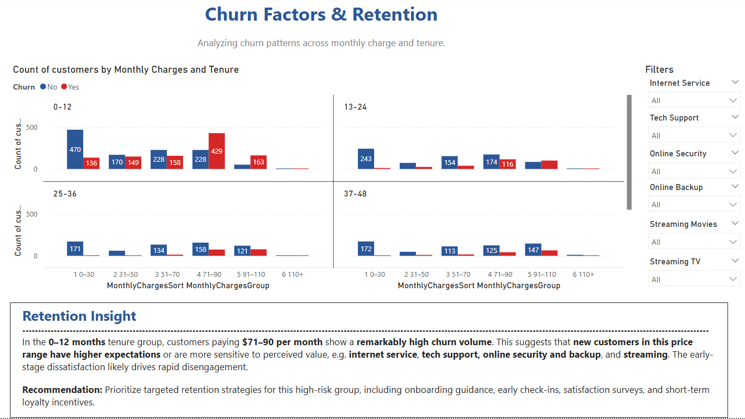 | 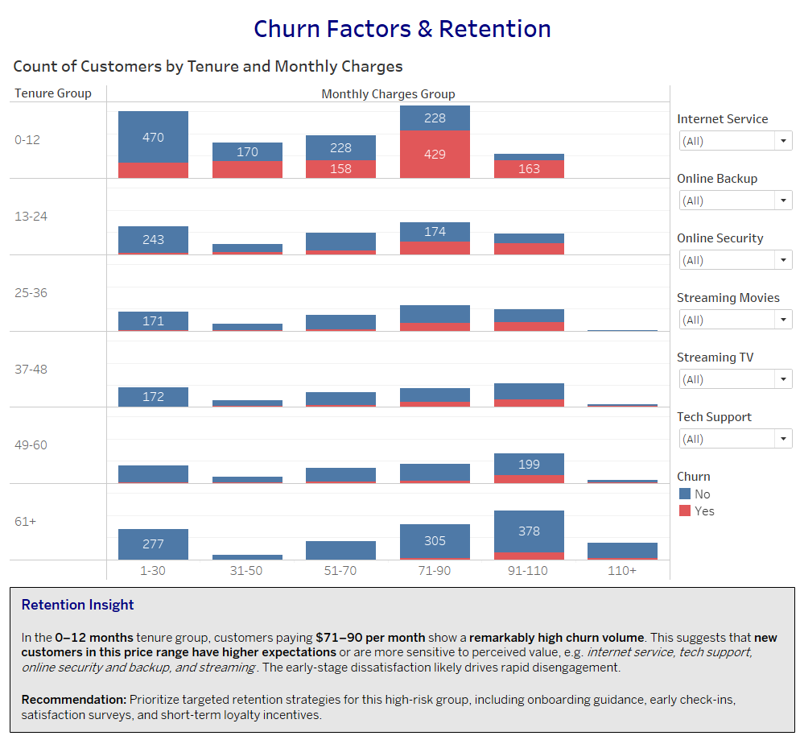

Retention Insight for the IBM Churn Dataset
In the 0–12 months tenure group, customers paying $71–90 per month show a remarkably high churn volume. This suggests that new customers in this price range have higher expectations or are more sensitive to perceived value, e.g. internet service, tech support, online security and backup, and streaming. The early-stage dissatisfaction likely drives rapid disengagement.
Recommendation: Prioritize targeted retention strategies for this high-risk group, including onboarding guidance, early check-ins, satisfaction surveys, and short-term loyalty incentives.

