Prepared by: Shek Yu, Wong
Date: June 3, 2025
Tools Used:
Power BI, IBM Telco Customer Churn Dataset,
DAX, Power Query
Telco Customer Churn Analysis
Power BI Dashboard Report

Contents
Project Overview 2
Key Objectives 2
Dashboard Structure and Dataset 2
GitHub Link 2
Screenshots 3
Page 1 – Overview 3
Page 2 – Customer Profile & Service 4
Page 3 – Churn Drivers & Retention 5

Project Overview
This Power BI dashboard analyzes customer churn behavior in a telecom company using the IBM Telco Churn dataset. It explores churn trends by customer profiles, contract types, tenure, monthly charges, and service usage.

Key Objectives
- Identify high-risk churn segments
- Understand churn drivers by service type and pricing
- Provide actionable retention insights

Dashboard Structure and Dataset
- Data Source: IBM Telco Customer Churn Dataset (~7,000 records, 21 columns)
- Visualization Pages:
  - Overview – Churn KPIs by contract/payment/tenure
  - Customer Profile & Service – Demographics and service churn behavior
  - Churn Drivers & Retention – Monthly charges, tenure, and dissatisfaction factors

GitHub Link
https://github.com/stephensyw/telecom-churn-dashboard

Screenshots

Page 1 – Overview
Customers with month-to-month contracts and paying via electronic check show the highest churn rate, indicating lower commitment and potential dissatisfaction with service terms.
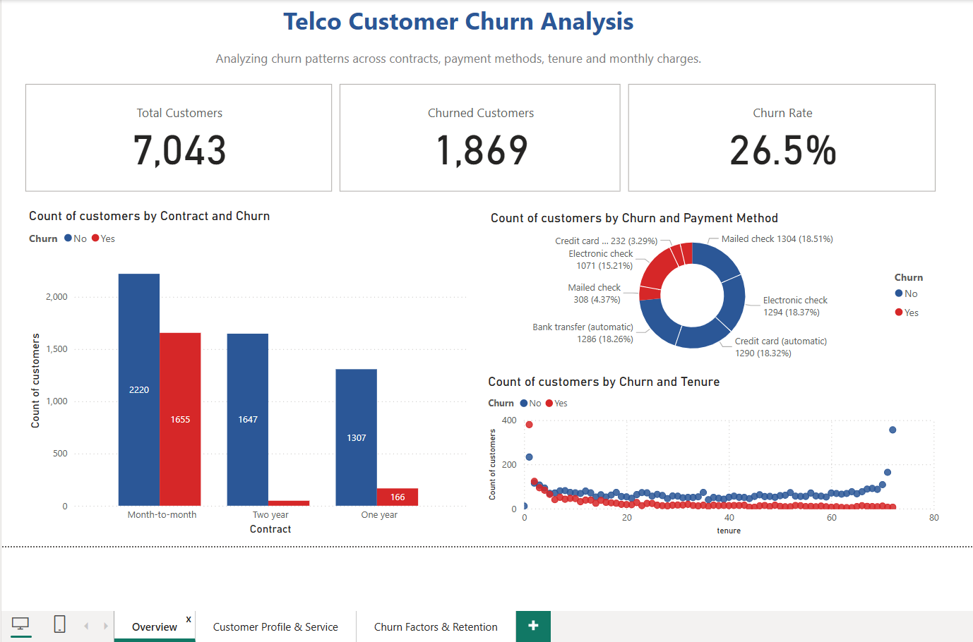

Page 2 – Customer Profile & Service
Customers with dependents, those using fiber optic and those without tech add-on services (e.g., online security, backup) are more likely to churn, suggesting targeted retention opportunities.
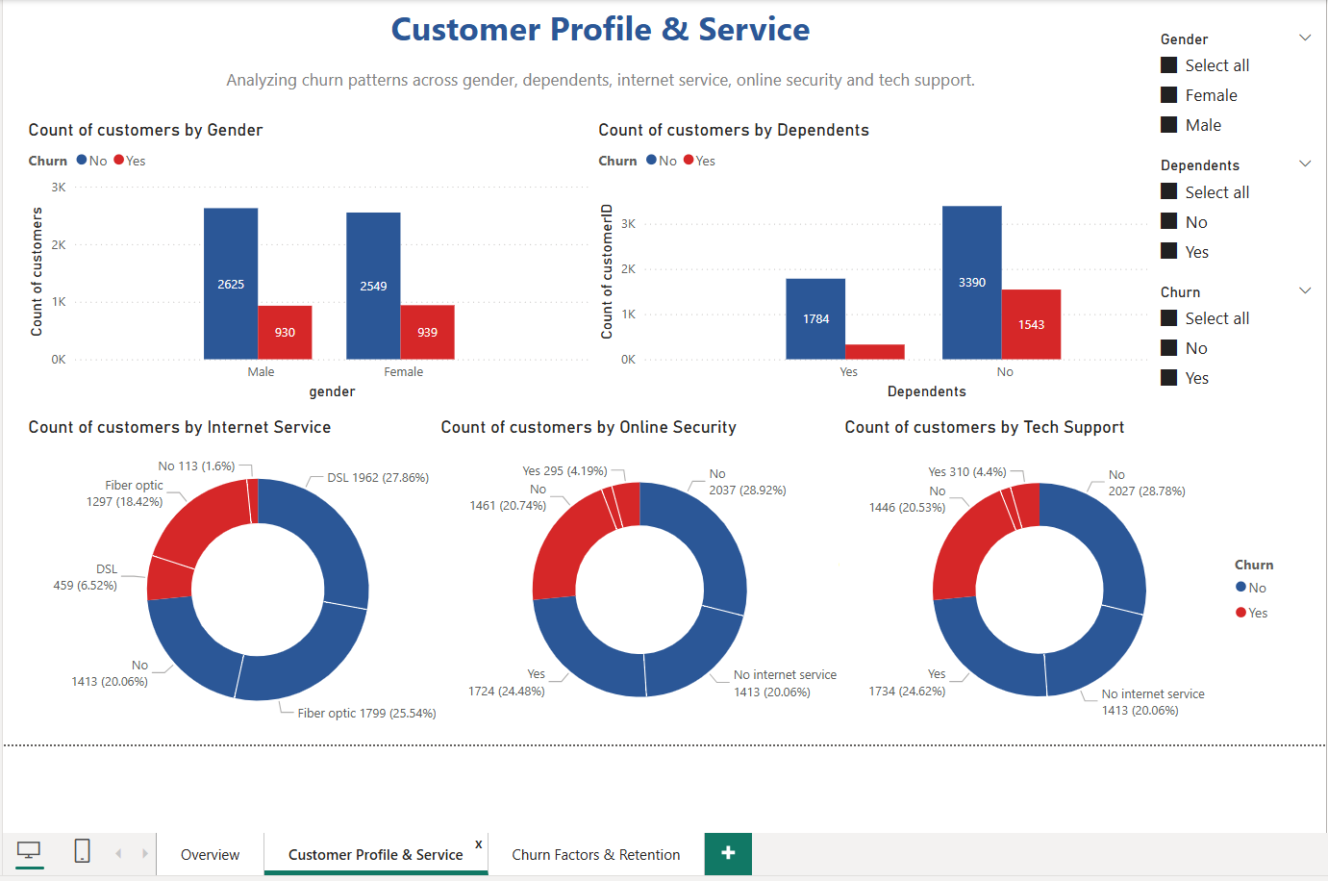

Page 3 – Churn Drivers & Retention
Churn rate is highest for customers with monthly charges between $71–$90 and tenure under 12 months, highlighting the need to review pricing and early-stage user experience.

