09/15/2023

**Stephen Current Task List**

In no particular order/priority, here are some of the tasks I am currently working on:

1. **Yaming**: PJM Basis Forecast

* Design a model that will forecast PJM On-peak basis given input parameters of load forecast, DA basis, and RT basis before 5 PM.
* Will use six months of historical data to train the model.
* Goal is to first start with a framework to provide preliminary results.

1. **Eric**: CRR and WECC planning power flow case match

* This is a continuation of one of the projects in my summer internship.
* So far, the mapping of 500 KV buses has been pretty successful. The next step is to try mapping the 230 KV buses.
* Goal is to create a similar mapping for these buses. Current model has only moderate success at this.

1. **Pranil:** Various tasks.

* Modification of Day Ahead Shift Factor Report
  + Automate a Python procedure to generate ERCOT DA basis calculations. I already made one for RT basis calculations, so I will modify it for DA calculations.
* Transmission Outages from YES to UPLAN
  + Combine Python and SQL to generate transmission outage information from Yes Energy and UPLAN.
  + Sample Output:

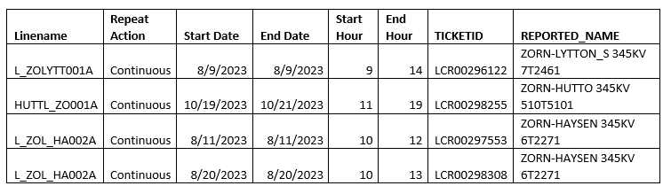

1. **Florence:**  Continue progressing on Gas Balancing project started during the summer.