**CISP-1020 Computer Science II/CITC-1313 .NET Programming**

**Chapter 11 Lab 1 – Class Diagramming II**

**Instructions**

Carefully read the narrative below.

* Bold each potential **class**.
* Underline each potential attribute or property.
* Italicize each potential *method*.

Using [LucidChart.com](http://www.lucidchart.com) (or similar application), develop a class diagram based on items identified above.

Create an inheritance hierarchy that a bank might use to represent customers' **bank accounts**. All customers at this bank can *deposit* (i.e., credit) money into their accounts and *withdraw* (i.e., debit) money from their accounts. More specific types of accounts also exist. **Savings accounts**, for instance, *earn interest* on the money they hold. Checking accounts, on the other hand, *charge a fee* per transaction.

Both savings accounts and checking accounts are a type of bank account. Regardless of type, all bank accounts have an account balance. When a bank account is created, a beginning deposit is made that makes up the initial account balance. That initial deposit must be greater than or equal to $0. All account owners can deposit additional funds into their accounts and withdraw money from their accounts. When an account owner deposits money into their account, their account is credited by that amount. When an account owner withdraws money from their account, their account is debited by that amount. When monies are withdrawn from an account, the debit amount cannot exceed the account's balance. If the amount to withdraw is greater than the account balance, the balance should be left unchanged, and the account owner is notified that the "Withdrawal amount exceeded account balance." All accounts owners can *view their account's current balance*.

Savings account have all the functionalities of a bank account. Savings accounts *draw interest* based on a set interest rate. When a savings account is created, a beginning deposit is made that makes up the initial account balance and the account's interest rate is set. A savings account's interest is calculated once a month by multiplying the interest rate by the account balance. Of course, monies can be both *deposited* and *withdrawn* from a savings account.

Checking accounts also have all the functionalities of a bank account. Every time cash is withdrawn from a checking account, a small fee is charged to the account (i.e., a transaction fee). When a checking account is created, a beginning deposit is made that makes up the initial account balance and the transaction fee is set. Depositing money into a checking account works the same as a regular bank account; however, withdrawing money from a checking account is different. When money is withdrawn from a checking account, the specified amount is withdrawn, and the transaction fee is deducted from the account. The account's balance must be enough to cover both the withdrawal amount and the transaction fee. The transaction fee is only charged if the withdrawal is successful.

Copy/paste your resulting diagram below:

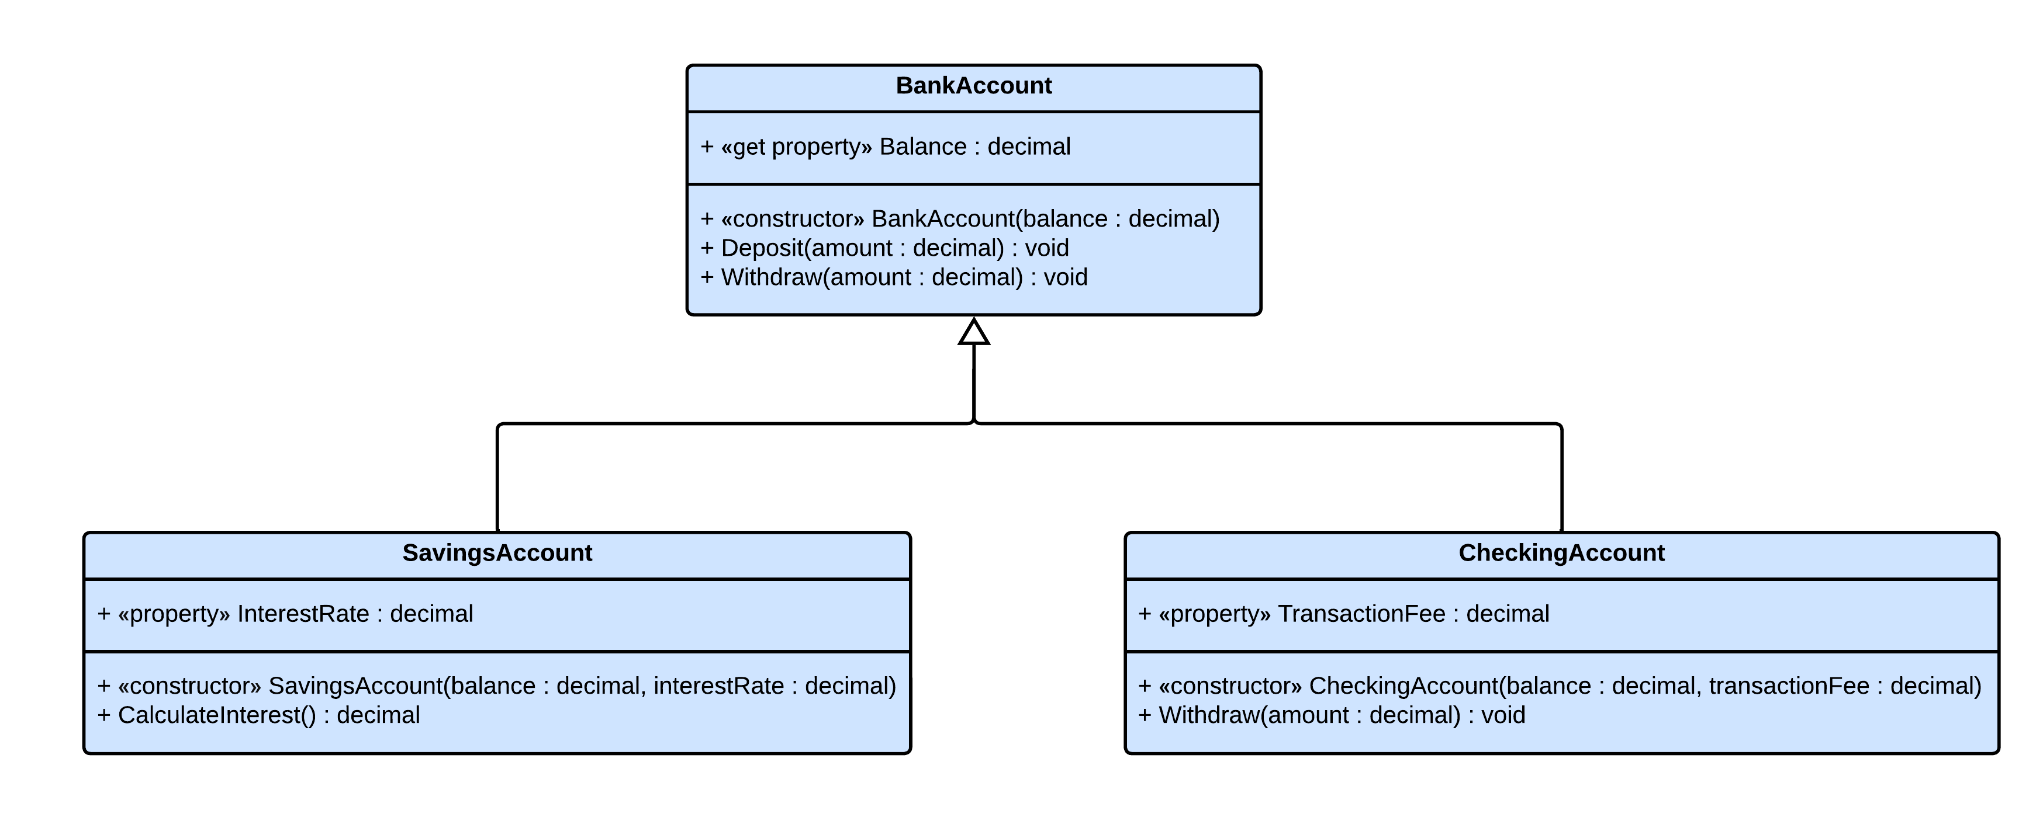

**Submission Instructions**

* Upload this file to the appropriate dropbox on eLearn.