**Experiment No.: 3**

**Aim:** Familiarization of linux commands.

**CO2:** Perform system administration task.

**Procedure:**

1.pwd - Print the working directory find the path of the current working directory

$pwd

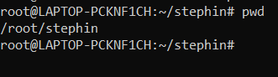

2.ls – To view the content of the directory

$ls

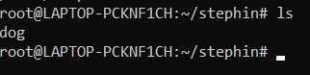

1.ls -R – To list the contents of sub directory

$ls -R

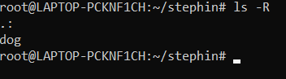

2.ls -l – Long listing of the contents

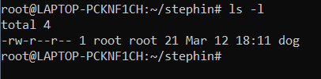

3.ls -a – To list the all hidden files

$ls -a

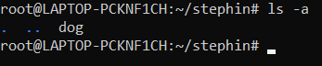

4.ls -al – List the files and directorys with detaild information.

$ls -al

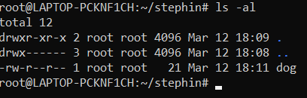

5.ls -t – List the files sorted in the order of last modified.

$ls -t

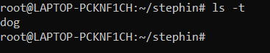

6.ls -r – To reverse the natural sorting order

$ls -r

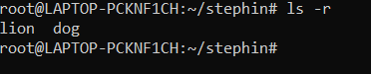

3.history – To review the command that have been previously executed for a certain period of time.

$history

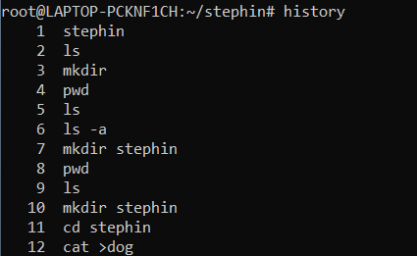

4.man – learn and understand about different command right from the shell using man command

$man

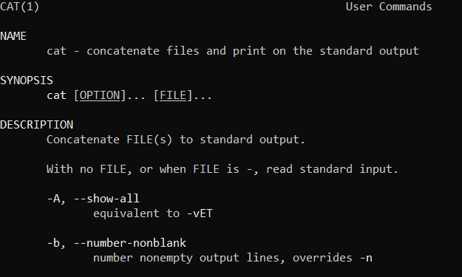

5.mkdir – To create a new directory

$mkdir



6.rmdir – To remove a directory

$rmdir



7.touch – To create new empty file

$touch



8.cat – Concatenate the files and print on the standard output

$cat

a. cat > filename.txt – To create a file with inserting contents

$cat > file.txt

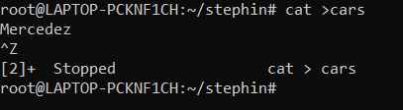

b. cat filename.txt – To view the content of the file

$cat file.txt



c. cat >> filename.txt – To append new contents to an existing file

$cat >> file.txt

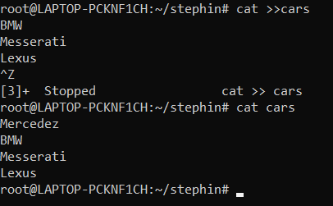

d. cat -n filename.txt – Number all output lines

$cat -n file.txt

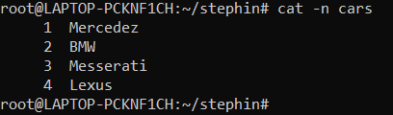

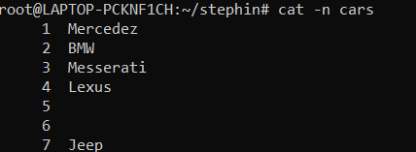

e. cat -b filename.txt – To remove the empty lines

$cat -b file.txt

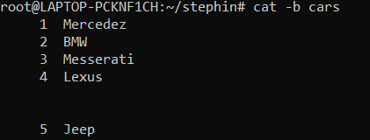

f. cat -E filename.txt – Display $ at end of each line

$cat -E file.txt

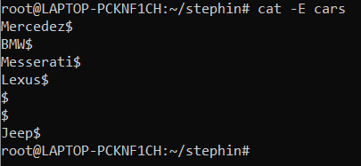

g. cat filename.txt| tr a-z A –Z > output.txt

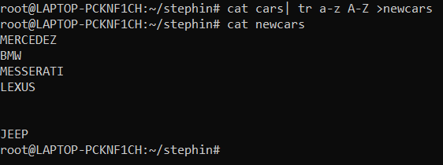

**Result**

The program was executed and the result was successfully obtained. Thus CO1 was obtained.

**Experiment No.: 4**

**Aim:** Familiarization of linux commands.

**CO2:** Perform system administration task.

**Procedure:**

1.Cut by Byte position

$cut –b1 filename.txt

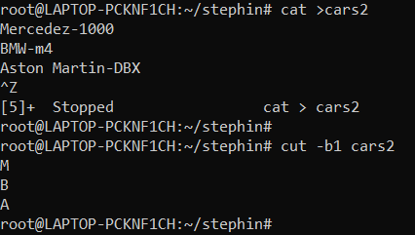

2.Cut by Character

$cut -c1 filename.txt

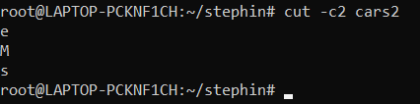

3.Cut 1st and 2nd column

$cut –d - -f1 filename

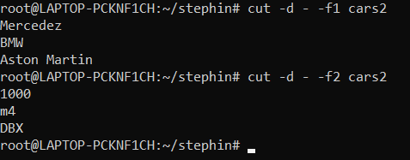

4.Paste

$paste file1 file2

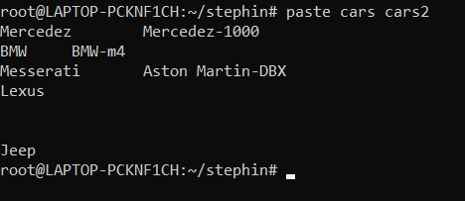

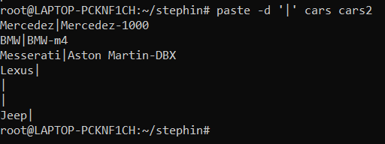

**Experiment-5**

Aim:

Familiarization of Linux Commands

Course Outcome(CO2):

Perform system administration task

Procedure:

1. read :- Read content of one line of input into a variable

$read

echo $REPLY :- To print the input from the default variable

Output:

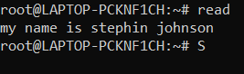

echo $REPLY :- To print the input from the default variable

* 1. read var1 var2 var3 :- To read into specific variables

$read var1 var2 var3

$echo “[$var1][$var2][$var3]”

Output:

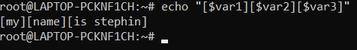

* 1. read input \ :- To read multiple lines

$read

My \

name is \

Stephin

Output:

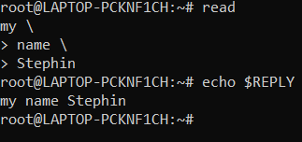

* 1. read -p :- Prompt text from user

$read -p “Enter your name”

$echo “my name is $REPLY”

Output:

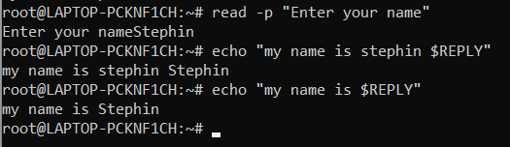

* 1. read -n :- Specify limit

$read -n 6 -p “Enter six characters only”

Output:



* 1. read -s :-For security. Hides input

$read -s -p “Enter the password: “

Output:

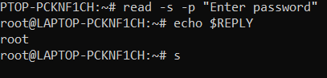

1. wc :- Word count display number of lines, number of words, number of bytes and file name

$wc file.txt

Output:

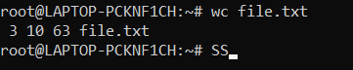

* 1. wc -l :- Display number of lines

$wc -l file.txt

Output:



* 1. wc -m :-Display number of bytes

$wc -m file.txt

Output:



* 1. wc -c :- Display number of characters

$wc -c file.txt

Output:

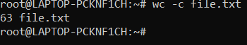

* 1. wc -w :-Display number of words

$wc -w file.txt

Output:



* 1. wc -L :- Displays length of longest line

$wc -L file.txt

Output:



1. more :- It is similar to cat to display the content. The difference is that in case of larger files, cat command output will scroll off your screen while more command display output one screenful at a time.

$more finalfantasy.txt

Output:

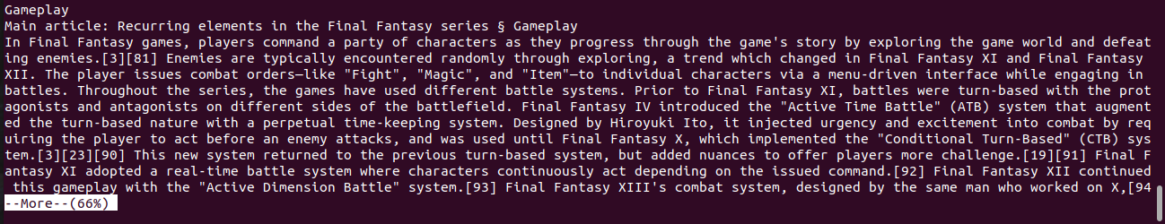

* 1. more +15 file.txt :- Will display content after the specified number of lines

$more +15 finalfantasy.txt

Output:

￼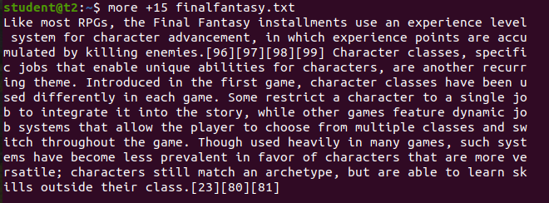

* 1. more +/pattern file.txt :- Search and navigate towards a particular string and view all the instances.

$more +/classes finalfantasy.txt

Output:

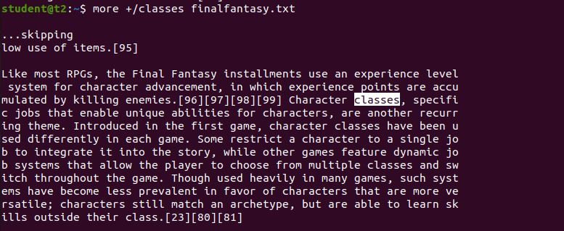

* 1. more -p file.txt :- Clear the whole screen and then display the text.

$more -p file.txt

Output:

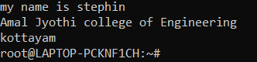

* 1. more -d file.txt :- Helps the user to navigate according to instructions, [space to continue and ‘q’ to quit]

$more -d finalfantasy.txt

Output:

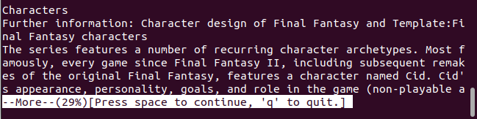

**Experiment 6: Date:** 14/03/2023

Aim:

Familiarization of Linux Commands

Course Outcome(CO2):

Perform system administration task

Procedure:

1. grep :- Filtering and Searching content easily

$gerp 34 Mark

Output:



* 1. grep -i :- Case insensitive search of a particular content￼

$grep -i 42 Mark

Output:

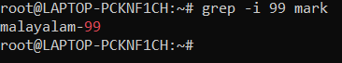

* 1. grep -v :- Exclude that content during search

$grep -v 42 Mark

Output:

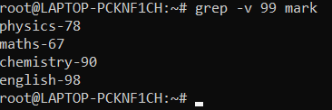

* 1. grep -A1 :- Specific content and one line after the content

$grep -A1 Maths Mark

Output:

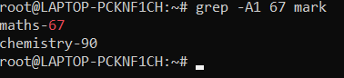

* 1. grep -B1 :- Specific content and one line before the content

$grep -B1 Maths Mark

Output:

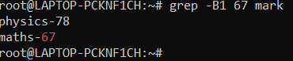

* 1. grep -C1 :- Specific content and one lone before and after the content.

$gerp -C1 Maths Mark

Output:

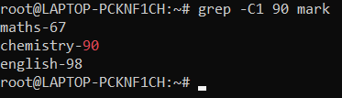

1. head :- Used to display the first content of the file(Top 10 lines by default)

$head numbers

Output:-

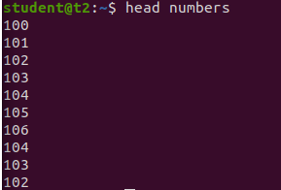

* 1. head -number filename:- Specific number of lines

$head -5 numbers

Output:

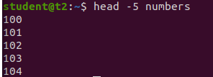

1. tail:- Used to display last contents of a file( last 10 by default)

$tail numbers

Output:

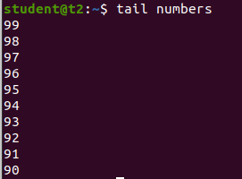

* 1. tail -number filename :- Specific number of content from last

$tail -5 numbers

Output:

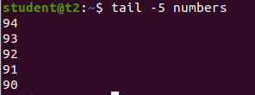

1. mv :- move from one location to another or it can be used to rename a file. Content will be overwritten.

$mv numbers Mark

Output:-

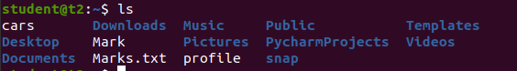

* 1. mv -b :- To take backup of a file while moving.

$mv -b Mark profile

Output:

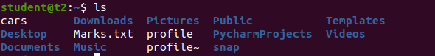

* 1. mv -i :- Prompt confirmation from user before overwriting.

$mv -i Marks.txt profile

Output:

