**Experiment No.: 3**

**Aim:** Familiarization of linux commands.

**CO2:** Perform system administration task.

**Procedure:**

1.pwd - Print the working directory find the path of the current working directory

$pwd

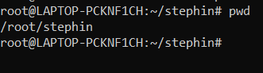

2.ls – To view the content of the directory

$ls

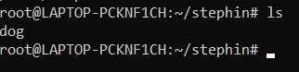

1.ls -R – To list the contents of sub directory

$ls -R

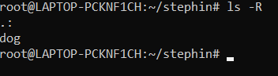

2.ls -l – Long listing of the contents

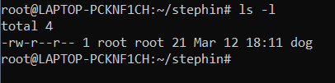

3.ls -a – To list the all hidden files

$ls -a

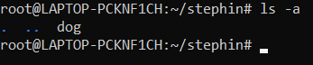

4.ls -al – List the files and directorys with detaild information.

$ls -al

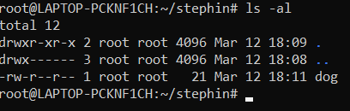

5.ls -t – List the files sorted in the order of last modified.

$ls -t

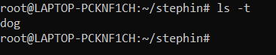

6.ls -r – To reverse the natural sorting order

$ls -r

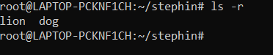

3.history – To review the command that have been previously executed for a certain period of time.

$history

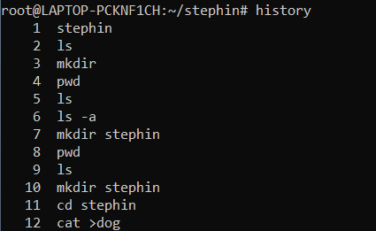

4.man – learn and understand about different command right from the shell using man command

$man

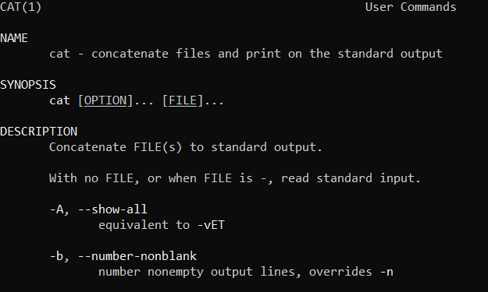

5.mkdir – To create a new directory

$mkdir



6.rmdir – To remove a directory

$rmdir



7.touch – To create new empty file

$touch



8.cat – Concatenate the files and print on the standard output

$cat

a. cat > filename.txt – To create a file with inserting contents

$cat > file.txt

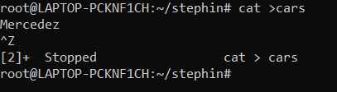

b. cat filename.txt – To view the content of the file

$cat file.txt



c. cat >> filename.txt – To append new contents to an existing file

$cat >> file.txt

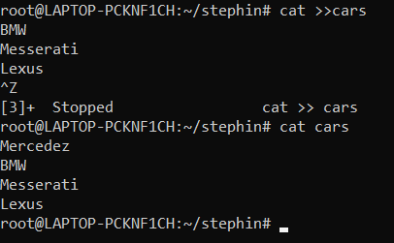

d. cat -n filename.txt – Number all output lines

$cat -n file.txt

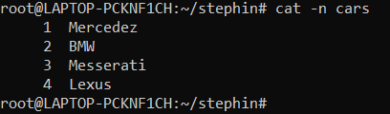

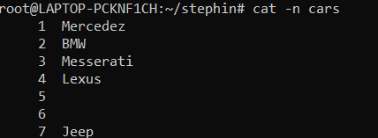

e. cat -b filename.txt – To remove the empty lines

$cat -b file.txt

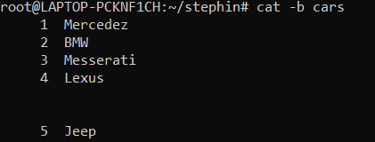

f. cat -E filename.txt – Display $ at end of each line

$cat -E file.txt

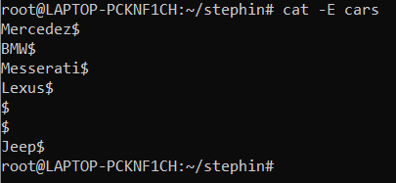

g. cat filename.txt| tr a-z A –Z > output.txt

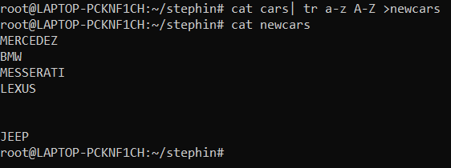

**Result**

The program was executed and the result was successfully obtained. Thus CO1 was obtained.

**Experiment No.: 4**

**Aim:** Familiarization of linux commands.

**CO2:** Perform system administration task.

**Procedure:**

1.Cut by Byte position

$cut –b1 filename.txt

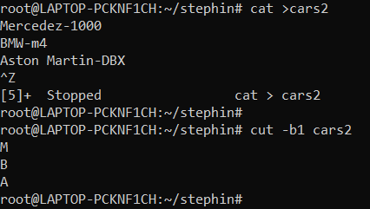

2.Cut by Character

$cut -c1 filename.txt

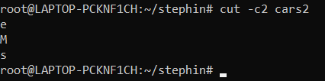

3.Cut 1st and 2nd column

$cut –d - -f1 filename

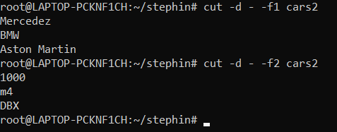

4.Paste

$paste file1 file2

