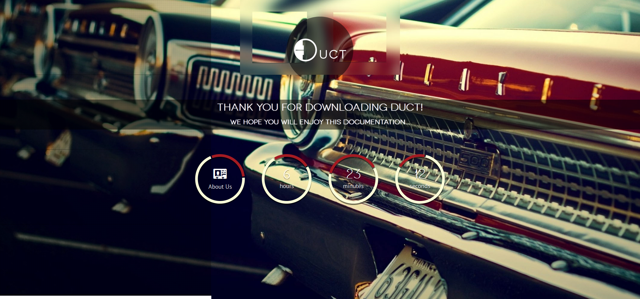

Table of Contents

How to use 3

Components 4

Logo 4

Title 4

Page Wrap 5

Mouse Radius 5

Tab Rows 5

Tab Columns 5

Tab Margins 5

Tab Shrink Ratio 6

Progress Bar Percent 6

Progress Bar Duration 6

Progress Bar Color 6

Progress Bar Background 6

Countdown 7

Blur effect 7

Newsletter 8

Contact 8

Social icons 9

Thank you 10

# How to use

This is a HTML template, so you will need basic knowledge of the Hyper Text Markup Language to customize your landing page.

All you need is basic PHP hosting and FTP access to your server to upload the entire contents of this HTML template’s folder.

We have made it easy to customize all the elements directly from HTML so you won’t need to edit any JavaScript or CSS yourself.

The directory structure is intuitive:

* **css/** – (directory) Cascade style sheets
* **js/** – (directory) JavaScript files
* **img/** – (directory) Images and fonts
* **PSD/** – (directory) PhotoShop documents of all the items you may need to customize
* **contact.php** – (file) PHP file for parsing the contact form
* **newsletter.php** – (file) PHP file for parsing the newsletter form
* **index.html** – (file) Main HTML template file

We will now guide you through all the components and options.

# Components

Even though this template heavily relies on JavaScript for animations and validations, you won’t need to write a single line of JavaScript code yourself.

We have implemented custom HTML tags to elements that get automatically parsed by JavaScript into component options.

## Logo



You can use your own logo by replacing **img/logo.png** with a **200** pixels by **200** pixels PNG image.

We have included the PhotoShop document so you can easily replace this graphic with your own.

The logo will be visible inside the top strip.

## Title

You can set the text that appears next to the logo.

<h1>**We're launching soon...**</h1>

<h2>**Fasten your seatbelts, it's going to be a thrilling ride**</h2>

Both headers are animated by sliding in from the sides. You can change the animation speed by setting the **data-progress-duration** attribute to the desired number of milliseconds (see section **Page Wrap** below).

## Page Wrap

The Page Wrap div holds most of this theme’s options as **data-** attributes.

<div id=**"page_wrap"** data-rows=**"4"** data-columns=**"8"** data-margin=**"0"** data-radius=**"300"** data-shrink=**"30"** data-progress=**"33"** data-progress-duration=**"3000"** data-progress-color=**"#ffffff"** data-progress-background=**"#ffffff"**></div>

### Mouse Radius

Tabs segment the page background so that it appears to shatter every time the mouse gets over the segments.

You can control all the aspects of this effect, from the pressure radius to the shrinking ratio.

Attribute: **data-radius**

Type: **integer**

Description: Set the radius (in pixels). This controls the sensitive area around the mouse, for which tiles react and shrink.

Default: **300**

### Tab Rows

Attribute: **data-rows**

Type: **integer**

Description: Set the number of tab rows.

Default: **4**

### Tab Columns

Attribute: **data-columns**

Type: **integer**

Description: Set the number of tab columns.

Default: **8**

### Tab Margins

Attribute: **data-margin**

Type: **integer**

Description: Set the distance (in pixels) between tabs. This is constant, regardless of the resolution.

Default: **0**

### Tab Shrink Ratio

Attribute: **data-shrink**

Type: **integer**

Description: Set the percentage at which to shrink each tile if the mouse is directly above the tile’s center (diagonals’ intersection). Allowed values: **10-90**

Default: **30**

### Progress Bar Percent

Attribute: **data-progress**

Type: **integer**

Description: Set your project’s percentage of completion. Allowed values: **0-100**

Default: **33**

### Progress Bar Duration

Attribute: **data-progress-duration**

Type: **integer**

Description: Set the progress bar animation speed in milliseconds.

Default: **3000**

### Progress Bar Color

Attribute: **data-progress-color**

Type: **string**

Description: Set the progress bar color. Hexadecimal values allowed.

Default: **#ffffff**

### Progress Bar Background

Attribute: **data-progress-background**

Type: **string**

Description: Set the progress bar color. Hexadecimal values allowed.

Default: **#ffffff**

## Countdown

The countdown automatically follows your mouse movements.

The **date** attribute dictates the date of release of your new outstanding project.

<div class=**"countdown"** date=**"2013-12-25"** data-color1=**"#fcffd9"** data-color2=**"#** **a41b22"**></div>

The date format is **YYYY-MM-DD**.

The **data-color1** and **data-color2** attributes are not mandatory and you can use any color you like, including hex, like **#ffffff**.

The **data-color2** attribute sets the color for the “remaining” part of the semi-circle.

## Blur effect

The tiles on the background are sharp whereas their background is faded out.

In order for the effect to work you must provide 2 images:

* **sharp.jpg**
* **blurred.jpg**

The sharp image is the original picture you wish to use for the background. The **blurred.jpg** image is a blurred version of the original. We recommend using PhotoShop’s **Gaussian Blur** @ 7px filter for this effect.

## Newsletter

The e-mail is validated both on the user-side, using JavaScript and on the server-side, just to make sure no hacker gets in.

You can customize the error and success codes by editing the **newsletter.php** file and changing the desired values:

**protected** $_messages = **array**(

self::MESSAGE_TRY_AGAIN => 'Please refresh and try again.',

self::MESSAGE_INVALID_FORM => 'Invalid form submitted.',

self::MESSAGE_INVALID_EMAIL => 'Invalid e-mail submitted.',

self::MESSAGE_COULD_NOT_SAVE => 'Could not save your e-mail.',

self::MESSAGE_SUCCESS => 'Thank you! You will be the first to know when we launch.',

);

## Contact

The contact form works the same as the newsletter, having its own designated **contact.php** file to handle the information.

Please not that the messages are different:

**protected** $_messages = **array**(

self::MESSAGE_TRY_AGAIN => 'Please refresh and try again.',

self::MESSAGE_INVALID_FORM => 'Invalid form submitted.',

self::MESSAGE_INVALID_NAME => 'Invalid or empty name submitted.',

self::MESSAGE_INVALID_CONTENT => 'Invalid or empty content submitted.',

self::MESSAGE_INVALID_EMAIL => 'Invalid e-mail submitted.',

self::MESSAGE_COULD_NOT_SAVE => 'Could not save your message.',

self::MESSAGE_SUCCESS => 'Thank you, %s! We will get back to you as soon as possible.',

);

The %s for the **MESSAGE_SUCCESS** string is replaced with the user’s name.

# Social icons

You may use one of the following Social icons:

<a href=**"javascript:void(0);"** class=**"social youtube"**>**Youtube**</a>

<a href=**"javascript:void(0);"** class=**"social yandex"**>**Yandex**</a>

<a href=**"javascript:void(0);"** class=**"social vkontakte"**>**Vkontakte**</a>

<a href=**"javascript:void(0);"** class=**"social vk"**>**Vk**</a>

<a href=**"javascript:void(0);"** class=**"social vimeo"**>**Vimeo**</a>

<a href=**"javascript:void(0);"** class=**"social twitter"**>**Twitter**</a>

<a href=**"javascript:void(0);"** class=**"social tumblr"**>**Tumblr**</a>

<a href=**"javascript:void(0);"** class=**"social steam"**>**Steam**</a>

<a href=**"javascript:void(0);"** class=**"social stackoverflow"**>**Stackoverflow**</a>

<a href=**"javascript:void(0);"** class=**"social soundcloud"**>**Soundcloud**</a>

<a href=**"javascript:void(0);"** class=**"social skype"**>**Skype**</a>

<a href=**"javascript:void(0);"** class=**"social share"**>**Share**</a>

<a href=**"javascript:void(0);"** class=**"social rss"**>**Rss**</a>

<a href=**"javascript:void(0);"** class=**"social readability"**>**Readability**</a>

<a href=**"javascript:void(0);"** class=**"social read-it-later"**>**Read-it-Later**</a>

<a href=**"javascript:void(0);"** class=**"social pocket"**>**Pocket**</a>

<a href=**"javascript:void(0);"** class=**"social pinterest"**>**Pinterest**</a>

<a href=**"javascript:void(0);"** class=**"social picasa"**>**Picasa**</a>

<a href=**"javascript:void(0);"** class=**"social openid"**>**Openid**</a>

<a href=**"javascript:void(0);"** class=**"social myspace"**>**Myspace**</a>

<a href=**"javascript:void(0);"** class=**"social moikrug"**>**Moikrug**</a>

<a href=**"javascript:void(0);"** class=**"social linked-in"**>**Linked-in**</a>

<a href=**"javascript:void(0);"** class=**"social lifejournal"**>**Lifejournal**</a>

<a href=**"javascript:void(0);"** class=**"social lastfm"**>**Lastfm**</a>

<a href=**"javascript:void(0);"** class=**"social jabber"**>**Jabber**</a>

<a href=**"javascript:void(0);"** class=**"social instapaper"**>**Instapaper**</a>

<a href=**"javascript:void(0);"** class=**"social habrahabr"**>**Habrahabr**</a>

<a href=**"javascript:void(0);"** class=**"social google"**>**Google**</a>

<a href=**"javascript:void(0);"** class=**"social github-octoface"**>**Github-octoface**</a>

<a href=**"javascript:void(0);"** class=**"social github-circle"**>**Github-circle**</a>

<a href=**"javascript:void(0);"** class=**"social foursquare"**>**Foursquare**</a>

<a href=**"javascript:void(0);"** class=**"social flickr"**>**Flickr**</a>

<a href=**"javascript:void(0);"** class=**"social flattr"**>**Flattr**</a>

<a href=**"javascript:void(0);"** class=**"social facebook"**>**Facebook**</a>

<a href=**"javascript:void(0);"** class=**"social evernote"**>**Evernote**</a>

<a href=**"javascript:void(0);"** class=**"social email"**>**Email**</a>

<a href=**"javascript:void(0);"** class=**"social dropbox"**>**Dropbox**</a>

<a href=**"javascript:void(0);"** class=**"social blogspot"**>**Blogspot**</a>

<a href=**"javascript:void(0);"** class=**"social bitbucket"**>**Bitbucket**</a>

<a href=**"javascript:void(0);"** class=**"social youtube-play"**>**Youtube-play**</a>

# Thank you

Thank you for purchasing the elegant **Duct.**

We wish you a great day!

**Stephino**