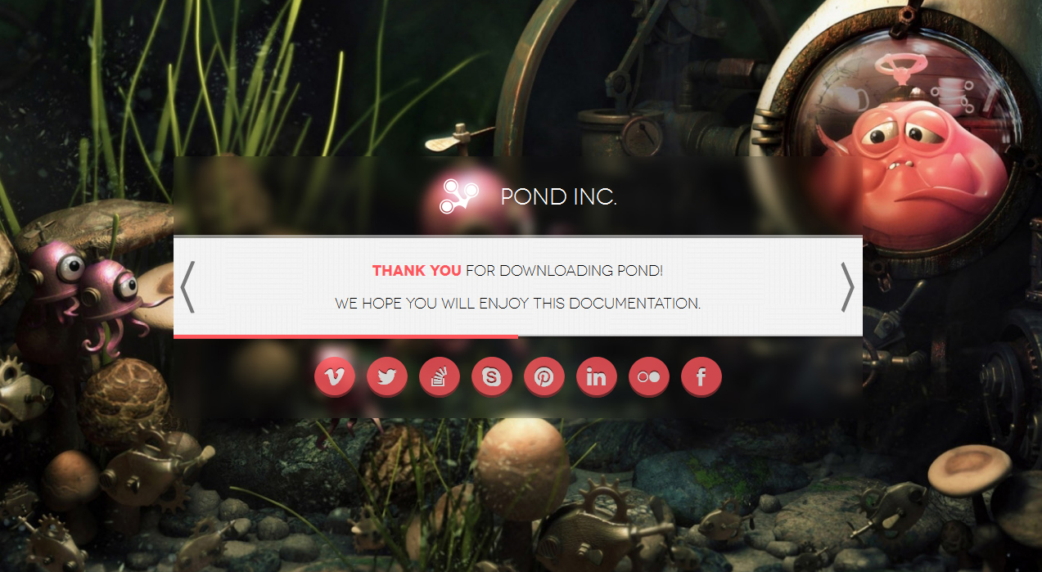

Table of Contents

How to use 3

Components 4

Logo 4

Title 4

Page Wrap 5

Ripples 5

Speed 5

Text speed 5

Pattern 5

Color 5

Dialogs 6

Countdown 6

Parallax 6

Newsletter 7

Contact 7

Social icons 8

Thank you 9

# How to use

This is a HTML template, so you will need basic knowledge of the Hyper Text Markup Language to customize your landing page.

All you need is basic PHP hosting and FTP access to your server to upload the entire contents of this HTML template’s folder.

We have made it easy to customize all the elements directly from HTML so you won’t need to edit any JavaScript or CSS yourself.

The directory structure is intuitive:

* **css/** – (directory) Cascade style sheets
* **js/** – (directory) JavaScript files
* **img/** – (directory) Images and fonts
* **PSD/** – (directory) PhotoShop documents of all the items you may need to customize
* **contact.php** – (file) PHP file for parsing the contact form
* **newsletter.php** – (file) PHP file for parsing the newsletter form
* **index.html** – (file) Main HTML template file

We will now guide you through all the components and options.

# Components

Even though this template heavily relies on JavaScript for animations and validations, you won’t need to write a single line of JavaScript code yourself.

We have implemented custom HTML tags to elements that get automatically parsed by JavaScript into component options.

## Logo

You can use your own logo by replacing **img/logo.png** with a **200** pixels by **200** pixels PNG image.

We have included the PhotoShop document so you can easily replace this graphic with your own.

The logo will be visible inside the top strip.

## Title

You can set the text that appears next to the logo.

<div class=**"title"**>**Pond Inc.**</div>

This text is animated (typed character by character). You can change the animation speed by setting the **data-text-speed** attribute to the desired number of milliseconds (see section **Page Wrap** below).

## Page Wrap

The Page Wrap div holds most of this theme’s options as **data-** attributes.

<div id=**"page_wrap"** data-ripples=**"15"** data-speed=**"4000"** data-text-speed=**"3000"** data-pattern=**"wood.png"** data-color=**"#ff565c"**>

### Ripples

Attribute: **data-ripples**

Type: **integer**

Description: Set the number of ripples scattered randomly on the screen on animation start.

Default: **15**

### Speed

Attribute: **data-speed**

Type: **integer**

Description: Set total animation speed in milliseconds.

Default: **4000**

### Text speed

Attribute: **data-text-speed**

Type: **integer**

Description: Set total animation speed for texts in milliseconds. This includes the logo and dialogs (see section **Dialogs** below).

Default: **3000**

### Pattern

Attribute: **data-patter**

Type: **string**

Description: Set background pattern image name (as found in **/img/backgrounds/**).

Default: **wood.png**

### Color

Attribute: **data-color**

Type: **string – hexadecimal representation of colors**

Description: Set color for the social icons, highlighted text and form buttons. You can highlight text in the dialogs section (see below) by marking it with **<b>Highlighted</b>**.

Default: **#ff565c**

### Dialogs

You can set Dialogs to be played one after the other on pageload.

<div class=**"content"**>

<p>**We are a** <b>**creative**</b> **agency based in Europe**</p>

<p>**We are preparing to launch our amazing new website**</p>

</div>

All you need to do is to add **paragraphs** to the **content** div. Each paragraph is individually animated with the set **Text speed** (see the section above).

## Countdown

The countdown uses vertical and horizontal bars to represent numbers.

All you’ll need to figure out is the release date:

<div class=**"countdown"** date=**"2013-09-03"** data-color=**"#abff3e"**></div>

The date format is **YYYY-MM-DD**.

The **data-color** attribute is not mandatory and you can use any color you like, including hex, like **#ffffff**. This dictates the bars colors.

## Parallax

We have added a parallax effect for the background image.

In order for the effect to work you must provide 2 images:

* **sharp.jpg**
* **blurred.jpg**

The sharp image is the original picture you wish to use for the background. The **blurred.jpg** image is a blurred version of the original. We recommend using PhotoShop’s **Gaussian Blur** @ 7px filter for this effect.

## Newsletter

The e-mail is validated both on the user-side, using JavaScript and on the server-side, just to make sure no hacker gets in.

You can customize the error and success codes by editing the **newsletter.php** file and changing the desired values:

**protected** $_messages = **array**(

self::MESSAGE_TRY_AGAIN => 'Please refresh and try again.',

self::MESSAGE_INVALID_FORM => 'Invalid form submitted.',

self::MESSAGE_INVALID_EMAIL => 'Invalid e-mail submitted.',

self::MESSAGE_COULD_NOT_SAVE => 'Could not save your e-mail.',

self::MESSAGE_SUCCESS => 'Thank you! You will be the first to know when we launch.',

);

## Contact

The contact form works the same as the newsletter, having its own designated **contact.php** file to handle the information.

Please not that the messages are different:

**protected** $_messages = **array**(

self::MESSAGE_TRY_AGAIN => 'Please refresh and try again.',

self::MESSAGE_INVALID_FORM => 'Invalid form submitted.',

self::MESSAGE_INVALID_NAME => 'Invalid or empty name submitted.',

self::MESSAGE_INVALID_CONTENT => 'Invalid or empty content submitted.',

self::MESSAGE_INVALID_EMAIL => 'Invalid e-mail submitted.',

self::MESSAGE_COULD_NOT_SAVE => 'Could not save your message.',

self::MESSAGE_SUCCESS => 'Thank you, %s! We will get back to you as soon as possible.',

);

The %s for the **MESSAGE_SUCCESS** string is replaced with the user’s name.

# Social icons

You may use one of the following Social icons:

<a href=**"javascript:void(0);"** class=**"social youtube"**>**Youtube**</a>

<a href=**"javascript:void(0);"** class=**"social yandex"**>**Yandex**</a>

<a href=**"javascript:void(0);"** class=**"social vkontakte"**>**Vkontakte**</a>

<a href=**"javascript:void(0);"** class=**"social vk"**>**Vk**</a>

<a href=**"javascript:void(0);"** class=**"social vimeo"**>**Vimeo**</a>

<a href=**"javascript:void(0);"** class=**"social twitter"**>**Twitter**</a>

<a href=**"javascript:void(0);"** class=**"social tumblr"**>**Tumblr**</a>

<a href=**"javascript:void(0);"** class=**"social steam"**>**Steam**</a>

<a href=**"javascript:void(0);"** class=**"social stackoverflow"**>**Stackoverflow**</a>

<a href=**"javascript:void(0);"** class=**"social soundcloud"**>**Soundcloud**</a>

<a href=**"javascript:void(0);"** class=**"social skype"**>**Skype**</a>

<a href=**"javascript:void(0);"** class=**"social share"**>**Share**</a>

<a href=**"javascript:void(0);"** class=**"social rss"**>**Rss**</a>

<a href=**"javascript:void(0);"** class=**"social readability"**>**Readability**</a>

<a href=**"javascript:void(0);"** class=**"social read-it-later"**>**Read-it-Later**</a>

<a href=**"javascript:void(0);"** class=**"social pocket"**>**Pocket**</a>

<a href=**"javascript:void(0);"** class=**"social pinterest"**>**Pinterest**</a>

<a href=**"javascript:void(0);"** class=**"social picasa"**>**Picasa**</a>

<a href=**"javascript:void(0);"** class=**"social openid"**>**Openid**</a>

<a href=**"javascript:void(0);"** class=**"social myspace"**>**Myspace**</a>

<a href=**"javascript:void(0);"** class=**"social moikrug"**>**Moikrug**</a>

<a href=**"javascript:void(0);"** class=**"social linked-in"**>**Linked-in**</a>

<a href=**"javascript:void(0);"** class=**"social lifejournal"**>**Lifejournal**</a>

<a href=**"javascript:void(0);"** class=**"social lastfm"**>**Lastfm**</a>

<a href=**"javascript:void(0);"** class=**"social jabber"**>**Jabber**</a>

<a href=**"javascript:void(0);"** class=**"social instapaper"**>**Instapaper**</a>

<a href=**"javascript:void(0);"** class=**"social habrahabr"**>**Habrahabr**</a>

<a href=**"javascript:void(0);"** class=**"social google"**>**Google**</a>

<a href=**"javascript:void(0);"** class=**"social github-octoface"**>**Github-octoface**</a>

<a href=**"javascript:void(0);"** class=**"social github-circle"**>**Github-circle**</a>

<a href=**"javascript:void(0);"** class=**"social foursquare"**>**Foursquare**</a>

<a href=**"javascript:void(0);"** class=**"social flickr"**>**Flickr**</a>

<a href=**"javascript:void(0);"** class=**"social flattr"**>**Flattr**</a>

<a href=**"javascript:void(0);"** class=**"social facebook"**>**Facebook**</a>

<a href=**"javascript:void(0);"** class=**"social evernote"**>**Evernote**</a>

<a href=**"javascript:void(0);"** class=**"social email"**>**Email**</a>

<a href=**"javascript:void(0);"** class=**"social dropbox"**>**Dropbox**</a>

<a href=**"javascript:void(0);"** class=**"social blogspot"**>**Blogspot**</a>

<a href=**"javascript:void(0);"** class=**"social bitbucket"**>**Bitbucket**</a>

<a href=**"javascript:void(0);"** class=**"social youtube-play"**>**Youtube-play**</a>

# Thank you

Thank you for purchasing the lovely **Pond.**

We wish you a great day!

**Stephino**