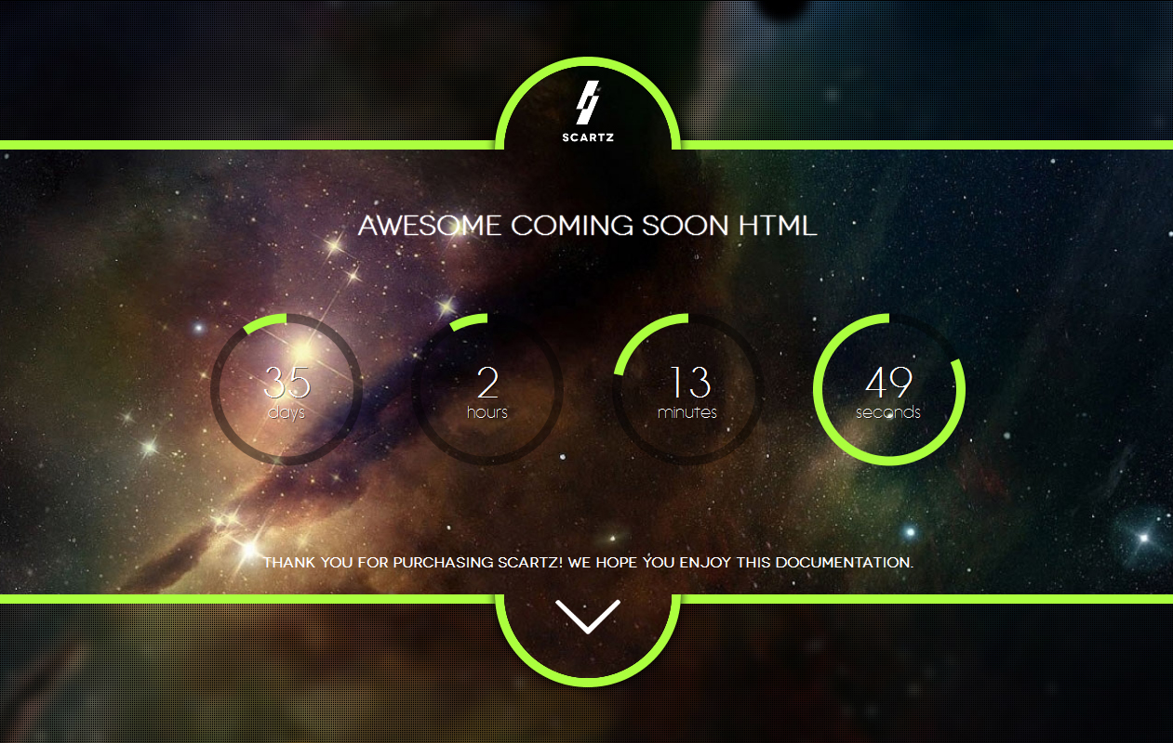

Table of Contents

How to use 3

Components 4

Logo 4

Header 4

Countdown 5

Slider 5

Curtains 6

Newsletter 7

Contact 7

About Us 7

Social icons 9

Thank you 10

# How to use

This is a HTML template, so you will need basic knowledge of the Hyper Text Markup Language to customize your landing page.

All you need is basic PHP hosting and FTP access to your server to upload the entire contents of this HTML template’s folder.

We have made it easy to customize all the elements directly from HTML so you won’t need to edit any JavaScript or CSS yourself.

The directory structure is intuitive:

* **css/** – (directory) Cascade style sheets
* **js/** – (directory) JavaScript files
* **img/** – (directory) Images and fonts
* **PSD/** – (directory) PhotoShop documents of all the items you may need to customize
* **contact.php** – (file) PHP file for parsing the contact form
* **newsletter.php** – (file) PHP file for parsing the newsletter form
* **index.html** – (file) Main HTML template file

We will now guide you through all the components and options.

# Components

Even though this template heavily relies on JavaScript for animations and validations, you won’t need to write a single line of JavaScript code yourself.

We have implemented custom HTML tags to elements that get automatically parsed by JavaScript into component options.

## Logo



You can use your own logo by replacing **img/logo.png** with a **200** pixels by **200** pixels PNG image.

We have included the PhotoShop document so you can easily replace this graphic with your own.

The logo will be visible inside the top semi-circle. It will be automatically resized based on the radius of that semi-circle, which varies with the screen width.

## Header

The header is simple, basic, HTML.

<h1>**Prepare to be amazed!**</h1>

<h3>**We will launch soon. Check out the section below for more information.**</h3>

Use your own words.

## Countdown

The countdown uses Canvas elements to display the discs that represent the time to launch.

It is pretty complicated but all you’ll need to figure out is the release date:

<div class=**"countdown"** date=**"2013-09-03"** data-color=**"#abff3e"**></div>

The date format is **YYYY-MM-DD**.

The **data-color** attribute is not mandatory and you can use any color you like, including hex, like **#ffffff**. This dictates the discs colors.

## Slider

We have decided to use a very simplistic slider. There are no navigation buttons, no slide “bubbles” and the HTML markup is simplistic.

<div class=**"slider"** data-duration=**"4000"**>

<img src=**"img/slider/1.jpg"**/>

<img src=**"img/slider/2.jpg"**/>

<img src=**"img/slider/3.jpg"**/>

</div>

The **data-duration** attribute indicates the time between slides, in milliseconds.

Each slide is an image you provide. The **src** attributes are not custom in any way. Simply include paths to the images you wish to use as slides.

**IMPORTANT**

For each image you specify, there must also be a **blurred** correspondent, for the blurred curtains effect to work. We recommend blurring these images with Photoshop **Gaussian blur**, **5px.**

Example: Your slider contains 3 images, as displayed above. You must also add

* **1-blurred.jpg**
* **2-blurred.jpg**
* **3-blurred.jpg**

in the same location as the corresponding crisp/original images, **without adding extra HTML elements to the slider.** Please note the naming: ***{original image name}*-blurred.*{original image extension}.***

## Curtains

This HTML template features a semi-transparent “curtains” transition.

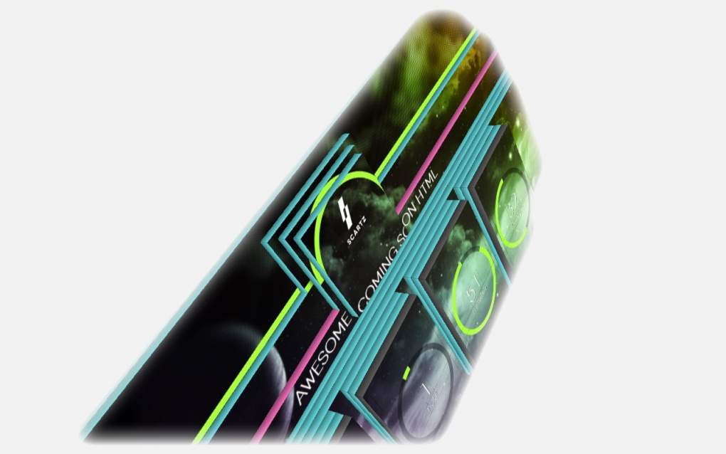Please note that:

* A parallax effect is revealed if you move your cursor
* The background image is faded out on the top and lower curtains
* The background image is crisp inside the semi-circles, as well as in the background layer

Although this effect is simple at first sight, it is actually quite difficult to replicate using CSS and HTML.

You don’t need to worry about that, though. All you have to edit is a simple HTML piece of code:

<div class=**"loading"** data-color=**"#abff3e"** data-courtain=**"1"** data-duration=**"3000"**></div>

You may change the following attributes:

* **data-color** – specify any CSS color, including HEX; sets the color for the circle border and median line
* **data-curtain** – integer; use one of the 2 pre-defined pixel patterns as an overlay for the top and bottom curtains; or add your own pattern in **/img/overlays/pattern.png** and use that name as the data-curtain value; a heads ups: the images in the top and bottom curtains are **actually faded out with PhotoShop**, this options only specifies another layer of CSS blurring. Please revisit the Slider section for more information about the blurred images
* **data-duration** – integer, number of milliseconds; defines how long the “loading” effect should take.

## Newsletter

The e-mail is validated both on the user-side, using JavaScript and on the server-side, just to make sure no hacker gets in.

You can customize the error and success codes by editing the **newsletter.php** file and changing the desired values:

**protected** $_messages = **array**(

self::MESSAGE_TRY_AGAIN => 'Please refresh and try again.',

self::MESSAGE_INVALID_FORM => 'Invalid form submitted.',

self::MESSAGE_INVALID_EMAIL => 'Invalid e-mail submitted.',

self::MESSAGE_COULD_NOT_SAVE => 'Could not save your e-mail.',

self::MESSAGE_SUCCESS => 'Thank you! You will be the first to know when we launch.',

);

## Contact

The contact form works the same as the newsletter, having its own designated **contact.php** file to handle the information.

Please not that the messages are different:

**protected** $_messages = **array**(

self::MESSAGE_TRY_AGAIN => 'Please refresh and try again.',

self::MESSAGE_INVALID_FORM => 'Invalid form submitted.',

self::MESSAGE_INVALID_NAME => 'Invalid or empty name submitted.',

self::MESSAGE_INVALID_CONTENT => 'Invalid or empty content submitted.',

self::MESSAGE_INVALID_EMAIL => 'Invalid e-mail submitted.',

self::MESSAGE_COULD_NOT_SAVE => 'Could not save your message.',

self::MESSAGE_SUCCESS => 'Thank you, %s! We will get back to you as soon as possible.',

);

The %s for the **MESSAGE_SUCCESS** string is replaced with the user’s name.

## About Us

The HTML markup is a Bootstrap modal:

<!--About us-->

<div class=**"modal hide fade"** id=**"about-us"** tabindex=**"1"** role=**"dialog"** aria-hidden=**"true"**>

<div class=**"modal-header"**>

<button type=**"button"** class=**"close"** data-dismiss=**"modal"** aria-hidden=**"true"**>**×**</button>

<h3>**About us**</h3>

</div>

<div class=**"modal-body"**>

**We are a creative agency based in Europe.**<br/>

**Lorem ipsum dolor sit amet is the way we start all of our sentences.**

</div>

</div>

Feel free to customize the **modal-body** with anything you like.

More info about Twitter Bootstrap’s modals: <http://twitter.github.io/bootstrap/javascript.html#modals>.

# Social icons

You may use one of the following Social icons:

<a href=**"javascript:void(0);"** class=**"social youtube"**>**Youtube**</a>

<a href=**"javascript:void(0);"** class=**"social yandex"**>**Yandex**</a>

<a href=**"javascript:void(0);"** class=**"social vkontakte"**>**Vkontakte**</a>

<a href=**"javascript:void(0);"** class=**"social vk"**>**Vk**</a>

<a href=**"javascript:void(0);"** class=**"social vimeo"**>**Vimeo**</a>

<a href=**"javascript:void(0);"** class=**"social twitter"**>**Twitter**</a>

<a href=**"javascript:void(0);"** class=**"social tumblr"**>**Tumblr**</a>

<a href=**"javascript:void(0);"** class=**"social steam"**>**Steam**</a>

<a href=**"javascript:void(0);"** class=**"social stackoverflow"**>**Stackoverflow**</a>

<a href=**"javascript:void(0);"** class=**"social soundcloud"**>**Soundcloud**</a>

<a href=**"javascript:void(0);"** class=**"social skype"**>**Skype**</a>

<a href=**"javascript:void(0);"** class=**"social share"**>**Share**</a>

<a href=**"javascript:void(0);"** class=**"social rss"**>**Rss**</a>

<a href=**"javascript:void(0);"** class=**"social readability"**>**Readability**</a>

<a href=**"javascript:void(0);"** class=**"social read-it-later"**>**Read-it-Later**</a>

<a href=**"javascript:void(0);"** class=**"social pocket"**>**Pocket**</a>

<a href=**"javascript:void(0);"** class=**"social pinterest"**>**Pinterest**</a>

<a href=**"javascript:void(0);"** class=**"social picasa"**>**Picasa**</a>

<a href=**"javascript:void(0);"** class=**"social openid"**>**Openid**</a>

<a href=**"javascript:void(0);"** class=**"social myspace"**>**Myspace**</a>

<a href=**"javascript:void(0);"** class=**"social moikrug"**>**Moikrug**</a>

<a href=**"javascript:void(0);"** class=**"social linked-in"**>**Linked-in**</a>

<a href=**"javascript:void(0);"** class=**"social lifejournal"**>**Lifejournal**</a>

<a href=**"javascript:void(0);"** class=**"social lastfm"**>**Lastfm**</a>

<a href=**"javascript:void(0);"** class=**"social jabber"**>**Jabber**</a>

<a href=**"javascript:void(0);"** class=**"social instapaper"**>**Instapaper**</a>

<a href=**"javascript:void(0);"** class=**"social habrahabr"**>**Habrahabr**</a>

<a href=**"javascript:void(0);"** class=**"social google"**>**Google**</a>

<a href=**"javascript:void(0);"** class=**"social github-octoface"**>**Github-octoface**</a>

<a href=**"javascript:void(0);"** class=**"social github-circle"**>**Github-circle**</a>

<a href=**"javascript:void(0);"** class=**"social foursquare"**>**Foursquare**</a>

<a href=**"javascript:void(0);"** class=**"social flickr"**>**Flickr**</a>

<a href=**"javascript:void(0);"** class=**"social flattr"**>**Flattr**</a>

<a href=**"javascript:void(0);"** class=**"social facebook"**>**Facebook**</a>

<a href=**"javascript:void(0);"** class=**"social evernote"**>**Evernote**</a>

<a href=**"javascript:void(0);"** class=**"social email"**>**Email**</a>

<a href=**"javascript:void(0);"** class=**"social dropbox"**>**Dropbox**</a>

<a href=**"javascript:void(0);"** class=**"social blogspot"**>**Blogspot**</a>

<a href=**"javascript:void(0);"** class=**"social bitbucket"**>**Bitbucket**</a>

<a href=**"javascript:void(0);"** class=**"social youtube-play"**>**Youtube-play**</a>

# Thank you

Thank you for purchasing the amazing **Scartz.**

We wish you a great day!

**Stephino**