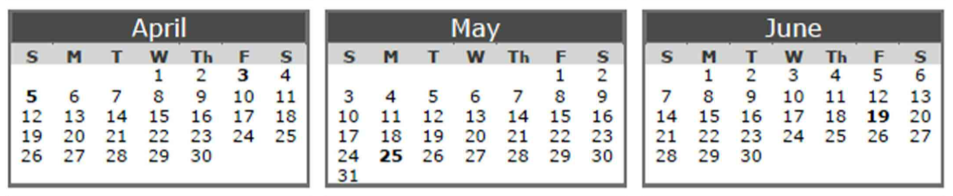
Design – 3rd Quarter
- Submit Form – requirements & dev story review [May 1, 2026]
  - Review existing submit form UX, draft or refine requirements, and prepare design specifications ready for dev story creation
- Community Enhancement TBD – full UX feedback cycle [July 3, 2026]
  - End-to-end UX feedback loop: research, design review, stakeholder/community feedback, and iteration sign-off
Design – Ongoing/Rolling
- Dev story UX/HCD review [Rolling]
  - Review of dev stories that require UX/HCD input before or during development.
- Ops story UX/HCD review [Rolling]
  - UX/HCD review of stories raised by the ops side of the team (workflows and touchpoints, design recommendations)
- Penpot – design system component builds and documentation [Ongoing]
  - Recreate current system components in Penpot, ensuring component library reflects the live design system accurately
    - End user components [November 30, 2026]
    - Admin only components [TBD]
____________________________________________________________________________________
- Storybook documentation [Future / Aspirational]
  - Document Penpot components, patterns, and usage guidelines to support consistency in Storybook

